**NODE.JS, NPM, Bower, Grunt, Jasmine, Karma Configuration and uses:**

1. Create a sample java or any other project in Eclipse (most preferable) or any Other IDE, perhaps you are familiar with.
2. Check if node.js is installed in your computer already. How? (open windows cmd prompt -> type npm

You should see: Usage: npm <command>

where <command> is one of:

access, add-user, adduser, apihelp, author, bin, bugs, c,

cache, completion, config, ddp, dedupe, deprecate, dist-tag,

dist-tags, docs, edit, explore, faq, find, find-dupes, get,

help, help-search, home, i, info, init, install, issues, la,

link, list, ll, ln, login, logout, ls, outdated, owner,

pack, ping, prefix, prune, publish, r, rb, rebuild, remove,

repo, restart, rm, root, run-script, s, se, search, set,

show, shrinkwrap, star, stars, start, stop, t, tag, team,

test, tst, un, uninstall, unlink, unpublish, unstar, up,

update, upgrade, v, verison, version, view, whoami

npm <cmd> -h quick help on <cmd>

npm -l display full usage info

npm faq commonly asked questions

npm help <term> search for help on <term>

npm help npm involved overview

1. If you see: ‘npm’ is not recognized as internal or external command, then download node.js from (<https://nodejs.org/en/>).
2. After successful installation, restart your computer and in cmd prompt change directory to project you have created above,

Eg: cd C:\Users\pkarnati\workspace\myProjectName

Note: if you want to know your current project path? eclipse -> right click on yourProjectName-> properties -> you will see path of your project.

Don’t make any mistakes, as we are going to install all modules in this directory path.

1. Notes on Node.js and NPM:

**If you've been working with Javascript for a while, you might have heard of npm: npm makes it easy for Javascript developers to share the code that they've created to solve particular problems, and for other developers to reuse that code in their own applications.**

**Once you're depending on this code from other developers, npm makes it really easy to check to see if they've made any updates to it, and to download those updates when they're made.**

**These bits of reusable code are called packages, or sometimes modules. A package is just a directory with one or more files in it, that also has a file called "package.json" with some metadata about this package. A typical application, such as a website, will depend on dozens or hundreds of packages. These packages are often small. The general idea is that you create a small building block which solves one problem and solves it well. This makes it possible for you to compose larger, custom solutions out of these small, shared building blocks.**

**There's lots of benefits to this. It makes it possible for your team to draw on expertise outside of your organization by bringing in packages from people who have focused on particular problem areas. But even if you don't reuse code from people outside of your organization, using this kind of module based approach can actually help your team work together better, and can also make it possible to reuse code across projects.**

**You can find packages to help you build your application by browsing the npm website. When you're browsing the website, you'll find different kinds of packages. You'll find lots of node modules. npm started as the node package manager, so you'll find lots of modules which can be used on the server side. There are also lots of packages which add commands for you to use in the command line. And at this point you can find a number of packages which can be used in the browser, on the front end.**

**So now that you have an idea of what npm can do, let's talk about how it works. When people talk about npm, they can be talking about one of three things. They could be talking about the website, which we've just been looking at. Or they could be talking about the registry, which is a big database of information about packages that people are sharing. Or the third thing they could be talking about is the client: when a developer decides to share their code, they use the npm client which is installed on their computer to publish that code up to the registry. And once there's an entry for this package in the registry, then other developers can use their npm clients to install the package from the registry. The entry in the registry for this package is also reflected on the website, where there's a page dedicated to this new package.**

**So that's what npm is. It's a way to reuse code from other developers, and also a way to share your code with them, and it makes it easy to manage the different versions of code**.

1. Installing a packages can be done different ways,
   1. Manually Creating a package.json and give dependencies
   2. Creating package.json runtime using command **“npm init”**
   3. Downloading packages directly with command npm install <package name> eg: npm install jquery
2. We will use npm init command to create package.json. (any questions please ask) because this is most obvious and useful way.
3. Run :
   1. npm init

eg: C:\Users\pkarnati\workspace\AngularjsTestProject> npm init

it will ask for all details of package.json like name, version etc..

* + 1. give name as you wish, eg: testsample or else just press enter to give the name in the brackets as default
    2. version(1.0.0) just press enter
    3. description: this is sample project
    4. entry point:(index.js): press enter
    5. test command: this is test
    6. git repository: press enter
    7. keywords: press enter
    8. author: give your name and press enter
    9. licence: (ISC) press enter
    10. Is this ok?(yes) press enter

You will see a package.json in your eclipse project

* 1. Now you can download all the packages required for your project, it can be done in two ways.
     1. Using command npm install <package-name>

Eg: npm install grunt

Or

* + 1. Manually giving dependencies in package.json

Type “npm install grunt” in cmd prompt and then you should see node_modules directory in your project and expanding shows that grunt package has been added to the modules. (if not, please let me know the issues you are facing to help you out.). so now we have added grunt package to node_modules using command prompt, then we will add some more packages or dependencies to node_modules using package.json as :

Add devDependencies json object to our package.json as:

{

"name": *"testsample"*,

"version": *"1.0.0"*,

"description": *"this is sample project"*,

"devDependencies": {

"angular-mocks": *"1.5.0"*,

"grunt": *"^0.4.5"*,

"grunt-bower-concat": *"^0.6.0"*,

"grunt-cache-bust": *"^1.1.0"*

},

"main": *"index.js"*,

"scripts": {

"test": *"this is test"*

},

"author": *"praveen"*,

"license": *"ISC"*

}

Type npm install in cmd prompt and check you node modules directory in your project, you should see grunt-bower-concat, grunt-cache-bust etc.. packages have been added.(if not let me know). I hope you understand, how we are installing packages to our packages using npm. So whenever we need a new package to be installed to our project, we add that package or library to our devDependencies json object and we do npm install in cmd prompt.

Let say, we need karma to our project, what I do is:

"devDependencies": {

"angular-mocks": *"1.5.0"*,

"grunt": *"^0.4.5"*,

"grunt-bower-concat": *"^0.6.0"*,

"grunt-cache-bust": *"^1.1.0"*,

"karma": *"^0.13.22"*

}

I added karma with version to our package.json and from cmd prompt did npm install. I see karma package in my node_modules in my project in eclipse.

### Imp Note : Please read the packages section in below link.

Full documentation here: <https://docs.npmjs.com/getting-started/using-a-package.json>

Bower Installation:

**Keeping track of all these packages and making sure they are up to date (or set to the specific versions you need) is tricky. Bower to the rescue!**

**Bower can manage components that contain HTML, CSS, JavaScript, fonts or even image files. Bower doesn’t concatenate or minify code or do anything else - it just installs the right versions of the packages you need and their dependencies.**

**To**[**get started**](https://bower.io/#getting-started)**, Bower works by fetching and installing**[**packages**](https://bower.io/search)**from all over, taking care of hunting, finding, downloading, and saving the stuff you’re looking for. Bower keeps track of these packages in a manifest file,**[**bower.json**](https://bower.io/docs/creating-packages/#bowerjson)**. How you use**[**packages**](https://bower.io/search)**is up to you. Bower provides hooks to facilitate using packages in your**[**tools and workflows**](https://bower.io/docs/tools)**.**

**Bower is optimized for the front-end. If multiple packages depend on a package - jQuery for example - Bower will download jQuery just once. This is known as a flat dependency graph and it helps reduce page load.**

1. Type npm install –g bower
2. This should add bower_components directory to you project in eclipse
3. Type bower install jquery
4. This should install jquery to your bower_components (please check, if success but cannot see, restart eclipse)
5. To create a bower.json as we did for package.json use this command : **bower init**
6. Name(testsample) press enter to use testsample as name or enter your own name
7. Description() same as a.
8. Main file(index.js) press enter
9. Keywords() press enter
10. Author(Praveen) press enter
11. Licence(ISC) press enter
12. Homepage press enter
13. Give answer Yes for all the questions it asks.

You should see bower.json in your project now.

Give all the dependencies required for your project, let say we need underscore, angular, angular-sanitize for our project. We will add them to our bower.json object as:

"dependencies": {

"jquery": *"^3.1.1"*,

"underscore": *"1.8.3"*,

"angular": *"~1.4.8"*,

"angular-sanitize": *"~1.4.8"*

}

And then do bower install from command line. All the libraries or packages will be added to you bower_components directory in your project please check.

(will continue with all other stuff)

Mohini can you please format the documentation properly and send it back to me whenever you have some free time.

Any question or issues facing while installing please let me know.Thanks.

**How to Run Project Locally on (http-server).**

1. Change directory to project path. Eg: cd C:Users/pkarnati/workspace/AngularjsProject
2. Run npm install http-server –g and npm install http-server(you should see http-server and list of files in your node_modules directory of your current project.
3. Run this command in Cygwin or putty: ./node_modules/.bin/http-server –a localhost –p 8000 –c-1
4. You should see like this 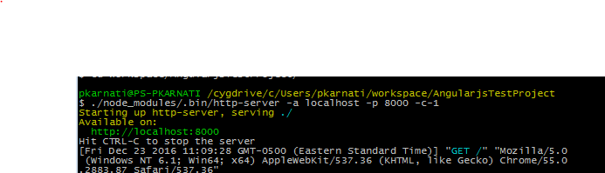
5. Now, run <http://localhost:8000> in your browser, you should see similar to like this. 6.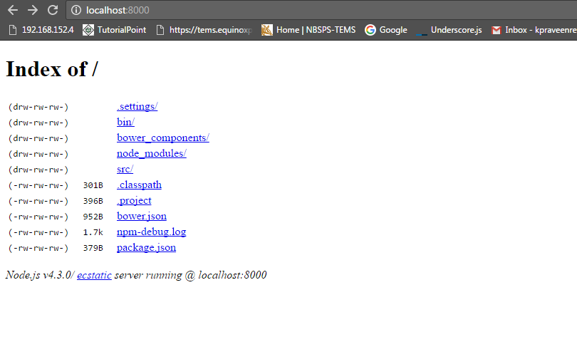
6. In the above case, I have html files saved in scr/ directory, as soon as I clicked src/ index.html file will be my start up page.

Any question please ask.