Kelsey Pritsker

kpritsker@gblsys.com

Abstract

This document strives to address all design questions and requirements necessary for the development of the software tools team product.

Software tools design document

2018

Contents

Introduction 2

Components 2

Input 2

Auto Complete 2

Checkboxes 2

Form Field 2

Radio Button 2

Select 2

Slide Toggle 2

Custom Components 3

Colors 3

Typography 3

508 Accessibility Compliance 3

ID Tool 3

Overall Layout 3

Multi-Select Editing 3

Validation 3

Filtering 3

Resizing 3

# Introduction

Purpose, intended use, angular info

# Components

Most components are adapted directly from [Material Design components for Angular](https://material.angular.io/).

## Input

### Auto Complete

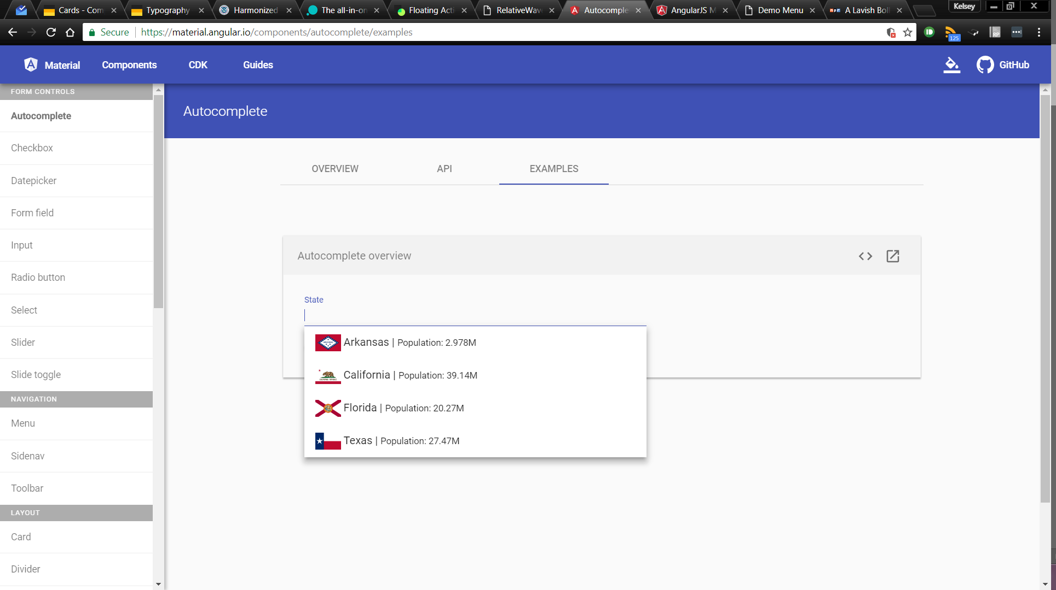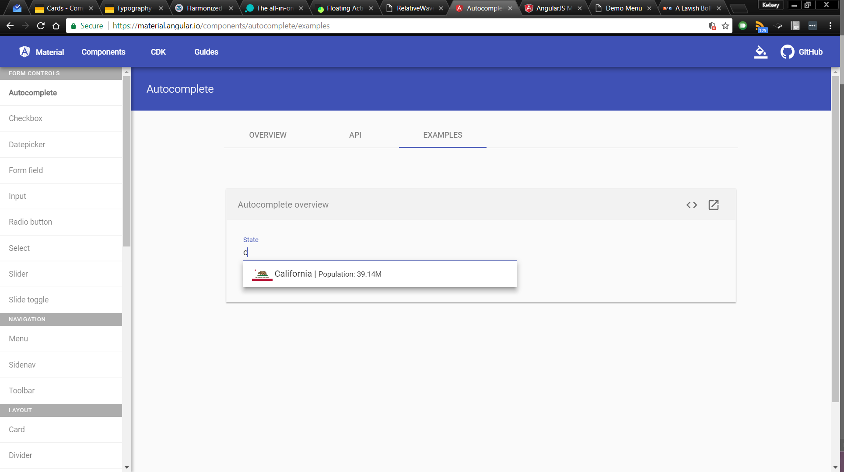Auto Complete is a text field along with a drop-down panel of suggested options. These options narrow as the user begins to type. This type of component will be used in all “search fields”. [Online examples](https://material.angular.io/components/autocomplete/examples)

### Checkboxes

Check boxes have three states: true, false, and intermediate. Check boxes that are true or intermediate are in the theme’s accent color. A checkbox’s associated text is used for accessibility purposes. Checkboxes without text should be given a description using defined accessibility labeling. [Online examples](https://material.angular.io/components/checkbox/examples)

  

### Form Field

##### Error State

### Radio Button

### Select

### Slide Toggle

# Custom Components

Tree structure,

# Colors

# Typography

Read only, editable, titles, subtitles, etc. Font: Consolas

# 508 Accessibility Compliance

<https://www.dhs.gov/sites/default/files/publications/Baseline_Tests_for_Software_and_Web_Accessibility_3.pdf>

# ID Tool

## Overall Layout

### Dimensions

### Scrolling

## Multi-Select Editing

## Validation

## Filtering

## Customizable Layout

## Right Click Functionality