**All Sites with All Payloads**

1.

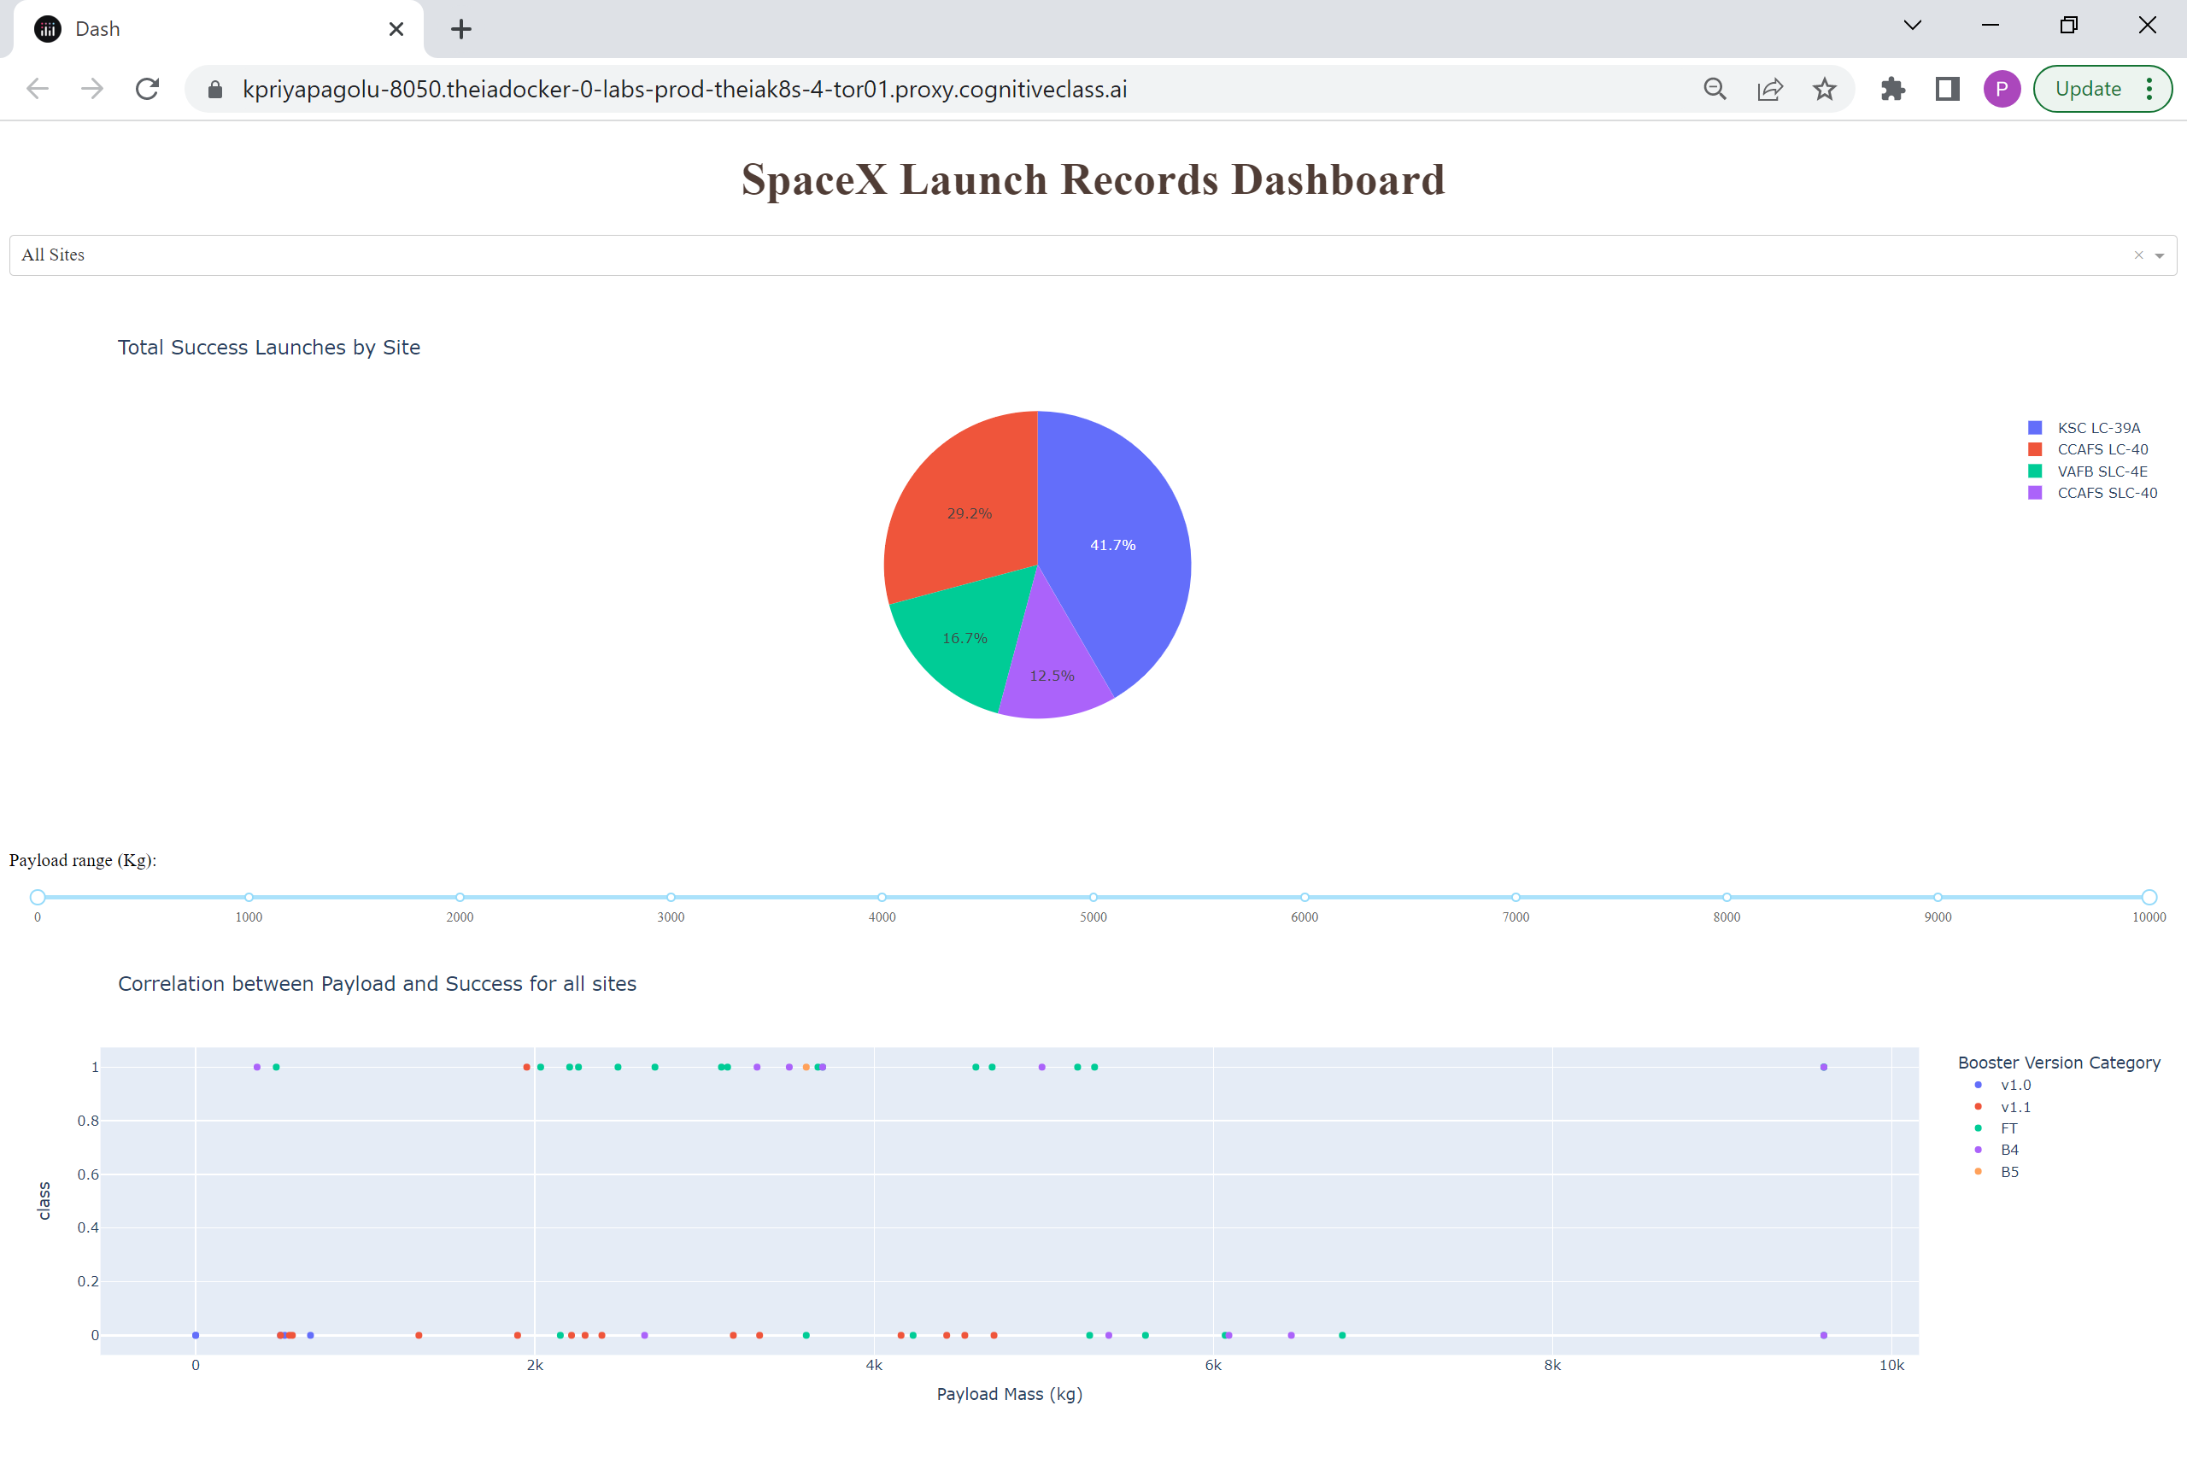

All Sites with different Payload ranges

2. payload range 0 to 3000

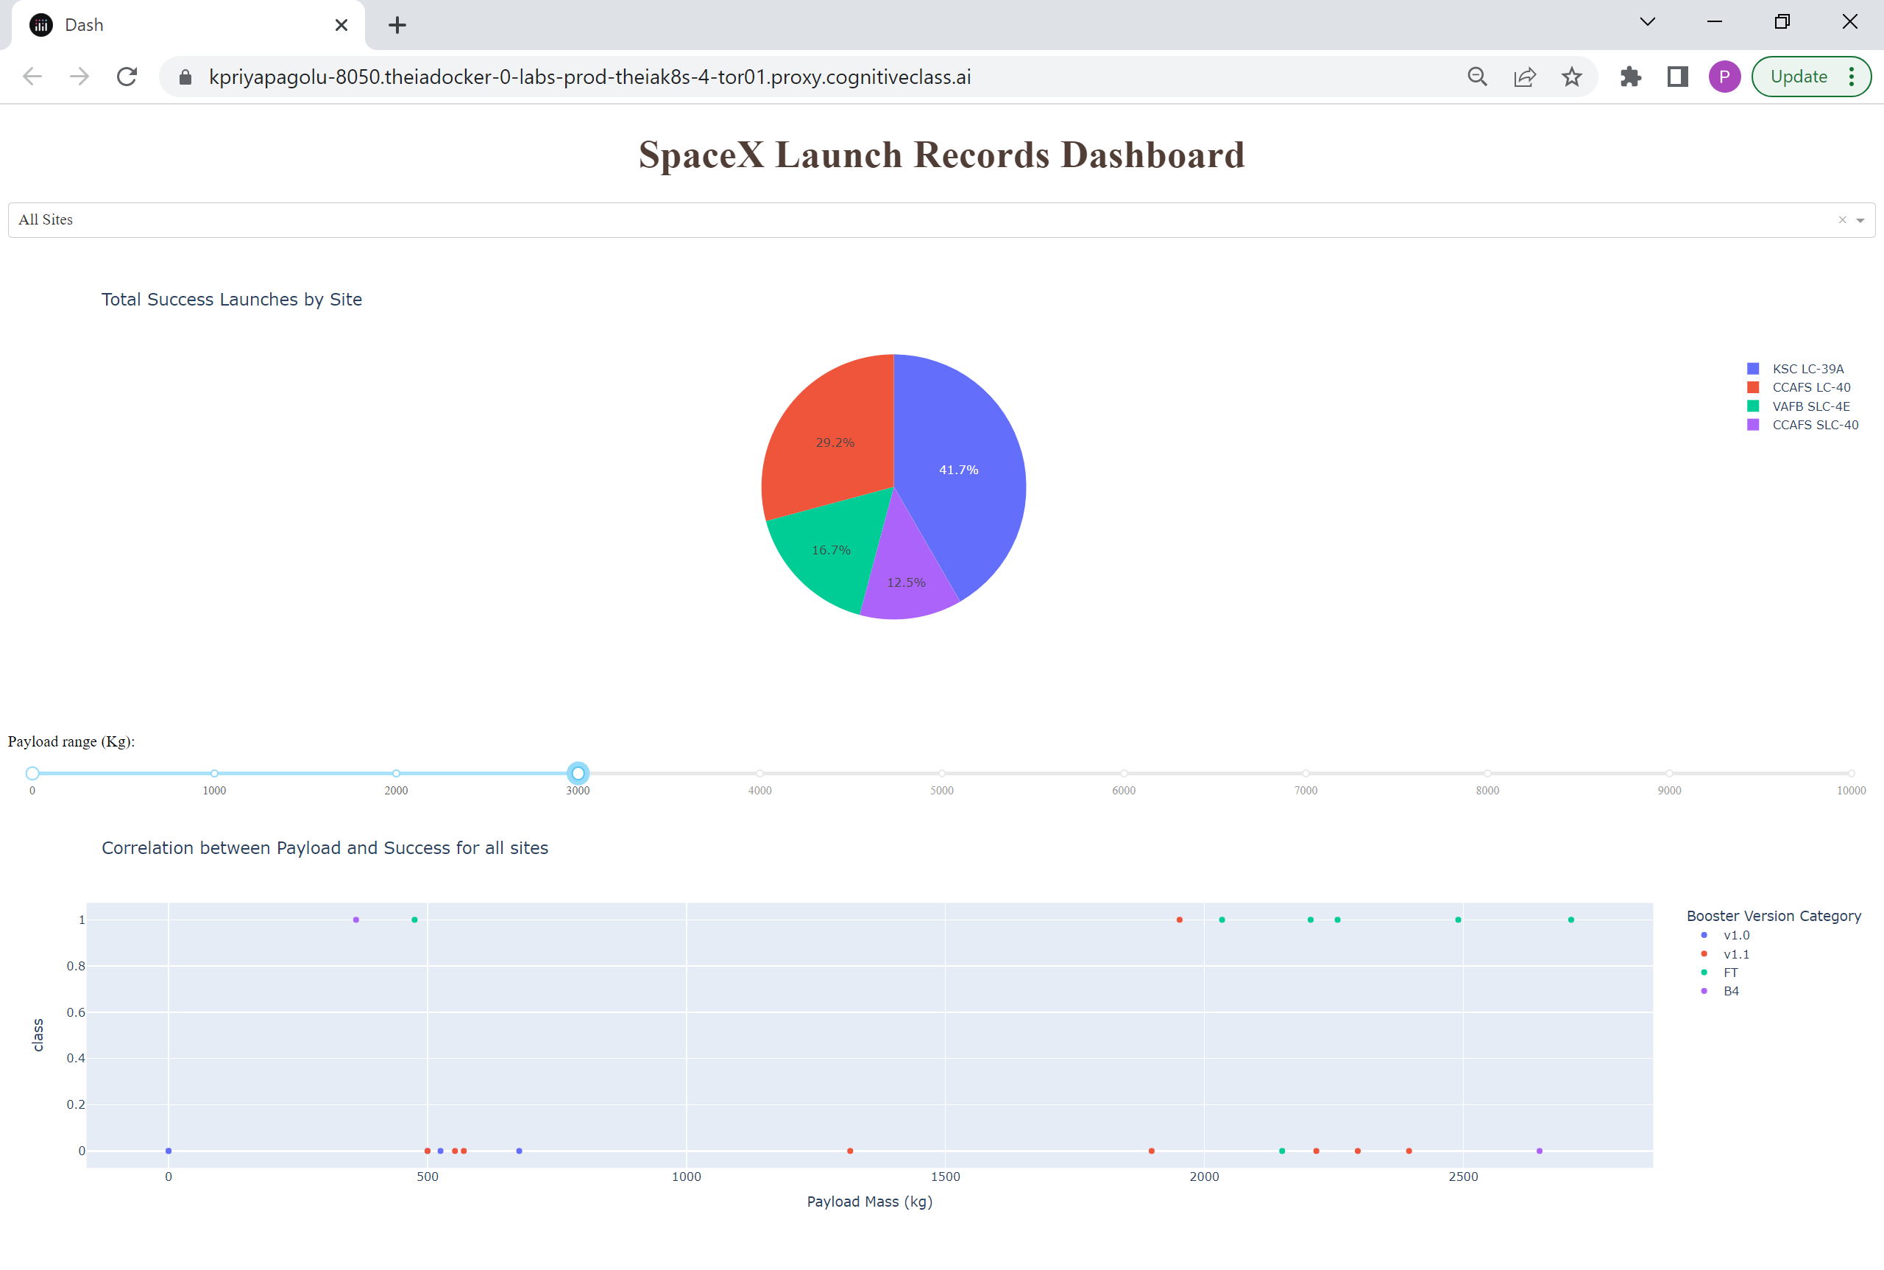

3. payload range 7000 to 10000

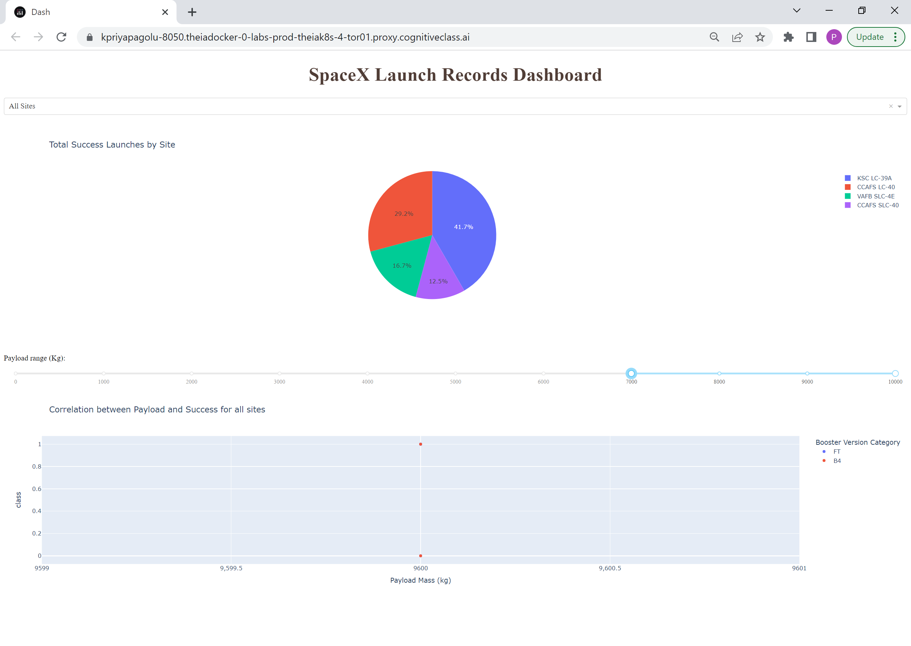

4. payload range 3000 to 7000

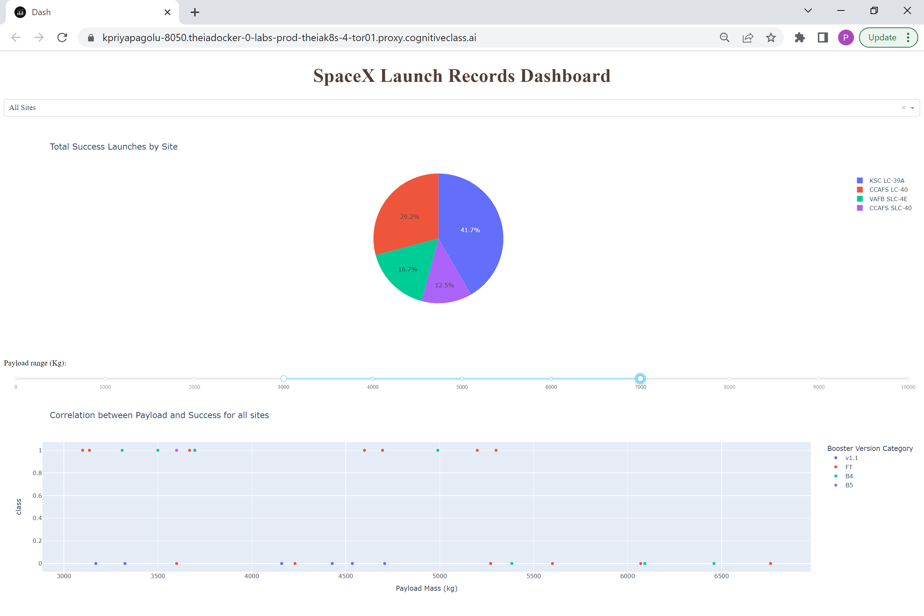

Selected Site with All payload

5. KSC LC-39A with all payload

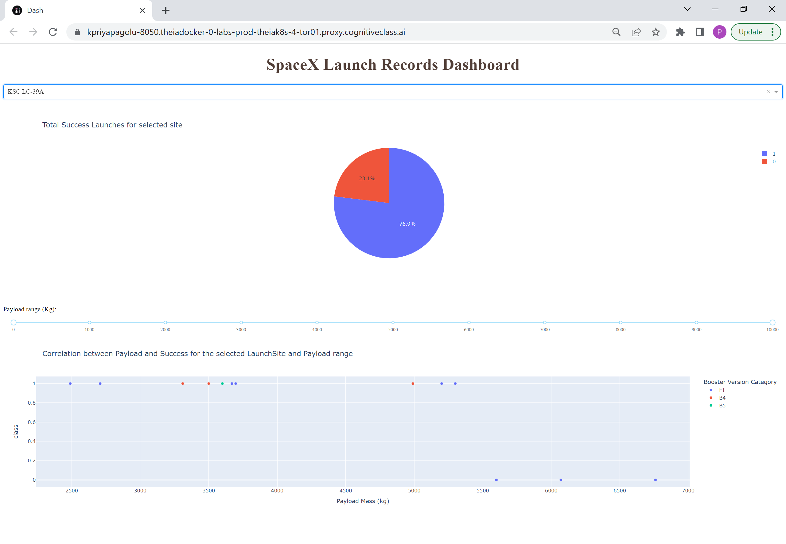

6. CCAFS LC-40 with all payload

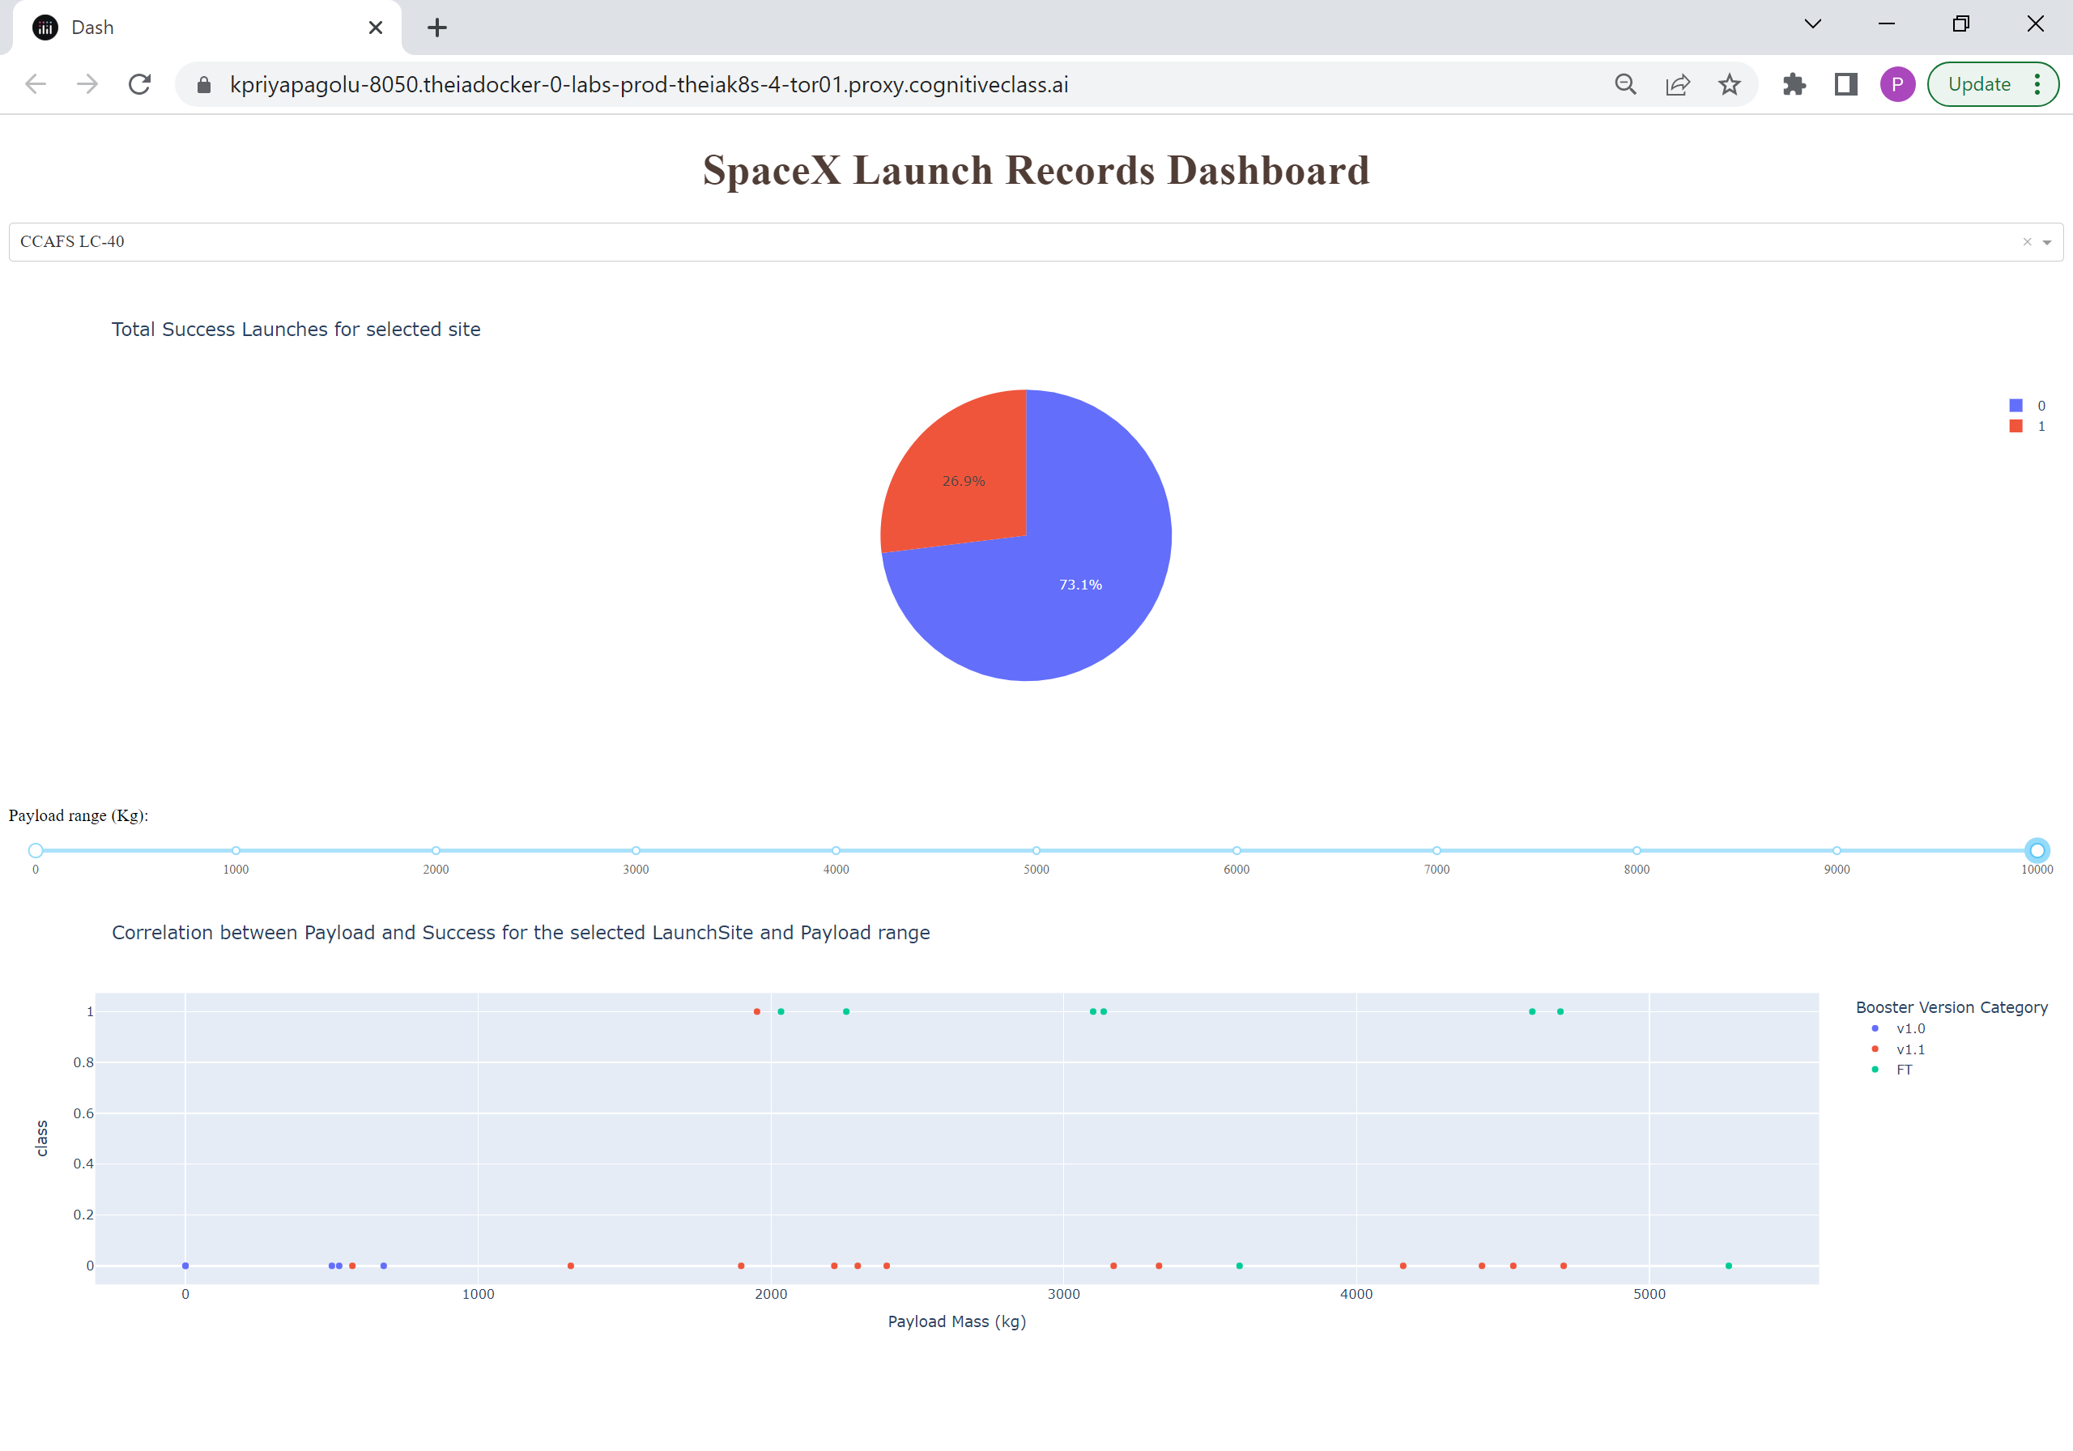

**Selected Launch Site with selected payload range**

7. KSC LC-39A with payload range of less than 5000

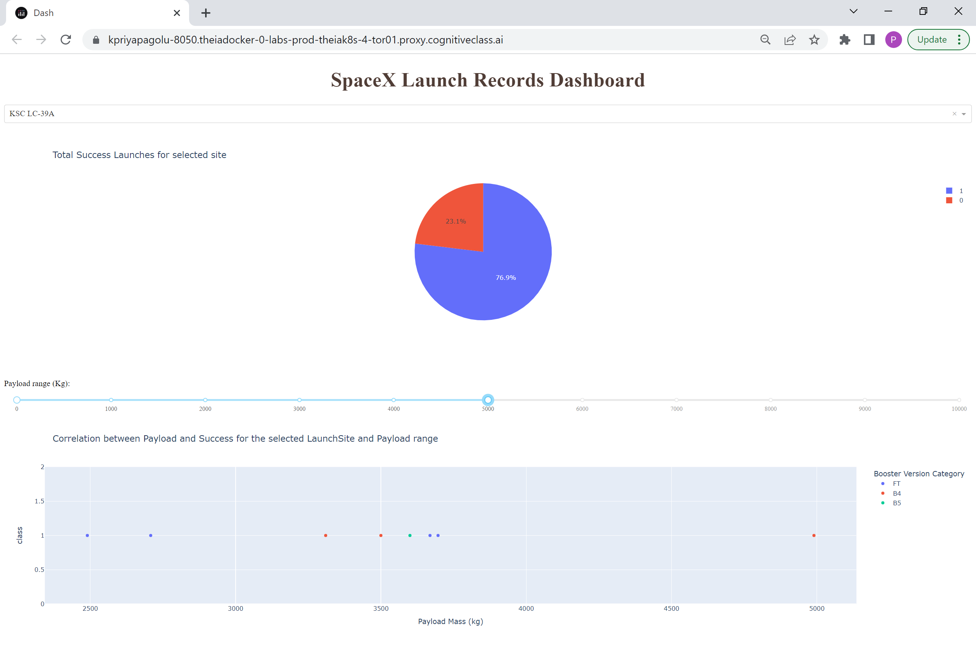

8. CCAFS LC-40 with payload range less than 2000

