ABDUL HAKKIM 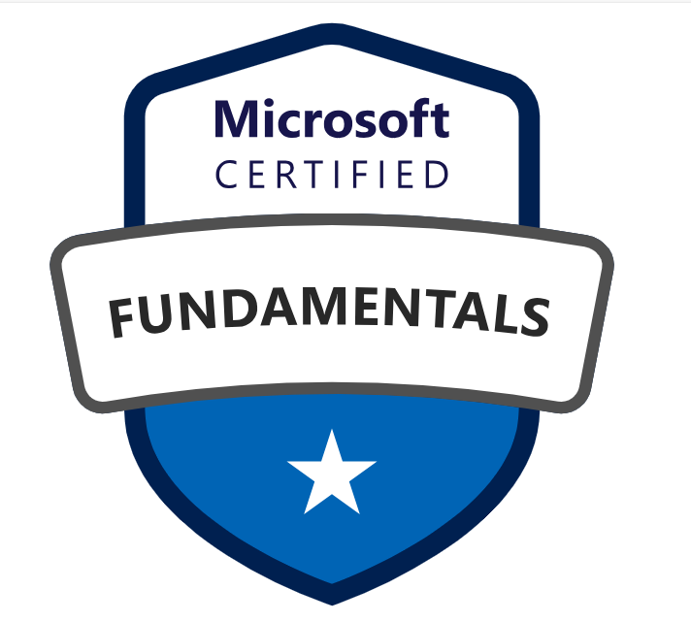 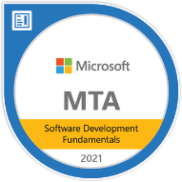 
E-Mail: kh.abdul@gmail.com
Mobile: +1 (480) 9316386 LinkedIn: https://www.linkedin.com/in/abdul-hakkim-kh/
PROFILE SUMMARY:
- Having 10+ years of IT experience in Software Development Life Cycle (SDLC) including analysis, design, development, and implementation of software applications, with 10 years of strong expertise in .NET technologies.
- Proficient in .NET technologies, including .NET Core, ASP.NET Core, ASP.NET MVC, Entity Framework Core, and .NET RESTful Web Services, to build scalable, maintainable applications.
- Experienced in integrating back-end with front-end technologies for seamless, responsive user interfaces, ensuring smooth communication between the client-side and server-side.
- Proficient in creating independent, loosely coupled microservices that communicate via RESTful APIs, utilizing tools like ASP.NET Core Web API and .NET RESTful Services.
- Skilled in designing secure, scalable, and high-performance APIs, implementing features like authentication, authorization, and API versioning, as well as handling JSON and XML data formats for optimal data exchange.
- Security integration expertise, including implementing OAuth2 and JWT to ensure secure communication and user authentication across applications.
- Experienced in frontend frameworks including Angular, NodeJS, ReactJS, TypeScript, and JavaScript, HTML5, CSS3, Bootstrap, AJAX, and jQuery UI for enhanced UI development and to build scalable, dynamic, and responsive web applications.
- Proficient in integrating applications with SQL databases, using Entity Framework Core (EF Core) and ADO.NET for seamless database interaction in ASP.NET Core.
- Experienced in designing, developing, and optimizing SQL queries for CRUD operations, as well as implementing SSIS packages for data extraction, transformation, and loading (ETL) and developing SSRS reports for data visualization and business insights.
- Strong testing and debugging skills using tools such as NUnit for unit testing, Selenium for UI testing, and Postman for API testing.
- Proficient in Microsoft Azure, including Azure App Services, Azure Functions, Azure SQL, Azure DevOps (CI/CD pipelines), Azure Service Bus, and cloud deployment best practices.
- Hands-on knowledge of Azure Data Lake Storage Gen2 for storing and managing large-scale structured and unstructured data, supporting analytics, reporting, and enterprise data workloads.
- Experience with Microsoft Fabric architecture, including OneLake, Lakehouse, and Data Warehouse concepts, enabling unified data engineering, analytics, and BI solutions.
- Understanding of security, governance, and performance optimization in Fabric and Data Lake, including role-based access control (RBAC), data partitioning, and cost-efficient data processing.
- Experienced in Azure DevOps practices, including CI/CD automation using GitHub Actions for streamlined builds, testing, and deployments across multiple environments.
- Managed version control using Git and GitHub, ensuring collaboration and code integrity among team members.
- Proficient in leveraging AI-powered development tools like Visual Studio IntelliCode and GitHub Copilot to enhance productivity, code quality, and development efficiency.
- Managed software development platforms using Agile, Scrum, and Waterfall methodologies.
- Domain expertise includes healthcare, airline, and education, with a focus on scalable and high-performance systems.
- Experience working with state education agencies or government educational institutions, delivering customized enterprise solutions for strategic planning, academic management, and administrative workflows.

Professional Experience:
Technical Lead & Full Stack Developer, Omnicron Technologies LLC , Columbus, OHIO, US, from January 2025 – Till date.

Title: Modular Revenue Cycle Management (RCM) System - Integrity Health Partner.

Environment: ASP.NET Core Web API, .NET Core, SQL Server, Angular, ReactJS, IIS, Azure DevOps, JWT Authentication, RBAC, ASP.NET Core Identity, RESTful APIs, Visual Studio, Postman, Git, Windows Server.

Responsibilities:
- Designed and developed robust, scalable, and secure .NET Core Web APIs to support critical healthcare services, including claims management, payment processing, and patient records.
- Developed and maintained RESTful APIs for claims processing and member eligibility using ASP.NET Core and SQL Server. Implemented OAuth2, JWT, and Role-Based Access Control (RBAC) in .NET APIs to safeguard sensitive healthcare data.
- Developed and maintained Angular applications for patient billing dashboards, claims tracking, and revenue analytics with seamless integration to .NET APIs.
- Implemented Angular services for centralized API communication, business logic handling, and state management, ensuring clean separation of concerns and consistent data flow across the application.
- Built responsive, accessible user interfaces using Angular, Bootstrap, and custom CSS, ensuring cross-browser compatibility and adherence to usability and accessibility standards.
- Optimized UI performance using lazy loading, on-demand module loading, RxJS observables, and async pipes, significantly improving page load times and user experience.
- Implemented role-based UI rendering aligned with backend RBAC, ensuring secure and personalized access to dashboards, claims data, and financial reports.
- Integrated real-time data visualization using charts and dashboards for revenue analytics, claims trends, and operational insights.
- Responsible for designing and optimizing SQL Server databases using stored procedures, indexing, and partitioning to ensure high-performance data processing for large-scale transactions, including developing SSIS packages for ETL processes and SSRS reports for business analytics and reporting.
- Leveraged MongoDB for efficient management of unstructured patient and transaction data, improving API responsiveness through effective document design and query optimization.
- Published APIs using Azure API Management (APIM) and monitored performance with Azure Monitor and Log Analytics.
- Created unit and integration tests using xUnit and Moq, and collaborated with QA to automate API testing using Postman.
- Implemented versioning, caching, and rate limiting strategies in Web APIs to enhance performance, maintain backward compatibility, and ensure efficient client integration.
- Documented APIs using Swagger (OpenAPI) and enforced best practices for request validation, error handling, and consistent response formatting across microservices.
- Built and deployed CI/CD pipelines using Azure DevOps and GitHub Actions, reducing manual deployment efforts and accelerating release cycles by 60%.
- Migrated on-premise applications to Microsoft Azure, resulting in a 40% cost reduction and improved scalability and uptime.

Lead and Senior Software Developer, University of Technology and Applied Science (UTAS), Muscat, OMAN, Sep 2014 – Dec 2024.
Environment: Angular, React, HTML5, CSS3, Bootstrap;.Net, C#, ASP.NET MVC; MSSQL; Git, Azure DevOps.
Responsibilities:
- Led design and development of multiple enterprise-level web applications for academic planning, research, HR, and administrative workflows.
- Specialized in modern UI development using Angular, and TypeScript, integrating with ASP.NET Core Web APIs and MS SQL Server backend.
- Built interactive dashboards using ReactJS and Angular to modernize user interfaces and dynamic data visualizations (charts, tables, goal tracking) for strategic planning modules using reusable components.
- Implemented reusable Components (forms, charts, dashboards, data grids) for academic planning and performance monitoring modules, reducing code duplication and improving maintainability.
- Designed and developed scalable ReactJS applications using functional components, Hooks (useState, useEffect, useContext), and modular architecture for enterprise academic and administrative systems.
- Built reusable React and Angular components (forms, dashboards, tables, charts) with clear separation of presentation and business logic, improving consistency and speeding up feature delivery.
- Implemented state management patterns using Context API and prop-driven data flow to handle complex UI interactions and real-time dashboard updates.
- Integrated React UI with RESTful APIs using Axios/Fetch, handling asynchronous data loading, error states, and secure token-based authentication.
- Optimized React application performance through code splitting, lazy loading, memoization (React.memo, useCallback), and efficient rendering strategies.
- Implemented role-based UI rendering and route protection in React applications aligned with backend RBAC and authentication mechanisms.
- Developed responsive and accessible React interfaces using Material UI, Bootstrap, and custom CSS, ensuring cross-browser and mobile compatibility.
- Wrote unit and integration tests for React components using Jest and React Testing Library to ensure UI stability and regression coverage.
- Integrated Components with RESTful APIs built in ASP.NET Core Web API to enable real-time data updates for strategic planning and reporting dashboards.
- Created responsive interfaces across desktop and mobile devices using Bootstrap, Material UI, and custom CSS.
- Implemented real-time data interactions using REST APIs, lazy loading, form validations, and notifications.
- Developed and maintained unit/integration tests using Jest, React Testing Library, Jasmine, and Karma.
- Migrated legacy systems from ASP.NET Web Forms and Razor Views to modern AngularJS and React-based UI.
- Participated in full SDLC with Agile methodologies: standups, sprints, reviews, and UAT sessions.
- Supported backend development in .NET Core, Entity Framework, and SQL Server for API integration and complex data logic.
- Contributed to CI/CD pipelines and DevOps tasks using Jenkins, Azure DevOps, and Git.
Module Lead – Single Network Application (SNAPP) for Delta Airlines, Hexaware Technologies Pvt. Ltd., Chennai, India From Feb 2011 to Sep 2014.
Environment: Java, Spring Framework, SOAP Web Services, SOA, GWT (Google Web Toolkit), HTML, AJAX, CSS, JavaScript.

Responsibilities:
- Primarily responsible for backend development and integration of SOAP-based services supporting passenger check-in, boarding, baggage handling, and flight connectivity modules.
- Developed and maintained robust service-oriented architecture (SOA) backend components using Spring framework, SOAP web services, and Java technologies.
- Collaborated with frontend UI developers using GWT framework to ensure smooth communication with backend services via SOAP calls.
- Led technical discussions and knowledge transfer sessions to clarify backend requirements and integration points across distributed teams.
- Coordinated daily stand-ups, technical meetings, and demos with downstream teams to align on API contracts, data exchange, and service availability.
- Conducted backend-focused code reviews, ensuring adherence to design patterns, coding standards, and system scalability.
- Assisted QA teams in formulating backend test strategies and troubleshooting service-level issues during integration testing.
- Prepared project estimates and task breakdowns primarily related to backend deliverables and service development.
- Managed defect logging and resolution related to backend services, maintaining close communication with all stakeholders.
EDUCATION:
- Master of Computer Application, Anna University; Secured Division - 2006.
- Bachelor of Computer Science, Madras University; secured Division – 2002.

TRAININGS & CERTIFICATIONS:
- Microsoft Certified: Azure Fundamentals
- MTA: Software Development Fundamentals (Microsoft)

Key Skills & Technologies:
- Languages/Technologies (Backend & Others): ASP.NET Core (C#), .NET Framework, Web API, Entity Framework, SQL Server, MongoDB.
- Languages/Technologies (UI): Angular, ReactJS, JavaScript, TypeScript, HTML5, CSS3, Bootstrap, RESTful APIs, OAuth2, JWT, Swagger.
- Cloud Platform: Azure App Services, Azure Functions, Azure SQL, Azure DevOps (CI/CD pipelines), and Azure Service Bus, Microsoft Fabric architecture, OneLake, Lakehouse.
- Databases: SQL Server, MySQL, MongoDB (NoSQL), SSIS (ETL), SSRS (Reporting).
- Tools and Servers: Visual Studio, Visual Studio Code, AI-assisted development tools (Visual Studio IntelliCode, GitHub Copilot), Git, GitHub, Azure DevOps, Jenkins, Postman, Swagger, NUnit, xUnit.

