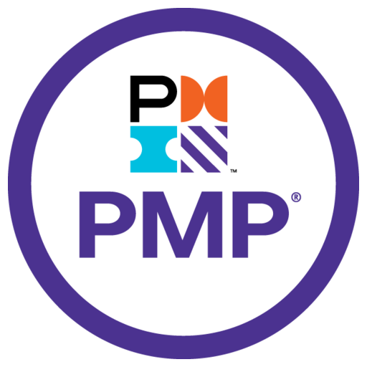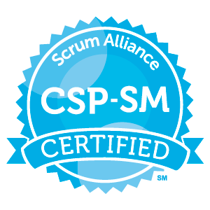 Name: Anish Kumar Yesu
PMP Certified
Certified Scrum Master
Certified SAFe Agilest 6.0
Majesco ICD/ICM Developer Certified
Email: anishktx1@gmail.com
Phone: +1 737 738 3454
LinkedIn Id Anish

Professional Summary
Highly accomplished IT professional with over 16 years of experience specializing in Project Delivery, Scrum Leadership, and QA/Testing practices. Proven expertise in managing end-to-end project lifecycles, optimizing resource allocation, and implementing risk mitigation strategies to ensure successful delivery of complex initiatives.

Core Competencies
- Insurance Domain Expertise: Extensive experience in Property & Casualty (Auto & Home), Life Insurance, and Data Conversion for Guidewire implementations using Data Warehouse/Data Lake architectures.
- Project Management & Leadership: Proven ability as a Project Manager and Scrum Lead for KPMG US and other high-profile clients, delivering results across complex, multi-stakeholder environments.
- Technical Expertise: 3+ years of hands-on experience with Majesco Billing ICD/ICM and over 7 years managing Guidewire PolicyCenter implementations.
- Agile & Scrum Methodologies: Adept at facilitating Scrum ceremonies including sprint planning, backlog grooming, daily stand-ups, and retrospectives.
- Risk & Quality Management: Skilled in identifying, assessing, and mitigating project risks, while ensuring adherence to quality, schedule, and budget targets.
- Cross-Functional Team Collaboration: Proven success in leading and coordinating cross-functional teams—including data scientists, engineers, and business stakeholders—to ensure alignment, execution, and delivery of project goals.
- Release & Deployment Coordination: Expertise in orchestrating release planning, deployment activities, and risk mitigation in Agile, Cloud, and Majesco environments for smooth product launches.

Key Competencies
- Project Scope & Delivery Management: Strong ability to define project scope, manage stakeholder expectations, and ensure timely, high-quality delivery.
- Testing & QA Oversight: Experienced in using tools like JIRA, Rally, Azure DevOps (ADO), and SOAP UI for test planning, execution, defect management, and reporting.
- Process Optimization & Methodologies: Skilled in Agile, Scrum, and V-Model frameworks, with a focus on continuous improvement and team productivity.
- Documentation & Compliance: Proficient in preparing comprehensive project documentation, including test plans, traceability matrices, status reports, and risk assessments.
- Leadership & Team Development: Proven record of leading distributed teams, mentoring junior staff, and driving projects from initiation through post-deployment.
- Cross-Functional Coordination: Experienced in coordinating efforts between data scientists, engineers, and stakeholders, ensuring seamless collaboration across technical and business units.
- DevOps & CI/CD Optimization: Experience in optimizing CI/CD pipelines, integrating quality assurance processes, and enhancing cross-functional delivery efficiency.

Professional Experience

Atlasis Technologies Scrum Master / Business Analyst (Guidewire Cloud Auto PolicyCenter P&C Implementation)

1/04/2025 – Till Date
- Requirements Gathering and Analysis: Collaborated with stakeholders to define business needs, identify problems, and document system/process requirements.
- Conducted requirements elicitation (interviews, workshops, surveys) and documented business/functional/non-functional requirements, user stories, and use cases.
- Utilized Jira / Azure DevOps (ADO),Confluence AI-Enabled, to track, manage, and prioritize requirements; developed/maintained a requirements traceability matrix.
- Process Improvement: Analyzed existing processes to identify inefficiencies and opportunities; designed/implemented improvements using Lean/Six Sigma.
- System Development: Translated business requirements into technical specifications; collaborated with IT to ensure alignment with business needs and industry standards.
- Participated in system design reviews and supported testing/deployment activities (SIT, UAT).
- Data Analysis: Analyzed data to identify trends/patterns and inform decision-making; collected/analyzed data from various sources (databases, spreadsheets).
- Developed/presented data-driven reports and visualizations; utilized SQL for data extraction.
- Stakeholder Management: Communicated with stakeholders to ensure alignment; built/maintained strong relationships and managed expectations.
- Facilitated meetings/presentations and negotiated solutions.
- Documentation: Created and maintained documentation (BRDs, functional specifications, process flows, user manuals); ensured accuracy and accessibility.
- Testing and Implementation: Participated in system testing and implementation; developed test plans/cases/scripts and coordinated UAT.
- Risk Management: Identified/assessed potential risks; developed/implemented mitigation strategies; monitored risks and reported to stakeholders.

USAA Lead Agilest (Guidewire Cloud Umbrella PolicyCenter P&C Implementation) : Plano, Texas
12/01/2023 – 12/30/2024
- Facilitated Core Scrum Events: Led all key Scrum ceremonies (Daily Stand-ups, Sprint Planning, Reviews, Retrospectives), AI Enabled, ensuring cadence, consistency, and alignment with SAFe Agile principles.
- Agile Coaching & Team Maturity: Mentored Agile teams, Product Owners, and junior Scrum Masters on Agile/SAFe practices, backlog refinement, and value-driven delivery to enhance autonomy and performance.
- Project & Program Management: Managed Agile projects (e.g., Guidewire Cloud PolicyCenter, GCP initiatives), aligning business goals with technical execution to ensure timely, high-quality deliveries.
- Managing GCP Projects & Global Delivery: Directed GCP projects while overseeing onshore and offshore teams within a Global Delivery Model, ensuring seamless collaboration, governance, and execution across geographies.
- End-to-End Planning: Developed and executed comprehensive end-to-end Project Plans and Release Plans, ensuring alignment with strategic priorities and successful delivery across multiple ARTs and value streams.
- Collaboration & Stakeholder Engagement: Partnered with cross-functional teams, stakeholders, and ARTs to groom/prioritize backlogs, align to the Definition of Ready/Done, and ensure strategic delivery alignment.
- Risk, Issue & Impediment Management: Proactively identified and resolved blockers across engineering, QA, architecture, and Gen AI/ML teams, maintaining delivery flow and cross-team synchronization.
- Jira & Agile Tooling Expertise: Utilized Jira, Confluence, and Jira Align for epic/story tracking, sprint reporting, and dependency management, enabling full visibility and traceability.
- Metrics-Driven Delivery: Leveraged Agile metrics (velocity, cycle time, burndown, defect density) to drive performance discussions, improve predictability, and boost delivery confidence.
- Continuous Improvement Initiatives: Led Inspect & Adapt workshops and implemented feedback loops from retrospectives, increasing team velocity by 20% and reducing defect leakage by 15%.
- DevOps & CI/CD Integration: Fostered collaboration between Scrum teams and platform engineers to support environment readiness, automation, and CI/CD pipeline alignment.
- Certified Agile Leader: Certified Scrum Master (CSM) with extensive experience in Scrum, Kanban, and SAFe frameworks; strong communication, problem-solving, and stakeholder management skills.

KPMG LLP (Scrum Master Life Insurance, Majesco Billing, Reinsurance) : Dallas Texas
01/02/2022 – 08/29/2023
- Collaborative Delivery: Facilitate Agile Scrum practices in partnership with the squad and stakeholders to ensure successful sprint execution aligned with the squad's mission. Foster a shared understanding of goals and sprint commitments and Used Tools like , Azure DevOps (ADO),
- Performance Acceleration: Drive continuous improvement by identifying and implementing Agile best practices. Provide coaching to elevate Agile maturity across squads and ensure alignment with KPIs and team-level OKRs.
- Metrics & Transparency: Maintain and communicate squad performance data through quality metrics, KPIs, and Agile artifacts (e.g., velocity, burndown charts). Establish transparent feedback loops and reporting for stakeholders.
- Agile Event Facilitation: Plan, facilitate, and actively engage in Agile ceremonies, including backlog refinement, sprint planning, daily stand-ups, retrospectives, and Scrum of Scrums. Ensure alignment with the Definition of Ready (DOR) and Definition of Done (DOD).
- Tool Enablement: Promote consistent and effective use of Agile tools (e.g., Jira, Mural, MS Teams) to increase collaboration, visibility, and delivery efficiency. Leverage tools for real-time tracking of quality metrics and sprint progress.

Majesco Scrum Master/ Sr. Scrum Lead (Glorifi Insurance)
- Led Scrum teams in the successful implementation of Majesco Billing for Life Insurance, ensuring alignment with business goals.
- Facilitated Scrum ceremonies (stand-ups, sprint planning, reviews, and retrospectives) to promote collaboration and drive efficiency.
- Worked closely with Product Owners to refine user stories, prioritize the backlog, and align sprint deliverables.
- Directed technical solution implementations, ensuring timely code delivery in coordination with business analysts and product owners.
- Collaborated with cross-functional teams to gather business requirements and define project objectives.
- Managed code reviews, testing, and risk mitigation to ensure high-quality deliverables and smooth project execution.

Siebrains Technologies Scrum Master (Inline Marine Majesco Billing P&C Insurance) : Bangalore, India 07/02/2020 – 25/11/2021
- Led projects in Inland Marine, Cyber, and Political Violence insurance sectors, managing Agile processes with tools like Jira and Kanban.
- Facilitated scrum ceremonies and maintained project progress reports, tracking milestones, risks, and budgets.
- Worked closely with clients and stakeholders to align projects with business needs and optimize workflows.

Adactin Australia ICare Insurance - Guidewire Scrum Master
02/03/2017 – 07-07-2020
- Managed the implementation of Guidewire PolicyCenter, overseeing defect tracking and resolution.
- Coordinated UAT efforts and worked with teams to address production issues and ensure proper functionality.
- Developed and executed test plans, tracked defects, and reported progress to stakeholders.
- Led multiple project releases, ensuring timely delivery within budget and aligned with project scope.
- Managed root cause analysis for defects, coordinated with business analysts and developers for issue resolution.
- Facilitated cross-functional collaboration to ensure consistent progress and alignment with client expectations.

IBM India Test Lead (AMICA Mutal Insurance)
09/2009 – 27/2017
- Led testing efforts for Guidewire ClaimCenter, PolicyCenter, and Billing Center modules.
- Managed quarterly Maintenance Release Production Defect Retests, ensuring timely resolution before go-live.
- Supported sprint releases in areas such as fraud detection, loss types, and damage assessments.
- Coordinated functional, integration, regression, and UAT testing efforts, ensuring alignment with business requirements.

Education

Education/Qualification
Degree and Year | University/ Board | Major and Specialization | Year Of Completion
MFT(Master of Foregin Trade) | Pondicherry University | Specialization: Foreign Trade | 2006
BSc.,(Computer Science) | Bangalore University | Specialization:  Computer Science | 2002

