ABDUL HAKKIM KHAJA BANDE NAWAZ 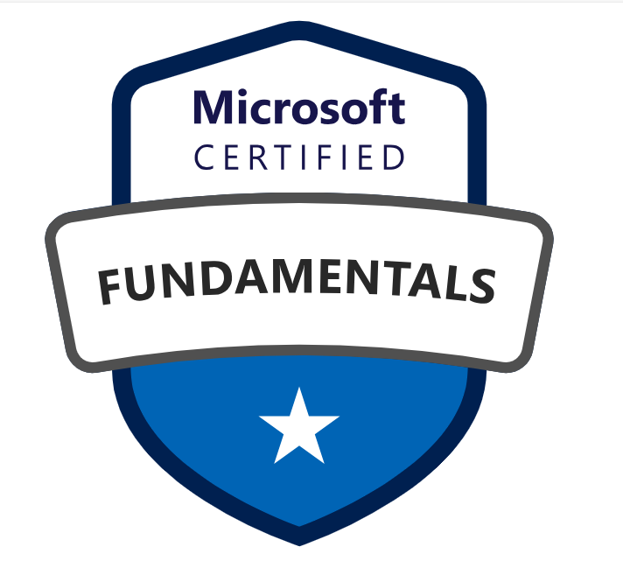 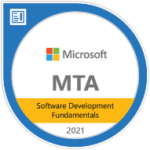 
E-Mail: kh.abdul@gmail.com
Mobile: +1 (480) 9316386 LinkedIn: https://www.linkedin.com/in/abdul-hakkim-kh/
PROFILE SUMMARY:
- Over 15 years of experience in the Software Development Life Cycle (SDLC), including analysis, design, development, and implementation of enterprise-grade applications.
- Lead a team of 4 developers in designing and delivering scalable, secure, and high-performance enterprise solutions using .NET Core, ASP.NET Core, C#, and Angular/React.
- Expertise in Microsoft Azure services, including Azure App Services, Azure Functions, Azure Kubernetes Service (AKS), Azure Service Bus, Event Grid, Azure SQL, Cosmos DB, and Azure API Management for cloud-native, distributed system architectures.
- Designed and implemented microservices-based architectures and RESTful APIs for enterprise solutions, ensuring loose coupling, high scalability, and maintainability.
- Defined solution architecture, technical roadmaps, and best practices aligned with business objectives, collaborating closely with product owners, developers, DevOps, and infrastructure teams.
- Implemented secure, resilient systems with OAuth2, JWT authentication, API versioning, and role-based access control (RBAC) across applications, ensuring compliance with regulatory and enterprise standards.
- Provided technical leadership, mentorship, and architectural governance across multiple projects, conducting architecture and code reviews, performance optimization, and knowledge-sharing sessions with the team.
- Developed and maintained front-end applications using Angular and React, integrating seamlessly with .NET APIs to deliver responsive, dynamic, and user-friendly interfaces.
- Streamlined CI/CD pipelines and DevOps practices using Azure DevOps and GitHub Actions, enabling automated builds, testing, and deployments across multiple environments.
- Implemented event-driven architectures and integration solutions leveraging Azure Service Bus, Event Grid, and API Management to enable seamless communication across microservices.
- Managed database solutions using Azure SQL, Cosmos DB, MSSQL, MySQL, and MongoDB, optimizing queries, indexing, and document modeling for high-performance data operations.
- Evaluated emerging technologies and recommended improvements to existing architecture, driving cloud adoption and innovation in enterprise solutions.
- Strong experience in Agile and Scrum methodologies, ensuring timely delivery, sprint planning, and alignment with business goals.
- Managed version control using Git and GitHub, ensuring collaboration and code integrity among team members.
- Developed rollback procedures to ensure smooth application upgrades, minimize downtime, and efficiently manage hotfixes during deployment.
- Managed software development platforms using Agile, Scrum, and Waterfall methodologies.
- Domain expertise includes healthcare, airline, and education, with a focus on scalable and high-performance systems.
- Experience working with state education agencies or government educational institutions, delivering customized enterprise solutions for strategic planning, academic management, and administrative workflows

Professional Experience:
Lead Solution Architect & Full Stack Developer, Integrity Health Partners, Columbus, OHIO, US, from January 2025 – Till date.

Title: Modular Revenue Cycle Management (RCM) System.

Environment: ASP.NET Core Web API, .NET Core, SQL Server, Angular, Azure DevOps, JWT Authentication, RBAC, ASP.NET Core Identity, RESTful APIs, Visual Studio, Postman, Git.

Responsibilities:
- Led a team of 4 developers, providing technical guidance, mentoring, and support in implementing .NET Core and Angular solutions, ensuring adherence to coding standards, best practices, and project timelines.
- Conducted architecture and code reviews, performance tuning sessions, and knowledge-sharing workshops to improve team efficiency, code quality, and solution scalability.
- Collaborated with business stakeholders, product owners, and DevOps/infrastructure teams to define technical roadmaps, solution architecture, and best practices aligned with business objectives.
- Championed Azure adoption and cloud-native architecture patterns, including microservices, event-driven designs, API management, and secure communication across distributed systems.
- Actively participated in Agile sprint planning, task estimation, and delivery oversight to ensure high-quality solutions with minimal downtime and effective release management.
- Designed and developed robust, scalable, and secure .NET Core Web APIs to support critical healthcare services, including claims management, payment processing, and patient records.
- Architected end-to-end solutions prioritizing high availability, performance, and HIPAA-compliant security, meeting healthcare regulatory standards.
- Developed and maintained RESTful APIs for claims processing and member eligibility using ASP.NET Core and SQL Server; integrated external APIs (EDI 270/271) for real-time insurance eligibility verification.
- Implemented OAuth2, JWT, and Role-Based Access Control (RBAC) in .NET APIs to safeguard sensitive healthcare data.
- Developed and maintained Angular applications for patient billing dashboards, claims tracking, and revenue analytics with seamless integration to .NET APIs.
- Optimized SQL Server performance with advanced indexing, partitioning, stored procedures, and query optimization to support high-volume transactions.
- Published APIs using Azure API Management (APIM) and monitored performance with Azure Monitor and Log Analytics.
- Built and deployed CI/CD pipelines using Azure DevOps and GitHub Actions, reducing manual deployment efforts and accelerating release cycles by 60%.
- Migrated on-premise applications to Microsoft Azure, achieving a 40% cost reduction while improving scalability, resilience, and uptime.
- Integrated secure API access and inter-system communication using OAuth2, JWT, and Azure-managed security practices to ensure end-to-end secure connectivity across multiple applications and services.
- Created unit and integration tests using xUnit and Moq, and collaborated with QA to automate API testing using Postman.
- Prepared comprehensive technical and functional documentation for RCM processes, APIs, and data workflows to support maintenance and stakeholder understanding.

Senior Software Developer, University of Technology and Applied Science (UTAS), Muscat, OMAN, Sep 2014 – Dec 2024.
Environment: Angular, HTML5, CSS3, Bootstrap;.Net, C#, ASP.NET MVC; MSSQL; Git, Azure DevOps.
Responsibilities:
- Led design and development of multiple enterprise-level web applications for academic planning, research, HR, and administrative workflows.
- Specialized in modern UI development using Angular, and TypeScript, integrating with ASP.NET Core Web APIs and MS SQL Server backend.
- Built interactive dashboards using Angular to modernize user interfaces and dynamic data visualizations (charts, tables, goal tracking) for strategic planning modules using reusable components.
- Created responsive interfaces across desktop and mobile devices using Bootstrap, Material UI, and custom CSS.
- Implemented real-time data interactions using REST APIs, lazy loading, form validations, and notifications.
- Developed and maintained unit/integration tests using Jest, React Testing Library, Jasmine, and Karma.
- Migrated legacy systems from ASP.NET Web Forms and Razor Views to modern AngularJS and React-based UI.
- Participated in full SDLC with Agile methodologies: standups, sprints, reviews, and UAT sessions.
- Supported backend development in .NET Core, Entity Framework, and SQL Server for API integration and complex data logic.
- Contributed to CI/CD pipelines and DevOps tasks using Jenkins, Azure DevOps, and Git.
Title: Curriculum Mapping and Development Framework.
Duration: Oct 2014 – November 2016.
We migrated from .NET C# version (ASP.NET VBA C++ & MVC) to a modern AngularJS frontend with C# Web API and MSSQL.

Responsibilities:
- Analyzed existing VBA and C++ applications, including architecture, dependencies, and business logic, to plan migration to C#.
- Identified components to migrate, including UI, business logic, API services, and database interactions, ensuring minimal disruption to existing workflows.
- Redesigned and implemented core business logic in C#, improving maintainability, performance, and aligning with modern coding standards.
- Created new ASP.NET Core Web API project, refactoring legacy procedures and functions into service layers following RESTful principles.
- Converted legacy VBA forms/UI to modern AngularJS templates, leveraging Bootstrap, Material Design, or custom CSS for responsive and user-friendly interfaces.
- Implemented AJAX-based form submissions and refactored legacy UI components to enhance usability and interactivity.
- Implemented Role-Based Access Control (RBAC) and AngularJS authentication guards to secure application routes.
- Optimized database queries, refactored legacy stored procedures, and migrated MSSQL databases to modern versions to improve performance and reliability.
- Conducted thorough debugging, unit testing, and validation to ensure functional parity with legacy VBA/C++ systems.
- Trained team members on modern C# practices, AngularJS best practices, and maintainable code design.
- Successfully deployed C# Web API backend and AngularJS frontend on IIS, ensuring scalability, security, and high performance.

Key Technologies: Frontend: Angular JS, HTML5, CSS3, Bootstrap; Backend: .Net, C#, ASP.NET MVC; Database: MSSQL, or any other relational database; Version Control: Git.
Module Lead – Single Network Application (SNAPP) for Delta Airlines, Hexaware Technologies Pvt. Ltd., Chennai, India From Feb 2011 to Sep 2014.
Environment: Java, Spring Framework, SOAP Web Services, SOA, GWT (Google Web Toolkit), HTML, AJAX, CSS, JavaScript.

Responsibilities:
- Primarily responsible for backend development and integration of SOAP-based services supporting passenger check-in, boarding, baggage handling, and flight connectivity modules.
- Developed and maintained robust service-oriented architecture (SOA) backend components using Spring framework, SOAP web services, and Java technologies.
- Collaborated with frontend UI developers using GWT framework to ensure smooth communication with backend services via SOAP calls.
- Led technical discussions and knowledge transfer sessions to clarify backend requirements and integration points across distributed teams.
- Coordinated daily stand-ups, technical meetings, and demos with downstream teams to align on API contracts, data exchange, and service availability.
- Conducted backend-focused code reviews, ensuring adherence to design patterns, coding standards, and system scalability.
- Assisted QA teams in formulating backend test strategies and troubleshooting service-level issues during integration testing.
- Prepared project estimates and task breakdowns primarily related to backend deliverables and service development.
- Managed defect logging and resolution related to backend services, maintaining close communication with all stakeholders.
EDUCATION:
- Master of Computer Application, Anna University; Secured Division - 2006.
- Bachelor of Computer Science, Madras University; secured Division – 2002.

TRAININGS & CERTIFICATIONS:
- Microsoft Certified: Azure Fundamentals
- MTA: Software Development Fundamentals (Microsoft)
- Oracle Certified Java Programmer (OCJP)

Key Skills & Technologies:
- Languages/Technologies (Backend & Others): VB.Net, ASP.NET Core (C#), .NET Framework, Web API, Entity Framework, SQL Server, MongoDB, Kafka, NUnit, xUnit, Selenium.
- Languages/Technologies (UI): Angular, ReactJS, JavaScript, TypeScript, HTML5, CSS3, Bootstrap, RESTful APIs, OAuth2, JWT, Swagger.
- Cloud Platform: Azure App Services, Azure Functions, Azure SQL, Azure DevOps (CI/CD pipelines),
- Databases: SQL Server, MySQL, MongoDB (NoSQL).
- Tools and Servers: Visual Studio, Visual Studio Code, Git, GitHub, Azure DevOps, Jenkins, Postman, Swagger, SSRS, Docker, NUnit, xUnit.

