# Invite to an Existing Factory

If someone created a Factory and wants to invite you, give them your email address and ask for an invite.

Check your email inbox for: "Join the Foundries.io Factory XXXXX".

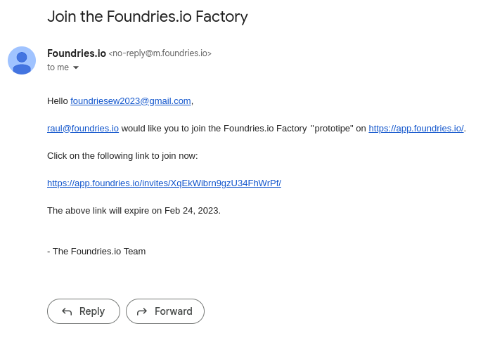

After accepting your invitation, check your Factory list and click on the Factory.

*Note: The Factory name will be used in the other chapters. Make sure you note it.*

