Psarros Konstantinos

kpsarro@outlook.com

Medical services

Τελική Εργασία για το «Προγραμματισμός με Java: Από το Α στο Ω»

Table of Contents

Database and Data Modeling Section 2

DBMS 2

*MySQL 8.0.34 & MySQL Workbench for data modeling* 2

*SQL DDL Scripts* 2

*ERD – Diagram* 9

GUI (Graphical User Interface) 9

Περιγραφή κλάσεων 9

GUI Structure 10

# Database and Data Modeling Section

## DBMS

### MySQL 8.0.34 & MySQL Workbench for data modeling

### SQL DDL Scripts

-- MySQL Workbench Forward Engineering

SET @OLD_UNIQUE_CHECKS=@@UNIQUE_CHECKS, UNIQUE_CHECKS=0;

SET @OLD_FOREIGN_KEY_CHECKS=@@FOREIGN_KEY_CHECKS, FOREIGN_KEY_CHECKS=0;

SET @OLD_SQL_MODE=@@SQL_MODE, SQL_MODE='ONLY_FULL_GROUP_BY,STRICT_TRANS_TABLES,NO_ZERO_IN_DATE,NO_ZERO_DATE,ERROR_FOR_DIVISION_BY_ZERO,NO_ENGINE_SUBSTITUTION';

-- -----------------------------------------------------

-- Schema medicalservices

-- -----------------------------------------------------

-- -----------------------------------------------------

-- Schema medicalservices

-- -----------------------------------------------------

CREATE SCHEMA IF NOT EXISTS `medicalservices` DEFAULT CHARACTER SET utf8 ;

USE `medicalservices` ;

-- -----------------------------------------------------

-- Table `medicalservices`.`SPECIALTIES`

-- -----------------------------------------------------

CREATE TABLE IF NOT EXISTS `medicalservices`.`SPECIALTIES` (

`SPECIALTY_ID` INT(3) NOT NULL,

`SPECIALTY_DESC` VARCHAR(45) CHARACTER SET 'utf8' NOT NULL,

PRIMARY KEY (`SPECIALTY_ID`),

INDEX `SPEC_DESC_IDX` (`SPECIALTY_DESC` ASC) VISIBLE)

ENGINE = InnoDB;

-- -----------------------------------------------------

-- Table `medicalservices`.`DOCTORS`

-- -----------------------------------------------------

CREATE TABLE IF NOT EXISTS `medicalservices`.`DOCTORS` (

`DOCTOR_ID` INT(11) NOT NULL,

`S_NAME` VARCHAR(45) NOT NULL,

`F_NAME` VARCHAR(45) NULL,

`SSN` INT(11) NOT NULL,

`SPECIALTIES_SPECIALTY_ID` INT(3) NOT NULL,

PRIMARY KEY (`DOCTOR_ID`, `SPECIALTIES_SPECIALTY_ID`),

UNIQUE INDEX `SSN_UNIQUE` (`SSN` ASC) VISIBLE,

INDEX `S_NAME` (`S_NAME` ASC) VISIBLE,

INDEX `fk_DOCTORS_SPECIALTIES1_idx` (`SPECIALTIES_SPECIALTY_ID` ASC) VISIBLE,

CONSTRAINT `fk_DOCTORS_SPECIALTIES1`

FOREIGN KEY (`SPECIALTIES_SPECIALTY_ID`)

REFERENCES `medicalservices`.`SPECIALTIES` (`SPECIALTY_ID`)

ON DELETE NO ACTION

ON UPDATE NO ACTION)

ENGINE = InnoDB;

-- -----------------------------------------------------

-- Table `medicalservices`.`PATIENTS`

-- -----------------------------------------------------

CREATE TABLE IF NOT EXISTS `medicalservices`.`PATIENTS` (

`PATIENT_ID` INT(11) NOT NULL,

`PS_NAME` VARCHAR(45) NOT NULL,

`PF_NAME` VARCHAR(45) NULL,

`PSSN` INT(11) NOT NULL,

`GENDER` VARCHAR(10) NULL,

`BIRTHDATE` VARCHAR(8) NOT NULL,

`LAST_VISIT_DATE` VARCHAR(8) NULL,

`ALLERGIES` VARCHAR(45) NULL,

`NOTES` VARCHAR(45) NULL,

`DOCTORS_DOCTOR_ID` INT(11) NOT NULL,

PRIMARY KEY (`PATIENT_ID`),

INDEX `PS_NAME` (`PS_NAME` ASC) INVISIBLE,

INDEX `fk_PATIENT_DOCTORS_idx` (`DOCTORS_DOCTOR_ID` ASC) VISIBLE,

CONSTRAINT `fk_PATIENT_DOCTORS`

FOREIGN KEY (`DOCTORS_DOCTOR_ID`)

REFERENCES `medicalservices`.`DOCTORS` (`DOCTOR_ID`)

ON DELETE NO ACTION

ON UPDATE NO ACTION)

ENGINE = InnoDB;

-- -----------------------------------------------------

-- Table `medicalservices`.`APPOITMENTSTATUS`

-- -----------------------------------------------------

CREATE TABLE IF NOT EXISTS `medicalservices`.`APPOITMENTSTATUS` (

`STATUS_ID` INT NOT NULL,

`STATUS_DESC` VARCHAR(45) NOT NULL,

PRIMARY KEY (`STATUS_ID`))

ENGINE = InnoDB;

-- -----------------------------------------------------

-- Table `medicalservices`.`APPOINTMENTS`

-- -----------------------------------------------------

CREATE TABLE IF NOT EXISTS `medicalservices`.`APPOINTMENTS` (

`AP_DATE` VARCHAR(8) NOT NULL,

`AP_TIME` VARCHAR(10) NOT NULL,

`AP_REASON` VARCHAR(45) NULL,

`PATIENT_PATIENT_ID` INT(11) NOT NULL,

`VISITS_VISIT_ID` INT(11) NULL,

`APPOITMENTSTATUS_STATUS_ID` INT NOT NULL,

`DOCTORS_DOCTOR_ID` INT(11) NOT NULL,

`APPOINTMENT_ID` INT(11) NOT NULL,

INDEX `AP_DATE` (`AP_DATE` ASC) VISIBLE,

PRIMARY KEY (`APPOINTMENT_ID`),

INDEX `fk_APOINTMENTS_APPOITMENTSTATUS1_idx` (`APPOITMENTSTATUS_STATUS_ID` ASC) VISIBLE,

INDEX `fk_APOINTMENTS_DOCTORS1_idx` (`DOCTORS_DOCTOR_ID` ASC) VISIBLE,

CONSTRAINT `fk_APOINTMENTS_APPOITMENTSTATUS1`

FOREIGN KEY (`APPOITMENTSTATUS_STATUS_ID`)

REFERENCES `medicalservices`.`APPOITMENTSTATUS` (`STATUS_ID`)

ON DELETE NO ACTION

ON UPDATE NO ACTION,

CONSTRAINT `fk_APOINTMENTS_DOCTORS1`

FOREIGN KEY (`DOCTORS_DOCTOR_ID`)

REFERENCES `medicalservices`.`DOCTORS` (`DOCTOR_ID`)

ON DELETE NO ACTION

ON UPDATE NO ACTION)

ENGINE = InnoDB;

-- -----------------------------------------------------

-- Table `medicalservices`.`VISITS`

-- -----------------------------------------------------

CREATE TABLE IF NOT EXISTS `medicalservices`.`VISITS` (

`VISIT_DATE` VARCHAR(20) NOT NULL,

`PERSCRIPTION_ID` INT(11) NULL,

`WEIGHT` INT(11) NULL,

`BLOOD_PRESURE` INT(11) NULL,

`TEMPERATURE` INT(11) NULL,

`DIAGNOSIS_NOTES` VARCHAR(45) NOT NULL,

`TREATMENT_NOTES` VARCHAR(45) NOT NULL,

`DOCTORS_DOCTOR_ID` INT(11) NOT NULL,

`PATIENT_PATIENT_ID` INT(11) NOT NULL,

PRIMARY KEY (`DOCTORS_DOCTOR_ID`, `PATIENT_PATIENT_ID`, `VISIT_DATE`),

INDEX `fk_VISITS_DOCTORS1_idx` (`DOCTORS_DOCTOR_ID` ASC) VISIBLE,

INDEX `fk_VISITS_PATIENT1_idx` (`PATIENT_PATIENT_ID` ASC) VISIBLE,

CONSTRAINT `fk_VISITS_DOCTORS1`

FOREIGN KEY (`DOCTORS_DOCTOR_ID`)

REFERENCES `medicalservices`.`DOCTORS` (`DOCTOR_ID`)

ON DELETE NO ACTION

ON UPDATE NO ACTION,

CONSTRAINT `fk_VISITS_PATIENT1`

FOREIGN KEY (`PATIENT_PATIENT_ID`)

REFERENCES `medicalservices`.`PATIENTS` (`PATIENT_ID`)

ON DELETE NO ACTION

ON UPDATE NO ACTION)

ENGINE = InnoDB;

-- -----------------------------------------------------

-- Table `medicalservices`.`PRESCRIPTIONS`

-- -----------------------------------------------------

CREATE TABLE IF NOT EXISTS `medicalservices`.`PRESCRIPTIONS` (

`PRESCRIPTION_ID` INT NOT NULL,

`PR_DATE` VARCHAR(8) NULL,

`PR_DOSAGE` VARCHAR(45) NULL,

`MEDIATION` VARCHAR(45) NULL,

`VISITS_VISIT_ID` INT(11) NOT NULL,

PRIMARY KEY (`PRESCRIPTION_ID`, `VISITS_VISIT_ID`))

ENGINE = InnoDB;

USE `medicalservices` ;

-- -----------------------------------------------------

-- Placeholder table for view `medicalservices`.`DOCTORSPECIALTIES`

-- -----------------------------------------------------

CREATE TABLE IF NOT EXISTS `medicalservices`.`DOCTORSPECIALTIES` (`specialty_desc` INT);

-- -----------------------------------------------------

-- Placeholder table for view `medicalservices`.`APPOITMENTSTATUSES`

-- -----------------------------------------------------

CREATE TABLE IF NOT EXISTS `medicalservices`.`APPOITMENTSTATUSES` (`status_desc` INT);

-- -----------------------------------------------------

-- View `medicalservices`.`DOCTORSPECIALTIES`

-- -----------------------------------------------------

DROP TABLE IF EXISTS `medicalservices`.`DOCTORSPECIALTIES`;

USE `medicalservices`;

CREATE OR REPLACE VIEW DOCTORSPECIALTIES AS SELECT doctors.*, specialties.specialty_desc FROM doctors INNER JOIN specialties ON specialties_specialty_id = specialty_id;

-- -----------------------------------------------------

-- View `medicalservices`.`APPOITMENTSTATUSES`

-- -----------------------------------------------------

DROP TABLE IF EXISTS `medicalservices`.`APPOITMENTSTATUSES`;

USE `medicalservices`;

CREATE OR REPLACE VIEW APPOITMENTSTATUSES AS SELECT Appointments.*, appoitmentstatus.status_desc FROM appointments INNER JOIN appoitmentstatus ON appoitmentstatus_status_id = status_id;

CREATE USER 'kpsarros' IDENTIFIED BY 'kps2152001@';

GRANT ALL ON `medicalservices`.* TO 'kpsarros';

SET SQL_MODE=@OLD_SQL_MODE;

SET FOREIGN_KEY_CHECKS=@OLD_FOREIGN_KEY_CHECKS;

SET UNIQUE_CHECKS=@OLD_UNIQUE_CHECKS;

### ERD – Diagram

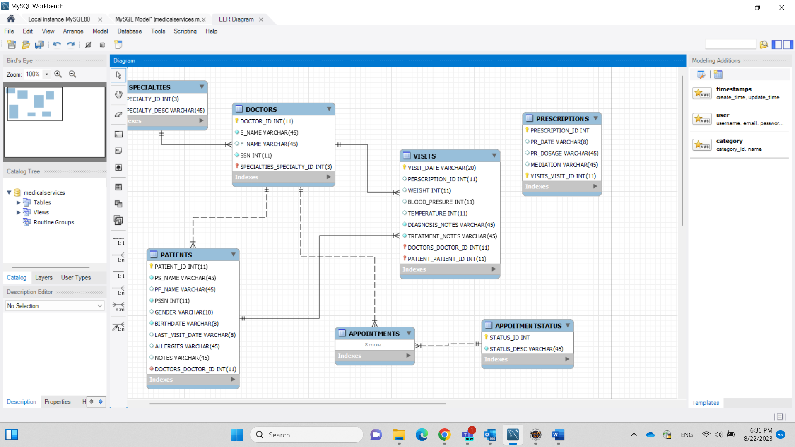

# GUI (Graphical User Interface)

Παρακάτω παρατίθεται η ιεραρχία των οθονών, κάθε μία από τις οποίες υλοποιείται σαν μια ανεξάρτητη java κλάση και περιέχονται στον φάκελο “medical_services\src\medical_services\views”.

To project γράφτηκε στο IDE Eclipse και για το UI χρησιμοποιήθηκε το Windows Builder plug in, από το Eclipse Marketplace

## Περιγραφή κλάσεων

MedicalServices: Main Driver (includes the Main method)

FrmLogin; Οθόνη Login

FrmInitialScreen: Αρχική οθόνη

FrmInsertDoctors: Εισαγωγή Ιατρού

FrmInsertPatients: Εισαγωγή Ασθενούς

MainWindow: Αναζήτηση / Καταχώρηση Ραντεβού

FrmAbout:

FrmVersion

FrmSearchDoctors: Επιλογή Ιατρού

FrmSearchPatients: Επιλογή Ασθενούς

## GUI Structure