Add a background image that might not fill the complete length of a large device
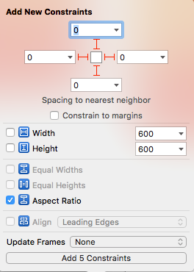
Add contraints:
- Deselect „Constrain to margins“
- Pin all edges to „0“ → 4 Constraints
- Select Aspect Ratio → 1 Constraint

Now the image streches.
On the „Attributes Inspector“ set the View Mode to „Aspect Fill“ → Now the image keeps its ratio but some details of the image may no longer be visible. In this example on the left and right, because the image fits on the length on Portrait and top and bottom on landscape.

Add the image items onto the background
- The „Retro-Calc“ image of the title is added near the top of the screen
  - Set View Mode to Aspect Fit
  - On the Pin Menu keep the Height (43) and Width (240) → 2 Constrains
- Add the „launchground“ image view
  - Pin Height 128
  - Pin Left, Right, Bottom to „0“ (deselect „Contrains to Margins“)
- Add ImageView for the Robot.
  - Pin Height 128, Pin Width 240, Align Horizontally in Container, Pin Top 57 to Retro Calc.
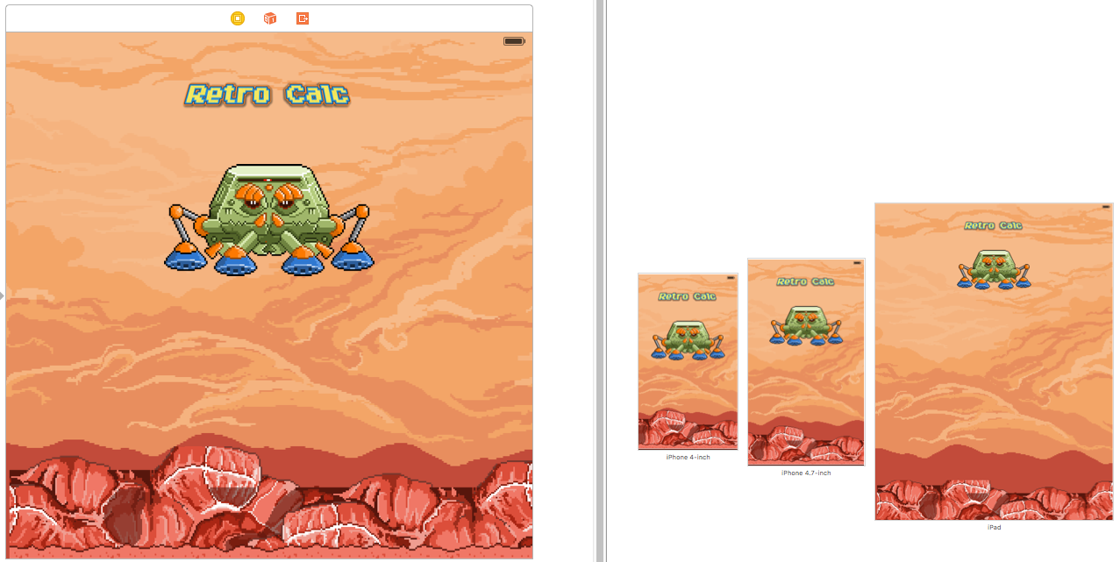

Add the Reset Button to Calculator

