1.

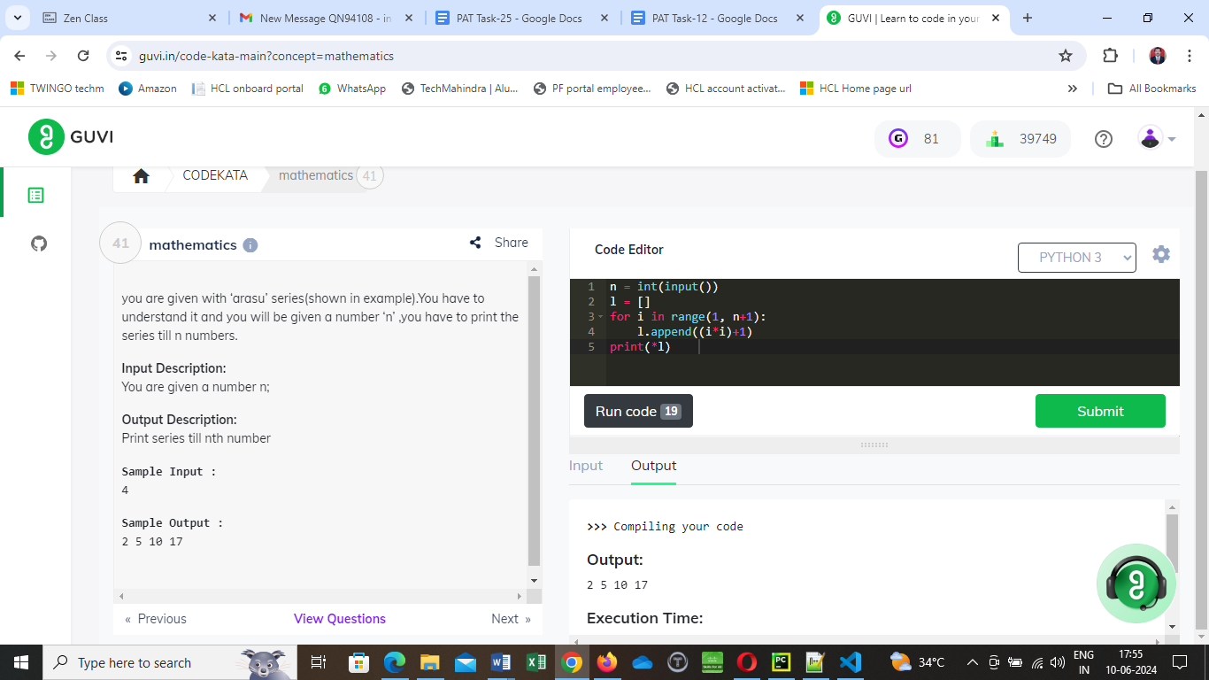

2.You are given a number ‘n’. You have to tell whether a number is great or not. A great number is a number whose sum of digits let (m) and product of digits let(j) when summed together gives the number back

#m+j=n

n=int(input())

t=n

sum=0

product=1

while n > 0:

digit=n%10

sum=sum+digit

#print("sum:", sum)

product=digit*product

#print( "Product", product)

n=n//10

res=sum+product

#print(res)

if res==t:

print("Great")

else:

print("no")

Input:59

Output:Great

3. 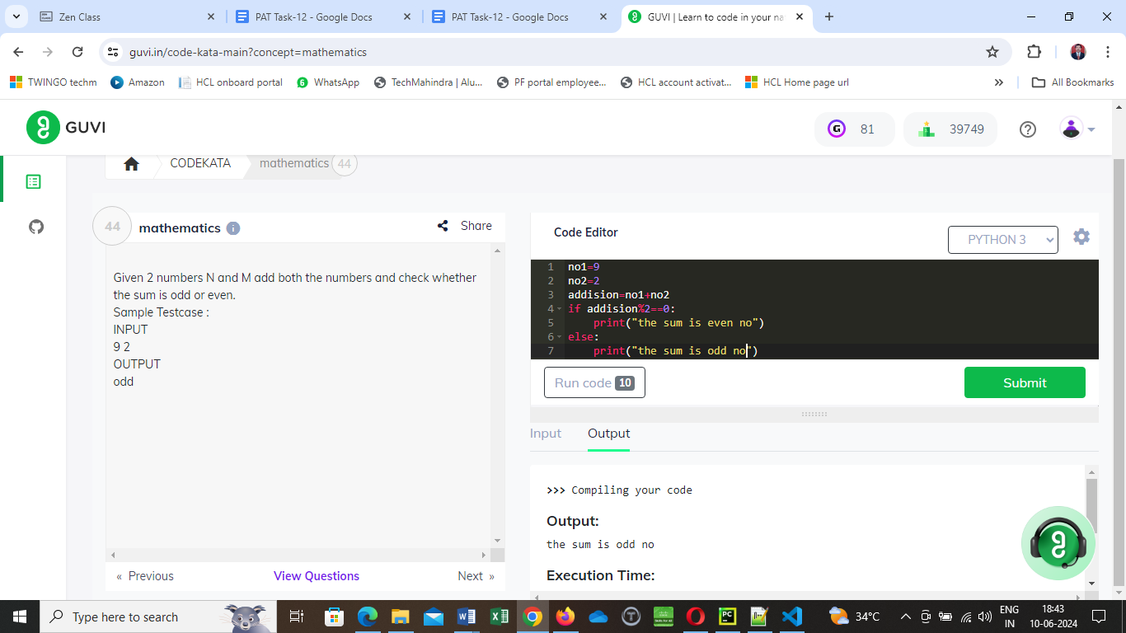

4.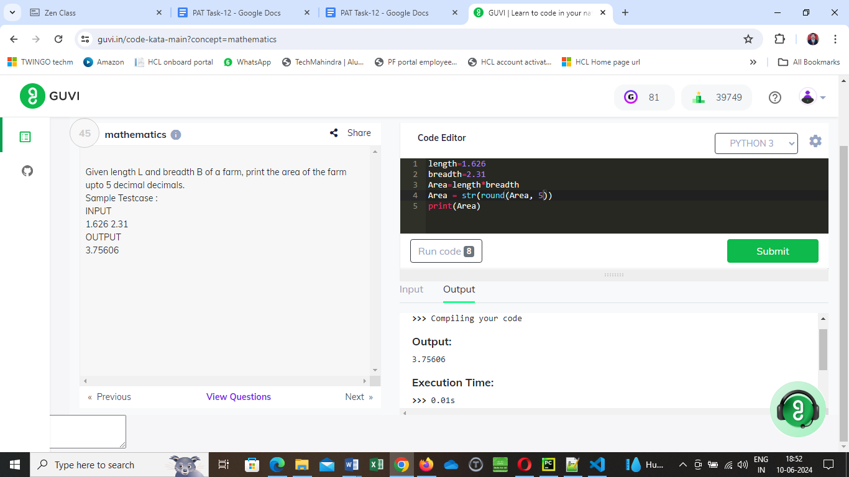

5.

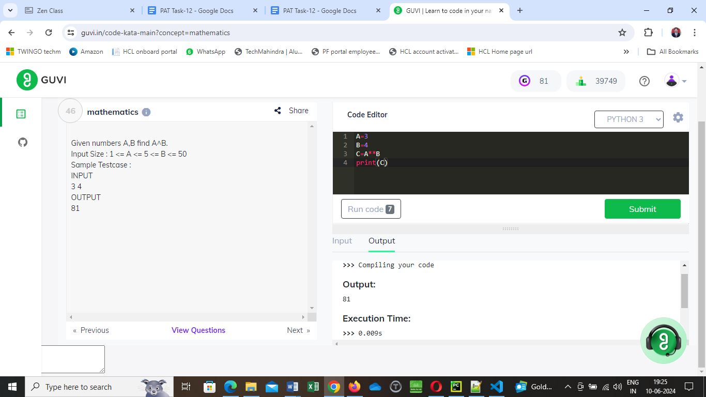

6.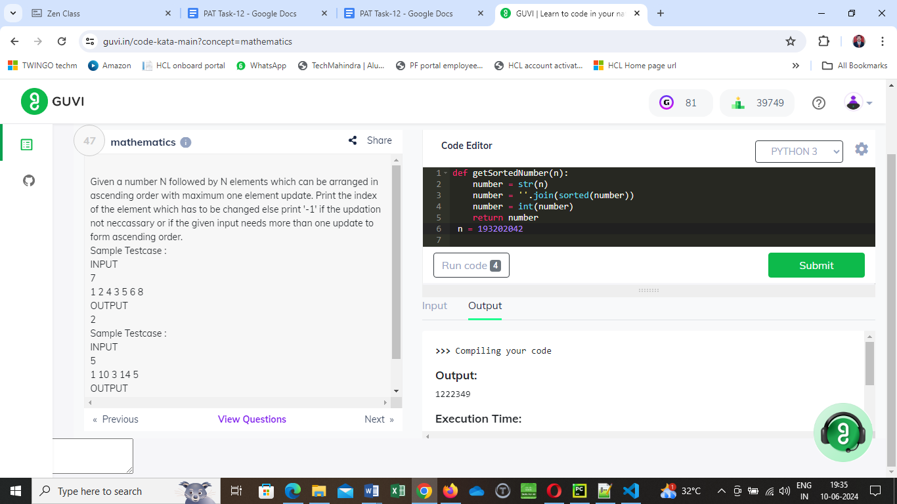

7.Given a range of 2 numbers (i.e) L and R count the number of prime numbers in the range (inclusive of L and R ).  
Input Size : L <= R <= 100000(complexity O(n) read about Sieve of Eratosthenes)

lower=2

upper=5

count = 0

print("prime numbers between", lower,"and", upper, "are:")

for num in range (lower, upper+1):

if num>1:

for i in range (2,num):

if num % i==0:

break

else:

print(num)

count += 1

print ( "count_prime:", count )

**Output:**

prime numbers between 2 and 5 are:

2

3

5

count_prime: 3

8. Given a number N, print its factors.  
Input Size : n<=100

def printfactors(n) :

i = 1

while i <= n :

if (n % i==0) :

print (i,end=" ")

i = i + 1

# Driver method

print ("The factors of 100 are: ")

printfactors(100)

##### Output:

The factors of 100 are:

1 2 4 5 10 20 25 50 100

9. Given a number N and an array of N integers, find the sum of all the negative numbers in the array.  
Input Size : N <= 100000

array=[11,22,33,44,55]

sum=0

for i in array:

    sum=sum+i

print(sum)

10. Given a number N, check whether it is prime or not. Print 'yes' if it is prime else print 'no'.

num = 123

# If given number is greater than 1

if num > 1:

    # Iterate from 2 to n // 2

    for i in range(2, (num//2)+1):

        # If num is divisible by any number between

        # 2 and n / 2, it is not prime

        if (num % i) == 0:

            print(num, "is not a prime number")

            break

    else:

        print(num, "is a prime number")

else:

    print(num, "is not a prime number")

11. Given a string S, check whether the given string is an anagram of the string “dhoni”. Anagram of a given string is a permutation of the set of characters present in the string. For example for the string “baba” aabb and baab are anagrams while aaab and bacd are not.

str1 = "Race"

str2 = "Care"

# convert both the strings into lowercase

str1 = str1.lower()

str2 = str2.lower()

# check if length is same

if(len(str1) == len(str2)):

# sort the strings

sorted_str1 = sorted(str1)

sorted_str2 = sorted(str2)

# if sorted char arrays are same

if(sorted_str1 == sorted_str2):

print(str1 + " and " + str2 + " are anagram.")

else:

print(str1 + " and " + str2 + " are not anagram.")

else:

print(str1 + " and " + str2 + " are not anagram.")

4.