**CMPT 310 Assignment 4 Report**

Joshua Campbell

301266191

**Part 1:**

**a)**

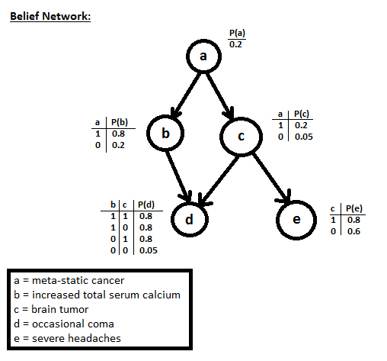

**b)** Since each variable is conditionally independent of its non-descendants given the value of its parents, an example of an implicit independence assumption would be that node e is conditionally independent of d given the value of c. For example, P(e|c,d) = P(e|c). This would mean that the probability of e is unaffected by the state of d when information about c is known.

**c)**

$$Formula for P\left(¬B | A\right)=\frac{P\left(A∩¬B\right)}{P\left(A\right)}=\frac{P\left(A\right)-P\left(A∩B\right)}{P\left(A\right)}=1-\frac{P\left(A∩B\right)}{P\left(A\right)}=1-P(B|A)$$

$$P\left(a,b,c,¬d,e\right)=P(a)P(b|a)P(c|a)P(¬d|b,c)P(e|c)= (0.2)*(0.8)*(0.2)*(1-0.8)*(0.8) = 0.00512$$

$$P\left(¬a,b,c,¬d,e\right)=P(¬a)P(b|¬a)P(c|¬a)P(¬d|b,c)P(e|c)=(1-0.2)*(0.2)*(0.05)*(1-0.8)*(0.8) = 0.00128$$

$$P\left(a,¬b,c,¬d,e\right)=P(a)P(¬b|a)P(c|a)P(¬d|¬b,c)P(e|c)= (0.2)*(1-0.8)*(0.2)*(1-0.8)*(0.8) = 0.00128$$

$$P\left(a,b,¬c,¬d,e\right)=P(a)P(b|a)P(¬c|a)P(¬d|b,¬c)P(e|¬c)= (0.2)*(0.8)*(1-0.8)*(1-0.8)*(0.6) = 0.00384$$

$$P\left(¬a,¬b,c,¬d,e\right)=P(¬a)P(¬b|¬a)P(c|¬a)P(¬d|¬b,c)P(e|c)= (1-0.2)*(1-0.2)*(0.05)*(1-0.8)*(0.8) = 0.0000512$$

$$P\left(¬a,b,¬c,¬d,e\right)=P(¬a)P(b|¬a)P(¬c|¬a)P(¬d|b,¬c)P(e|¬c)= (1-0.2)*(0.2)*(1-0.05)*(1-0.8)*(0.6) = 0.01824$$

$$P\left(a,¬b,¬c,¬d,e\right)=P(a)P(¬b|a)P(¬c|a)P(¬d|¬b,¬c)P(e|¬c)= (0.2)*(1-0.8)*(1-0.2)*(1-0.05)*(0.6) = 0.01824$$

$$P\left(a¬,¬b,¬c,¬d,e\right)=P(¬a)P(¬b|¬a)P(¬c|¬a)P(¬d|¬b,¬c)P(e|¬c)= (1-0.2)*(1-0.2)*(1-0.05)*(1-0.05)*(0.6) = 0.34656$$

**d)**

In order to determine if the patient is more likely to have meta-static cancer given that they are not experiencing occasional comas, but they are experiencing severe headaches, we can use Bayes’ Rule and inference by enumeration to perform diagnostic analysis.

$$P\left(a | ¬d,e\right)=\frac{P\left(a,¬d,e\right)}{P\left(¬d,e\right)}=αP\left(a,¬d,e\right), α=\frac{1}{P\left(¬d,e\right)}$$

$$αP\left(a,¬d,e\right)=α\sum_{b}{\sum_{c}{P\left(a,b,c,¬d,e\right)=α\sum_{b}{\sum_{c}{P\left(a\right)P\left(b | a\right)P\left(c | a\right)P\left(¬d | b,c\right)P(e|c)}}}}$$

$$=α\left(P\left(a\right)P\left(b | a\right)P\left(c | a\right)P\left(¬d | b,c\right)P\left(e | c\right)+ P\left(a\right)P\left(¬b | a\right)P\left(c | a\right)P\left(¬d | ¬b,c\right)P\left(e | c\right)+P\left(a\right)P\left(b | a\right)P\left(¬c | a\right)P\left(¬d | b,¬c\right)P\left(e | ¬c\right)+P\left(a\right)P\left(¬b | a\right)P\left(¬c | a\right)P\left(¬d | ¬b,¬c\right)P\left(e | ¬c\right)\right)=α\left(0.00512+0.00128+0.00384+0.01824\right)=α(0.02848)$$

$$α=\frac{1}{P\left(¬d,e\right)}; P\left(¬d,e\right)=\sum_{a}{\sum_{b}{\sum_{c}{P(a,b,c,¬d,e)}}}$$

$$=P\left(a\right)P\left(b | a\right)P\left(c | a\right)P\left(¬d | b,c\right)P\left(e | c\right)+ P\left(a\right)P\left(¬b | a\right)P\left(c | a\right)P\left(¬d | ¬b,c\right)P\left(e | c\right)+P\left(a\right)P\left(b | a\right)P\left(¬c | a\right)P\left(¬d | b,¬c\right)P\left(e | ¬c\right)+P\left(a\right)P\left(¬b | a\right)P\left(¬c | a\right)P\left(¬d | ¬b,¬c\right)P\left(e | ¬c\right)+P\left(¬a\right)P\left(b | ¬a\right)P\left(c | ¬a\right)P\left(¬d | b,c\right)P\left(e | c\right)+ P\left(¬a\right)P\left(¬b | ¬a\right)P\left(c | ¬a\right)P\left(¬d | ¬b,c\right)P\left(e | c\right)+P\left(¬a\right)P\left(b | ¬a\right)P\left(¬c | ¬a\right)P\left(¬d | b,¬c\right)P\left(e | ¬c\right)+P\left(¬a\right)P\left(¬b | ¬a\right)P\left(¬c | ¬a\right)P\left(¬d | ¬b,¬c\right)P\left(e | ¬c\right)=0.00512+0.00128+0.00384+0.01824+0.00128+0.0000512+0.01824+0.34656=0.3946112$$

$$∴α=\frac{1}{0.3946112}$$

$$∴P\left(a | ¬d,e\right)=\frac{0.02848}{0.3946112}=0.07217<P\left(a\right)=0.2$$

Since $P\left(a | ¬d,e\right)=0.07217<0.2=P(a)$ we are less inclined to believe that the patient has cancer given the available information.

**Part 2:**

**Initial Calculations (L = number of Low Risk of flooding outcomes, M = number of Medium Risk of flooding outcomes, H = number of High Risk of flooding outcomes):**

Total Outcomes: 5 Low risks of flooding, 3 Medium risks of flooding, 6 High risks of flooding

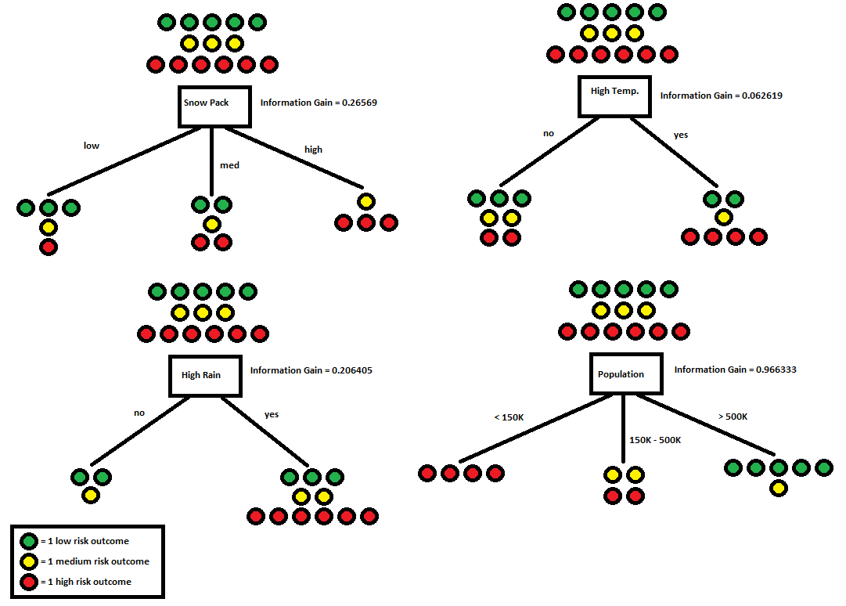

**Functions Used:**

$Entropy$ = $I\left(\frac{L}{L+M+H},\frac{M}{L+M+H},\frac{H}{L+M+H}\right)= {-\frac{L}{L+M+H}log}_{2}\left(\frac{L}{L+M+H}\right){-\frac{M}{L+M+H}log}_{2}\left(\frac{M}{L+M+H}\right){-\frac{H}{L+M+H}log}_{2}\left(\frac{H}{L+M+H}\right)$

$$Remainder\left(attribute\right)=\frac{\sum_{i=1}^{n \left(branches of attribute\right)}{\left(L_{i}+M_{i}+H_{i}\right)*}I(\frac{L_{i}}{L_{i}+M_{i}+H_{i}},\frac{M_{i}}{L_{i}+M_{i}+H_{i}},\frac{H_{i}}{L_{i}+M_{i}+H_{i}})}{L+M+H}$$

$$Information Gain=IG\left(attribute\right)=I\left(\frac{L}{L+M+H},\frac{M}{L+M+H},\frac{H}{L+M+H}\right)-Remainder\left(attribute\right)$$

**Node 1:**

**Population:**

$$entropy<150K branch: -\frac{4}{4}\log_{2}\left(\frac{4}{4}\right)-\frac{0}{4}-\frac{0}{4}=0 bits$$

$$entropy 150K-500K branch: -\frac{0}{4}-\frac{2}{4}\log_{2}\left(\frac{2}{4}\right)-\frac{2}{4}\log_{2}\left(\frac{2}{4}\right)=1 bit$$

$$entropy >500K branch: -\frac{5}{6}\log_{2}\left(\frac{5}{6}\right)-\frac{1}{6}\log_{2}\left(\frac{1}{6}\right)-\frac{0}{6}=0.65 bits$$

The above branch entropies are used to calculate remainder:

$Remainder\left(Pop\right)=\frac{4}{14}\left(-\frac{4}{4}\log_{2}\left(\frac{4}{4}\right)\right)+\frac{4}{14}\left({-\frac{2}{4}log}_{2}\left(\frac{2}{4}\right){-\frac{2}{4}log}_{2}\left(\frac{2}{4}\right)\right)+\frac{6}{14}\left({-\frac{5}{6}log}_{2}\left(\frac{5}{6}\right){-\frac{1}{6}log}_{2}\left(\frac{1}{6}\right)\right)=\frac{4}{14}\left(0\right)+\frac{4}{14}\left(1\right)+\frac{6}{14}\left(0.65\right)= 0.564286 bits$

$$IG\left(Population\right)={-\frac{5}{14}log}_{2}{(\frac{5}{14})}{-\frac{3}{14}log}_{2}{(\frac{3}{14})}{-\frac{6}{14}log}_{2}{(\frac{6}{14})}-Remainder\left(Population\right)= 0.966333 bits$$

**Snow Pack:**

$$entropy low snow pack branch: -\frac{3}{5}\log_{2}\left(\frac{3}{5}\right)-\frac{1}{5}\log_{2}\left(\frac{1}{5}\right)-\frac{1}{5}\log_{2}\left(\frac{1}{5}\right)=1.371 bits$$

$$entropy medium snow pack branch: -\frac{2}{5}\log_{2}\left(\frac{2}{5}\right)-\frac{1}{5}\log_{2}\left(\frac{1}{5}\right)-\frac{2}{5}\log_{2}\left(\frac{2}{5}\right)=1.522 bits$$

$$entropy high snow pack branch: -\frac{1}{4}\log_{2}\left(\frac{1}{4}\right)-\frac{3}{4}\log_{2}\left(\frac{3}{4}\right)-\frac{0}{4}=0.811 bits$$

The above branch entropies are used to calculate remainder:

$Remainder\left(Snow\right)=\frac{5}{14}\left(-\frac{3}{5}\log_{2}\left(\frac{3}{5}\right)-\frac{1}{5}\log_{2}\left(\frac{1}{5}\right)-\frac{1}{5}\log_{2}\left(\frac{1}{5}\right)\right)+\frac{5}{14}\left({-\frac{2}{5}log}_{2}\left(\frac{2}{5}\right){-\frac{1}{5}log}_{2}\left(\frac{1}{5}\right){-\frac{2}{5}log}_{2}\left(\frac{2}{5}\right)\right)+\frac{4}{14}\left({-\frac{1}{4}log}_{2}\left(\frac{1}{4}\right){-\frac{3}{4}log}_{2}\left(\frac{3}{4}\right)\right)=\frac{5}{14}\left(1.371\right)+\frac{5}{14}\left(1.522\right)+\frac{4}{14}\left(0.811\right)=1.264929 bits$

$$IG\left(Snow\right)={-\frac{5}{14}log}_{2}{(\frac{5}{14})}{-\frac{3}{14}log}_{2}{(\frac{3}{14})}{-\frac{6}{14}log}_{2}{(\frac{6}{14})}-Remainder\left(Snow\right)= 0.26569 bits$$

**High Temp:**

$$entropy no branch: -\frac{3}{7}\log_{2}\left(\frac{3}{7}\right)-\frac{2}{7}\log_{2}\left(\frac{2}{7}\right)-\frac{2}{7}\log_{2}\left(\frac{2}{7}\right)=1.557 bits$$

$$entropy yes branch: -\frac{2}{7}\log_{2}\left(\frac{2}{7}\right)-\frac{1}{7}\log_{2}\left(\frac{1}{7}\right)-\frac{4}{7}\log_{2}\left(\frac{4}{7}\right)=1.379 bits$$

The above branch entropies are used to calculate remainder:

$Remainder\left(Temp\right)=\frac{7}{14}\left({-\frac{3}{7}log}_{2}\left(\frac{3}{7}\right){-\frac{2}{7}log}_{2}\left(\frac{2}{7}\right){-\frac{2}{7}log}_{2}\left(\frac{2}{7}\right)\right)+\frac{7}{14}\left({-\frac{2}{7}log}_{2}\left(\frac{2}{7}\right){-\frac{1}{7}log}_{2}\left(\frac{1}{7}\right){-\frac{4}{7}log}_{2}\left(\frac{4}{7}\right)\right)=\frac{7}{14}\left(1.557\right)+\frac{7}{14}\left(1.379\right)=1.468 bits$

$$IG\left(Temp\right)={-\frac{5}{14}log}_{2}{(\frac{5}{14})}{-\frac{3}{14}log}_{2}{(\frac{3}{14})}{-\frac{6}{14}log}_{2}{(\frac{6}{14})}-Remainder\left(Temp\right)= 0.062619 bits$$

**High Rain:**

$$entropy no branch: -\frac{2}{3}\log_{2}\left(\frac{2}{3}\right)-\frac{1}{3}\log_{2}\left(\frac{1}{3}\right)-\frac{0}{3}=0.918 bits$$

$$entropy yes branch: {-\frac{3}{11}log}_{2}\left(\frac{3}{11}\right){-\frac{2}{11}log}_{2}\left(\frac{2}{11}\right){-\frac{6}{11}log}_{2}\left(\frac{6}{11}\right)=1.435 bits$$

The above branch entropies are used to calculate remainder:

$Remainder\left(Rain\right)=\frac{3}{14}\left(-\frac{2}{3}\log_{2}\left(\frac{2}{3}\right)-\frac{1}{3}\log_{2}\left(\frac{1}{3}\right)\right)+\frac{11}{14}\left({-\frac{3}{11}log}_{2}\left(\frac{3}{11}\right){-\frac{2}{11}log}_{2}\left(\frac{2}{11}\right){-\frac{6}{11}log}_{2}\left(\frac{6}{11}\right)\right)=\frac{3}{14}\left(0.918\right)+\frac{11}{14}\left(1.435\right)=0.564286 bits$

$$IG\left(Rain\right)={-\frac{5}{14}log}_{2}{(\frac{5}{14})}{-\frac{3}{14}log}_{2}{(\frac{3}{14})}{-\frac{6}{14}log}_{2}{(\frac{6}{14})}-Remainder\left(Rain\right)= 0.206405 bits$$

Therefore the first node of the Decision Tree is Population since it has the most Information Gain.

Since Populations with <150K residents are always at high risk of flooding, this will be the first leaf on the tree (High Risk).

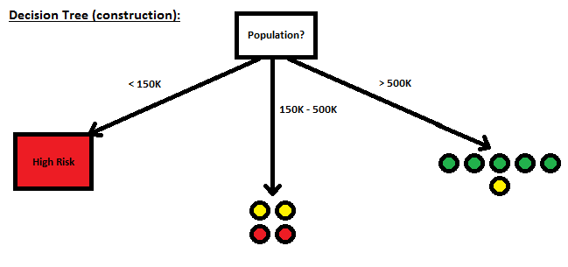

**Node 2:**

For populations in the range of 150K-500K, the outcomes are 2 Medium risks of flooding and 2 High risks of flooding.

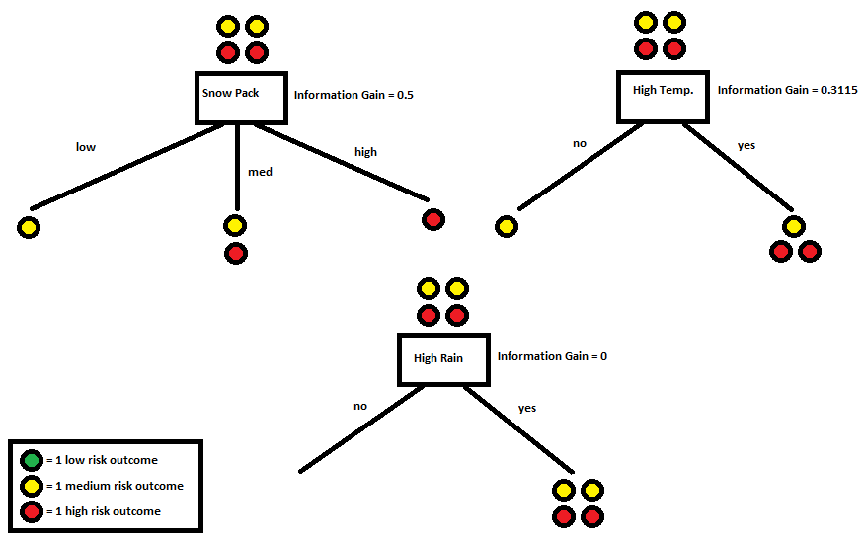

The Information Gains for attributes based on the 150K-500K branch are:

**Snow Pack:**

$$entropy low snow pack branch: -\frac{0}{1}{-\frac{1}{1}log}_{2}\left(\frac{1}{1}\right)-\frac{0}{1}=0 bits$$

$$entropy medium snow pack branch: -\frac{0}{2}-\frac{1}{2}\log_{2}\left(\frac{1}{2}\right)-\frac{1}{2}\log_{2}\left(\frac{1}{2}\right)=1 bit$$

$$entropy high snow pack branch: -\frac{0}{1}-\frac{0}{1}{-\frac{1}{1}log}_{2}\left(\frac{1}{1}\right)=0 bits$$

The above branch entropies are used to calculate remainder:

$Remainder\left(Snow\right)=\frac{1}{4}\left({-\frac{1}{1}log}_{2}\left(\frac{1}{1}\right)\right)+\frac{2}{4}\left({-\frac{1}{2}log}_{2}\left(\frac{1}{2}\right){-\frac{1}{2}log}_{2}\left(\frac{1}{2}\right)\right)+\frac{1}{4}\left({-\frac{1}{1}log}_{2}\left(\frac{1}{1}\right)\right)=\frac{1}{4}\left(0\right)+\frac{2}{4}\left(1\right)+\frac{1}{4}\left(0\right)= 0.5 bits$

$$IG\left(Snow\right)={-\frac{2}{4}log}_{2}{(\frac{2}{4})}{-\frac{2}{4}log}_{2}{(\frac{2}{4})}-Remainder\left(Snow\right)= 0.5 bits$$

**High Temp:**

$$entropy no branch: -\frac{0}{1}{-\frac{1}{1}log}_{2}\left(\frac{1}{1}\right)-\frac{0}{1}=0 bits$$

$$entropy yes branch: -\frac{0}{3}-\frac{1}{3}\log_{2}\left(\frac{1}{3}\right)-\frac{2}{3}\log_{2}\left(\frac{2}{3}\right)=0.918 bits$$

The above branch entropies are used to calculate remainder:

$Remainder\left(Temp\right)=\frac{1}{4}\left({-\frac{1}{1}log}_{2}\left(\frac{1}{1}\right)\right)+\frac{3}{4}\left({{-\frac{1}{3}log}_{2}\left(\frac{1}{3}\right)-\frac{2}{3}log}_{2}\left(\frac{2}{3}\right)\right)=\frac{1}{4}\left(0\right)+\frac{3}{4}\left(0.918\right)= 0.6885 bits$

$$IG\left(Temp\right)={-\frac{2}{4}log}_{2}{(\frac{2}{4})}{-\frac{2}{4}log}_{2}{(\frac{2}{4})}-Remainder\left(Temp\right)= 0.3115 bits$$

**High Rain:**

$$entropy no branch: -0-0-0=0 bits$$

$$entropy yes branch: -\frac{0}{4}-\frac{2}{4}\log_{2}\left(\frac{2}{4}\right)-\frac{2}{4}\log_{2}\left(\frac{2}{4}\right)=1 bit$$

The above branch entropies are used to calculate remainder:

$Remainder\left(Rain\right)=\frac{0}{4}\left(0\right)+\frac{4}{4}\left({-\frac{2}{4}log}_{2}{(\frac{2}{4})}{-\frac{2}{4}log}_{2}{(\frac{2}{4})}\right)=\frac{0}{4}\left(0\right)+\frac{4}{4}\left(1\right)=1 bit$

$$IG\left(Rain\right)={-\frac{2}{4}log}_{2}{(\frac{2}{4})}{-\frac{2}{4}log}_{2}{(\frac{2}{4})}-Remainder\left(Rain\right)= 0 bits$$

* Snow Pack: IG(Snow) = I(Snow) – Remainder(Snow) = 1 – 0.5 = 0.5 bits
* High Temp: IG(Temp) = I(Temp) – Remainder(Temp) = 1 – 0.6885 = 0.3115 bits
* High Rain: IG(Rain) = I(Rain) – Remainder(Rain) = 1 – 1 = 0 bits

Therefore, the child node of the 150K-500K branch is Snow Pack since it has the most information gain.

Since the Low branch of Snow Pack only has one outcome, it will become a leaf node (Medium Risk). Since the High branch of Snow Pack only has one outcome, it will become a leaf node (High Risk).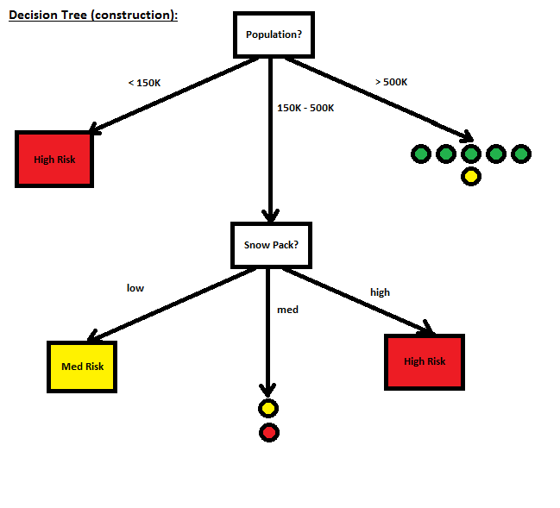

**Node 3:**

For populations > 500K, the outcomes are 5 Low risks of flooding and 1 Medium risk of flooding.

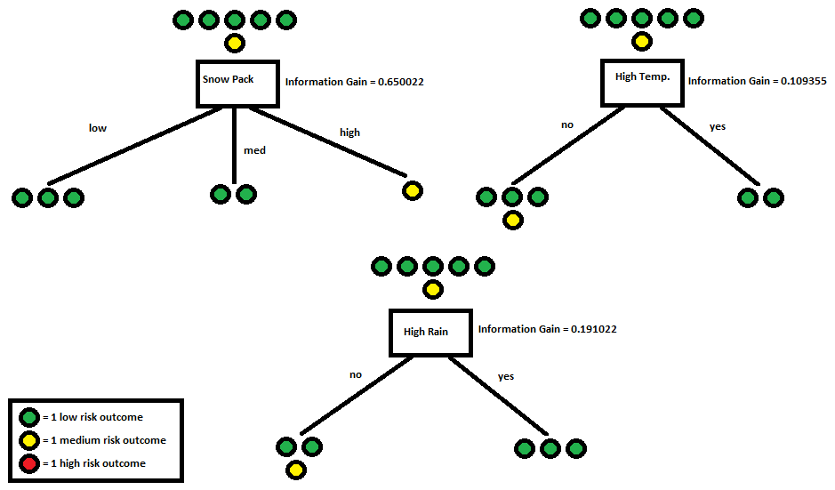

The Information Gains for attributes based on the > 500K branch are:

**Snow Pack:**

$$entropy low snow pack branch: {-\frac{3}{3}log}_{2}\left(\frac{3}{3}\right)-\frac{0}{3}-\frac{0}{3}=0 bits$$

$$entropy medium snow pack branch: -\frac{2}{2}\log_{2}\left(\frac{2}{2}\right)-\frac{0}{2}-\frac{0}{2}=0 bits$$

$$entropy high snow pack branch: -\frac{0}{1}{-\frac{1}{1}log}_{2}\left(\frac{1}{1}\right)-\frac{0}{1}=0 bits$$

The above branch entropies are used to calculate remainder:

$Remainder\left(Snow\right)=\frac{3}{6}\left({-\frac{3}{3}log}_{2}\left(\frac{3}{3}\right)\right)+\frac{2}{6}\left(-\frac{2}{2}\log_{2}\left(\frac{2}{2}\right)\right)+\frac{1}{6}\left({-\frac{1}{1}log}_{2}\left(\frac{1}{1}\right)\right)=\frac{3}{6}\left(0\right)+\frac{2}{6}\left(0\right)+\frac{1}{6}\left(0\right)= 0 bits$

$$IG\left(Snow\right)={-\frac{5}{6}log}_{2}{(\frac{5}{6})}{-\frac{1}{6}log}_{2}{(\frac{1}{6})}-Remainder\left(Snow\right)= 0.650022 bits$$

**High Temp:**

$$entropy no branch: {-\frac{3}{4}log}_{2}\left(\frac{3}{4}\right){-\frac{1}{4}log}_{2}\left(\frac{1}{4}\right)-\frac{0}{4}=0.811 bits$$

$$entropy yes branch: -\frac{2}{2}\log_{2}\left(\frac{2}{2}\right)-\frac{0}{2}-\frac{0}{2}=0 bits$$

The above branch entropies are used to calculate remainder:

$Remainder\left(Temp\right)=\frac{4}{6}\left({-\frac{3}{4}log}_{2}\left(\frac{3}{4}\right){-\frac{1}{4}log}_{2}\left(\frac{1}{4}\right)\right)+\frac{2}{6}\left(-\frac{2}{2}\log_{2}\left(\frac{2}{2}\right)\right)=\frac{1}{4}\left(0.811\right)+\frac{3}{4}\left(0\right)= 0.540667 bits$

$$IG\left(Temp\right)={-\frac{5}{6}log}_{2}{(\frac{5}{6})}{-\frac{1}{6}log}_{2}{(\frac{1}{6})}-Remainder\left(Temp\right)= 0.109355 bits$$

**High Rain:**

$$entropy no branch: -\frac{2}{3}\log_{2}\left(\frac{2}{3}\right)-\frac{1}{3}\log_{2}\left(\frac{1}{3}\right)-\frac{0}{3}=0.918 bits$$

$$entropy yes branch: -\frac{3}{3}\log_{2}\left(\frac{3}{3}\right)-\frac{0}{3}-\frac{0}{3}=0 bits$$

The above branch entropies are used to calculate remainder:

$Remainder\left(Rain\right)=\frac{3}{6}\left(-\frac{2}{3}\log_{2}\left(\frac{2}{3}\right)-\frac{1}{3}\log_{2}\left(\frac{1}{3}\right)\right)+\frac{3}{6}\left(-\frac{3}{3}\log_{2}\left(\frac{3}{3}\right)\right)=\frac{3}{6}\left(0.918\right)+\frac{3}{6}\left(0\right)=0.459 bits$

$$IG\left(Rain\right)={-\frac{5}{6}log}_{2}{(\frac{5}{6})}{-\frac{1}{6}log}_{2}{(\frac{1}{6})}-Remainder\left(Rain\right)= 0.191022 bits$$

* Snow Pack: IG(Snow) = I(Snow) – Remainder(Snow) = 0.650022 – 0 = 0.650022 bits
* High Temp: IG(Temp) = I(Temp) – Remainder(Temp) = 0.650022 – 0.540667 = 0.109355 bits
* High Rain: IG(Rain) = I(Rain) – Remainder(Rain) = 0.650022 – 0.459 = 0.191022 bits

Therefore, the child node of the > 500K branch is Snow Pack since it has the most information gain.

Since the Low branch of Snow Pack only has one outcome, it will become a leaf node (Low Risk). Since the Medium branch of Snow Pack only has one outcome, it will become a leaf node (Low Risk). Since the High branch of Snow Pack only has one outcome, it will become a leaf node (Medium Risk).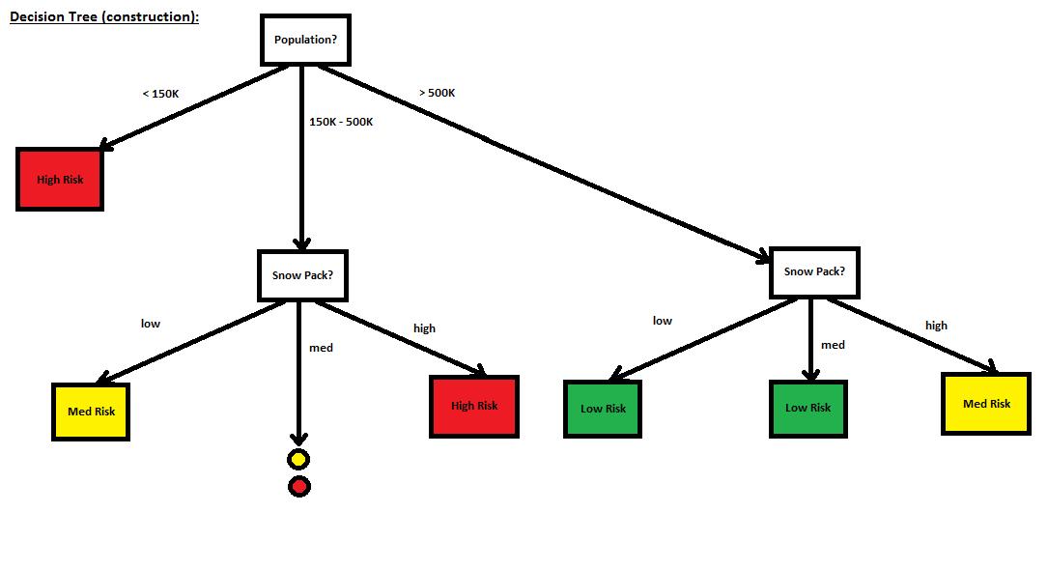

**Node 4:**

For populations in the range of 150K-500K with a medium snow pack, the outcomes are 1 Medium risk of flooding and 1 High risk of flooding.

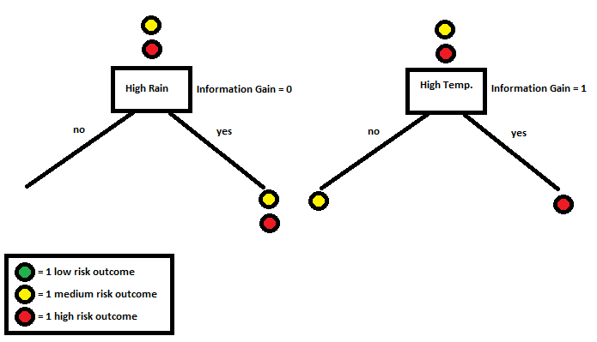

The Information Gains for attributes based on this branch path are:

**High Temp:**

$$entropy no branch:-\frac{0}{1}{-\frac{1}{1}log}_{2}\left(\frac{1}{1}\right)-\frac{0}{1}=0 bits$$

$$entropy yes branch: -\frac{0}{1}-\frac{0}{1}-\frac{1}{1}\log_{2}\left(\frac{1}{1}\right)=0 bits$$

The above branch entropies are used to calculate remainder:

$Remainder\left(Temp\right)=\frac{1}{2}\left({-\frac{1}{1}log}_{2}\left(\frac{1}{1}\right)\right)+\frac{1}{2}\left({-\frac{1}{1}log}_{2}\left(\frac{1}{1}\right)\right)=\frac{1}{2}\left(0\right)+\frac{1}{2}\left(0\right)= 0 bits$

$$IG\left(Temp\right)={-\frac{1}{2}log}_{2}{(\frac{1}{2})}{-\frac{1}{2}log}_{2}{(\frac{1}{2})}-Remainder\left(Temp\right)= 1 bit$$

**High Rain:**

$$entropy no branch: -0-0-0=0 bits$$

$$entropy yes branch: -\frac{0}{2}-\frac{1}{2}\log_{2}\left(\frac{1}{2}\right)-\frac{1}{2}\log_{2}\left(\frac{1}{2}\right)=1 bit$$

The above branch entropies are used to calculate remainder:

$Remainder\left(Rain\right)=\frac{0}{2}\left(0\right)+\frac{2}{2}\left(-\frac{1}{2}\log_{2}\left(\frac{1}{2}\right)-\frac{1}{2}\log_{2}\left(\frac{1}{2}\right)\right)=\frac{0}{2}\left(0\right)+\frac{2}{2}\left(1\right)=1 bit$

$$IG\left(Rain\right)={-\frac{1}{2}log}_{2}{(\frac{1}{2})}{-\frac{1}{2}log}_{2}{(\frac{1}{2})}-Remainder\left(Rain\right)= 0 bits$$

* High Temp: IG(Temp) = I(Temp) – Remainder(Temp) = 1 – 0 = 1 bit
* High Rain: IG(Rain) = I(Rain) – Remainder(Rain) = 1 – 1 = 0 bits

Therefore, the child node for this branch path is High Temp since it has the most information gain.

Since the No branch of High Temp only has one outcome, it will become a leaf node (Medium Risk). Since the High branch of High Temp only has one outcome, it will become a leaf node (High Risk).

Since all branches now lead to leaves, the complete decision tree is:

