# Updating jQuery

When updating jQuery we need to remember to make sure we correctly configure it to be able to map the minified version to the non-minified version for the debugger.

The download page includes the minified, non-minified and map files.  You need to download all three and update the ***contents*** of our existing files with the contents of each (not simply overwrite the files).

You then need to edit the “jquery.min.map” file to point it to our files:  
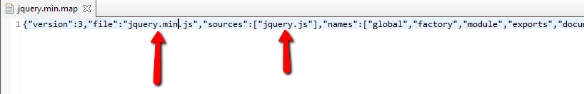

You then need to edit the minified file to tell it to use the map, by adding a special comment at the bottom:

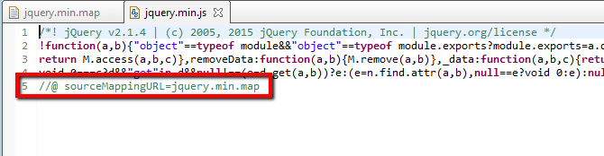

Kevin Turner  
XXX, 00 XXX 0000