Square OV – Quick Start Guide
  - A practical first-time user guide for accessing and using the Official Visits system.

1. What Square OV Is For
Square OV is an Official Visits application designed to help users manage visit-related information in one place. This guide explains the basic steps for getting started, signing in, navigating the system, and completing common tasks.

2. Before You Begin
- Make sure you have a working internet connection.
- Use a modern browser such as Microsoft Edge, Chrome, Safari, or Firefox.
- The system works on a desktop or a mobile device

3. Open the Site
- Open your web browser.
- Go to ov.kpturner.co.uk.
- Sign in – or register a new account if you do not have one.
- Wait for the home page or dashboard to load before selecting any options.
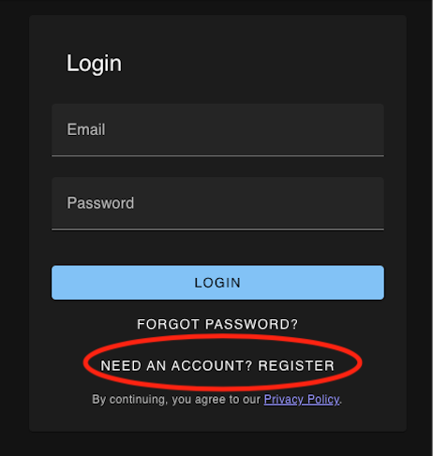

4. Main dashboard
This is where you manage the official visits you have been allocated for your year. You can also add fictitious OVs or even OVs that are allocated to somebody else. Whatever you do here is private to your account (although visible to an administrator if you need help).
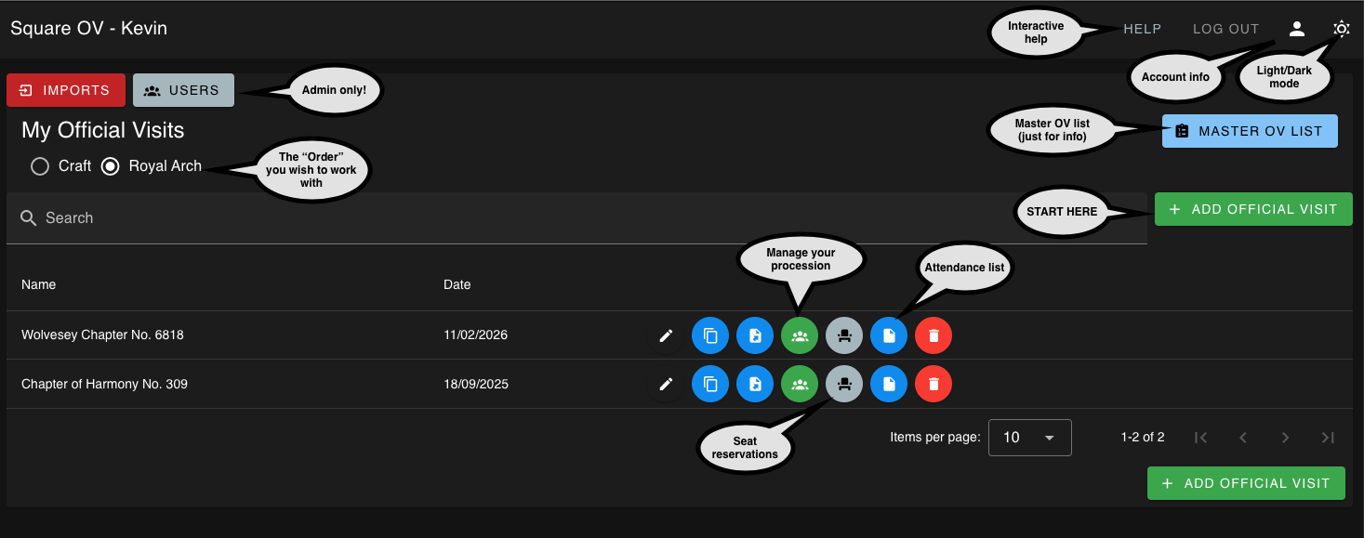

5. Add Official Visit
Select from the master OV list for the Masonic Year you are interested in OR simply make one up from scratch
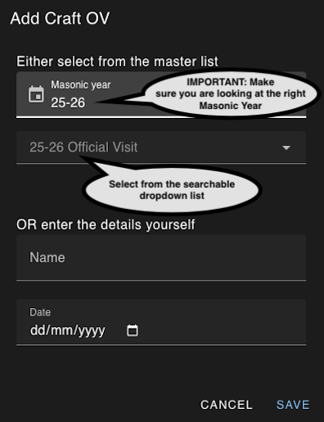

6. Manage your procession
When you add an OV you are automatically taken to the page to manage the officers and see your procession. You can also select this option for any existing OV on your dashboard. NOTE: When you add an OV from the master OV list, the initially allocated officers will be pre-populated in your officer list. You can edit officers and/or add and remove as you see fit WITHOUT impacting the original master list.

Officers
IMPORTANT: To benefit from this system, except for the VIP, DC, Standard Bearer & Sword Bearer, you should try to make sure all officers are positioned with the “automatic” value. This enables the procession to be ordered correctly by rank (and other precedence rules). You can, of course, override anything in special circumstances.
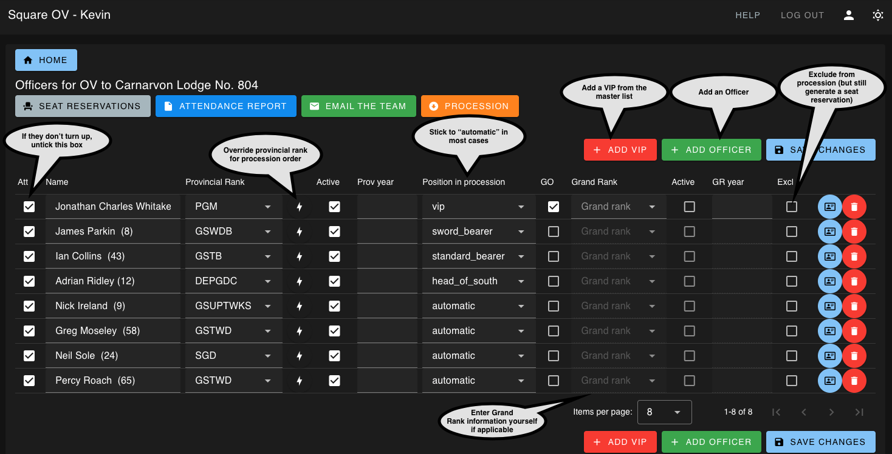

What is the provincial rank override for? An officer may hold a provincial rank of “Provincial Grand Charity Steward” but they may also be a “Provincial Senior Granbd Warden”. The latter rank is what should be used to position the officer correctly in the procession. This option allows you to provide that information whilst retaining the correct information on their seat reservation.
Grand Rank trumps provincial rank in the procession order obviously. The system does not know about an officer’s Grand Rank. Make sure you enter this yourself and save it.

Add an Officer
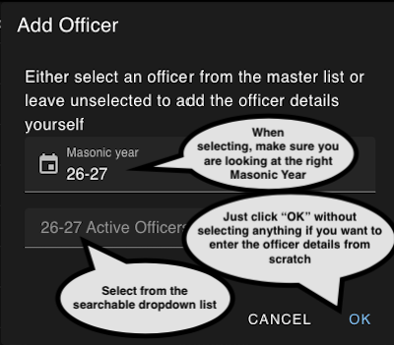

Procession
This automatically adjusts as you add/remove/edit officers in the officers list.
You can print it out if you wish.
The rank order is included on the left for reference purposes.
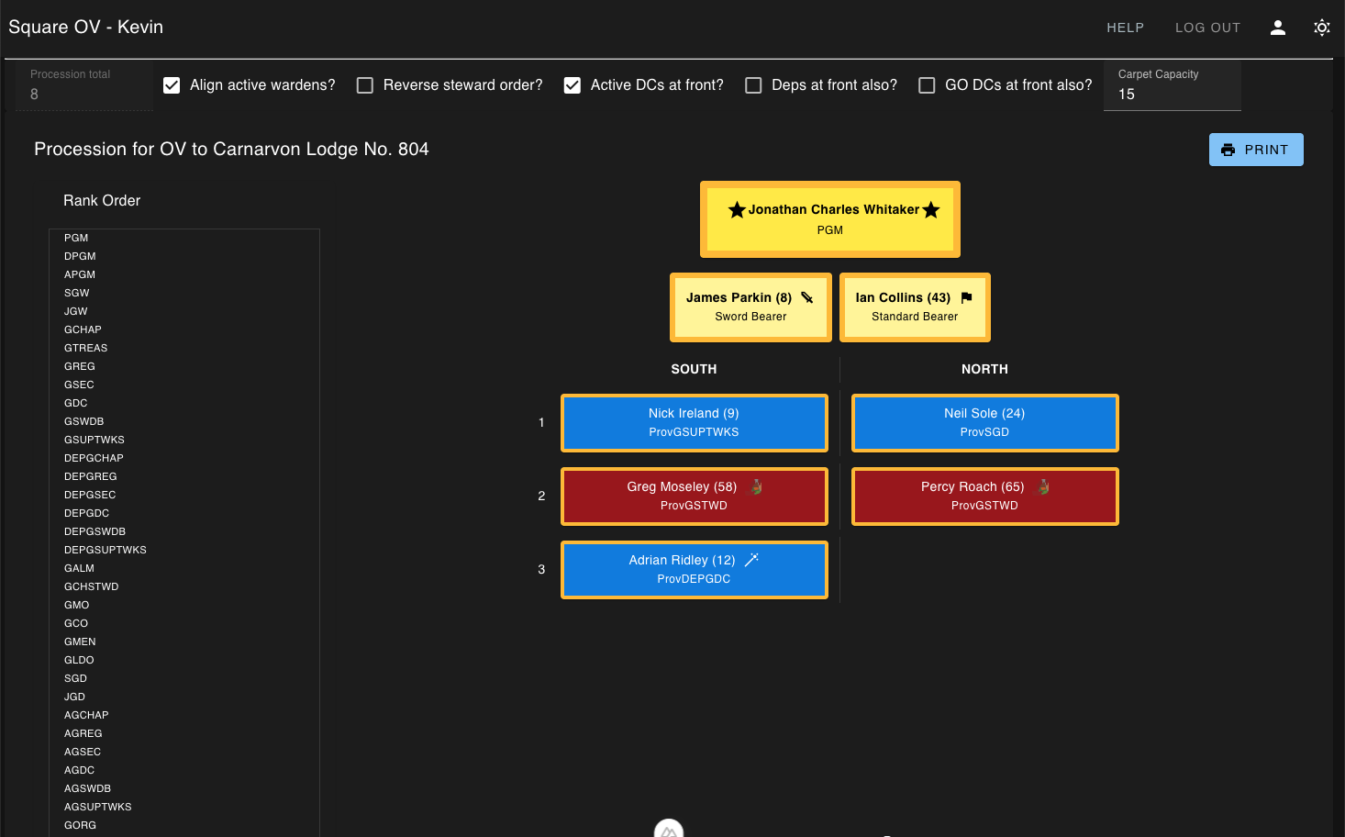

Seat Reservations
For your convenience, the system provides printable, correctly labelled seat reservations for the officers you have included in your procession, together with an optional number of spares.
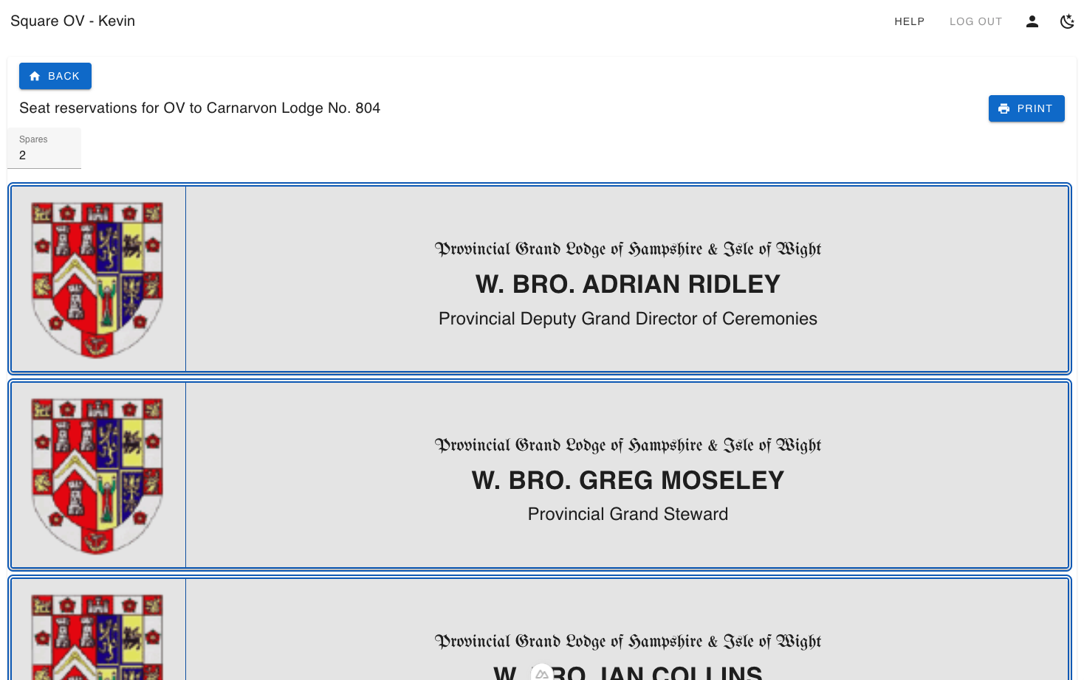

Attendance List
The system provides a printable attendance list for you to use when officers arrive at the venue should it be useful. It is also downloadable in xlsx format.

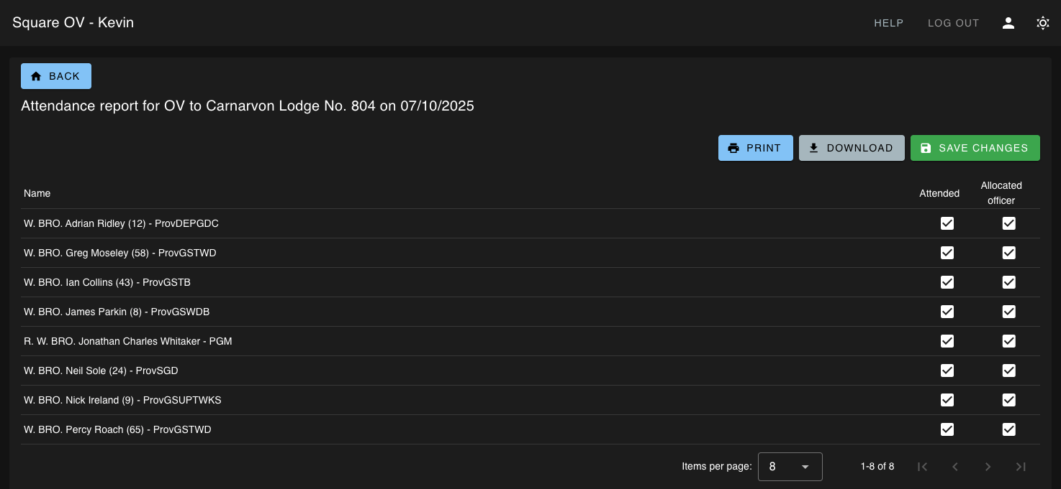

7. Troubleshooting
Issue | Try this
The site will not open | Check the web address, refresh the page, and confirm your internet connection is working.
You cannot sign in | Check your username and password, then contact the administrator if access still fails. If you have simply forgotten your password, use the password reset option.
You cannot see an option | Your account may not have permission for that area. Ask an administrator to check your access.
Changes do not appear to save | Most things in your officers list are saved automatically, but you can always use the “Save Changes” button to be sure. If this does not work contact support.

8. Getting Help
If you are unsure what to do next, use the interactive “Help” button and ask your question. It is an interactive AI chat bot which understands how the system works. If you are still stuck use the “Support” button (on the help page) and send a message to the Administrator.
