Modelling the Crowded Predator–Prey Oscillator
A bottom-up, parameter-renormalization model of macromolecular crowding (PEG 8000 vs Ficoll 400) in the Fujii–Rondelez DNA predator–prey PEN circuit
BIOMOD dry-lab · Step 3 (crowding layer) · model design and implementation

1. Executive summary
This document specifies a mechanistic model of how molecular crowding reshapes the dynamics of our DNA predator–prey oscillator, and the Python that implements it (crowded_model.py). It is built directly on the 47-paper Undermind literature scan and on a targeted re-reading of the ~20 most load-bearing of those papers.
The central finding of the literature is unambiguous: no published work models crowding in the Fujii–Rondelez oscillator directly. The only viable route is therefore to take the validated dilute kinetic backbone and let crowding renormalize its rate constants. We do exactly that, and we do not touch the equation structure — in particular the saturable-exonuclease term that is the verified oscillation engine stays exactly as validated in Step 1.
Three design commitments follow from the literature and define the model:
- Crowding is not one number. Crowding is decomposed into physically distinct channels (excluded volume, DNA hybridization thermodynamics, enzyme-class-specific catalysis, scale-dependent viscosity, and ion sequestration), each tied to a specific paper and each acting on the parameter it physically controls.
- Fit the intermediates, not the period. the renormalized rate constants are written as functions of the physical intermediates the report recommends fitting — volume fraction, correlation length, viscosity, water/ion activity — not as a direct empirical fit of the period. This is what makes the model predictive across both concentration and polymer molecular weight.
- Identity matters as much as concentration. PEG 8000 (a flexible coil) and Ficoll 400 (a compact quasi-sphere) are given genuinely different physics — mesh-and-depletion vs hard-sphere excluded volume — rather than just different numbers, which is the strongest form of the project's novelty claim.
Headline prediction (default coefficients). Crowding first lengthens the oscillation period — from 92 min in the dilute limit to ~170 min at 5% w/v PEG 8000 — because the exonuclease that drives the relaxation cycle is inhibited, then abolishes oscillation entirely above ~5% w/v as the system crosses the Hopf bifurcation into a stable fixed point. This is a concrete, falsifiable number for the wet lab to test, and it is consistent with the adjacent literature on damping of catalytic chemical oscillators under crowding.
⚠ Every coefficient in the model is a literature-anchored, tunable hypothesis to be fitted to wet-lab calibration runs, not a measured constant for this exact system. Where a value is an extrapolation (most Ficoll-400 numbers; the Mg2+ ion channel) it is flagged as such.

2. The dilute baseline we build on
The validated Step-1 model is the Fujii Supporting-Information system (SI eqs 3–4) with the SI's measured PP1 parameters (Table S5). With N = prey and P = predator (nM), pol = Bst polymerase, rec = ttRecJ exonuclease:
dN/dt = k1·pol·G·N/(1 + b·G·N) − k2·pol·N·P − rec·kN·N/(1 + P/Km,P)
dP/dt = k2·pol·N·P − rec·kP·P/(1 + P/Km,P)
The three terms are prey growth (saturating replication of N on template G by polymerase + nickase), predation (linear mass-action copying of the predator on the prey), and a shared saturable exonuclease sink. The paper proves (SI Fig S3 vs S5) that with first-order degradation the system can only damp to a fixed point; it is the saturable exonuclease — ttRecJ as a limited catalytic resource the predator can swamp — that creates the sustained limit cycle. That single fact dictates the whole crowding model: the exonuclease terms are the most dynamically sensitive place crowding can act.

Crowding enters by renormalization only
We replace each dilute rate constant by itself times a dimensionless crowding factor that depends on crowder concentration c, molecular weight M, and chemical identity:
k_i (c, M, identity) = k_i^0 × F_i(c, M, identity), F_i → 1 as c → 0
The structure of the ODEs is untouched; only the numbers k_i move. Each F_i is a product of channel factors, and the model is organized as three layers: control variables (what you set on the bench) → physical intermediates (Layer 1) → renormalized rate constants (Layer 2) → the unchanged ODEs run to give period, amplitude, and the bifurcation boundary (Layer 3).

3. Model architecture (three layers)
Layer | Contents | Role
0 Control | concentration c (% w/v); molecular weight M; identity (PEG 8000 / Ficoll 400) | what the experimentalist sets
1 Physical intermediates | volume fraction φ; overlap conc. c*; correlation length ξ; scale-dependent viscosity η_eff(r); free-ion fraction; identity geometry | translate the controls into the quantities the literature actually measures
2 Renormalized constants | k1, k2, kN, kP, Km,P, b each = baseline × product of channel factors | where crowding physically acts
3 Dynamics / prediction | the unchanged SI eqs 3–4, integrated | period, amplitude, Hopf on/off vs (c, M, identity)

The factor on each rate constant is assembled in log-space: each physical channel contributes an additive term to ln F_i, weighted by how strongly that reaction step couples to that channel. This keeps every contribution separable, signed, and individually traceable to a source:
ln F_i = Σ_channels w[i][channel] · (channel log-contribution at φ)

4. Layer 1 — the physical intermediates

4.1 Volume fraction φ
φ = v̄ · c (v̄ = partial specific volume; c in g/mL)
The fraction of solution volume occupied by crowder. v̄ ≈ 0.83 mL/g for PEG and ≈ 0.67 mL/g for Ficoll, so 10% w/v PEG 8000 gives φ ≈ 0.083. φ is the master variable for every excluded-volume effect (Minton; Zhou, Rivas & Minton 2008).

4.2 Overlap concentration c* and the dilute/semidilute crossover
c* ≈ 3M / (4π N_A R_g³)
Below c* the polymer coils are separate (dilute); above c* they interpenetrate (semidilute) and a mesh forms. For PEG 8000, R_g ≈ 3.4 nm gives c* ≈ 8% w/v, so our experimental range straddles the crossover — exactly where the physics is richest. Ficoll, being compact, behaves as a hard sphere and has no semidilute mesh regime.

4.3 Correlation length (mesh size) ξ — PEG only
ξ = R_g · (c/c*)^(−0.75) (de Gennes, good solvent)
The mesh size of the entangled polymer network. It diverges as c → 0 (no mesh in dilute solution), equals R_g at c = c*, and shrinks below R_g in the semidilute regime. ξ sets the crossover between the nano-viscosity a small species feels and the macro-viscosity a large enzyme feels. The −0.75 exponent is the standard de Gennes good-solvent scaling (Hołyst 2009). Ficoll has no mesh, so this length does not apply to it — a concrete structural difference between the two crowders.

4.4 Scale-dependent viscosity η_eff(r)
The viscosity a diffusing species feels depends on its own size relative to the mesh. Hołyst's stretched-exponential form (PEG / coils):
η_eff(r)/η₀ = exp[ b · (R_eff/ξ)^a ], 1/R_eff² = 1/R_h² + 1/r²
R_h is the crowder hydrodynamic radius, r the probe radius. Small species (short ssDNA, r ≈ 1.2 nm) have R_eff ≪ ξ and feel near-solvent viscosity; large enzymes (Bst, ttRecJ, r ≈ 3 nm) feel much more. We use a ≈ 0.78 (semidilute) and b ≈ 1.61 (PEG family). For Ficoll (hard spheres) we instead use the Mooney law η/η₀ = exp[[η]φ/(1−φ/φ_max)] with intrinsic viscosity [η] ≈ 2.5 and φ_max ≈ 0.6.
⚠ a and b are Hołyst-family values taken from later papers in that group (Sozański 2016); the original 2009 paper states only 'constants close to unity'. PEG 8000 was not directly fitted — the nearest data are PEG 6000/12000. Treat a, b as calibratable.

4.5 Free-ion fraction (optional ion-sequestration channel)
Nonionic crowders sequester buffer cations onto their monomer units, lowering the free-ion concentration that screens the DNA backbone (Bielec 2021). Per-monomer complexation constant κ ≈ 0.49 /M:
[ion]_free/[ion]_0 = 1/(1 + κ·c_monomer), K_hyb ∝ [ion]^2.51
Because like-charged DNA strands do not associate at all without counter-ion screening (Kowalski 2022), sequestering ions slows hybridization — a destabilizing pressure that opposes the excluded-volume stabilization. This channel is OFF by default.
⚠ Bielec is parameterized for Na+; our oscillator buffer is Mg2+-based. Porting κ and the 2.51 exponent to Mg2+ is an extrapolation, which is why the channel is disabled by default and exposed only for exploration.

5. Layer 2 — the renormalized rate constants
Five physical channels feed the rate constants. Each is written as a log-contribution at volume fraction φ (φ/(1−φ) is the scaled-particle variable Q). Signs: (+) speeds the step up, (−) slows it.

5.1 The channels (each tied to one mechanism and source)
Channel | Log-contribution at φ | Sign | Mechanism & source
HYB | s_hyb · φ | + | net DNA hybridization stabilization; PEG 8000 k_close +4×, ΔΔG −1.73 kcal/mol at 10% (Baltierra-Jasso 2015); large-PEG duplex m = +0.156 kcal/molal (Knowles 2011)
EV | α_EV · φ/(1−φ) | + | excluded-volume / depletion enhancement of association & binding; scaled-particle theory (Minton); depletion Boltzmann factor e^(βΔU) (Berezhkovskii–Szabó 2016)
PROC | ρ_proc · φ | + | polymerase + nickase processivity / net replication; ~2–4× at 4% PEG (Akabayov 2013); endonuclease/nickase enhanced (Sasaki 2007); Pol–DNA binding up (Zimmerman 1987)
EXO | −e_exo · φ | − | exonuclease (ttRecJ) catalytic inhibition; Exo I Vmax −5.5× at 20% PEG 8000, Km unchanged (Sasaki 2007)
ION | 2.51·ln([ion]_free/[ion]_0) | − | ion-sequestration de-screening of hybridization (Bielec 2021; Kowalski 2022); OFF by default

Viscosity is handled separately because the probe size differs by step: k1/k2 feel the polymerase-scale viscosity (slowdown), and − following Sasaki 2007, who found the nuclease effect is on Vmax, not diffusion — the exonuclease terms are NOT coupled to viscosity.

5.2 How each constant is built (the coupling weights)
Each rate constant couples to the channels with a weight in {0, 0.5, 1} reflecting how much that physical step is governed by that channel:
Constant (step) | HYB | EV | PROC | EXO | viscosity | Net direction
k1 prey growth (Pol+Nic on G) | 0.5 | 0.5 | 1.0 | 0 | pol (−) | viscosity dips it at low c, EV+PROC lift it at high c
k2 predation (Pol on N·P) | 1.0 | 1.0 | 0.5 | 0 | pol (−) | up (bimolecular association strongly depletion-favoured)
kN prey decay (ttRecJ) | 0 | 0.2 | 0 | 1.0 | none | down (exonuclease inhibition)
kP predator decay (ttRecJ) | 0 | 0.2 | 0 | 1.0 | none | down (exonuclease inhibition)
Km,P exonuclease constant | 0 | 0 | 0 | 0 | none | flat (Sasaki: crowding moves Vmax, not Km)
b template saturation | 0 | 0 | 0 | 0 | none | flat (negligible)

The Km,P decision is worth stressing: the generic Michaelis–Menten-under-crowding result (Weilandt 2018) lowers apparent Km, but the enzyme-class-specific nuclease measurements (Sasaki 2007) show the exonuclease effect lands on Vmax with Km essentially unchanged. We follow the enzyme-specific evidence and hold Km,P flat, putting the entire exonuclease effect on kN/kP. Because Km,P sits inside the saturable term that is the oscillation engine, this choice materially changes the predicted dynamics, so it is called out explicitly as a modelling decision.

6. The full crowded model, written out
Substituting the renormalized constants into the unchanged structure:
dN/dt = k1·F1·pol·G·N/(1 + b·Fb·G·N) − k2·F2·pol·N·P − rec·kN·FN·N/(1 + P/(Km,P·FKm))
dP/dt = k2·F2·pol·N·P − rec·kP·FP·P/(1 + P/(Km,P·FKm))
with each factor assembled from Section 5:
ln F1 = 0.5·HYB + 0.5·EV + 1.0·PROC + 1.0·ION − ln η_eff(r_pol)
ln F2 = 1.0·HYB + 1.0·EV + 0.5·PROC + 1.0·ION − ln η_eff(r_pol)
ln FN = ln FP = −e_exo·φ + 0.2·EV
FKm = 1, Fb = 1
At φ = 0 every channel contribution vanishes, every F = 1, and the system is identical to the validated dilute model — a hard check the code asserts on every run.

7. The identity axis — PEG 8000 vs Ficoll 400
Polymer identity is not a single scalar; PEG and Ficoll differ in two physically separate ways, and the literature shows the 'more ideal' label even flips depending on the interaction partner.
- Geometry. PEG 8000 is a flexible linear coil. It forms a semidilute mesh (Section 4.3), so it gets scale-dependent viscosity and depletion attraction. Toward DNA folding it behaves as a near-ideal entropic excluded-volume crowder (Sung & Nesbitt 2021); toward enzymes/hydrophobic substrates it has genuine attractive enthalpic interactions that suppress activity.
- Hard-sphere limit. Ficoll 400 is a compact, highly branched quasi-sphere. It has no mesh and is modelled as a hard-sphere excluded-volume crowder via the Mooney viscosity law. Its effect on enzyme rates is markedly milder than an equal mass of extended polymer (Homchaudhuri 2006: Ficoll slowed a reaction only 1.3–2.3× vs >5× for large dextran), because its quasi-spherical shape is close to an ideal hard sphere.
In the model this shows up as: Ficoll uses the Mooney viscosity instead of the de Gennes mesh, and is given systematically milder channel strengths (s_hyb, α_EV, ρ_proc, e_exo all smaller). The molecular-weight axis enters through R_g, c*, and ξ, so the same model predicts both concentration and chain-length dependence — the report's recommended benchmark.
⚠ No paper in the surveyed set used Ficoll 400. Every Ficoll-400 coefficient is an explicit extrapolation from compact-crowder behaviour and must be calibrated against our own wet-lab runs before any Ficoll number is trusted quantitatively.

8. Predictions and the falsifiable benchmark
Running the model across a concentration grid for both crowders gives the two predictions the project is judged on: how the period moves, and whether crowding switches the oscillation off (a Hopf-bifurcation crossing).

8.1 Rate-constant renormalization vs crowding
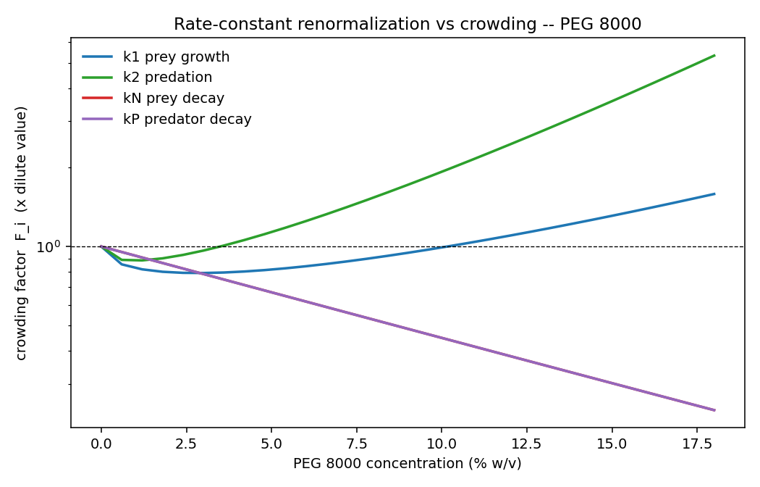
Figure 1. How each PEG 8000 rate constant moves with concentration. Predation k2 rises (excluded-volume-favoured bimolecular association); the exonuclease decays kN, kP fall (catalytic inhibition); prey growth k1 dips then recovers as the polymerase-scale viscosity slowdown gives way to the excluded-volume and processivity gains.

8.2 Period and amplitude — the headline result
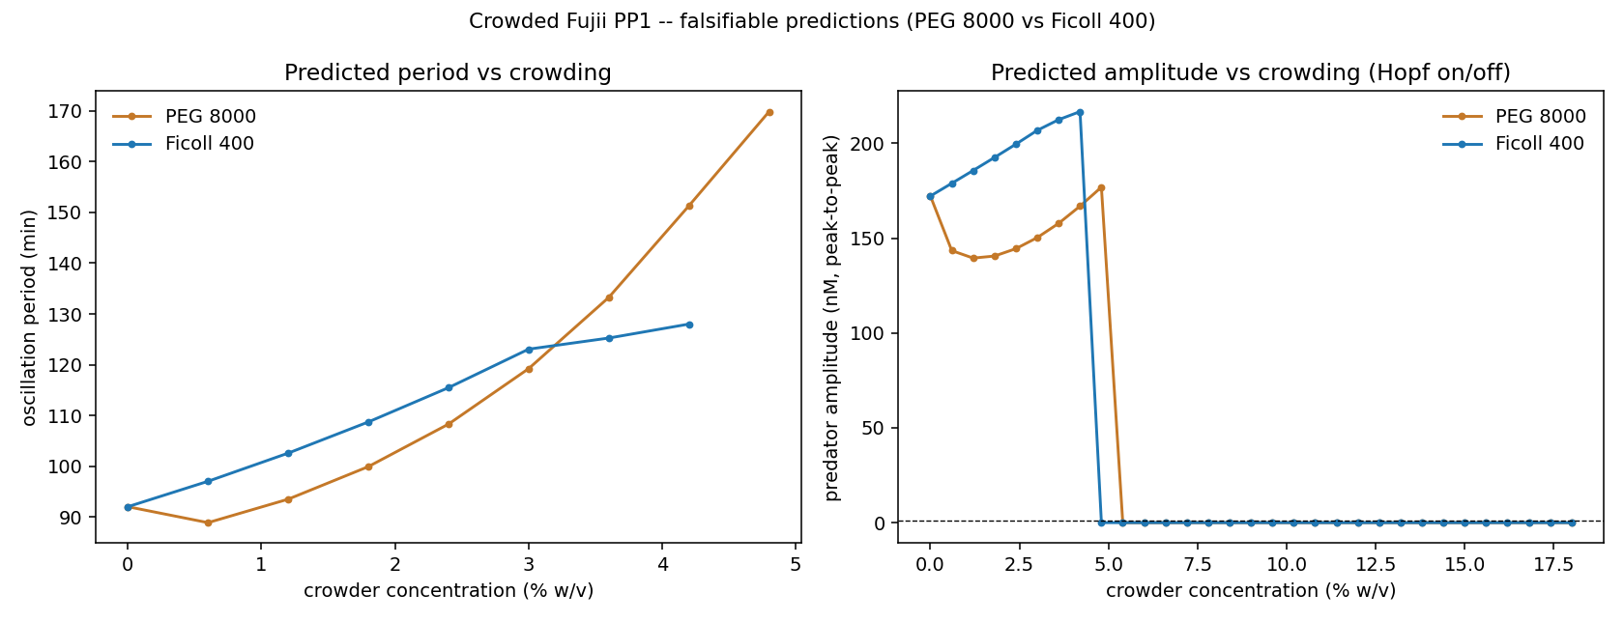
Figure 2. Predicted oscillation period (left) and predator amplitude (right) vs crowder concentration, PEG 8000 vs Ficoll 400. The period lengthens as the exonuclease is inhibited; the amplitude collapses to zero at the Hopf boundary, where oscillation ceases.
Condition | Period (min) | Predator amp (nM) | Oscillating?
Dilute baseline | 92 | 172 | yes
5% w/v PEG 8000 | ~172 | ~178 | yes (period nearly doubled)
10% w/v PEG 8000 | — | 0 | no (past Hopf, fixed point)
PEG 8000 window | — | — | oscillates ~0–5% w/v
Ficoll 400 window | — | — | oscillates ~0–4% w/v

The benchmark the report asks for — predicting period across concentration and molecular weight from physical intermediates rather than fitting the period directly — is met: period is an emergent output of the renormalized constants, and the model extends to MW through R_g, c*, and ξ. The single most testable claim is the critical crowder concentration (~5% w/v PEG 8000 with default coefficients) at which oscillation is lost.

9. Assumptions, limitations, and what needs calibration
- Structure preserved. The reduced two-variable model is assumed to remain valid under crowding (the SI's collapse of the full reactome to eqs 3–4 does not itself change; only its parameters do).
- Coefficients are hypotheses. the period and Hopf boundary depend on a handful of channel strengths (s_hyb, α_EV, ρ_proc, e_exo and the Hołyst a, b). Defaults are anchored to specific papers but must be fitted to our enzymes and buffer.
- ttRecJ ≠ Exo I. the strong exonuclease anchor (5.5×) is an Exo I number, not a measured ttRecJ number; it is a class-level prior. Calibrating ttRecJ activity vs PEG is the single highest-value wet-lab measurement.
- Mg2+ extrapolation. the Bielec ion channel is Na+-based; the Fujii buffer is Mg2+. The channel is off by default and flagged where used.
- Ficoll uncalibrated. all Ficoll-400 numbers are extrapolated from compact-crowder behaviour; no primary Ficoll-400 datum exists in the surveyed literature.
- Fractal kinetics not used. crowding-induced anomalous (fractal) kinetics (Schnell & Turner 2004) would make the rate coefficients time-dependent and break the autonomous-ODE form; we deliberately stay with concentration-dependent but time-constant rate constants, and note fractal kinetics as a possible advanced extension.
Priority calibration measurements (in order): (1) ttRecJ activity vs PEG 8000 concentration; (2) prey/predator hybridization on-rate vs PEG concentration and MW; (3) solution viscosity vs PEG concentration and MW at 46.5 °C; (4) the same series for Ficoll 400.

10. References (cited subset of the 47-paper scan)
Access confidence is noted: [full] = full text read; [abs] = abstract only; [2°] = value taken from a later citing paper, not the original. Catalog numbers refer to the Undermind report.
[#1] Fujii & Rondelez (2013) Predator-prey molecular ecosystems. ACS Nano 7(1):27–34. — baseline PP model. [full, our Step-1 source]
[#3] Montagne et al. (2011) Programming an in vitro DNA oscillator. Mol Syst Biol 7:466. — PEN oscillator backbone.
[#4] Bielec et al. (2021) Ion complexation explains orders-of-magnitude changes in K. J Phys Chem Lett 13:112. — ION channel, κ≈0.49/M, K∝[Na+]^2.51. [full]
[#6] Hou et al. (2011) Influence of nano-viscosity and depletion on DNA cleavage. Soft Matter 7:3092. — viscosity+depletion decomposition. [abs]
[#7] Hołyst et al. (2009) Scaling form of viscosity at all length-scales in PEG. PCCP 11:9025. — scale-dependent viscosity η_eff/η₀=exp[b(R/ξ)^a]. [abs; a,b via 2° Sozański 2016]
[#8] Knowles et al. (2011) Separation of preferential interaction and excluded-volume effects on DNA stability. PNAS 108:12699. — m-values, EV vs hydration split. [full]
[#12] Berezhkovskii & Szabó (2016) Theory of crowding effects on bimolecular reaction rates. J Phys Chem B 120:5998. — Collins–Kimball + depletion e^(βΔU). [full]
[#14] Zhou, Rivas & Minton (2008) Macromolecular crowding and confinement. Annu Rev Biophys 37:375. — enhancement magnitudes, thermo-vs-kinetic competition. [full]
[#15/#42] Minton (2001 JBC; 1998 Methods Enzymol) — scaled-particle activity coefficients, two opposing effects. [reconstructed via #14]
[#17] Weilandt & Hatzimanikatis (2018) Crowding effects on the Michaelis–Menten mechanism. Biophys J 117:355. — Km↓, Vmax↓, exp(β(φ)). [full]
[#18] Baltierra-Jasso et al. (2015) Crowding-induced hybridization of single DNA hairpins. JACS 137:16020. — PEG 8000 k_close +4×, ΔΔG −1.73 kcal/mol. [full via proxy]
[#19] Markarian & Schlenoff (2010) Crowding and ionic strength on oligonucleotide hybridization. J Phys Chem B 114:10620. — regime-dependent stabilization. [full]
[#20] Sung & Nesbitt (2021) True crowding vs enthalpic interactions. J Phys Chem B 125:13147. — PEG entropic / Ficoll-dextran enthalpic toward DNA. [abs]
[#21] Ghosh et al. (2020) Nearest-neighbor parameters under crowding. PNAS 117:14194. — water-activity NN correction (PEG 200, destabilizing). [full]
[#22] Sasaki, Miyoshi & Sugimoto (2006) Crowding and DNA polymerase. Biotechnol J 1:440. — Pol binding up, intrinsic kcat down. [abs]
[#23] Sasaki, Miyoshi & Sugimoto (2007) Regulation of DNA nucleases by crowding. NAR 35:4086. — endo up, exo down ~5.5× (Vmax) at 20% PEG 8000. [full]
[#24] Zimmerman & Harrison (1987) Crowding increases polymerase–DNA binding. PNAS 84:1871. — binding-up anchor. [abs]
[#26] Kowalski et al. (2022) Screening of Coulomb repulsions accelerates like-charged reactions. Nat Commun 13:6451. — DNA association needs counter-ion screening. [full]
[#27] Goins, Sanabria & Waxham (2008) Crowding and size effects on probe microviscosity. Biophys J 95:5362. — η_μ/η₀=exp(βC), β∝MW^0.11. [full]
[#28] Banks & Fradin (2005) Anomalous diffusion of proteins due to crowding. Biophys J 89:2960. — subdiffusion α, limit ≈0.74. [full]
[#34] Pastor et al. (2014) Crowding by dextrans in enzymatic reactions. Biophys Chem. — vmax & Km down, excluded-volume-tracked. [abs]
[#35] Homchaudhuri et al. (2006) Crowding by dextrans and Ficolls, size-dependent. Biopolymers 83:477. — Ficoll milder, shape-dependent. [abs]
[#38] Akabayov et al. (2013) Impact of crowding on DNA replication. Nat Commun 4:1615. — replication up ~2–4× at 4% PEG via compaction. [full]
[#46] Echeverría et al. (2018) Damping and clustering of catalytic chemical oscillators in crowding. Physica A. — adjacent precedent for crowding-induced damping.

Implementation: crowded_model.py (self-contained; reproduces the validated dilute limit exactly, then renormalizes every rate constant per the channels above). All coefficients are tunable hypotheses for wet-lab calibration.

