Assignment Module 8
Portfolio Project: Examining Graduate Data in R
Kimberly Puhala, Ph.D.
Colorado State University – Global Campus
Portfolio Project: Examining Graduate Data in R
Each year, my office collects information from graduating seniors in a graduate survey, but little has been done in terms of analyzing the data, reporting out the data, or communicating the results. As higher education faces the challenging future of decreased enrollments due to decreases in birth rates (Conley, 2019), it will be important to understand what factors lead to success, as well as student perceptions of their undergraduate experience. The graduate survey is administered in mid-April to all graduating seniors and it collects information on plans after graduation, activities students participated in as an undergraduate, and an overall recommendation rating for the college. The dataset consists of survey data from approximately 1,200 graduates over four years, from 2016 to 2019. Summary statistics will be presented, and statistical analysis will be conducted to determine whether there are differences between genders or races on several factors. In addition, recommender scores are useful as a means to evaluate the college (Rothwell, 2019). The analysis will also examine whether there are differences in recommender ratings based on gender, race, or number of internships.
Graduate Survey Instrument
The graduation survey is a 40-item survey that was developed in-house and measures several factors of the student undergraduate experience. The survey collects demographic information, data on club and sports participation, data on leadership roles held by the student, and data on the number of internships in which the student participated. The graduate is asked to rate how likely they would be to recommend the college to a friend, and an open-ended question allows the graduate to explain why they gave the particular rating that they did. This analysis will be useful in beginning to identify areas that aid in helping students reach graduation, allowing the college to change practices in order to keep more students until they graduate, thus mitigating some of the financial concerns of having fewer traditional aged undergraduates enroll in the college.
Hypotheses of interest
The research literature in higher education indicates that having a college internship can be advantageous to graduates. Holding an internship during college can lead to greater success in post-graduation career outcomes; in addition, graduates who had internships are more likely to be employed upon graduation (Knouse, Tanner, & Harris, 1999). The article also indicated that white students were more likely to have internships than nonwhite students, but there were no differences in genders (Knouse, Tanner, & Harris, 1999). Given the social justice implications of potential positive outcomes of having access to an internship, I will examine whether there are differences in internships completions between genders and races. The following hypotheses will be tested:
Hypothesis 1:
H1₀: There are no differences between genders on the average number of internships completed;
H1_{A}: There are differences between genders on the average number of internships completed
Hypothesis 2:
H2₀: There are no differences between white students and students of color in the average number of internships completed;
H2_{A}: There are differences between white students and students of color on the average number of internships completed
In addition, it is important to understand whether the different genders and races of students impact their qualitative experience of the campus. One way to capture this sentiment is via the recommendation ratings that the student provides on the survey. Average recommendation ratings will be analyzed to examine whether there are differences between genders and races. The analysis will be extended to see whether or not those that had internships gave higher average recommender scores than those who didn’t, and also whether this differs as a function of gender or race. Additional hypotheses to be tested include:
Hypothesis 3:
H3₀: There are no differences among the following groups in average recommender rater scores: Men & Women, White students & students of color, students with different numbers of internships
H3_{A}: There are differences among the following groups in average recommender rater scores: Men & Women, White students &Students of Color, students with different numbers of internships
Several data analyses will be performed utilizing the R open-source analytic program. Independent sample t-tests will be conducted to test Hypotheses 1 through 4. Open-ended answers provided by students on why they gave their particular rating will also be examined and will inform the analyses. Visualizations will be provided through R software.
Data Preparation
Graduate survey data is collected from each graduate through a Qualtrics® survey that is sent to students through their college email account. Data is collected annually, and the dataset contains data from the most recent four years’ of graduating classes (years 2016 to 2019). There were a total of 1,412 graduates in this time period, and this dataset contains 1,220 observations, for an overall response rate of 86.4%. Datasets first had to be downloaded from Qualtrics and saved as SPSS files. SPSS was used to combine the four datasets into one using the Data/Merge/Add Cases command. Data cleaning included de-identifying the dataset of any personally identifying information, deleting ‘preview’ records from Qualtrics which represent people testing the survey, as well as removing any variables that I was not interested in using for this analysis. I also changed the variable names from the question number to text that describes the variable. As I was changing the variable names, I noticed that one of the years of the graduate survey had inserted an additional question, so that the numbering of the same question was off in the two files. I corrected this data manually by cutting and pasting the data into the correct locations in the database, which was not a problem with this small dataset. Also, I tried to replace the values of the “N/A” cells with blanks but was unable to figure out how to do this as R Studio kept crashing when I used the following command: gsub(pattern=”N/A”, replacement=”0”, x=graddata) (Davies, 2016). I ended up simply replacing the cells in Excel and re-importing the file into R Studio, after which I read a section about missing data in R and realized the program was already excluding missing values by its settings (Davies, 2016). I also provided data labels in R for the different variables of interest. In the future, I want to learn more about how to use Python or R to do this type of data cleaning. However, these errors also point to the need to ensure that all variable labels and questions are aligned, even if you think the survey setup was identical from year to year; I’m not sure I would have discovered this error if I was just working within R.
Results
Summary statistics were produced to examine the variables. During this examination, I realized that the variable for the number of internships was ordinal rather than numerical, with values 1=None; 2=1, 3=2, and 4=3 or more. However, I still wanted to use this variable as numeric, since the data was ordinal and therefore held meaning. From the summary statistics, I produced several charts within the R program to get a better sense of the data distribution. The first I produced was a bar chart of the distribution of the race. Race was categorized into four labels, including Student of Color, White Student, International Student, and Unknown. I had to increase the axes, add labels, add data mark labels, and introduce some color, which I did with the R commands ylim, main, text, and col.
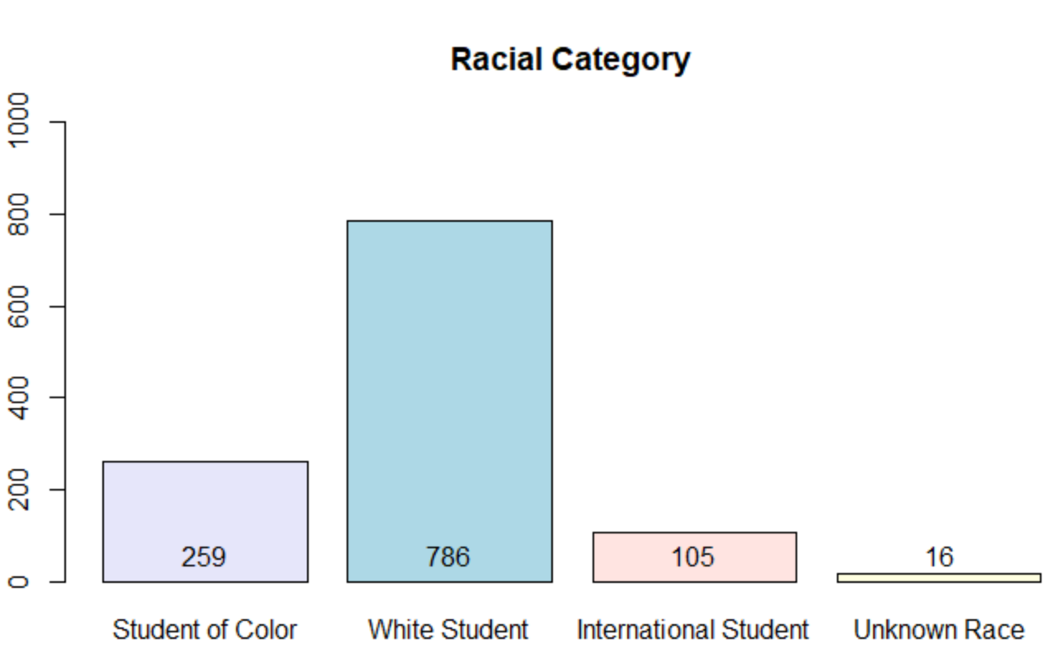
Figure 1. Distribution of graduates’ race.
The second graph I produced was a bar chart of the number of internships. This graph took several attempts as I had typed in one of the variable names without the underscore. This exercise made me realize how debugging can consist of simply checking for typos, especially in that R has two versions of quotation marks, which are extremely hard to see with the naked eye.
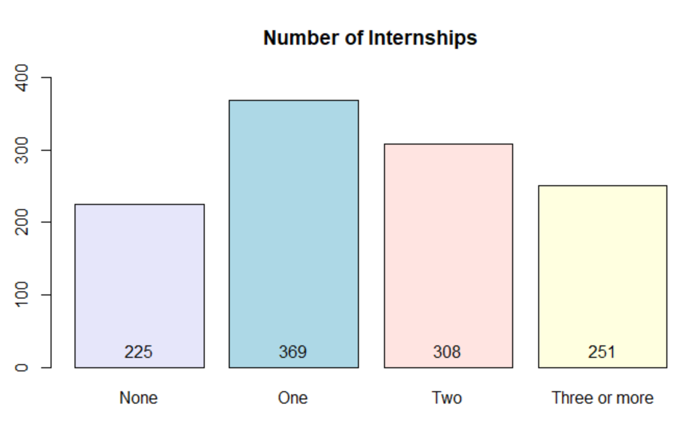
Figure 2. Distribution of number of internships in which graduates participated.
The last graph I produced were boxplots of the average recommendation rating for each subgroup in which I was interested.
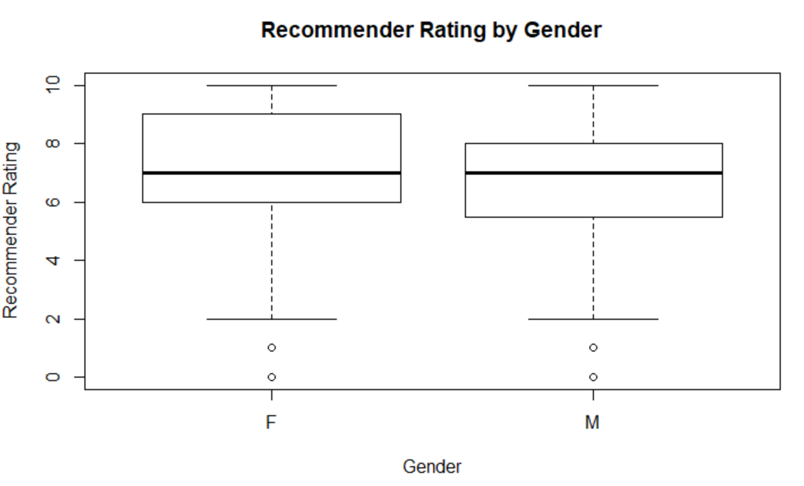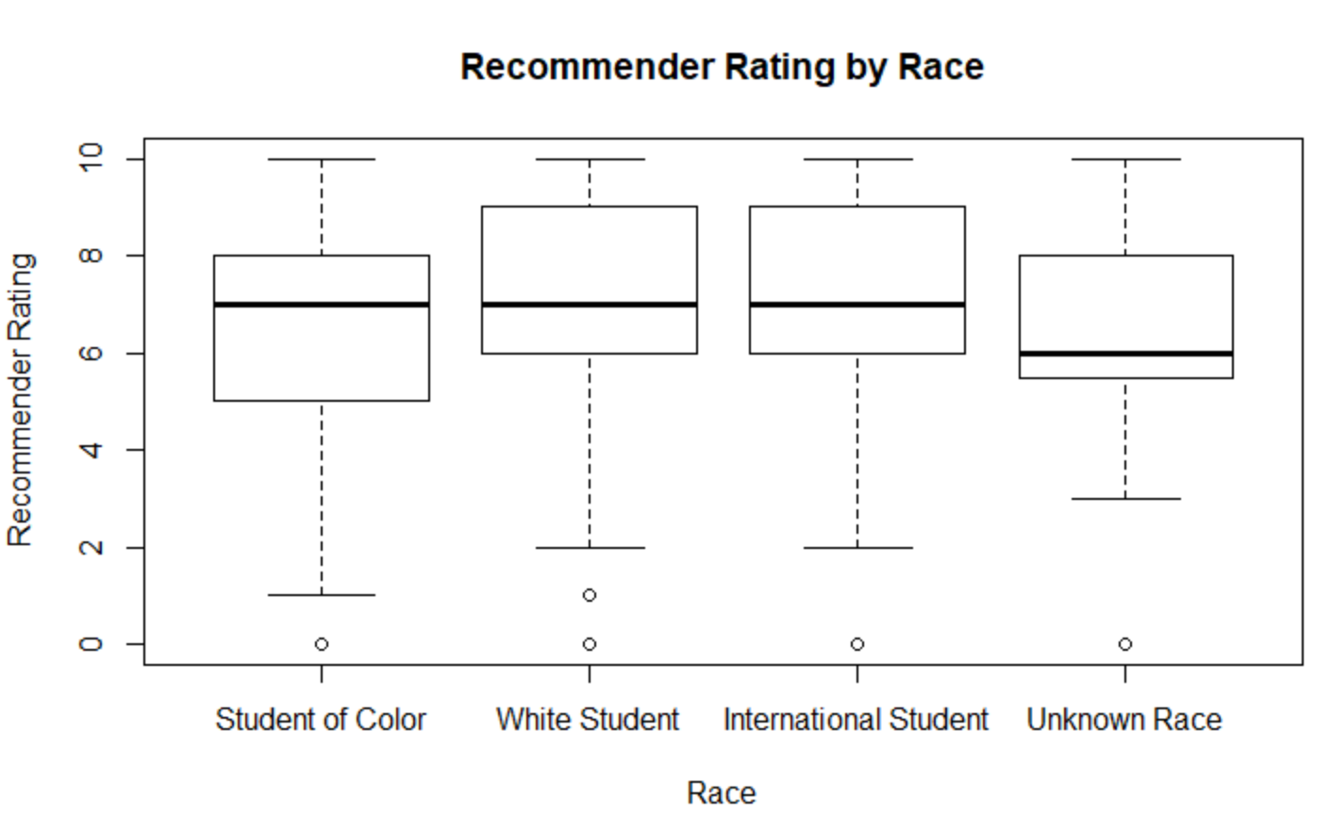
Figure 3. Recommender rating by gender. Figure 4. Recommender rating by race.
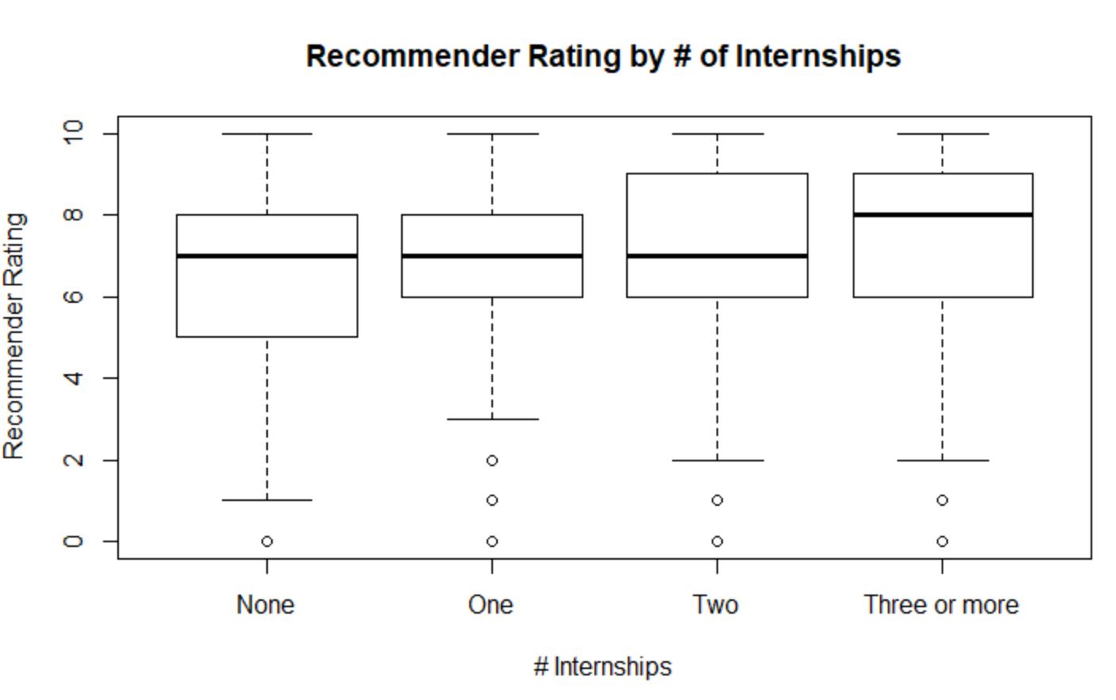
Figure 6. Recommender rating by number of internships completed.

Number of Internships
The first question of interest is whether there are gender or racial differences in the number of internships completed. I had to convert the variable NU_INTERNSHIPS from a categorical variable that was used to produce Figure 6 back into a numeric variable using as.numeric. Then I conducted an independent samples t-test to determine whether there are differences in the number of internships completed by men and women. The t-test indicated that there were no differences between men and women in the number of internships completed (2.43 vs. 2.54, p=.09). Next, I wanted to test whether there were differences between white students and students of color on the number of internships completed. I wanted to restrict my analysis to white students and students of color to see if my results were similar to those found by Knouse, Tanner, & Harris (1999). I tried multiple times to subset the dataset so that I could examine only two categories of the RACECAT variable that had 4 levels. I wanted to analyze the difference between Students of Color and White Students but kept getting error messages in R as follows:
t.test(formula=graddata$NU_INTERNSHIPS,graddata$RACECAT[graddata$RACECAT=="Student of Color"|graddata$RACECAT=="White Student"])
Error in var(x) : Calling var(x) on a factor x is defunct.
Use something like 'all(duplicated(x)[-1L])' to test for a constant vector.
In addition: Warning message:
In mean.default(x) : argument is not numeric or logical: returning NA

I ended up running the test in SPSS and found that there were no significant differences between wthie students and students of color on the number of internships completed (2.48 vs 2.49, p=.075). [NOTE: Later, after extensive research, I figured out the problem was with the missing values and found an alternative solution to running ANOVAs in R—see analysis below]. Therefore, my data did not find the same difference between white students and students of color as was found in Knouse, Tanner, & Harris (1999).

Recommender Ratings
Recommender ratings were examined to determine if there were differences in ratings between men and women or between different racial groups. An independent samples t-test indicated that there were no differences between men and women in average recommender ratings (6.8 vs. 7.1, p=n.s.). Next, an analysis of variance (ANOVA) test was conducted to examine whether there were statistical differences between races on recommender rating scores. Race consisted of four levels, including Student of Color, White Student, International Student, and Unknown Race. The ANOVA indicated that there were differences in the recommender rating score among different racial groups. Tukey’s post hoc testing indicated that White students rated themselves as more likely to recommend the college to a friend than Students of Color (7.13 vs. 6.56, p<.01). Last, an ANOVA was conducted to test whether there were differences in recommender rating scores based on the number of internships completed by a student. I had to convert the NU_INTERNSHIPS variable back into a factor to use it as a categorical variable. After doing so, the ANOVA indicated that there were no significant differences in recommender rating scores based on the number of internships, as expressed categorically with levels None, One, Two, and Three or More. It took me a while to figure out that the test was not statistically significant because I couldn’t find the p-value in the test results. I ran the test in SPSS and received a p-value of .061. When I went back into R and compared the code and results to the ANOVA I ran that showed statistical significance, I wondered if R doesn’t provide p-values for tests that are not statistically significant, or whether I did something wrong in the analysis.
Discussion
Interesting insights can be gathered by examining data from students who graduated from college that can assist with directing scare resources. While prior research revealed that there were differences between races in the number of completed internships (Knouse, Tanner, & Harris, 1999), research from this college indicated that there weren’t differences among races. One explanation for this could be that this college guarantees that students will have funding to complete an internship. This data could be used to provide feedback to upper management that students from all racial groups participate in internships at this college, which is not true elsewhere. Second, I would alert upper management to the fact that White students provided higher recommender rating scores than Students of Color. I would want to explore this difference further in an attempt to find reasons that there were differences in order to remedy them. The data that indicated that there aren’t differences between recommender rating scores based on the number of internships completed by a student is also interesting, but I would be more cautious in communicating this information. The p-value of .06 indicates that the relationship is approaching significance; in addition, this finding is less intuitive as the assumption by the college is that more internships are better and they would expect to see higher average ratings based on a higher number of internships. I may recommend that another study be developed to look specifically at this topic and would collect better information to answer that question.
Conclusion
This analysis is the initial exploratory analysis of the graddata dataset. This analysis was useful in determining that there were no differences between men and women or between White students and Students of Color in the number of internships completed. It is good news that these subgroups are accessing the resource of having and internship at equal rates. However, White students provided higher recommender rating scores than Students of Color. There are many factors that play a role in both student outcomes and recommender ratings, so additional questions remain. In the future, it will be useful to extend this analysis to identify other factors that are playing a role. In addition to developing more studies to specifically target the questions that arose from this analysis, it would be useful to create a regression model with this dataset. A regression model would allow for a greater understanding of the various factors that impact outcomes, the amount that each contributes to the variation in the outcome, and could be extended to use for predicting outcomes. Once the important factors are identified, the college could then target resources toward those factors that contribute the most to successful outcomes.

References
Conley, B. (2019). The great enrollment crash: Students aren't showing up. And it's only going to get worse. The Chronicle of Higher Education, 11 Oct. 2019, p. B6+. Retrieved from Gale OneFile: Business, https://link.gale.com/apps/doc/A603979511/ITBC?u=mlin_s_wheaton&sid=ITBC&xid=6637d633
Davies, T.M. (2016). The Book of R: A First Course in Programming and Statistics. San Francisco, CA: No Starch Press, Inc.
Knouse, S.B., Tanner, J.R., & Harris, E.W. (1999). The relation of college internships, college performance, and subsequent job opportunity. Journal of Employment Counseling, 36, 35-43. Retrieved from https://onlinelibrary.wiley.com/doi/pdf/10.1002/j.2161-1920.1999.tb01007.x
R Core Team (2017). R: A language and environment for statistical computing. R Foundation for Statistical Computing, Vienna, Austria. URL https://www-R-project.org/
Rothwell, J. (2019). Assessing the validity of consumer ratings for higher education: Evidence from a new survey. The Journal of Consumer Affairs, 53(1), 167-200. Retrieved from https://onlinelibrary.wiley.com/doi/full/10.1111/joca.12201

APPENDIX A: CLEAN CODE FOR GRADUATE SURVEY DATA
# After getting an error message, I realized I needed the library in order to import Excel file
library(readxl)

# Load data into R from Excel spreadsheet of graduate survey data; named the dataframe graddata
> graddata <- read_excel("S:/institutional_research/KP_Director/CSU_Global/MIS500/Modules/Module8/Master_Graduate_Survey_2016_to_2019.xlsx")

# Recode variable holding racial categories
graddata$RACECAT <- factor(graddata$RACECAT,
levels = c(0,1,2,3),
labels = c("Student of Color", "White Student", "International Student", "Unknown Race”))
# Assigning table to race.freq and creating bar graph
race.freq<-table(graddata$RACECAT)
> barplot(race.freq)
> table(race.freq)

barplot(race.freq,ylim=c(0,1000),main = "Racial Category")

# Final bar chart with colors, mark labels and title

bprace<-barplot(race.freq,col=c("lavender","lightblue","mistyrose","lightyellow"),ylim=c(0,1000),main = "Racial Category",text(bprace,0,round(race.freq,0),cex=1,pos=3))

# assigning labels to NU_INTERNSHIPS
graddata$NU_INTERNSHIPS <- ordered(graddata$NU_INTERNSHIPS,
levels = c(1,2,3,4),
labels = c("None", "One", "Two", "Three or more"))
bpnuinternships<-barplot(nuinternships.freq,col=c("lavender","lightblue","mistyrose","lightyellow"),ylim=c(0,400),main = "Number of Internships",text(bpnuinternships,0,round(nuinternships.freq,0),cex=1,pos=3))

# final boxplot for recommender by gender
boxplot(RECOMMEND~GENDER,data=graddata,main="Recommender Rating by Gender",xlab="Recommender Rating", ylab="Gender")

# final boxplot for recommender by race
boxplot(RECOMMEND~RACECAT,data=graddata,main="Recommender Rating by Race",xlab="Race", ylab="Recommender Rating")

# final boxplot for recommender by internship
boxplot(RECOMMEND~NU_INTERNSHIPS,data=graddata,main="Recommender Rating by # of Internships",xlab="# Internships",ylab="Recommender Rating")

* ttest to determine whether men and women had different # internships
t.test(graddata$NU_INTERNSHIPS~graddata$GENDER)

*t-test to determine whether races differ on # internships -- to couldn’t figure out how to do this
t.test(formula=graddata$NU_INTERNSHIPS,graddata$RACECAT[graddata$RACECAT=="Student of Color"|graddata$RACECAT=="White Student"])
Error in var(x) : Calling var(x) on a factor x is defunct.
Use something like 'all(duplicated(x)[-1L])' to test for a constant vector.
In addition: Warning message:
In mean.default(x) : argument is not numeric or logical: returning NA

*to get tukeys posthoc
TukeyHSD(rater.anova)

*to get means by subgroup
aggregate(RECOMMEND~RACECAT,graddata,mean)
RACECAT RECOMMEND
1 Student of Color 6.562249
2 White Student 7.138852
3 International Student 7.257426
4 Unknown 6.466667

*to get anova of avg recommender score by racial category and see results
rater.anova<-aov(graddata$RECOMMEND~graddata$RACECAT,data=graddata)
> rater.anova

> TukeyHSD(rater.anova)
Tukey multiple comparisons of means
95% family-wise confidence level

Fit: aov(formula = graddata$RECOMMEND ~ graddata$RACECAT, data = graddata)

$`graddata$RACECAT`
diff
White Student-Student of Color 0.57660281
International Student-Student of Color 0.69517675
Unknown-Student of Color -0.09558233
International Student-White Student 0.11857394
Unknown-White Student -0.67218514
Unknown-International Student -0.79075908
lwr upr
White Student-Student of Color 0.143637192 1.0095684
International Student-Student of Color -0.003059483 1.3934130
Unknown-Student of Color -1.669149833 1.4779852
International Student-White Student -0.508814605 0.7459625
Unknown-White Student -2.215621964 0.8712517
Unknown-International Student -2.428523361 0.8470052
p adj
White Student-Student of Color 0.0035408
International Student-Student of Color 0.0515080
Unknown-Student of Color 0.9986405
International Student-White Student 0.9621560
Unknown-White Student 0.6769174
Unknown-International Student 0.6000134

> aggregate(RECOMMEND~RACECAT,graddata,mean)
RACECAT RECOMMEND
1 Student of Color 6.562249
2 White Student 7.138852
3 International Student 7.257426
4 Unknown 6.466667
> t.test(graddata$RECOMMEND~graddata$GENDER)

Welch Two Sample t-test

data: graddata$RECOMMEND by graddata$GENDER
t = 1.7691, df = 680.2, p-value = 0.07732
alternative hypothesis: true difference in means is not equal to 0
95 percent confidence interval:
-0.02942972 0.56527443
sample estimates:
mean in group F mean in group M
7.100806 6.832884

> raterintern.anova<-aov(graddata$RECOMMEND~graddata$NU_INTERNSHIPS,data=graddata)
> raterintern
Error: object 'raterintern' not found
> raterintern.anova
Call:
aov(formula = graddata$RECOMMEND ~ graddata$NU_INTERNSHIPS, data = graddata)

Terms:
graddata$NU_INTERNSHIPS Residuals
Sum of Squares 32.128 6006.619
Deg. of Freedom 1 1139

Residual standard error: 2.29643
Estimated effects may be unbalanced
77 observations deleted due to missingness

> summary(graddata$NU_INTERNSHIPS)
Min. 1st Qu. Median Mean 3rd Qu. Max. NA's
1.000 2.000 2.000 2.507 3.000 4.000 65

> graddata$NU_INTERNSHIPS <- ordered(graddata$NU_INTERNSHIPS,
+ levels = c(1,2,3,4),
+ labels = c("None", "One", "Two", "Three or more"))
>
Levels: None < One < Two < Three or more
> nuintern.anova<-aov(graddata$RECOMMEND~graddata$NU_INTERNSHIPS,data=graddata)
>
> nuintern.anova
Call:
aov(formula = graddata$RECOMMEND ~ graddata$NU_INTERNSHIPS, data = graddata)

Terms:
graddata$NU_INTERNSHIPS Residuals
Sum of Squares 38.926 5999.820
Deg. of Freedom 3 1137

Residual standard error: 2.297148
Estimated effects may be unbalanced
77 observations deleted due to missingness
> t.test(graddata$RECOMMEND~graddata$GENDER)

Welch Two Sample t-test

data: graddata$RECOMMEND by graddata$GENDER
t = 1.7691, df = 680.2, p-value = 0.07732
alternative hypothesis: true difference in means is not equal to 0
95 percent confidence interval:
-0.02942972 0.56527443
sample estimates:
mean in group F mean in group M
7.100806 6.832884

