

DATABASE

SPECIFICATIONS

MMMTech

U.S. Department of Housing and Urban Development

December 2020
Revision Sheet

Release No. | Date | Revision Description
Rev. 0 | 5/30/00 | Database Specifications Template and Checklist
Rev. 1 | 4/10/02 | Conversion to WORD 2000 format

 | Database Specifications Authorization Memorandum

I have carefully assessed the Database Specifications for the (System Name). This document has been completed in accordance with the requirements of the HUD System Development Methodology.

MANAGEMENT CERTIFICATION - Please check the appropriate statement.

______ The document is accepted.

______ The document is accepted pending the changes noted.

______ The document is not accepted.

We fully accept the changes as needed improvements and authorize initiation of work to proceed. Based on our authority and judgment, the continued operation of this system is authorized.
Maksym Melnyk 12/04/2020
_______________________________ _____________________
NAME DATE
Project Leader

_______________________________ _____________________
NAME DATE
Operations Division Director

_______________________________ _____________________
NAME DATE
Program Area/Sponsor Representative

_______________________________ _____________________
NAME DATE
Program Area/Sponsor Director

DATABASE SPECIFICATIONS

TABLE OF CONTENTS

Page #

1.0 GENERAL INFORMATION 1-1
1.1 Purpose 1-1
1.2 Scope 1-1
1.3 System Overview 1-1
1.4 Project References 1-1
1.5 Acronyms and Abbreviations 1-2
1.6 Points of Contact 1-2
1.6.1 Information 1-2
1.6.2 Coordination 1-2
1.6.3 Additional Points of Contact 1-2
1.6.4 Data Owners 1-2
2.0 DATABASE IDENTIFICATION AND DESCRIPTION 2-1
2.1 Naming Conventions 2-1
2.2 Database Identification 2-1
2.3 Systems Using the Database 2-1
2.4 Relationship to Other Databases 2-1
2.5 Schema Information 2-1
2.5.1 Description 2-1
2.5.2 Physical Design 2-1
2.5.3 Physical Structure 2-1
2.6 Data Dictionary 2-1
2.7 Special Instructions 2-2
1.0 DATABASE ADMINISTRATIVE INFORMATION 2-1
3.1 Responsibility 2-1
3.2.1 Database Management System (DBMS) Configuration 2-2
3.2.2 Hardware Configuration 2-2
3.2.3 Database Software Utilities 2-2
3.2.4 Support Software Available for Maintaining Database 2-3
3.3 Storage Requirements 2-4
3.4 Recovery 2-5
3.5 Partition/File Information 2-5
3.5.1 Content 2-5
3.5.2 Description 2-6
3.5.3 Partition/File Interdependencies

1.0 GENERAL INFORMATION

NOTE TO AUTHOR: Highlighted, italicized text throughout this template is provided solely as background information to assist you in creating this document. Please delete all such text, as well as the instructions in each section, prior to submitting this document. ONLY YOUR PROJECT-SPECIFIC INFORMATION SHOULD APPEAR IN THE FINAL VERSION OF THIS DOCUMENT.

The Database Specifications are intended to support program coding and database generation by the development group. The database structure, content, data fields, and records are defined.

GENERAL INFORMATION

1.1 Purpose

Describe the purpose of the Database Specifications.

1.2 Scope

Describe the scope of the Database Specifications as it relates to the project.

1.3 System Overview

Provide a brief system overview description as a point of reference for the remainder of the document. In addition, include the following:

- Responsible organization
- System name or title
- System code
- System category
- Major application: performs clearly defined functions for which there is a readily identifiable security consideration and need
- General support system: provides general ADP or network support for a variety of users and applications
- Operational status
- Operational
- Under development
- Undergoing a major modification
- System environment and special conditions

1.4 Project References

Provide a list of the references that were used in preparation of this document. Examples of references are:

- Previously developed documents relating to the project
- Documentation concerning related projects
- HUD standard procedures documents

1.5 Acronyms and Abbreviations

Provide a list of the acronyms and abbreviations used in this document and the meaning of each.

1.6 Points of Contact

1.6.1 Information

Provide a list of the points of organizational contact (POCs) that may be needed by the document user for informational and troubleshooting purposes. Include type of contact, contact name, department, telephone number, and e-mail address (if applicable). Points of contact may include, but are not limited to, helpdesk POC, development/maintenance POC, and operations POC.

1.6.2 Coordination

Provide a list of organizations that require coordination between the project and its specific support function (e.g., installation coordination, security, etc.). Include a schedule for coordination activities.

1.6.3 Additional Points of Contact

Additional points of contact are included in section 3.1.

1.6.4 Data Owners

Identify points of contact for those who either own or are responsible for data quality, currency, accuracy, etc.

2.0 DATABASE IDENTIFICATION AND DESCRIPTION

DATABASE IDENTIFICATION AND DESCRIPTION

2.1 Naming Conventions

Discuss the logical and physical naming standards and conventions.

2.2 Database Identification

Identify the names or labels by which the database may be uniquely identified. Specify the code name, tag, or label by which each database table or file may be uniquely identified.

Descriptive information may also be provided.

2.3 Systems Using the Database

Identify the systems that will use the database. Include the full system identification and model, modification, version number, and IAS system code.

2.4 Relationship to Other Databases

Indicate whether the database will supersede or interface with other databases, and specify which one(s).

2.5 Schema Information

Describe the overall structure in the schema or other global definition of the database.

2.5.1 Description

Describe the schema and each sub-schema of the system including name, file type and name, data description language, access control keys, concurrence locking, data name mapping, overall partition/file limitations and controls, redefinition and access path restrictions and any other limitations or restrictions.

2.5.2 Physical Design

Graphically depict the physical design of the database.

2.5.3 Physical Structure

Describe and depict in a graphic representation the physical structure (partitions, files, indexes, pointers) and the logical components of the database. Identify the criteria required to achieve operating efficiency.

2.6 Data Dictionary

Reference the data dictionary and attach it as an appendix to this document.

2.7 Special Instructions

Identify instructions to be followed by personnel who will contribute to the generation of the database and who will use it for testing and operational purposes. Such instructions may include:

- Identify any specialized criteria for entering data into the database.
- Identify source documents for the rules and procedures to be followed when submitting data for entry into the database.
- Identify source documents for the machine run instructions for generating, modifying, updating, or otherwise using the database. In very large systems, in which the details of such instructions are extensive, reference sections of other documents in which this specific information may be found.

3.0 DATABASE ADMINISTRATIVE INFORMATION

DATABASE ADMINISTRATIVE INFORMATION

3.1 Responsibility
Database administrator:
- Install and maintain the performance of database servers.
- Develop processes for optimizing database security.
- Set and maintain database standards.
- Manage database access.
- Performance tuning of database systems.
- Install, upgrade, and manage database applications.
- Diagnose and troubleshoot database errors.
- Recommend and implement emerging database technologies.
- Create and manage database reports, visualizations, and dashboards.
- Create automation for repeating database tasks.
- Be available for on-call support as needed.

System administrator:
- Install and configure software and hardware.
- Manage network servers and technology tools.
- Set up accounts and workstations.
- Monitor performance and maintain systems according to requirements.
- Troubleshoot issues and outages.
- Ensure security through access controls, backups and firewalls.
- Upgrade systems with new releases and models.
- Develop expertise to train staff on new technologies.
- Build an internal wiki with technical documentation, manuals and IT policies.

Security administrator:
- Create, drop, alter, and rename security label components
- Create, drop, and rename security policies
- Create, drop, and rename security labels
- Attach security policies to tables and detach security policies
- Grant security labels to users and revoke security labels
- Grant and revoke exemptions from security policies

3.2 System Information

3.2.1 Database Management System (DBMS) Configuration

A Database Management System is defined as the software system that allows users to define, create, maintain and control access to the database. A DBMS helps to define, create, manipulate and share the database among different users and applications.

3.2.2 Hardware Configuration

Identify the hardware configurations on which the database will reside.

Configuration Item | Data event management and impact event management
Platform | - Intel Core i7 CPU: 4 vCPU, Frequency: 2.2 GHz and Threads :16  - SPARC Enterprise T-Series or M-Series Servers,  CPU: 4 CPUs, of 3 GHz, UltraSPARC T2, and 32 threads or more  - CPU: 4 vCPU, Frequency: 2.2GHz and threads :16
RAM | 8 GB
Storage configuration | 200 GB (30 GB for the server + 170 GB for the database)  15000 RPM drive or a tier 1 SAN storage (2-4 GBps SAN dedicated channel)

3.2.3 Database Software Utilities

    - DBMS software can include System profilers, Network Managers, Application Launchers, disk repair, file manager, file compression and data security. These all apply to the database as data was transferred into the database and managed to properly handle the opening of all test tables. These software utilities help to open the program, MySQL, and allows for the programming of data. Although the efforts seem to be minimal, there are surfaces of development that are ignored. A consumer normally does not think about the efforts made and establish the level of necessity for all operations to run under simple utilities mentioned above. These all work together to keep the created database up to date and the software allows real time translation and projection.

3.2.4 Support Software Available for Maintaining Database

Support software such as MySQL and Workbench and many more are considered normal support software but for this project specifically, MySQL and Workbench. were considered essential as they were directly related to the database.

Name | Version | Function | Major operating characteristics
Ubuntu | 20.04.1 LTS (x86_64) | Operation system | - Open Source  - Multi-User  - Multi Programmable  - Portable
MySQL | 20.10 (x86, 64-bit) | Database management system/ | - Data Security  - On-Demand Scalability  - High Performance  - Comprehensive Transactional Support  - Complete Workflow Control  - Reduced Total Cost of Ownership  - The Flexibility of Open Source
MySQL Workbench | 20.10 (x86, 64-bit) | - Visual database design tool  - Report Writer  - Query language  - Database loading software  - Storage allocation  - File processing program  - Data cleaning software | - Design  - Develop  - Administer

3.3 Storage Requirements

All the information in a database is organized and structured in database tables. These tables are stored on the hard disk of the database server. The database tables are divided into columns and rows, just like a regular graphic table. In a database table, the columns specify the information category and the data type, and the rows hold the actual information. This structure is chosen for its ease of use – it can be easily indexed, accessed or modified.

Database component | Size
Field storage | = 272*255  = 69360
Book1 table | = number of records * field storage * 1.5  = 92,313,664 * 69,360 * 1.5  = 9,604,313,602,560
Name index | = number of records x (7 + number of fields in index + index field storage) * 2  = 92,313,664 * (7 + 2 + 272) * 2  = 103,760,558,336

3.4 Recovery

It is important to back up your databases so that you can recover your data and be up and running again in case problems occur, such as system crashes, hardware failures, or users deleting data by mistake. Backups are also essential as a safeguard before upgrading a MySQL installation, and they can be used to transfer a MySQL installation to another system or to set up replica servers. Mysqldump is a command-line utility that is used to generate the logical backup of the MySQL database. It produces the SQL Statements that can be used to recreate the database objects and data.

3.5 Partition/File Information

3.5.1 Content
Partitioning is the database process where very large tables are divided into multiple smaller parts. By splitting a large table into smaller, individual tables, queries that access only a fraction of the data can run faster because there is less data to scan. The main of goal of partitioning is to aid in maintenance of large tables and to reduce the overall response time to read and load data for particular SQL operations.

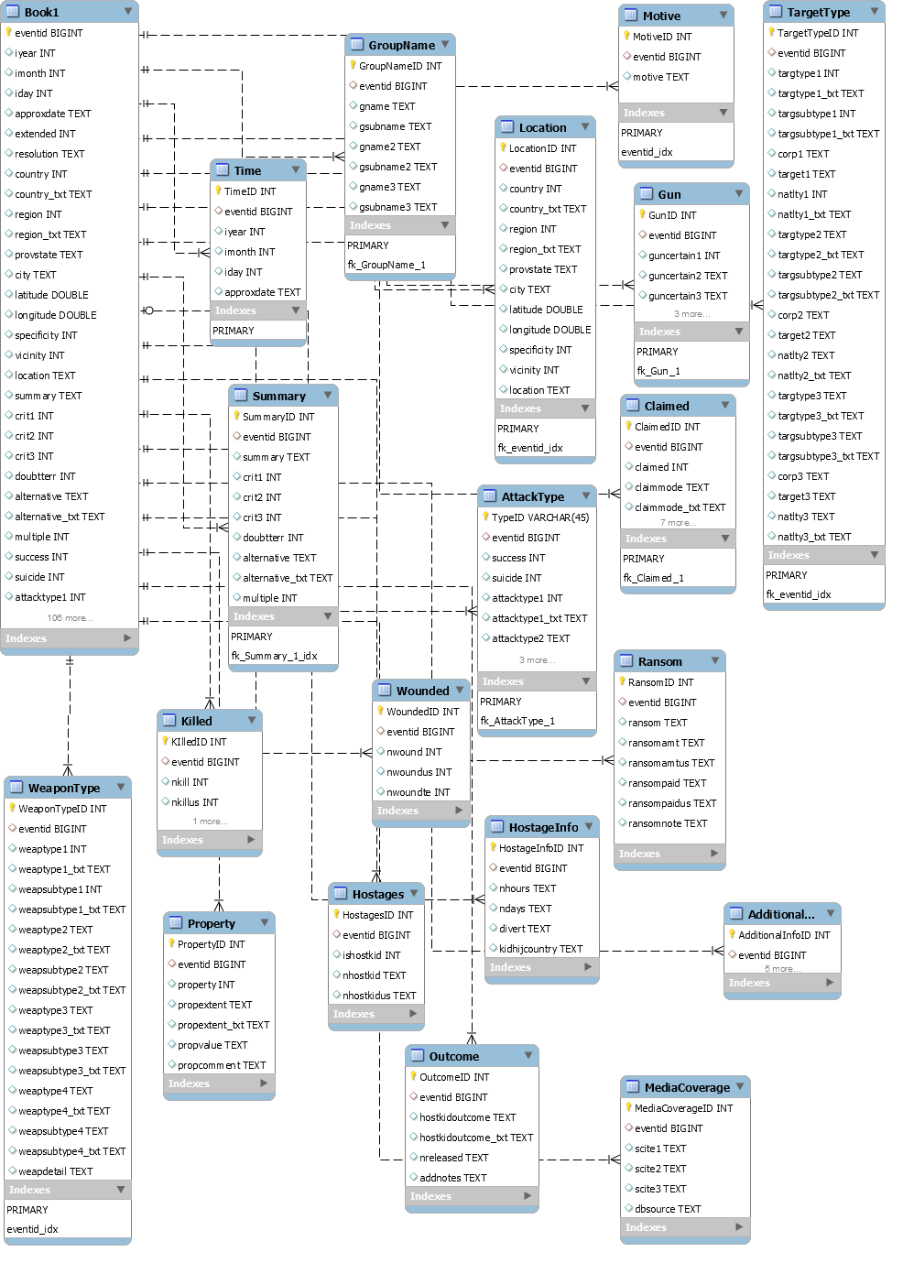
Database partition EER Diagram

3.5.2 Description

Name | Type | Description
AdditionalInfo | 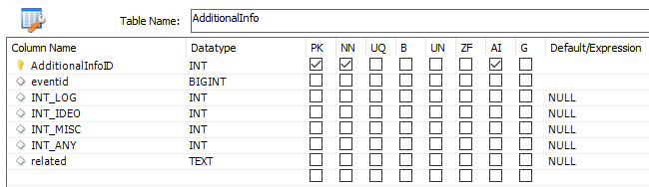 | Additional information about the event
AttackType | 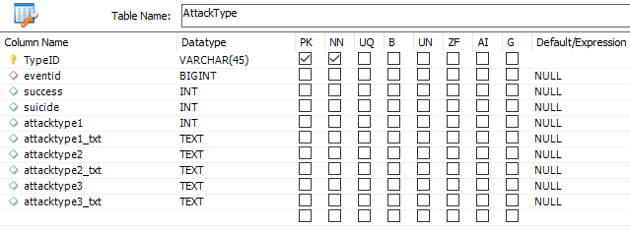 | All if the information regarding the type of attack and success rate
Book1 | Includes all columns of the database | -
Claimed | 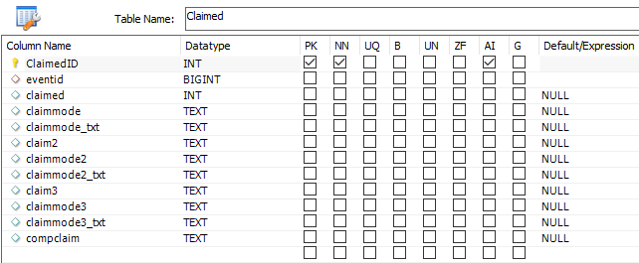 | All of the information regarding the claimed
GroupName | 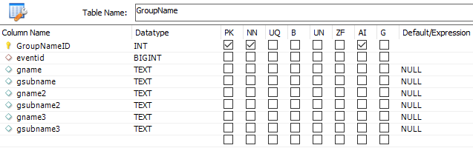 | All of the information about the Group Name
Gun | 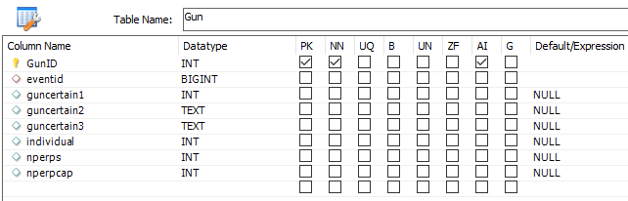 | All of the information about the Gun used
HostageInfo | 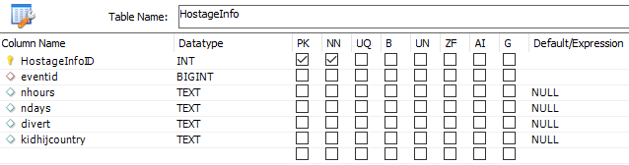 | All of the information about the Hostages
Hostages | 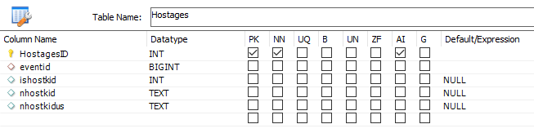 | All of the information about the children hostages
Killed | 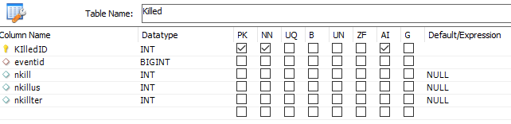 | All of the information about the killed people
Location | 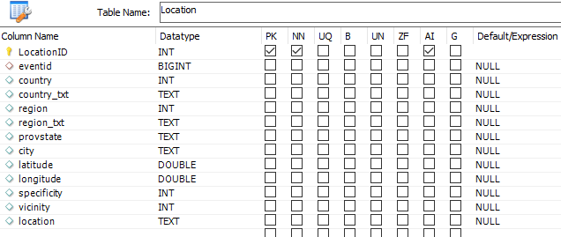 | All of the information about the location
MediaCoverage | 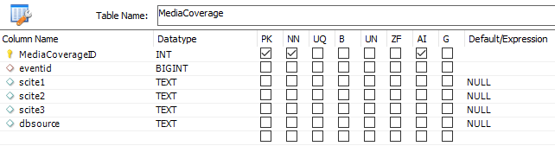 | All of the information about the coverage by the Media
Motive | 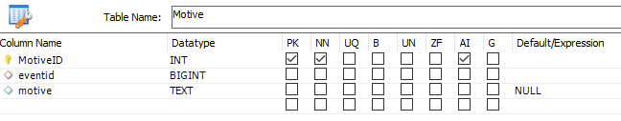 | Group motive
Outcome | 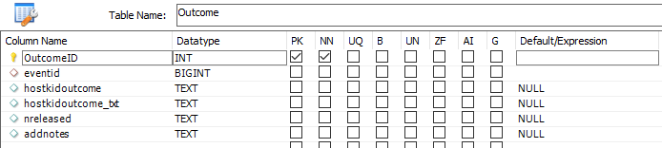 | All of the information about the result of the act
Property | 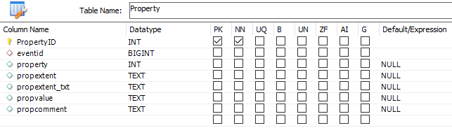 | All of the information about the property damage
Ransom | 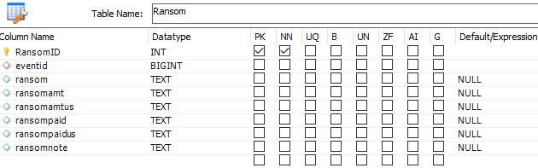 | All of the information about the ransom
Summary | 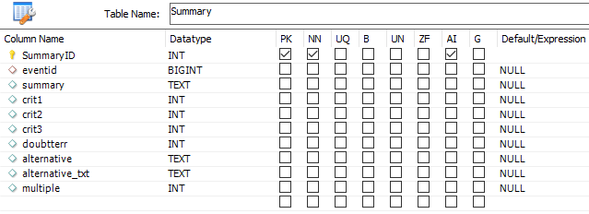 | All of the information about the overall summary
TargetType | 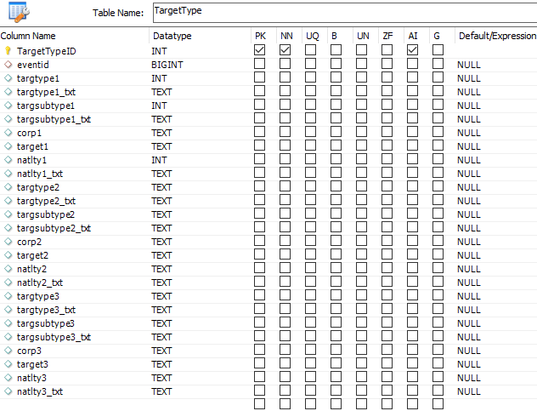 | All of the information about the type of the target
Time | 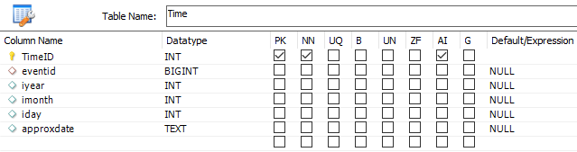 | All of the information about the time and date
WeaponType | 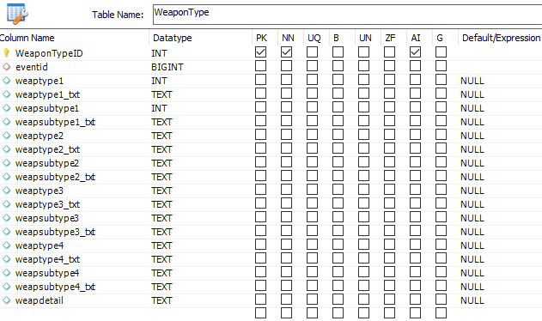 | All of the information about the weapon used
Wounded | 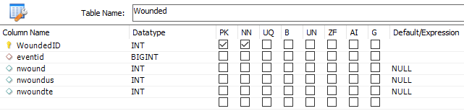 | All of the information about the wounded

