# Heart Beat Classification using Machine Learning

**ABSTRACT**

*Accurate classification of heartbeat signals is essential for the early detection and diagnosis of cardiac anomalies. This study leverages a hybrid architecture combining Convolutional Neural Networks (CNNs) and Long Short-Term Memory (LSTM) networks to analyze electrocardiogram (ECG) signals. The CNNs extract local features, while LSTMs capture temporal dependencies, enabling robust classification. The PTB dataset was used for binary classification, and the MIT-BIH dataset for multi-class classification into five heartbeat categories, with preprocessing steps including dataset balancing, normalization, and spectrogram generation. The model, trained with binary cross-entropy loss and evaluated using metrics such as accuracy, precision, recall, and AUC, demonstrated superior performance in detecting cardiac anomalies. Despite challenges like class imbalance and noisy data, the results underscore the potential of CNN-LSTM architectures for improving cardiac diagnostics.*

***Keywords*–Heartbeat Classification, Electrocardiogram (ECG) Signals. Recurrent Neural Networks (RNNs), Long Short-Term Memory (LSTM) Networks**

1. **INTRODUCTION**

Arrhythmia refers to an irregular frequency or rhythm in a patient's heartbeat. While most arrhythmias pose minimal threats to human health, certain types, such as rapid atrial fibrillation, paroxysmal supraventricular tachycardia, and persistent ventricular tachycardia, can lead to severe symptoms or complications [1]. These conditions may manifest as palpitations, chest discomfort, dizziness, low blood pressure, sweating, fainting, and, in extreme cases, sudden death. Therefore, symptomatic arrhythmias demand immediate medical attention. Among these, atrial fibrillation (AF) is the most common sustained arrhythmia, contributing significantly to the risks of heart failure, dementia, and stroke [2]. This type of supraventricular tachycardia is associated with considerable morbidity and mortality. The prevalence of AF escalates with age and is more commonly observed in men than women. For instance, in 2009, AF affected approximately 1–2% of the global population, and projections suggest that the number of AF patients in Europe and the United States could double or triple over the next 20–30 years[3]. In developing countries, the prevalence of AF is slightly lower, with around 0.6% of men and 0.4% of women being affected. In China, the age-adjusted prevalence is reported to be 6.5 per 1000 individuals, primarily among those aged 60 years and older, and remains lower compared to Western nations, particularly in middle-aged groups. Besides AF, other serious arrhythmias include atrial flutter, bradycardia, and ventricular bigeminy, which also require precise diagnosis and treatment.

Globally, tachyarrhythmias are responsible for approximately half of all cardiovascular deaths and contribute to 15% of total mortality. Consequently, rapid and accurate detection of abnormal heart rhythms is critical, particularly for middle-aged and elderly populations. The electrocardiogram (ECG) is a widely used, non-invasive tool that monitors and graphically records the heart's electrical activity, providing valuable insights into cardiac function. However, due to the non-linear nature of ECG signals and their low amplitude, subtle changes in the data often go unnoticed by human observation[4]. Additionally, obtaining a comprehensive diagnosis typically requires long-term monitoring, such as 24-hour Holter recordings, which can be tedious and time-consuming for manual analysis. This highlights the need for automated diagnostic tools to improve the efficiency and accuracy of ECG [5].

The medical image analysis community has taken notice of these pivotal developments. However, the transition from systems that use handcrafted features to systems that learn features from the data has been gradual. Before the breakthrough of Alex Net, many different techniques to learn features were popular. Bengio et al. (2013) provide a thorough review of these techniques.[7] For example, rule-based systems, as demonstrated by Sufi et al., have achieved high accuracy in diagnosing ventricular fibrillation and other cardiac abnormalities. Similarly, Martis et al. employed independent component analysis (ICA) and k-nearest neighbor classifiers to distinguish between normal, atrial fibrillation, and atrial flutter signals with remarkable sensitivity and specificity. Despite their efficacy on specific datasets, these methods often suffer from poor generalization, overfitting, and reduced performance when tested on new data. Deep learning has emerged as a powerful alternative to traditional techniques, offering significant improvements in both generalization and feature extraction.

Page 1

Convolutional Neural Networks (CNNs) have become a preferred method for medical image interpretation, including cardiac imaging, due to their robustness against noise and their ability to learn hierarchical features through deep-layered structures[6]. For example, Acharya et al. developed an 11-layer CNN model capable of classifying four arrhythmia types with high accuracy using ECG data. Additionally, Oh SL et al. combined CNNs and Long Short-Term Memory (LSTM) networks to classify variable-length ECG signals effectively. Yildirim et al. further enhanced ECG beat classification using bidirectional LSTM networks and wavelet sequences, showcasing the potential of deep learning in ECG analysis..

In general, although these methods show good performance in the ECG diagnosis of a known database, they do not perform well in practice owing to various shortcomings, such as poor generalization performance for new data. When validated using an independent dataset, these systems demonstrate an ECG classification performance that is not as good as that with a known dataset, and the systems show overfitting .

A logical next step is to let computers learn the features that optimally represent the data for the problem at hand. This concept lies at the basis of many deep learning algorithms: models (networks) composed of many layers that transform input data (e.g. images) to outputs (e.g. disease present/absent) while learning increasingly higher-level features. The most successful type of models for image analysis to date are convolutional neural networks (CNNs)[7]. These performance characteristics are reflected in a layer-by-layer network structure. As the layers in the network deepen, features are learned and represented in a more abstract and concise manner. Currently, there are numerous methods for analyzing ECG signals based on deep learning.

Despite these advancements, many existing methods face limitations, such as a reliance on single datasets, lack of cross-validation, and insufficient incorporation of key rhythm features like inter-beat intervals. To overcome these shortcomings, this study proposes a novel deep learning approach that combines CNN and LSTM architectures. By integrating ECG segments and RR intervals as multiple inputs, this method enhances spatial and temporal feature extraction, improving classification performance across six ECG classes: Normal (N), Atrial Fibrillation (AFIB), Bradycardia (B), Premature (P), Atrial Flutter (AFL), and Aberrant Rhythm (ABR). The proposed model is validated on multiple databases, including MIT-

BIH Arrhythmia, Atrial Fibrillation, and Normal Sinus Rhythm Databases, to assess its generalization and reliability[8].

,

are not directly applied as the network input.

In addition, previous studies used a single database to verify the results, and there was no independent cross-validation . s

Considering the advantages and disadvantages of the existing methods, this study proposed a classification method based on deep learning for ECG signals that can analyze and recognize six classes of ECG segments, including N, AFIB, B, P, AFL, and ABR. In addition to automatic feature extraction of the CNN from the ECG, the interval between two adjacent R peaks (RR interval) is also inputted into the model as an auxiliary feature of the ECG signals to improve the identification performance.

To extract the spatial information and time information of the ECG signals and improve the abstraction ability of the model, this study combines CNN and LSTM as a new network structure with ECG fragments and RR intervals as multiple inputs[9]. To evaluate the generalization performance, the method was validated on the MIT-BIH arrhythmia database and two other databases: The MIT-BIH Atrial Fibrillation Database (AFDB) and The MIT-BIH Normal Sinus Rhythm Database (NSRDB).

This method tackles the challenges of conventional diagnostic techniques by enhancing the precision and speed of arrhythmia detection through automated analysis. By utilizing both rhythm-related and structural features, the proposed model achieves superior generalization and abstraction . The combination of CNN and LSTM architectures allows for effective identification of intricate patterns in ECG data. This advancement aims to support clinical practices by enabling more accurate diagnoses and better treatment strategies for arrhythmias.

This study aims to advance ECG signal analysis by leveraging deep learning techniques, providing a more accurate, robust, and efficient solution for arrhythmia diagnosis.

**2. LITERATURE REVIEW**

Due to its potential to enhance cardiac diagnostics, machine learning and deep learning have been actively researched for the categorisation of heartbeat signals. For processing sequential data .The accurate identification of arrhythmias remains a crucial focus in cardiac healthcare, with extensive research dedicated to improving diagnostic techniques. Early methods for ECG signal analysis relied heavily on traditional computational approaches, such as rule-based systems and machine learning classifiers. For instance, rule-based techniques have demonstrated high accuracy in detecting specific conditions, such as ventricular flutter and atrial fibrillation, by leveraging predefined patterns within ECG data. Similarly, machine learning methods like k-nearest neighbor (k-NN) classifiers have been used to classify arrhythmias by extracting meaningful features from ECG signals [10]. Despite their effectiveness on curated datasets, these methods often struggle with generalization, making them less reliable when applied to new or varied datasets.

## Page 2

such as electrocardiogram (ECG) signals, Recurrent Neural Networks (RNNs) and Long Short-Term Memory (LSTM) networks have shown great promise among other methods.

**1. Recurrent Neural Networks (RNNs):** RNNs are a type of neural network that records temporal relationships over time steps by preserving a hidden state. This allows them to analyse sequential input. This qualifies them for uses including voice recognition, ECG signal processing, and time-series forecasting. However, RNNs have limitations when it comes to modelling long-term dependencies in sequences, such as the vanishing gradient problem.  
Researchers have used RNNs in the context of ECG classification for tasks including aberrant heartbeat categorisation and arrhythmia identification.

**2. Long Short-Term Memory (LSTM) Networks:** LSTM networks are a specific kind of RNN that can recognise long-term relationships in sequences by using gated mechanisms to solve the vanishing gradient problem.

**3. OBJECTIVE**

In order to help in the early identification of cardiac disorders, the main goal of this project, "Heartbeat Classification Using CNN and LSTM Networks for Early Detection of Cardiac Anomalies," is to create a deep learning-based system for the automated categorisation of heartbeat data. Using datasets like PTB and MIT-BIH, the research seeks to categorise ECG signals into many categories for multi-class classification and into normal and pathological categories for binary classification [11]. The suggested framework aims to increase classification accuracy and reliability by combining Long Short-Term Memory (LSTM) networks for modelling temporal relationships and Convolutional Neural Networks (CNNs) for feature extraction. Additionally, the research uses sophisticated preprocessing methods including data balancing, spectrogram creation, and normalisation to solve issues like class imbalance and loud ECG signals. In order to capitalise on their individual advantages in feature extraction and temporal modelling, the suggested approach for heartbeat classification combines Convolutional Neural Networks (CNNs) and Long Short-Term Memory (LSTM) networks.

**4.1 Initial Preparation :** The ECG data goes through the following preparation procedures to guarantee the model functions properly.  
**Data Balancing:** Using oversampling and under sampling strategies to address the class imbalance in the PTB and MIT-BIH datasets.

**Normalisation:** To improve training stability, scale the ECG signals to a constant range.  
Spectrogram generation is the process of transforming unprocessed ECG data into frequency-domain representations in order to get fine-grained CNN layer information

**4.2 Architecture of the Model**

**Networks using Long Short-Term Memory (LSTM):**  
In order to capture the temporal relationships present in ECG signals, LSTM layers process the sequential data.  
In LSTMs, gated mechanisms make sure that over time, pertinent information is kept and extraneous data are eliminated.  
**Completely Interconnected Layers:**  
In order to classify the extracted spatial and temporal information, they are flattened and run through thick layers.



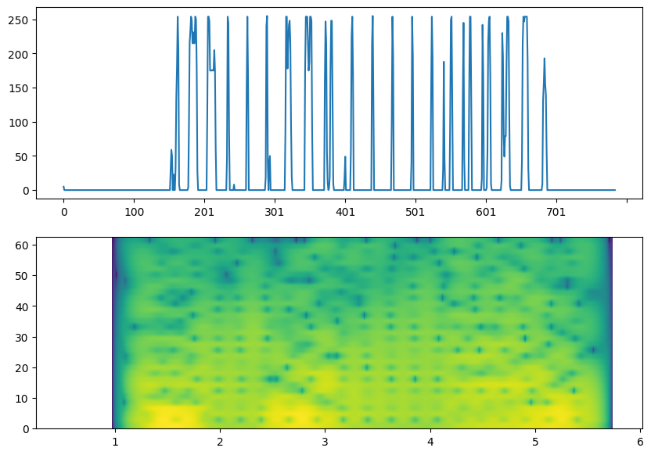



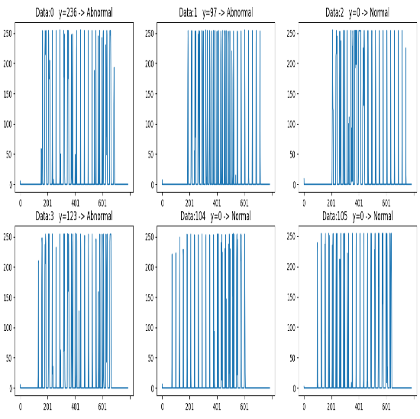

**4.3 Training and Optimisation Loss Function:** binary cross-entropy for classification into binary classes and categorical cross-entropy for classification into many classes.. Regularisation: In order to avoid overfitting, dropout layers are supplied.

Page 3

Early Stopping: To prevent overfitting and conserve processing power, training ends when the validation loss remains constant.

**4.4 Building the Deep Learning Model**

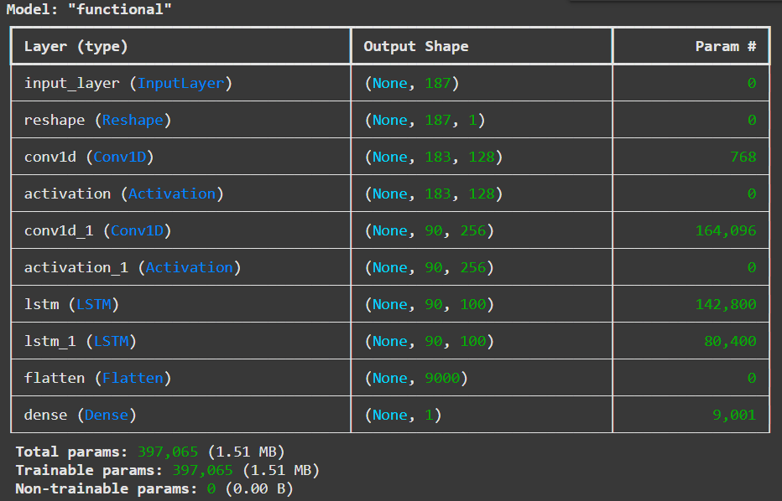.

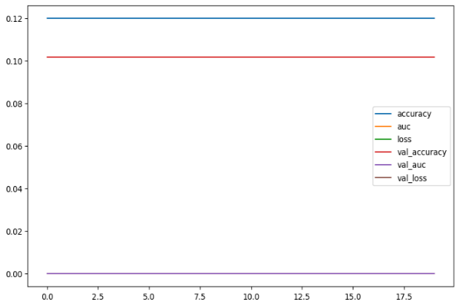

**Fig 2 Training Progress**

In essence, this code visualizes the training history of the model by plotting the recorded metrics over the epochs, helping to understand how the model's performance evolved during training.

**Algorithm 1: Long Short-Term Memory (LSTM)**

**Overview**  
LSTMs are a specialized type of Recurrent Neural Network (RNN) designed to address the vanishing gradient problem and effectively capture long-term dependencies in sequential data. They use a sophisticated cell structure with gate mechanisms.

**Key Components of LSTM**

1. **Cell State**: Stores information over extended periods and acts as the memory component.
2. **Input Gate**: Regulates the flow of new information into the cell state.
3. **Forget Gate**: Determines which information from the previous cell state should be discarded.
4. **Output Gate**: Decides which information from the cell state is output at the current time step.

**How LSTMs Work**

1. **Input**: The current input and the previous hidden state are fed into the LSTM cell.
2. **Cell State Update**: Combines the old state, new input, and forget gate's decision.
3. **Output**: The output gate processes the updated cell state to produce the final output.

**Advantages of LSTM**

* **Effective Handling of Long-Term Dependencies**: Ideal for tasks involving long sequences, such as language modeling and time series analysis.
* **Robustness to Vanishing Gradients**: The gate mechanism mitigates this issue, enabling deep LSTM networks to be trained effectively.
* **Versatility**: LSTM architectures can be customized for various applications.

**Applications**

* **Natural Language Processing**: Text generation, machine translation, sentiment analysis.
* **Speech Recognition**: Automatic speech recognition systems.
* **Time Series Analysis**: Stock price prediction, weather forecasting.
* **Anomaly Detection**: Identifying unusual patterns in data streams.

**Algorithm 2: Recurrent Neural Networks (RNNs)**

**Overview**  
RNNs are artificial neural networks designed to process sequential data. Unlike traditional feedforward networks, RNNs have directed cycles, allowing them to maintain a "memory" of past inputs and capture long-term dependencies.

**Core Concepts of RNNs**

1. **Sequential Data**: Effective for tasks where the order of elements matters (e.g., text, audio, video).
2. **Memory**: Hidden states store past input information, influencing the network's current output.
3. **Backpropagation Through Time (BPTT)**: Training algorithm for calculating gradients through multiple time steps.

**Applications**

* **Natural Language Processing**: Text generation, machine translation, sentiment analysis.
* **Speech Recognition**: Automatic speech recognition systems.
* **Time Series Analysis**: Stock price prediction, weather forecasting.
* **Anomaly Detection**: Identifying unusual patterns in data streams.

By leveraging their sequential memory capability, RNNs and their variants like LSTMs and GRUs address complex sequential data challenges across various domains

## Page 4

## 

# Result and discussion

**Results of the MIT-BIH database**

The method for the MIT-BIH database was verified, and the data are shown in label 1 of Fig. 3. The five-fold cross-validation strategy was employed. A stratified random test was performed by dividing the data into five equal portions. At each validation, 80 % of the data for model training was used, and the remaining 20 % of the data was used for model testing. The test was repeated five times until all data were tested.

**Discussion**

Many studies on automatic ECG arrhythmia recognition have been performed based on the MIT-BIH arrhythmia database, as listed in Table 11, Table 12. To compare the literature in Table 11 (for the ECG beats analysis), an ECG segment of 10 s (instead of an ECG beat) was analyzed, which provided initial heartbeat rhythm information and was consistent with the diagnosis of short-term continuous signals by doctors. Compared with the literature [1for the ECG segment

**Confusion Matrix:**

* + Heatmap of the confusion matrix for binary and multi-class classification.

**Performance Metrics:**

* + Precision-recall curves or ROC (Receiver Operating Characteristic) curves.

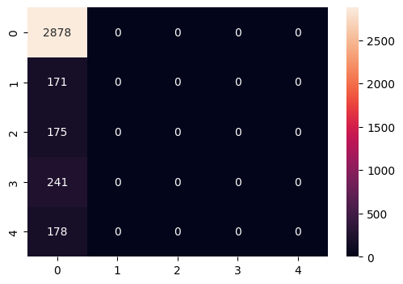

**Fig 3 Matrix Evaluation**

This code snippet visualizes a subset of data points from the Data Frame X. It creates a figure with 6 subplots, plotting each data point individually and labeling it as either 'Normal' or 'Abnormal' based on the corresponding value in the y Series.

The s variable is used to control which parts of the

data are plotted in the subplots.

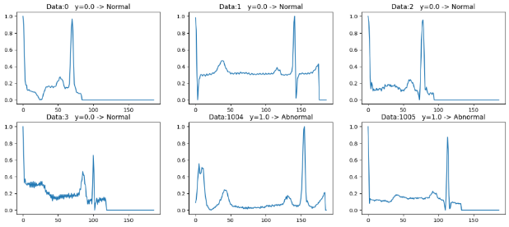

**Fig 4 Normal VS Abnormal**

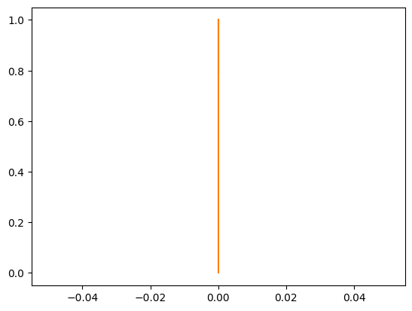 

**Fig 5 relationship between precision, recall, and thresholds**

* One line representing the relationship between **thresholds** and **precision** for class 0.
* Another line representing the relationship between **thresholds** and **recall** for class 0.

This visualization helps to understand how changing the classification threshold affects the precision and recall of the model for the specific class. It's often used to analyse the trade-off between precision and recall and to choose an appropriate threshold for a given application.

Ppahkihklh

## Page 5

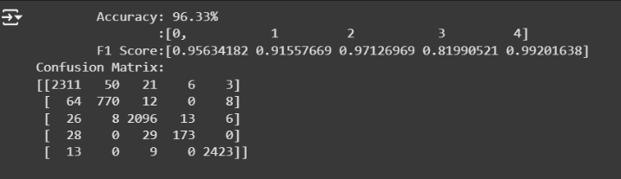

In essence, this code block takes the calculated performance metrics (acc, f1, and cm) and presents them in a user-friendly format on the output. This helps to quickly understand how well the model is performing on the given task.

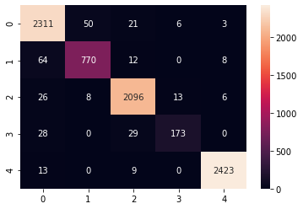

# Conclusion

Accurate diagnosis and early prevention of arrhythmias are important for reducing the incidence of heart disease. To design an efficient and robust automatic computer-aided diagnosis system, this study proposes a CNN + LSTM network structure based on the deep learning method, which can classify six types of ECG fragments. The recognition rate for the MIT-BIH arrhythmia database is 99.32 %. The generalization for new data is adequate, and the recognition rate reaches 97.15 % for the independentbetween precision and recall and to choose an appropriate threshold for a given application

**III .References**

# [Arrhythmia on ECG Classification using CNN](https://www.kaggle.com/code/gregoiredc/arrhythmia-on-ecg-classification-using-cnn)

# <https://ieeexplore.ieee.org/document/10286090>

1. [**https://ieeexplore.ieee.org/document/9027740**](https://ieeexplore.ieee.org/document/9027740)
2. [**Automated arrhythmia classification based on a combination network of CNN and LSTM - ScienceDirect**](https://www.sciencedirect.com/science/article/abs/pii/S1746809419304008#preview-section-snippets)
3. [https://www.sciencedirect.com/science/article/abs/pii/S0020025517306539](https://www.sciencedirect.com/science/article/abs/pii/S1746809419304008)

[6.https://www.sciencedirect.com/science/article/pii/S0167739X17324548](https://www.sciencedirect.com/science/article/abs/pii/S1746809419304008)

7.<https://www.sciencedirect.com/science/article/abs/pii/S1361841516000128>

8.<https://www.sciencedirect.com/science/article/abs/pii/S0196064415014742>

9.<https://www.sciencedirect.com/science/article/pii/S1746809416300830>

[10.**H**ttps://www.sciencedirect.com/science/article/pii/S1746809413001213](https://www.sciencedirect.com/science/article/abs/pii/S1746809419304008)

Page 6