

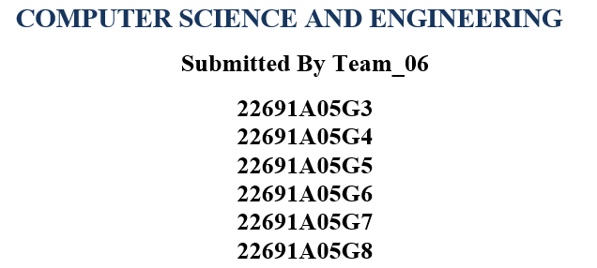

### Under the Guidance of

**Ms. Ramya Palaniappan M.E.(Ph.D.)**

### F:\mits LOGO.jpgAssistant Professor



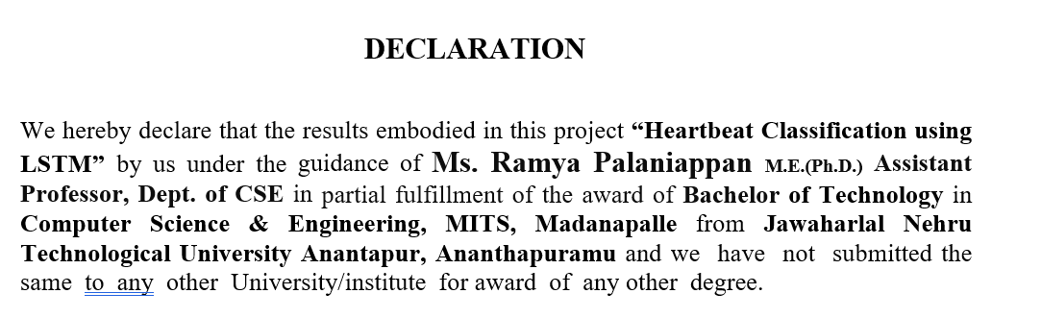

### Date :

**Place :**

## **PROJECT ASSOCIATES**

**22691A05G3**

**22691A05G4**

**22691A05G5**

**22691A05G6**

**22691A05G7**

**22691A05G8**

I certify that above statement made by the students is correct to the best of our knowledge.

## **ABSTRACT**

Accurate classification of heartbeat signals is essential for the early detection and diagnosis of cardiac anomalies. This study utilizes Recurrent Neural Networks (RNNs), specifically Long Short-Term Memory (LSTM) networks, to classify electrocardiogram (ECG) signals into normal and abnormal categories. Two datasets were used: the PTB dataset for binary classification and the MIT-BIH dataset for multi-class classification into five heartbeat categories. Preprocessing involved balancing datasets, normalizing data, and generating spectrograms to enhance feature extraction.

The proposed model integrates Convolutional Neural Networks (CNNs) and LSTM layers. CNNs were used to extract local features, while LSTMs captured temporal dependencies inherent in ECG signals. The model was trained using binary cross-entropy loss and evaluated on metrics such as accuracy, precision-recall, and area under the curve (AUC). This study includes, Binary Classification (PTB Dataset): 2,093 training and 897 testing observations after preprocessing.

Multi-Class Classification (MIT-BIH Dataset): A combined dataset of 12,142 observations for five heartbeat categories. Results indicate that the integration of CNNs and LSTMs enhances the detection of cardiac anomalies compared to conventional methods. However, performance was affected by challenges like class imbalance, noisy data, and suboptimal hyperparameters. Despite these limitations, the RNN-based approach demonstrated the ability to capture complex patterns in sequential data, emphasizing the potential of LSTMs in medical signal processing.

Keywords: Heartbeat Classification, Electrocardiogram (ECG) Signals. Recurrent Neural Networks (RNNs), Long Short-Term Memory (LSTM) Networks

# **INTRODUCTION**

The early identification and diagnosis of cardiac abnormalities including arrhythmia and myocardial infarction depend heavily on the precise categorisation of heartbeat signals. The electrical activity of the heart is recorded by electrocardiogram (ECG) signals, which are a useful tool for diagnosing various diseases.  
Significant progress has been made in automating these procedures thanks to developments in deep learning. Long Short-Term Memory (LSTM) networks, a subset of recurrent neural networks (RNNs), are particularly good at identifying temporal connections in sequential data, such as ECG signals. When used in conjunction with Convolutional Neural Networks (CNNs) for feature extraction, these techniques offer a strong foundation for accurate heartbeat classification.

This study investigates the use of CNNs and LSTMs to classify heartbeats into five categories for multi-class classification using the MIT-BIH dataset, and into two categories (normal and abnormal) for binary classification using the PTB dataset. To improve feature extraction and model performance, preprocessing techniques such data balance, normalisation, and spectrogram creation were used.

## **2. LITERATURE REVIEW**

Due to its potential to enhance cardiac diagnostics, machine learning and deep learning have been actively researched for the categorisation of heartbeat signals. For processing sequential data, such as electrocardiogram (ECG) signals, Recurrent Neural Networks (RNNs) and Long Short-Term Memory (LSTM) networks have shown great promise among other methods.

**1. Recurrent Neural Networks (RNNs):** RNNs are a type of neural network that records temporal relationships over time steps by preserving a hidden state. This allows them to analyse sequential input. This qualifies them for uses including voice recognition, ECG signal processing, and time-series forecasting. However, RNNs have limitations when it comes to modelling long-term dependencies in sequences, such as the vanishing gradient problem.  
Researchers have used RNNs in the context of ECG classification for tasks including aberrant heartbeat categorisation and arrhythmia identification.

**2. Long Short-Term Memory (LSTM) Networks:** LSTM networks are a specific kind of RNN that can recognise long-term relationships in sequences by using gated mechanisms to solve the vanishing gradient problem.

## **3. OBJECTIVE**

In order to help in the early identification of cardiac disorders, the main goal of this project, "Heartbeat Classification Using CNN and LSTM Networks for Early Detection of Cardiac Anomalies," is to create a deep learning-based system for the automated categorisation of heartbeat data. Using datasets like PTB and MIT-BIH, the research seeks to categorise ECG signals into many categories for multi-class classification and into normal and pathological categories for binary classification. The suggested framework aims to increase classification accuracy and reliability by combining Long Short-Term Memory (LSTM) networks for modelling temporal relationships and Convolutional Neural Networks (CNNs) for feature extraction. Additionally, the research uses sophisticated preprocessing methods including data balancing, spectrogram creation, and normalisation to solve issues like class imbalance and loud ECG signals.

# **Proposed Method** In order to capitalise on their individual advantages in feature extraction and temporal modelling, the suggested approach for heartbeat classification combines Convolutional Neural Networks (CNNs) and Long Short-Term Memory (LSTM) networks.

**4.1 Initial Preparation**The ECG data goes through the following preparation procedures to guarantee the model functions properly.  
**Data Balancing:** Using oversampling and under sampling strategies to address the class imbalance in the PTB and MIT-BIH datasets.  
**Normalisation:** To improve training stability, scale the ECG signals to a constant range.  
Spectrogram generation is the process of transforming unprocessed ECG data into frequency-domain representations in order to get fine-grained CNN layer information.  
**4.2 Architecture of the Model**

**Networks using Long Short-Term Memory (LSTM):**  
In order to capture the temporal relationships present in ECG signals, LSTM layers process the sequential data.  
In LSTMs, gated mechanisms make sure that over time, pertinent information is kept and extraneous data are eliminated.  
**Completely Interconnected Layers:**  
In order to classify the extracted spatial and temporal information, they are flattened and run through thick layers.

****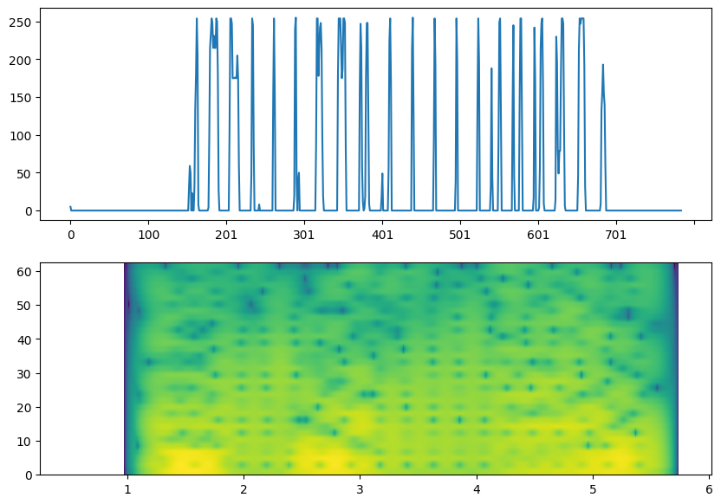

.

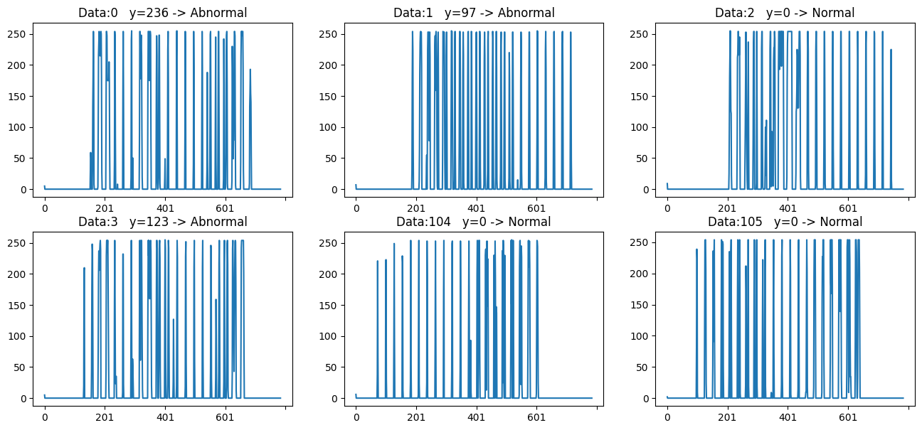

**4.3 Training and Optimisation Loss Function:** binary cross-entropy for classification into binary classes and categorical cross-entropy for classification into many classes.  
Adam optimiser is used for adaptive and effective weight adjustments.  
Regularisation: In order to avoid overfitting, dropout layers are supplied.  
Early Stopping: To prevent overfitting and conserve processing power, training ends when the validation loss remains constant.

**4.4 Building the Deep Learning Model**

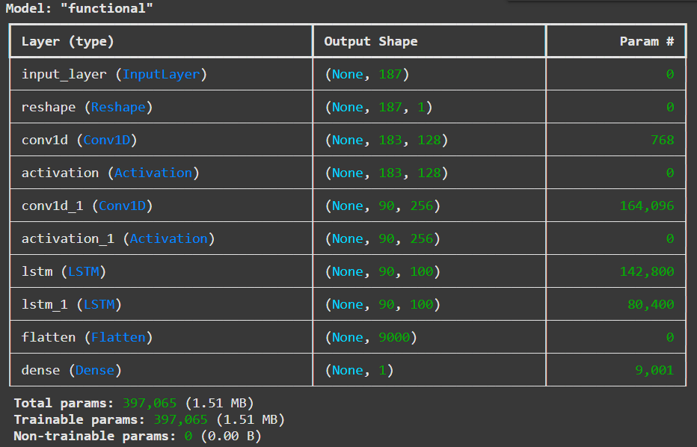

The training progress of the machine learning model. It generates a plot that shows how different metrics (like accuracy, loss, etc.) changed over the training epochs.

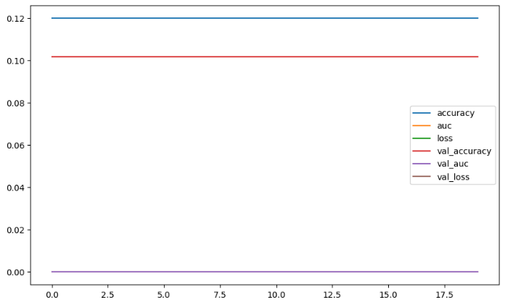

**Fig 2 Training Progress**

In essence, this code visualizes the training history of the model by plotting the recorded metrics over the epochs, helping to understand how the model's performance evolved during training.

**5. Evaluation**

* **Confusion Matrix:**
  + Heatmap of the confusion matrix for binary and multi-class classification.
* **Performance Metrics:**
  + Precision-recall curves or ROC (Receiver Operating Characteristic) curves.

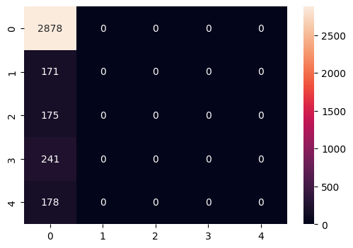

**Fig 3 Matrix Evaluation**

This code snippet visualizes a subset of data points from the Data Frame X. It creates a figure with 6 subplots, plotting each data point individually and labeling it as either 'Normal' or 'Abnormal' based on the corresponding value in the y Series. The s variable is used to control which parts of the data are plotted in the subplots.

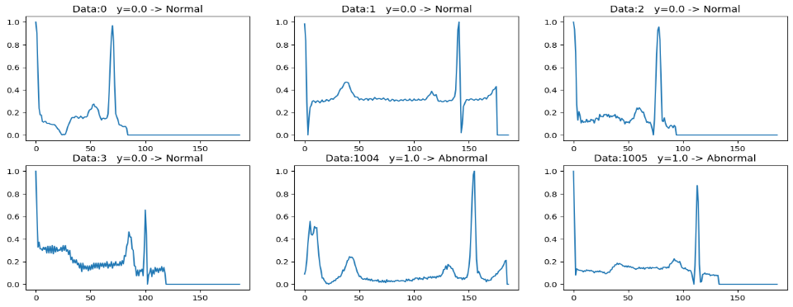

**Fig 4 Normal VS Abnormal**

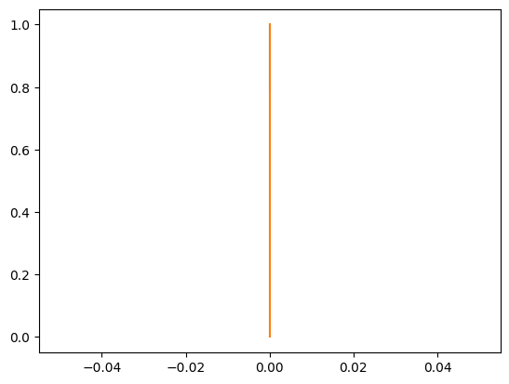 

**Fig 5 relationship between precision, recall, and thresholds**

* One line representing the relationship between **thresholds** and **precision** for class 0.
* Another line representing the relationship between **thresholds** and **recall** for class 0.

This visualization helps to understand how changing the classification threshold affects the precision and recall of the model for the specific class. It's often used to analyse the trade-off between precision and recall and to choose an appropriate threshold for a given application.

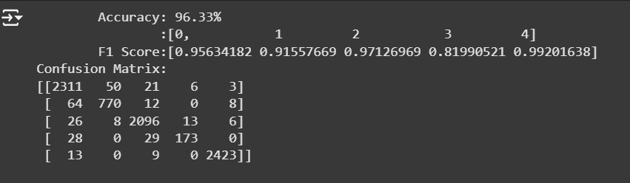

In essence, this code block takes the calculated performance metrics (acc, f1, and cm) and presents them in a user-friendly format on the output. This helps to quickly understand how well the model is performing on the given task.

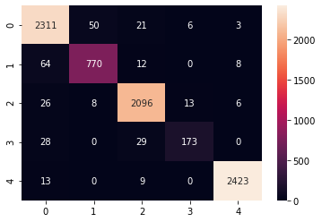

**Fig 6 visualize a confusion matrix using a heatmap**

# **CONCLUSION** This study shows how well CNNs and LSTMs work together to classify heartbeats. Even though the results indicate a great deal of promise for clinical applications, the system has to be improved in the future to become more reliable and scalable.

# **REFERENCE**

# [**Arrhythmia on ECG Classification using CNN**](https://www.kaggle.com/code/gregoiredc/arrhythmia-on-ecg-classification-using-cnn)

# [**https://ieeexplore.ieee.org/document/10286090**](https://ieeexplore.ieee.org/document/10286090)

[**https://ieeexplore.ieee.org/document/9027740**](https://ieeexplore.ieee.org/document/9027740)

<https://github.com/kpunithkumar63/HeartbeartClassification>

**Programming Language: Python**

# 