Twitter Tweets

Kevin Putschko

11/4/2019

# Introduction

This and that.

# Chatter Plot

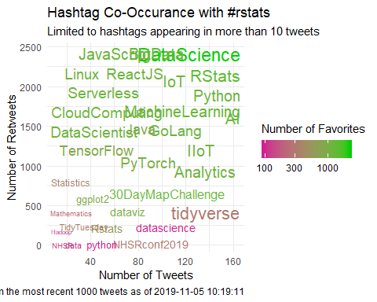

# Co-Occurance Chart

