**Python Installation**

**From:** [**https://software.rc.fas.harvard.edu/training/scraping/install/**](https://software.rc.fas.harvard.edu/training/scraping/install/)

**1) Introduction**

We'll be using Python in the class, and it'll save lots of time if, before arriving at the class, everyone has this installed and is familiar how to open, edit, and run a script (which is just a text file) using Python.

Furthermore, we'll be using IDLE, Python's own IDE (Integrated Development Environment) — combined source code editor and Python interpreter GUI. The course does not rely on any of its specific features, but it makes working with Python on Windows much easier and provides a multi-platform basis for examples.

**2) Create a Folder for Course Files**

No significant storage resources will be required, just a convenient place to browse, download files, create text files, etc. For example, C:\Documents and Settings\MY_USERNAME\My Documents\course (Windows), or ~/budt758x (Mac/Linux). This is referred to generically as *BUDT758X* below.

**3) Install Python (and IDLE)**

There's a new major release of Python out, version 3. We are ***not*** using this — we're using **version 2**.

**Windows**

Python and IDLE are not installed by default.

* Browse to <http://www.python.org/download>.
* Look for the Windows downloads, choose the one appropriate for your architecture (32-bit or 64-bit). At the time of writing, the choices are:
  + **32-bit**: [Python 2.7.3 Windows Installer](http://www.python.org/ftp/python/2.7.3/python-2.7.3.msi)
  + **64-bit**: [Python 2.7.3 Windows X86-64 Installer](http://www.python.org/ftp/python/2.7.3/python-2.7.3.amd64.msi)

If you don't know the system architecture, try running winmsd.exe (in Windows XP) or msinfo32.exe (in Windows 7). Look at System Type and/or Processor. It will look this [this](https://software.rc.fas.harvard.edu/training/scraping/install/winmsd.exe.winxp.png) for 32-bit, or [this](https://software.rc.fas.harvard.edu/training/scraping/install/msinfo32.exe.win7.png) for 64.

* Run the installer and click through the prompts. Default options are usually just fine. This installs IDLE, too, by default.

IDLE (Python GUI) and Python (command line) should now by in your program menu, under Python 2.7, and Python will be associated with .py files. However they're going to need to know about the files we create during the course. This is easiest if we start IDLE from the *BUDT758X* folder itself. Let's create a Windows script, idle.bat that does that:

* Browse to your *BUDT758X* directory.
* Right-click in the empty space, choose New -> Text Document, name it idle.bat (accept the warning about file extensions).
* Edit the file by right-clicking and choosing Edit.
* Enter the single line:

C:\Python27\Lib\idlelib\idle.bat

* Close the file.

You should now be able to double-click idle.bat to open IDLE.

**Mac**

Python is installed by default, but IDLE is not (and Python is likely a little old). Follow these instructions for a Mac binary install, or install from source, using the instructions further down the page.

* Browse to <http://www.python.org/download>.
* Look for the Mac download, choose the one appropriate for your architecture (32-bit or 64-bit) and OS X version. If you don't know the system architecture, try running arch or uname -m in Terminal.app (To find Terminal: Go to Finder->Application->Utilities). At the time of writing, the choices are:
  + **32-bit for Mac OS X 10.3 through 10.6**:
    - [Python 2.7.3 Mac OS X 32-bit i386/PPC Installer](http://www.python.org/ftp/python/2.7.3/python-2.7.3-macosx10.3.dmg)
  + **32-bit or 64-bit OS X 10.6**:
    - [Python 2.7.3 Mac OS X 64-bit/32-bit x86-64/i386 Installer](http://www.python.org/ftp/python/2.7.3/python-2.7.3-macosx10.6.dmg)
* Run the installer and click through the prompts. Default options are usually just fine. This installs IDLE, too, by default.

We're going to want to launch IDLE from within the *BUDT758X* directory. This should work by default. Open up Terminal.app from the Applications menu, and type:

cd BUDT758X

Where *BUDT758X* is replaced by the directory you chose to use for the course. Now type:

idle &

and hit ENTER to launch IDLE.

**Linux (can be ignored)**

Python is installed by default, but sometimes IDLE is not. Either install IDLE using your distro's package manager, e.g. apt-get install idle (Ubuntu/Debian/etc.), yum install python26-tools (RHEL/CentOS/etc.), USE=tk emerge -avn python (Gentoo), etc., or install new version of Python from source (which will include IDLE).

Launching IDLE from the *BUDT758X* directory will be the same as for the Mac case above (just use your favorite terminal instead of Terminal.app).

**Alternative Method**

On Mac or Linux, you can instead compile Python from source. Instructions are [here](https://software.rc.fas.harvard.edu/training/scraping/install/source.html).

**4) Try IDLE**

You should now have an IDLE session open that looks something like this:

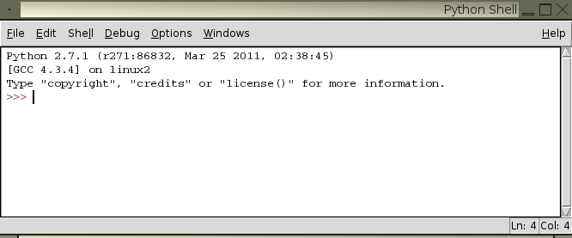

This is where we'll pick up the course. If you're feeling ambitious, try creating a Python script by clicking File -> New Window, which will open a text editor window, and enter the following line:

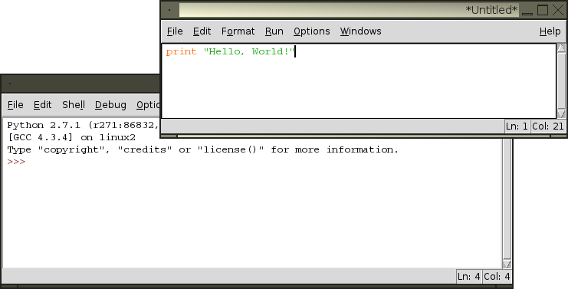

Click File -> Save and enter hw.py for the filename. Then click Run -> Run Module to run the script:

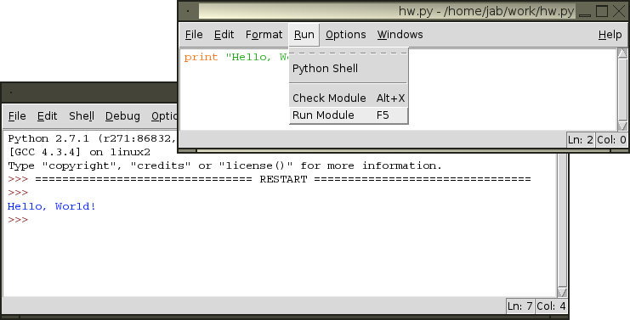

You have now written and run a Python script.

**5) Try Terminal on Mac**

On Mac OS X, you can open the terminal and type Python. You will get into the Python interactive environment.