JTunes

User Guide

**Table of Contents**

**About Us & JTunes window**……………………………………………… **2**

**User Options**……………………………………………………………….. **3**

* **Creating new account**.......................................................................... **3**
* **Log in**……………………………………………………………….... **4**
* **Log out**.................................................................................................. **5**

**Player Navigation**………………………………………………………….. **6**

**Libraries and Tabs**………………………………………………………… **7**

* **JTunes cloud library**………………………………………………… **7**
* **Playlist library**…………………………………………………......… **8**

**Accessing your Local library on local computer**.………………………... **9**

* **Playlist library**……………………………………………………….. **9**
* **Song library**……………………………………………………….... **10**

**Troubleshooting common problems**…………………………………….. **12**

**About Us**

JTunes is a digital media player application developed by Team Syzygy used for playing and organizing digital music through their personal computers. Through the JTunes Cloud Server, users can download music, organize them into playlists where users may remove (playlists as well) or add songs into the playlist through personal preference. JTunes keeps tracks of songs by creating a virtual JTunesCloud library allowing users to modify playlist attributes and choice of music. Although JTunes offers music for users to download, the music available are all in midi file formats (.mid) instead of any song they want to listen to. All downloaded songs will be saved in the users local library so if they want to listen on a different computer, they must re-download the song as the music previously stored will not appear on a different computer unless already downloaded. In addition to playlist support, users are able to rename playlists, add and remove songs from it. To access the playlist, users must search for their own folder name created when they log in and search for their email as the directory name and the playlist will appear as a text file of all songs stored in the playlist when first created. JTunes also offers a shuffle mode where users may play songs at random without any preference.

**JTunes main window**

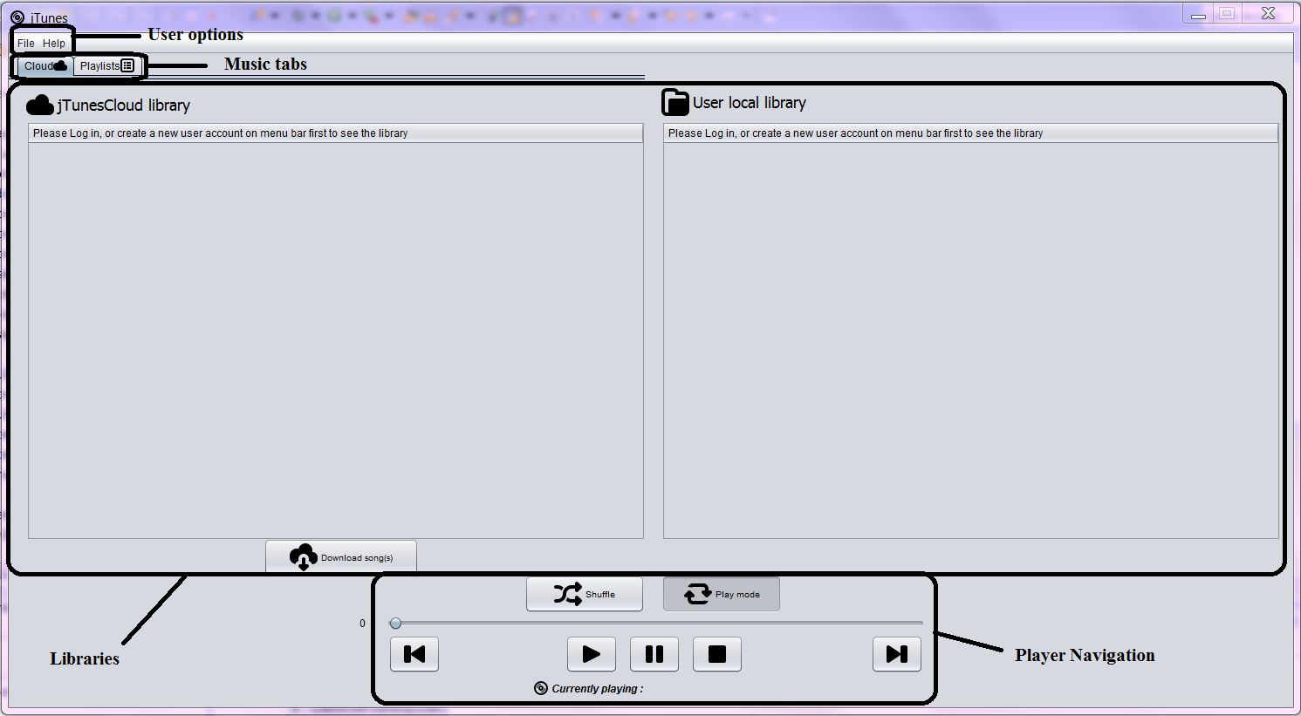

**User options**

1. **Creating a new account**

For users who are new to the application without a user, please follow the instructions below for setting up a new account in JTunes.

**Step 1**: On the top left of the JTunes window, hover your mouse over and click on the File tab

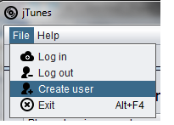

**Step 2:** Enter a valid name, email, and password and click on OK. A visual example is provided below.

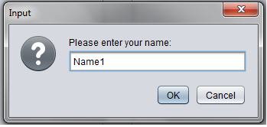

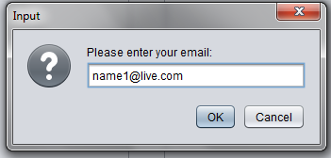

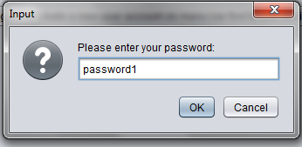

Please continue on reading after you have successfully created a new user in the system.

1. **Log in**

To start navigating through your JTunes program, user log in is required.

If you are an existing user or have already created a user previously, please follow the steps below to log in.

**Step 1:** Hover your mouse over to the top left of the JTunes window and click on the File tab and select Log In

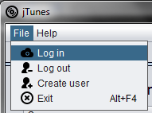

**Step 2:** Enter a valid email address and password and click OK

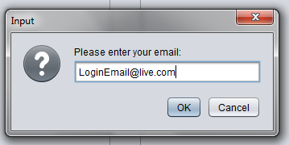

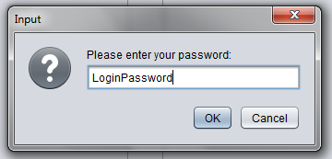

If you have successfully logged in, a window like this should pop up:

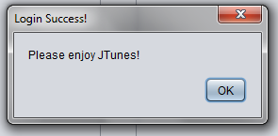

1. **Log out**

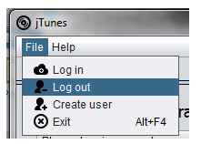

If you are finished with the JTunes application, you may select log out to exit your music library

**Step 1:** Hover your mouse over to the File tab and select on Log Out.

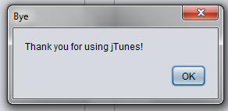

You will be notified when you have successfully logged out with a window like above.

**Step 2: (Optional)** If you want to exit the program you mean hover your mouse over to the File tab and click on Exit.

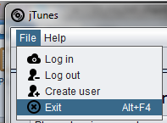

*Alternatively you may hold onto alt + F4 as a shortcut to exit quicker*.

**Player Navigation**

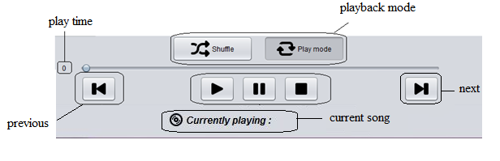



**Play Time** Shows how far into the song you are at displayed

**Previous/Next** Press previous to select previous song, press next to select the next song

**Playback Mode** Shuffle mode plays songs at random, Play mode plays song in order of

position in playlist or in your local music library.

**Play** Press play to start the playback.

**Pause** Press pause to pause the playback.

**Stop**  Press stop to stop the playback.



**Libraries & Tabs**

1. **JTunes Cloud Library**

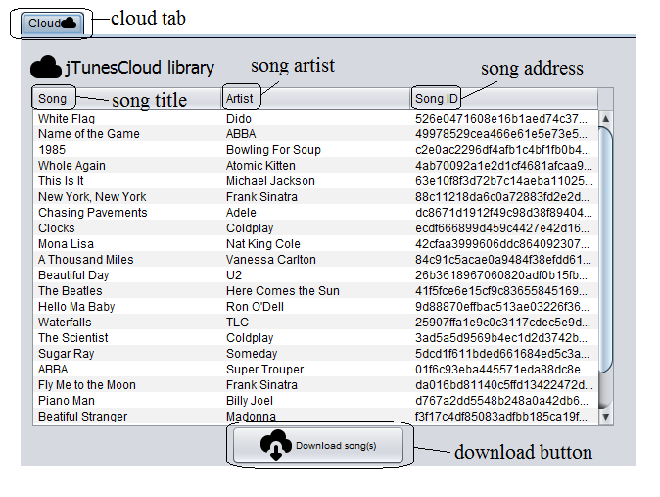





**Cloud ta**b Shows the user what tab you are currently in

**Song title**  Displays the name of the song

**Song artist** Displays the artist who sang the song

**Song address** Displays a computer recognized language for the program to search for the

corresponding song in the server to download to the users local library

**Download button** Download the highlighted/selected song from the JTunes Cloud music library into

the users local library



1. **Playlist Library**

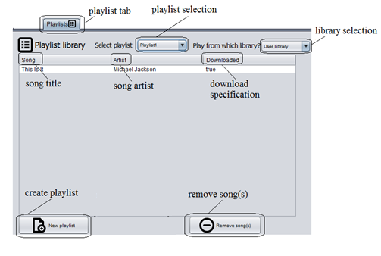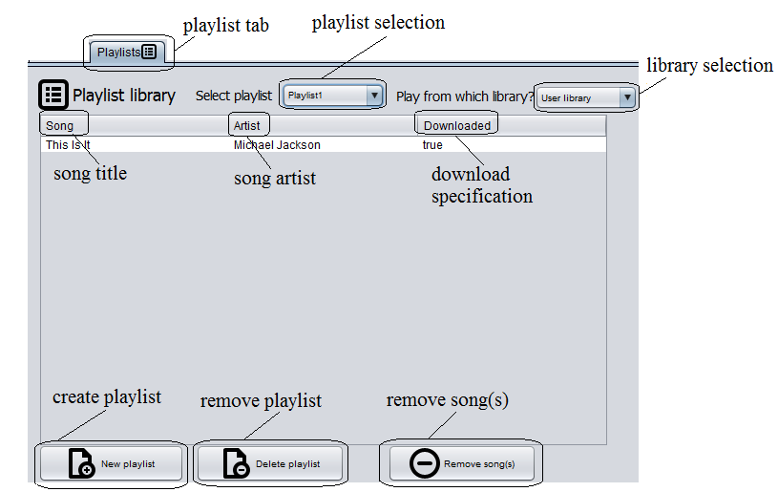

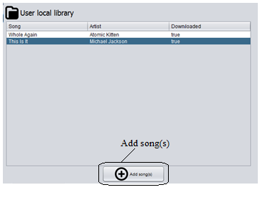





**Playlist tab**  Shows user what tab they are currently on

**Playlist selection** Gives user the option to select which playlist they would like to listen to

**Library selection** Gives user the option to select which library they would like to listen

From

**Song title**  Displays the name of the song in the playlist

**Song** **artist** Displays the artist of the song in the playlist

**Download** **specification** If the song is successfully downloaded and stored into playlist, the tab

should display “true”

**Create** **playlist** Enables user to create their own playlist

**Remove song(s)**  Enables user to delete unwanted songs in the playlist

**Add song(s**) Enables user to add songs of their preference 

**Accessing your library on the local computer**

To access your files, you have to manually search through the directories yourself to open up the file.

**1.Playlist Library**

**Step 1:** Go to your JTunes folder where the JTunes executable is saved in. Select jTunes>data>users>”user email”>”playlist”.txt

(A visual example is provided below)

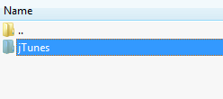

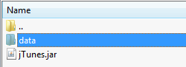

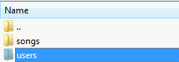>

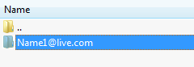

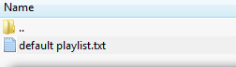

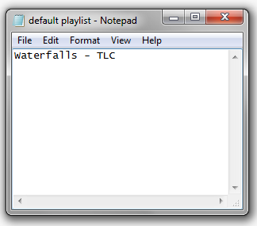

**2. Song Library (User Local Library)**

**Step 1:** Go to your JTunes folder where the JTunes executable is saved in. Select jTunes>data>Songs

A visual example will be provided below





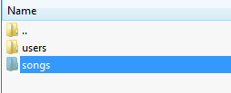

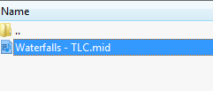

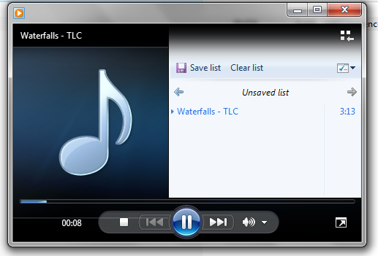

Depending on which music player you are using, by double clicking on the song file, you will be able to listen on your own computer separately outside of the JTunes application

**Troubleshooting common problems**

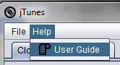

Q: I cannot play the music

A: Make sure your music is downloaded from the JTunes Cloud and is saved in your users local library

Make sure the volume on your machine is not muted

Make sure you pressed the play button after selecting a song from the users local ibrary or your

Playlist

Q: How do I download music?

A: Select the song(s) you would like to download from the server and select the Download button below

the list of available songs and make sure they appear on your users local library.

Q: Why am I not able to log in?

A: Make sure your log in information is correct or if you have entered a valid email address of the form

[xxx@yyy.com](mailto:xxx@yyy.com). This is the only email format the program recognizes and accepts.

Q: The server will not allow me to log in at all when I click on log in.

A: Make sure you are connected to the internet or a wireless network. The JTunes Cloud server requires

internet connection to connect to the server in order to display the list of available songs for the user

to download.

Q: Am I able to search for songs I want to download that is not on the server?

A: No, JTunes has a finite list of music and will only be the available songs for user to download and play

through.

Q: I want to access my playlist text file but I cannot find it.

A: Your playlist will be stored in JTunes/data/users/<user email>/<user playlist>.txt where the JTunes

executable is saved in. For more information, go to page 9.