software enginEering fundamental(003)

Team members: Quinn Keenan, Kerric Shiu, Yongju Lee

Final group project

Professor: Please include a workflow of any of your user story. As you can see below I did the steps list firstly then I draw the diagram with three shapes. Rectangle (step), Diamond shape (condition to check), and the circle for start and end of the workflow. Make sure every step is in the diagram.

**Sign-up flow**

1. Open the **Health home** app.
2. Tap the “sign up” Button.
3. Tap the **any letter in “choose your role”**
4. If you want to make the account as gym goer, tap the gym-goer.
5. If you want to make the account as athlete, tap the athlete.
6. Otherwise, tap the trainer
7. Click “enter your email address” and enter the email address.
8. Click “enter your password” and enter your password.
9. Click “confirm your password” and enter your password.
10. Tap “sign up” button.

`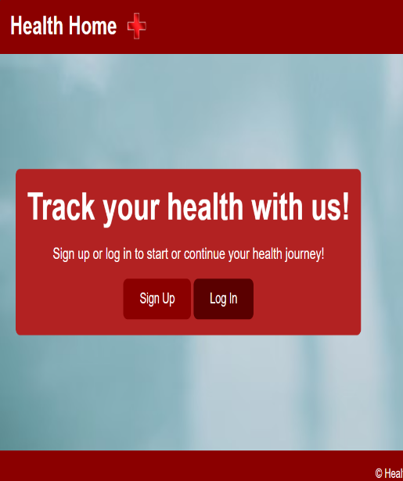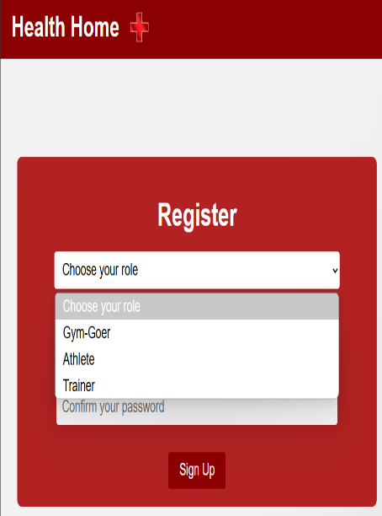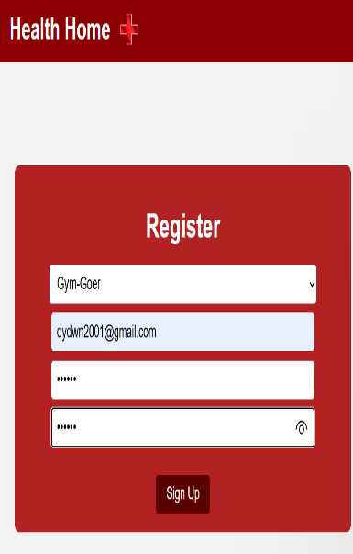

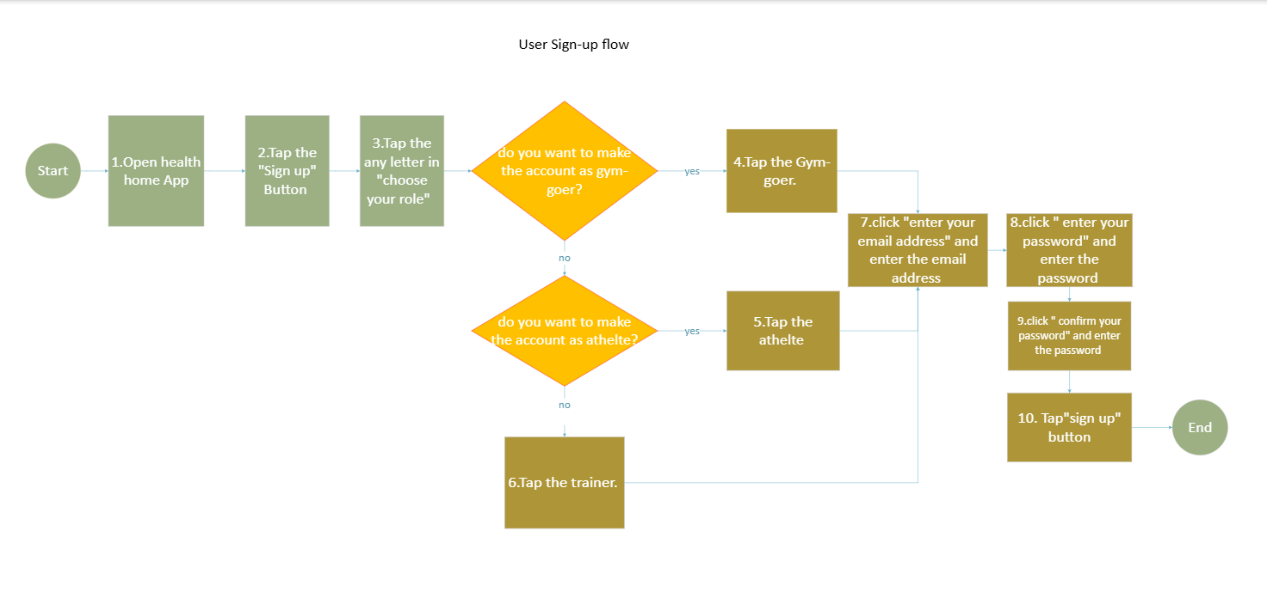

Professor: I want you to write about what you did in each Scrum phase (See the below in **blue)**.

1. Mention your user roles and how you started having at least 10 user stories
2. Then the “backlog grooming” when we did the priority and estimation for each user storiy
3. Then the “Sprint Planing” when we planned the spring according to your team criteria: Capacity, spring duration, people in your team, and whatnot.
4. Finally tell me how you Sprint is finishing. Let’s say out of 10 user stories we only complete 7 because such and such..
5. For the previous steps (2-4) include the screenshots for Summary, List and Dashboard.
6. Use the following as reference. (Please do not give me the same paragraph)
7. Add whatever you think it is important for me to know
8. Note1: Plese add some acceptance criteria in any user story. (Jira)
9. The report in real life is not used, but it is a proof that you are summarizing what **you learned**.
10. The cover page is just an example. Include team#, team member names, and whatnot.

**Summary – Before Grooming Backlog Meeting**

We are preparing for our upcoming backlog grooming session, where we will review **55 user stories** in our current backlog. The primary objectives of this meeting are to clarify requirements, refine estimates, and ensure alignment with our development priorities.

Key focus areas include:

* Validating the scope and acceptance criteria of each user story.
* Identifying dependencies or potential blockers.
* Estimating effort and assigning priorities based on business value.

By the end of this session, we aim to have well-defined user stories that are ready for upcoming sprints, improving development efficiency and delivery timelines.

**Summary – After Backlog Grooming Meeting**

Our backlog grooming session has been successfully completed, during which we reviewed and refined **26 user stories**. Key outcomes include:

* **Clarified Requirements** – Ensured that all user stories have well-defined scope and acceptance criteria.
* **Effort Estimation** – Assigned appropriate story points to each user story for better sprint planning.
* **Prioritization** – Ranked stories based on business value and dependencies to align with upcoming sprint goals.
* **Identified Dependencies & Risks** – Flagged potential blockers and assigned action items to resolve them before development begins.

Team 2 - report after grooming

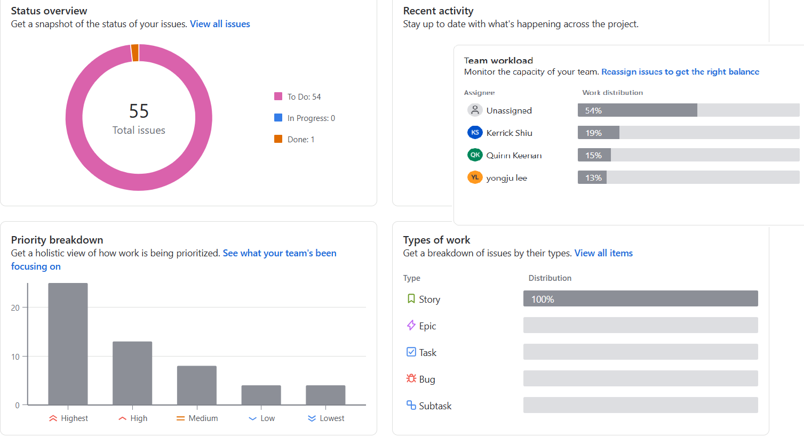

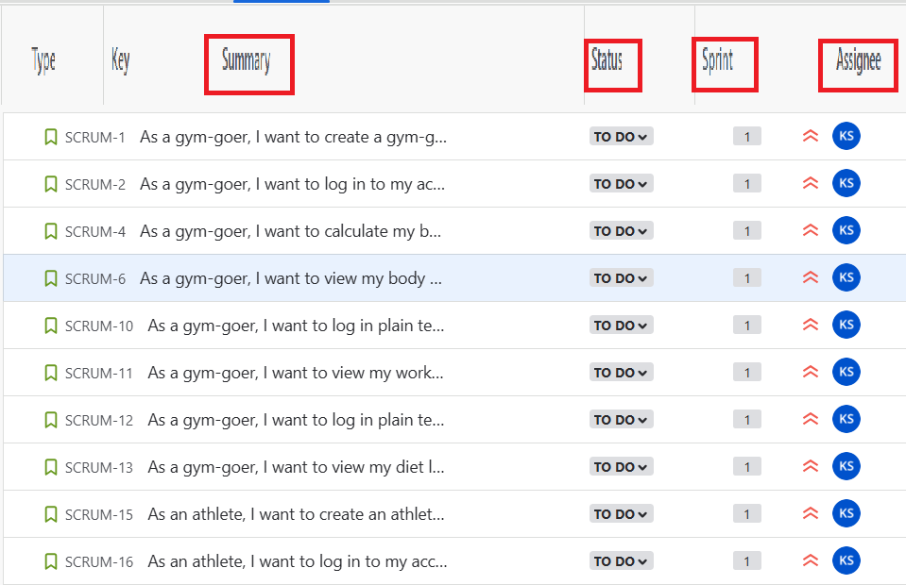

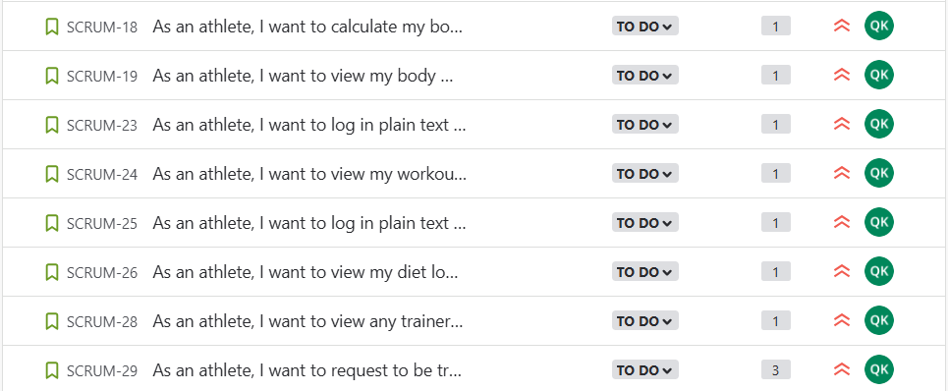

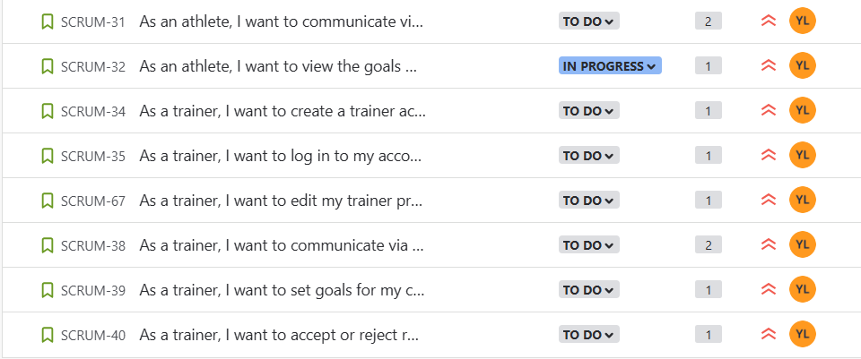

**Summary – Sprint Planning Meeting**

Our sprint planning session has been successfully completed, during which we selected **26 user stories** with the **highest priority** from the backlog. Key decisions and outcomes include:

* **Story Selection** – Chose user stories based on business value, urgency, and dependencies.
* **Effort Estimation Alignment** – Ensured that the selected stories align with previously assigned story points.
* **Team Capacity Consideration** – Assigned tasks based on the availability and workload of each team member to optimize efficiency.
* **Sprint Goals Defined** – Established clear objectives for the sprint to ensure alignment with project milestones.

With this structured plan, we are set for an efficient development cycle, ensuring timely delivery of key features and enhancements.

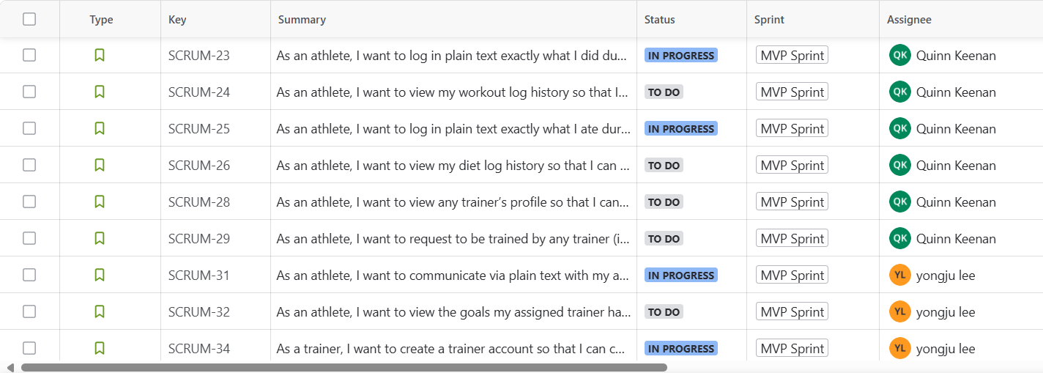

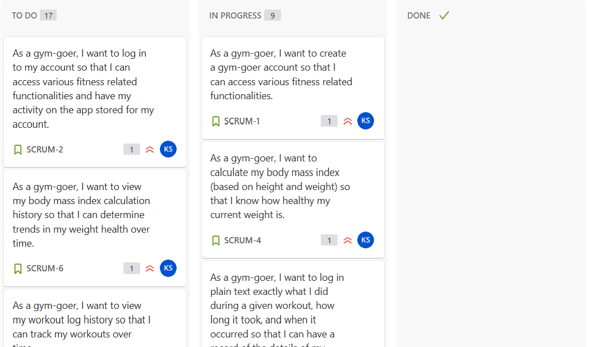

**Summary – Sprint Completion**

Our sprint has successfully concluded, delivering **26 completed user stories** while **0 remain incomplete**, and **0 has been transferred to the next sprint**. Key highlights include:

* **Completed Work** – Successfully developed, tested, and delivered 26 user stories, meeting acceptance criteria and business objectives.
* **Focused on highest priority** – focusing on highest priority was the key to make software completed well in terms of quality.
* **Time management** – it was challenging to get the job done in time, but allocating the sprints to every member based on sprints point made us manage the time easily due to awareness of difficulty.
* **Communication – asking every member’s opinion can be time consuming, but it brings people together. Therefore, team members work together well.**
* **Retrospective Insights** – Identified key takeaways to improve future sprint planning, including better estimation, risk mitigation, and workload balancing.

Overall, this sprint has made significant progress, and our team remains focused on continuous improvement for the next development cycle.



