BTS530 – Assignment 1

Student name – Iceal Claveria

Student Number – 052-174-133

Team 03

System Use Cases:

* Rating – Vincent Wong
* Search – Vincent Wong
* Profile – Kevin Pham
* Create Account – Kevin Pham
* Comment – Iceal Claveria
* Update – Iceal Claveria
* Recommendation – Faiq Malik

Use Cases

Comment Component:

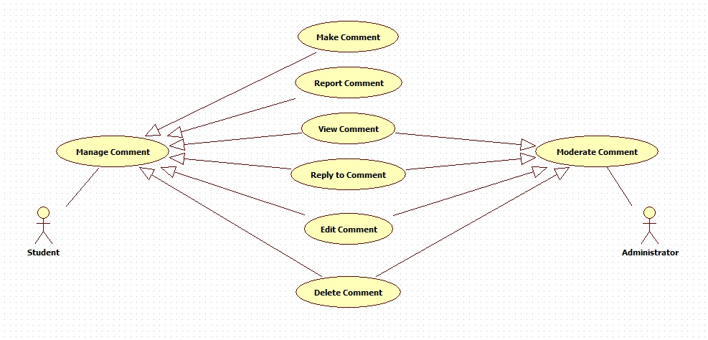

Update Component:

