BTS530 - Assignment 1

Student name - Vincent Wong

Student Number – 026-433-136

Team 03

System Use Cases:

* Rating Component – Vincent
* Search Component – Vincent
* Profile Component – Kevin
* Create Account Component – Kevin
* Comment Component – Iceal
* Update Component – Iceal
* Recommendation Component – Faiq Malik

Use case: Rating Component

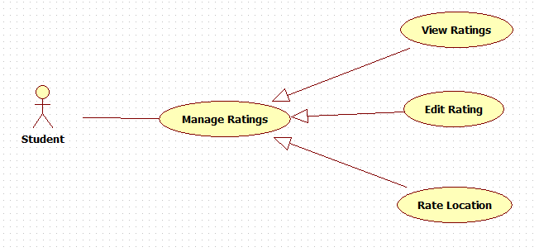

Search Component

