BTS530 Assignment 1

Student Name: Kevin Pham

Student Number: 053 284 139

Team Number: 3

All Use Cases:

* Rating Component – Vincent
  + View Ratings
  + Edit Ratings
  + Create Ratings
* Search Component - Vincent
  + Search location
* Profile Component – Kevin
  + Student EditAccount
  + Student ViewLocationHistory
  + Student MakeComment
  + Student View Recommendation
  + Administrator SuspendAccount
  + Administrator DeleteAccount
  + Administrator ViewRecommendation
  + Administrator ViewComments
* Create Account Component – Kevin
  + Create Customer Account
* Comment Component – Iceal
  + Student –
    - Making a Comment
    - Reporting a Comment
    - Viewing a Comment
    - Replying to a Comment
    - Editing a Comment
    - Deleting a Comment
  + Admin-
    - Making a Comment
    - Viewing a Comment
    - Replying to a Comment
    - Editing a Comment
    - Deleting a Comment
* Update Component – Iceal
  + Adding a Location
  + Updating a Location
  + Deleting a Location
  + Viewing Locations
* Recommendation Component – Faiq
  + Moderate Recommendation
  + Student Edit Recommendation
  + Student Make Recommendation
  + Student View Recommendation
* Proximity Component – Faiq
  + Set Proximity
  + Custom Proximity

Use case as follows:

Create Account Component

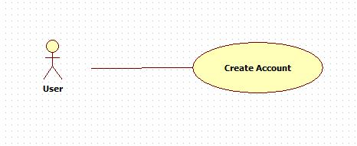

Profile Component

