

**Final Year Project,**

**Functional Spec,**

**Gym and Analytical App/Dashboard.**

Author: Kevin Quinn.

Student No: C00216607.

Supervisor: Greg Doyle.

Contents

Overview 3

Functionality 4

1) Base Application Creation 4

2) Integration of Personal Trainer Features 4

3) Implementation of Exercise Form Analysis (Optional) 4

4) Implementation of User Data Analysis (Optional) 4

Users 5

Use Cases 5

Full System Use Case Diagram 5

Register Use Case 6

Login Use Case 7

Change Password Use Case 8

CRUD Workouts Use Case 9

CRUD Nutritional Plans Use Case 10

Record Workout Use Case 11

Record Nutritional Use Case 12

View Workouts Use Case 13

View Nutritional Plans Use Case 14

Add Clients Use Case 15

Exercise Image Analysis Use Case 16

Scenarios 17

Scenario 1: Personal Trainer. 17

Scenario 2: Client. 17

Scenario 3: General User 18

UI/UX 18

Home Screen 19

Record Workout Screen 20

Metrices 21

Precedent for this Application 21

Table of Figures 21

References 21

Appendix 22

Declaration 22

# Overview

The application is to be used by personal trainers and clients. The application will contain features for personal trainers allowing them to effectively manage and communicate with their clients about their fitness regime, allowing them to track the progress their client is making, as well as make changes to their workouts or nutritional plans whenever they may be needed. The application will also allow the user to track their own fitness regime without the need for a personal trainer, meaning they can create and track their own workout and nutritional plans. Also an area of I want to research into with this project is the possible implementation of machine learning to benefit the user to start this research off I shall begin by trying to create a model that can tell the difference between two exercises for example a squat and a bench press. From here depending on time and difficulty I would like to research further than this and make a more advanced model, but this is unlikely. Another feature which could be implemented is using machine learning to analyse the users recorded data such as their workout information and use this data to provide feedback on how to improve based around a certain goal which the user can set E.g. building strength.

# Functionality

With this application there are four sections of functionality to be considered with development. The first part is the application itself containing features such as creating an account etc. The second being the integration of a personal trainer being able to interact with and manage their clients through the app. The third being the implementation of machine learning with image analysis to be used with checking exercise form. Finally, the fourth being the implementation of machine learning to analyse user data and provide feedback.

## Base Application Creation

The first feature to be implemented is the base application itself. This could be said to be the foundation of the app which will be built upon with the future pieces of functionality listed below. This base application will contain functionality such as creating an account and logging into the application. Also, the ability for the users to create workout plans, nutritional plans and record their day to day activities such as the food they ate to meet their nutritional plan or the workout they undertook to meet their workout plan. With the user’s data being recorded helpful visualisations will be used to then display this data back to the user and allow them to accurately track their progress.

## Integration of Personal Trainer Features

This second feature will be the integration of functionality to allow a personal trainer to effectively manage and couch their client. This will include the ability to create an account of type “Personal Trainer”, where the personal trainer will have the ability to view all their clients, manage and change each of their fitness regimes. The personal trainer will also be provided with a page to view their client’s overall progression which will include helpful visualisations of data to make it simpler and more efficient to view the data and then be able to make the changes necessary to each client to aid them in their improvement with their fitness regime. The personal trainer will also be provided with the same ability as a normal user account to track their own fitness regime.

## Implementation of Exercise Form Analysis (Optional)

This piece of functionality will give the user the ability to import a video of them completing a rep of a certain exercise E.g. from their local storage on their device which will then be analysed by the app using machine learning to determine whether the reputation was completed correctly or incorrectly and, in that case, provide feedback on how to correct this form. This will involve the video being uploaded to a server where the machine learning analysis will take place and said results will be returned to the user once complete.

## Implementation of User Data Analysis (Optional)

This feature will allow the users fitness regime data to be analysed by the application using machine learning to provide positive feedback including changes that could be made to regime to increase progression towards a certain goal. For E.g. a user could be looking to increase their strength, they will supply this as a goal to the application and the machine learning feature will analyse their current regime data and provide feedback that will increase their progression rate towards that goal. This will be implemented server side, so the machine learning analysis will happen on the server on the data stored in the database and then the results will be shown to the user.

# Users

This application is being developed to be used by personal trainers in the fitness industry and their clients, as well being used by users who want to improve their own fitness without the use of a personal trainer. Due to this not all users will be familiar with how a fitness regime works as they could be completely new to the fitness. The application will be developed in a way that it will be understandable and useable by all users. As of June 2019, 500,000 people were a member of a fitness institution in Ireland [1]. With this number increasing every year, due to the further investment into the health and fitness industry, more people are looking for ways to become healthier and fitter than ever. This gives great market exposure to an application in this sector, especially if you include the world market of potential users and not just those in the Irish region.

# Use Cases

## Full System Use Case Diagram

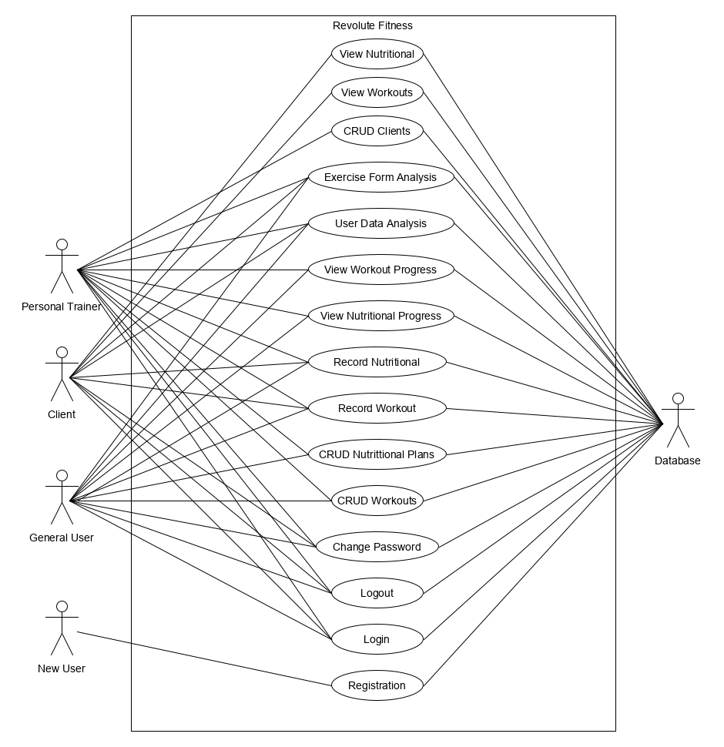

Figure 1: Full System Use Case Diagram

## Register Use Case

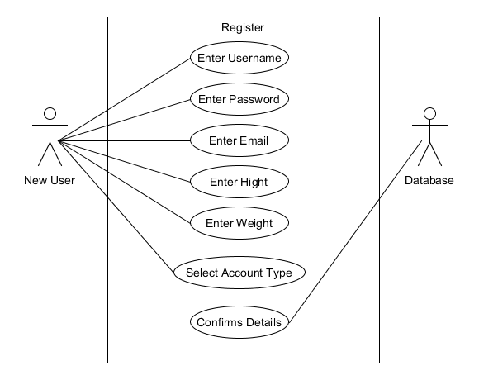

Figure 2: Register Use Case Diagram

**Use Case:** Register

**Actors:** New User, Database.

**Brief Description:** The new user will enter their username, password, email, height and weight and then select their fitness goal and account type. The database accepts these values and confirms the account has been created.

**Main Success Scenario:**

1. The user enters a username.
2. The user enters a password.
3. The user enters an email.
4. The user enters their body weight.
5. The user enters their height.
6. The user selects their fitness goal.
7. The user selects their account type.
8. The user’s details are sent to the database.
9. The database checks that username and email are unique.
10. The users account is created.
11. The database confirms the account has been created.

**Alternatives**

2a**.** The user’s password does not meet strength standards.

1. The user is asked to retype password.

9a. The user’s email or username is already in use.

1. The user is told the username or email already exists and to use another one.

## Login Use Case

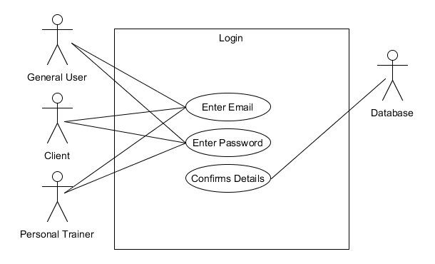

Figure 3: Login Use Case Diagram

**Use Case:** Login

**Actors:** General User, Client, Personal Trainer, Database.

**Brief Description:** The General User/Client/Personal Trainer will enter their email, password. The database will check if these values are correct then log the user in.

**Main Success Scenario:**

1. The General User/Client/Personal Trainer enters an email.
2. The General User/Client/Personal Trainer enters a password.
3. The user’s details are sent to the database.
4. The database checks that username and password are correct.
5. The General User/Client/Personal Trainer is logged in.
6. The database confirms the General User/Client/Personal Trainer has been logged in.

**Alternatives**

4a**.** The General User/Client/Personal Trainer password or email are incorrect.

1. The General User/Client/Personal Trainer is asked to retype credentials.

## Change Password Use Case

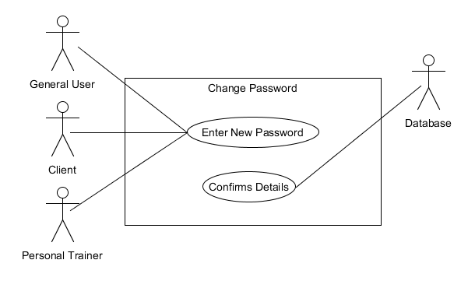

Figure 4: Change Password Use Case Diagram

**Use Case:** Change Password

**Actors:** General User, Client, Personal Trainer, Database.

**Brief Description:** The user will request a change password link to be sent to their email from there after opening the link they will be provided with the page to change their password.

**Main Success Scenario:**

1. The User requests the change password link.
2. The User checks their emails for the link.
3. The User opens the link and is displayed with the change password page.
4. The User enters their new desired password.
5. The User clicks submit, and their password is now changed.

**Alternatives:**

5a. The user does not type a valid password.

1. The user re-enters the desired password to meet password requirements.

## CRUD Workouts Use Case

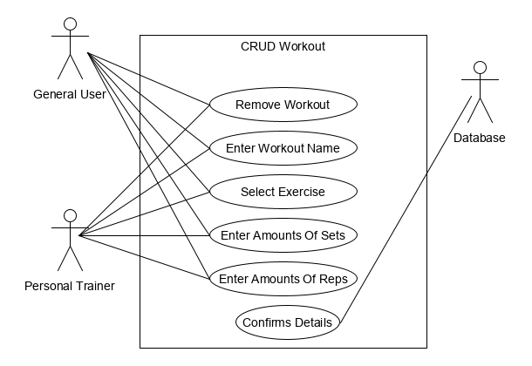

Figure 5: CRUD Workout Use Case Diagram

**Use Case:** CRUD Workouts

**Actors:** General User, Personal Trainer, Database.

**Brief Description:** The User will have the ability to delete a workout, view the workout, edit the workout and create a workout. First the user will be in a view of all their workouts with the ability to delete them view the or create a new one. If a user chooses to view one, they will have the ability to edit it.

**Main Success Scenario:**

1. The User enters the view workout view.
2. They can choose to delete a workout.
3. They can choose to view a workout.
4. If viewing the workout, they can select to edit.
5. They can choose to create a workout.
6. The User will enter a workout name.
7. The User will select an exercise.
8. The User will enter the amount of Sets.
9. The User will enter the amount of Reps.
10. The User will click create.
11. The workout will be added to their current workouts.

**Alternatives:**

9a. User wants to add another exercise.

1. User clicks “Add Exercise” button.
2. User’s screen is populated with the necessary extra fields.

## CRUD Nutritional Plans Use Case

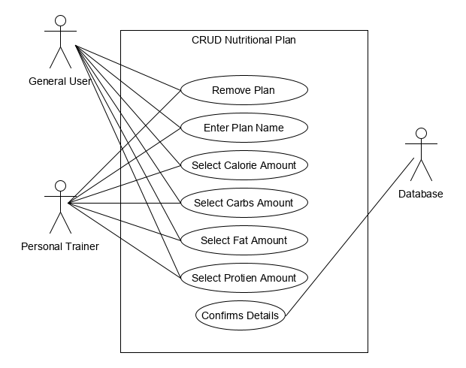

Figure 6: CRUD Nutritional Plan Use Case Diagram

**Use Case:** CRUD Nutritional Plan

**Actors:** General User, Personal Trainer, Database.

**Brief Description:** The user will be able to create a nutritional plan which involves entering a plan name, entering the intake calories and macro’s, which are carbs, fat and protein.

**Main Success Scenario:**

1. User enters create nutritional plan screen.
2. User enters plan name.
3. User enters calories.
4. User enters carbs.
5. User enters fats.
6. User enters protein.
7. User confirms details.
8. Plan stored in database.

**Alternatives:**

## Record Workout Use Case

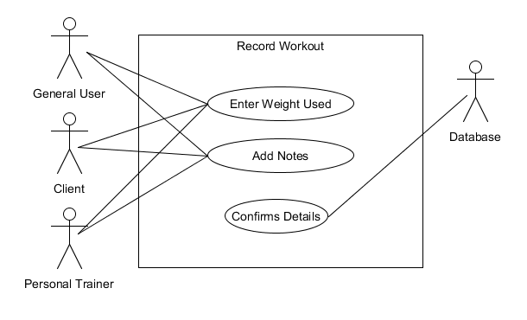

Figure 7: Record Workout Use Case Diagram

**Use Case:** Record Workout

**Actors:** General User, Client, Personal Trainer, Database.

**Brief Description:** The User will begin in the record workout view where they will select from there list of workouts which one, they want to record. They will then be presented with a screen to enter in the weight they used for each exercise, add notes and then record the workout.

**Main Success Scenario:**

1. User enters record workout screen on a workout.
2. User enters the weight used for each exercise.
3. User adds notes to be saved along with the workout.
4. User records the workout.

**Alternatives:**

4a. User did not enter a weight for an exercise.

1. User enters a valid weight.

## Record Nutritional Use Case

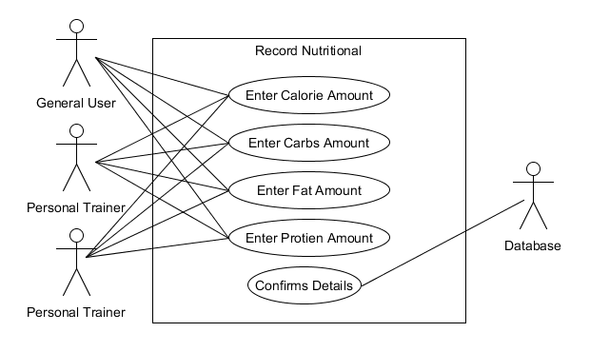

Figure 8: Record Plan Use Case Diagram

**Use Case:** Record Nutritional Plan

**Actors:** General User, Client, Personal Trainer, Database.

**Brief Description:** The user enters the record nutritional screen where the will enter the calories consumed that day along with the carbs, fats and proteins which will then be recorded into the database.

**Main Success Scenario:**

1. User enters record nutritional screen.
2. User enters calories taken that day.
3. User enters carbs taken that day.
4. User enters fats taken that day.
5. User enters proteins taken that day.
6. User clicks confirm.
7. Details stored in database.

**Alternatives:**

## View Workouts Use Case

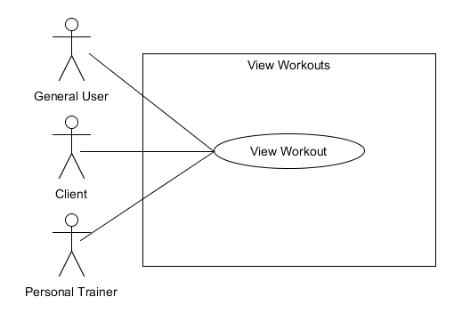

Figure 9: View Workout Use Case Diagram

**Use Case:** View Workouts

**Actors:** General User, Client, Personal Trainer.

**Brief Description:** User will navigate from the main dashboard to the view workouts page where they will get a view of all the workouts the application currently stores for them from here the user can click into a workout to view it in more detail or have the option to edit it.

**Main Success Scenario:**

1. User clicks “View Workouts” button in main dashboard.
2. User is presented with the view workouts page.
3. View workouts page is populated with user’s workout.
4. User clicks into one of their workouts.

**Alternatives:**

3a. The user has no workouts created thus the page is populated with a notice to make one.

1. User creates a workout.

## View Nutritional Plans Use Case

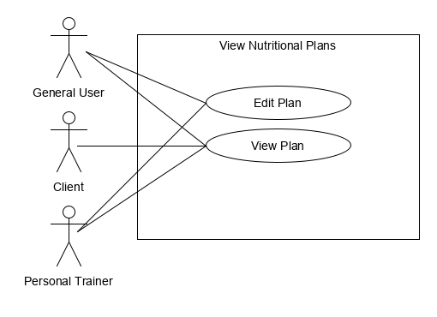

Figure 10: View Nutritional Plans Use Case Diagram

**Use Case:**

**Actors:**

**Brief Description:**

**Main Success Scenario:**

**Alternatives:**

## Add Clients Use Case

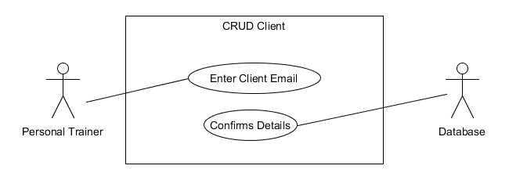

Figure 11: Add Client Use Case Diagram

**Use Case:** Add Clients.

**Actors:** Personal Trainer, Database.

**Brief Description:** The personal trainer will enter the “Manage Clients” screen. From here they can enter an input the email of the new client they want to add as one of their clients. If the email matches a free client, then the client shall be populated into the clients list.

**Main Success Scenario:**

1. Personal trainer enters manage clients screen
2. Personal trainer enters email input, the client’s email.
3. Personal trainer clicks the add button.
4. The new client is added to the list of clients.

**Alternatives:**

4a. Personal trainer entered wrong email and no client was found.

1. Personal trainer enters correct email.

## Exercise Image Analysis Use Case

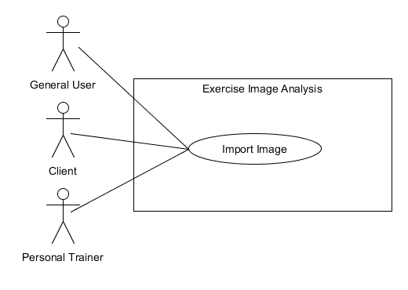

Figure 12: Exercise Image Analysis Use Case Diagram

**Use Case:** Exercise Image Analysis

**Actors:** General User, Client, Personal Trainer.

**Brief Description:** The user will begin by clicking the “Exercise Analysis” button on the main dashboard. From here the user will be brought to the analysis page where an image can be taken with the mobile device of someone preforming a bench press or squat and the image will be analysed and classified.

**Main Success Scenario:**

1. User clicks “Exercise Analysis” button and is brought to the screen.
2. User takes picture or uploads picture with mobile device.
3. User clicks “Predict”.
4. Results of analysis displayed to user.

**Alternatives:**

2a. Users image fails to upload.

1. User retries.

# Scenarios

With this application there are multiple scenarios in which a user may use it. Since this application will cater to personal trainers, their clients and just general users there will be many ways in which the application will be used. This document will provide a scenario for each user type based on their believed needs for this application.

## Scenario 1: Personal Trainer.

* The personal trainer (PT) will open the application on their mobile device E.g. Samsung S8.
* The PT will already be logged in from previous uses.
* The PT is met with the home screen dashboard page with all their available features.
* The PT selects the “View Clients” tab and begins to browse their clients.
* The PT selects one of their newer clients and opens their profile.
* The PT views their clients tracked work out and nutritional progress as recorded by the user.
* The PT notices the client has progressed in an area in the workout plan.
* The PT changes the workout plan to accommodate for this improvement.
* The PT messages the client notifying them of the change.

James is a personal trainer working in IT Carlow. James is a member of the Revolute Fitness Application which he uses to track and manage his clients on a day to day basis. After taking out his mobile device, James opens the application. From here James does not have to login due to his previous use on the application. James is met with the home dashboard where he continues to select the “View Clients” tab. James is looking through his list of clients for a new client of his which joined up two months ago. James locates his client Sarah and views her profile. James looks through her progress in her workouts and nutritional plans using features built into the app for graphing this progress. James sees a big improvement in Sarah’s workouts. He then continues to locate Sarah’s current workout plan and begins to make changes to match the improvement she has made. James then sends Sarah a message to let her know that he made this change to her workout and praises her for her improvement.

## Scenario 2: Client.

* The client will open the application on their mobile device.
* The client will be logged in from previous uses.
* The client is met with the application home screen dashboard with all available features.
* The client records todays workout progress using the record workout feature on the home screen.
* The client receives a message from their personal trainer.
* The client’s workout for that day has been updated and they can view it now.

Sarah is a student at IT Carlow, she wanted to improve her fitness, so she hired James a personal trainer to help her progress with her fitness goals. Sarah’s personal training experience is managed through the Revolute Fitness Application by her personal trainer James. Today after Sarah has completed her workout, she opens out her mobile device and proceeds to open the Revolute Fitness app. From here she is greeted by the home screen dashboard where she selects the record workout feature. Here Sarah records here workout that she completed today. Sarah receives a push notification from the application. It is a message from James saying he has updated her workout for that day. Sarah can now view the workout.

## Scenario 3: General User

* The user will open the application on their mobile devise.
* The user will be logged in from previous uses on the application.
* The user will be met by the home screen dashboard of the application.
* The user will select the “Exercise Form Analysis” feature of the application.
* The user will be prompted to select the exercise in which they want to check.
* The user will be prompted to upload a video of them completing the exercise from a certain angle.
* The user will upload the video and wait for the analysis to be complete.
* The user will be informed that they are using correct technique and form with this exercise.

Sam is a student at IT Carlow. Sam is new to the gym and strength training in general. He uses the Revolute Fitness Application to help manage his own fitness progress including managing his workouts and nutritional plans. Today Sam is going to the gym and he is going to be trying a new exercise to him, a squat. He is unsure if he can do it correctly, so he plans to use the “Exercise Form Analysis” feature of the Revolute Fitness Application. Sam proceeds to the gym and records a video of himself completing the squat. He opens the application and since he has used the application before he is still logged in. He is met by the home screen dashboard, where he selects the “Exercise Form Analysis” feature, he selects the squat as the exercise that he wants to analyse and proceeds to upload the video. The application proceeds to analyse the video and informs Sam that he is using correct technique when completing this exercise.

# UI/UX

With there being different types of users, E.g. Personal Trainer, Client and General User, there will be different versions of some pages to accommodate their uses. The idea is to create a simple and usable UI which will allow use of all features easily and quickly, without being overly complex.

## Home Screen

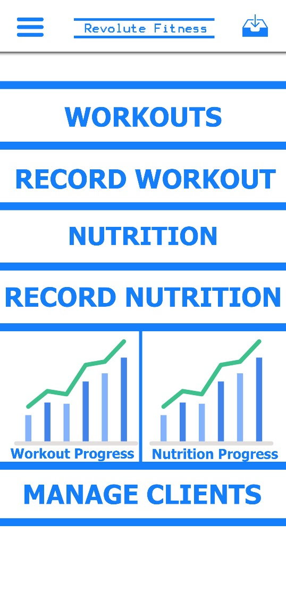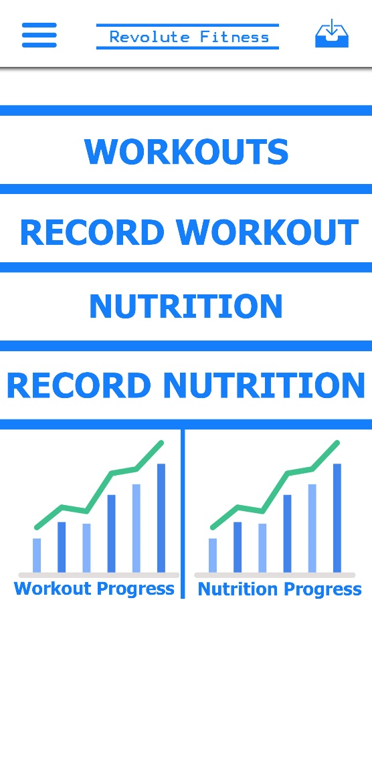

Figure 13: Home Screen UI Prototype.

This design is an example of what the home screen could look like. Using contrasting colours means easy accessibility for users with poor eyesight. Since multiple types of users could be using this screen, there will be a few variations as can be seen above.

## Record Workout Screen

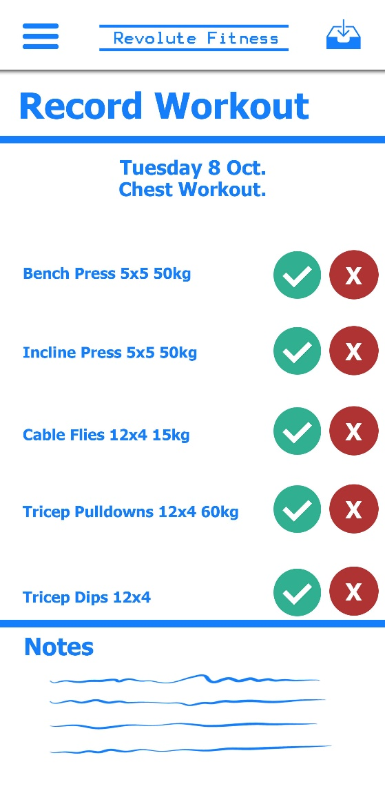

Figure 14: Record Workout Screen UI Prototype.

The record workout screen is an example of a standard screen that will be used across all users. Users will record workouts based on workouts which have already been created. They will either record that they completed the listed exercise or not and can add notes to each workout.

# Metrices

The success of this application will be determined by the fact of it having met the following criteria.

* Base app structure including user creation and logging in and recording fitness regimes.
* Personal trainer integration allowing them to manage and track client’s fitness regime.
* The feature of user data analysis to provide helpful feedback using machine learning.
* The feature of exercise form analysis to identify if a user is performing an exercise correctly.

# Precedent for this Application

The precedence for the development of this application came from my own experience as someone trying to better themselves in fitness. From this I could see what was needed as a user of this app to be successful and I am essentially developing something which must meet my own standards of success which will be that I want to use this app myself on a day to day basis.

# Table of Figures

Figure 1: Full System Use Case Diagram.

Figure 2: Register Use Case Diagram.

Figure 3: Login Use Case Diagram.

Figure 4: Change Password Use Case Diagram.

Figure 5: CRUD Workout Use Case Diagram.

Figure 6: CRUD Nutritional Plan Use Case Diagram.

Figure 7: Record Workout Use Case Diagram.

Figure 8: Record Nutritional Use Case Diagram.

Figure 9: View Workouts Use Case Diagram.

Figure 10: View Nutritional Plans Use Case Diagram.

Figure 11: Add Client Use Case Diagram.

Figure 12: Exercise Form Analysis Use Case Diagram.

Figure 13: Home Screen UI Prototype.

Figure 14: Record Workout Screen UI Prototype.

# References

1. Irelandactive.ie. (2019). [online] Available at: https://www.irelandactive.ie/contentfiles/EuropeActive_Deloitte_EHFMR_2018_IE.PDF [Accessed 14 Nov. 2019].

# Appendix

## Declaration

* I declare that all material in this submission e.g. thesis/essay/project/assignment is entirely my/our own work except where duly acknowledged.
* I have cited the sources of all quotations, paraphrases, summaries of information, tables, diagrams or other material; including software and other electronic media in which intellectual property rights may reside.
* I have provided a complete bibliography of all works and sources used in the preparation of this submission.
* I understand that failure to comply with the Institute’s regulations governing plagiarism constitutes a serious offense.

**Student Name:** Kevin Quinn

**Student Number:** C00216607

**Signature:**



**Date**: 20/04/2020