

**Final Year Project,**

**Research Document,**

**Gym Personal Training & Analytics App.**

Author: Kevin Quinn.

Student No: C00216607.

Supervisor: Greg Doyle.

Contents

1. Abstract. 3

2. Introduction. 4

3. Existing Apps. 5

3.1. MyFitnessPal 5

3.2 Samsung Health. 6

4. Machine Learning. 7

4.1. User Data Analysis. 7

4.2. Exercise Form Analysis. 7

5. Implementation of Technology. 7

5.1. Front-end technologies. 7

5.1.1. Xamarin. 7

5.1.2. Ionic 4 8

5.2. Machine Learning. 8

5.2.1. Pandas. 9

5.2.2. Plotly. 9

5.2.3. Scikit Learn. 9

5.2.4. Tensor Flow. 9

5.2.5. Keras. 9

5.2.6. OpenCV. 10

5.3. Cloud and Database Infrastructure. 10

5.3.1 Google Cloud Services. 10

5.3.2 AWS Amplify. 10

5.3.3 Googles Firebase. 10

6. Testing. 11

6.1. Automation Testing. 11

6.2. Manual User Testing. 11

7. Conclusion. 12

7.1 Mobile App Framework. 12

7.2 Machine Learning Development. 12

7.3 Cloud Infrastructure for Mobile Backend. 12

8. Table of Figures. 12

9. References. 13

10. Appendix 14

10.1. Declaration 14

# Abstract.

The purpose of this project is to develop an application that would allow personal trainers, coaches and managers interact with their clients and players online, where workout plans, fitness regimes and nutritional plan can be managed in one place and be easily distributed and used by the users E.g. clients, players and gym goers. This app will also be a place where the solo gym goer or player can manager their own workout plans etc. The project will see the implementation of machine learning in 2 areas, analysing user data to provide valuable feedback to help improve their time in the gym, and the implementation of image/video analysis to analyse the users form when completing a certain exercise and determine whether it is correct or needs to be improved and how.

Currently in Ireland there is on average 500,000 people registered as a member in gyms and fitness centres across the country. Put this with the large number of people who are members of sports teams in Ireland and we have a large populous who can be positively affected by this app and could really see more people focusing on their health and fitness.

# 2. Introduction.

Fitness and body health are big up-coming trends in the world today. Which can be seen by the rising number of gym goers in Ireland currently at 500,000 and rising. Using machine learning, the aim of this project is to provide gym goers and people of the fitness industry in general an app in which can aid them in their venture to becoming fit, losing weight or getting stronger.

People usually go to the gym for one or a couple of the following reasons,

* To lose weight.
* To get fitter.
* To get stronger.

Weather it’s because they are a part of a sports team and want to up there stamina to keep up with the growing demands of fast paced sports, or to get stronger to be able to take big hits, serve up their own and be able to continue on with the game, to work solely on just getting stronger and pushing them next PR’s on the bench, to solely focusing on their physique wanting to lose weight and gain muscle mass.

These are all goals in which people who use gym’s these days could be looking for and to be at the top of their game, and achieve their goal quickly and efficiently takes planning, lots of planning and preparing otherwise the time put in could all just be a waste.

Therefore, people now turn to fitness coaches and personal trainers who have college degrees to plan and prepare for them. For a price, you can get expert knowledge to plan out your whole fitness regime, leaving you to put in the hard work of following it.

Or teams turning to strength and conditioning coaches to up their players to the next level and get an edge on the competition.

There is a big market for an app like this, but it needs a selling point. There needs to be a reason to install this app as if its just recording user data and storing it, a notebook and pen or even an excel document would be just as easy and effective. Not only that but the marketplace is already saturated by well established apps which provide an easy to understand and manage user interface which is used by millions of people each day.

That’s why this app will have to do all this plus more to really take off and be useful to the client. This is where allowing easy interactions and manageability between personal trainers etc and their clients etc comes into play. There are several apps in the marketplace that have this feature, but match this with the implementation of machine learning to allow effective analysis of a user’s data, compare this data with other user’s data to provide valuable feedback to the client and trainer and this is a game changer. Along with machine learning for image and video analysis to allow a feature which can check a client’s form on various exercises such as bench presses and squats and this leaves a nearly one of kind app in a market of thousands.

With all these factors in mind, this project really has the potential to be very successful.

# 3. Existing Apps.

## 3.1. MyFitnessPal

MyFitnessPal is a well-established fitness app in the market and has been around for nearly 13 years. It has a heavy focus on nutritional management and aims more towards the weight loss side of fitness. It has a very clean and user-friendly interface which is simplistic and aesthetically pleasing making use of the IOS / Bootstrap design approach with nice contrasting colours. It provides the features of,

* Tracking daily calorie intake.
* Recording basic daily workouts.
* Beneficial data visualizations for the user.
* A social media / community aspect where users can post statuses.

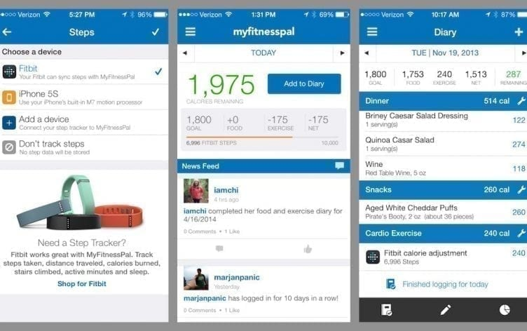

#### Figure 1: MyFitnessPal User Interface.[11]

The one feature it lacks which is where one of this project focuses are is the interaction between a trainer and client, and obviously the exercise form checker using machine learning. All in all I believe I can take some good points from MyFitnessPal, including its approach of a clean and simple user interface, the possibility of a some sort of nutritional tracker, but most importantly its visualisations of its user data which I believe are really beneficial to the user and can be a great source of motivation to continue their fitness regime but also to continue using the app.[8]

## 3.2 Samsung Health.

Samsung health is Samsung’s health and fitness app developed specifically for their android platform of mobile phones. Like MyFitnessPal it benefits from a real clean user interface with easy to use features. The app also has a heavy focus on the dietary and nutritional side of fitness, which seems to be the focus of app in this area. Whereas with this app the more physical attributes of fitness will be the focus.

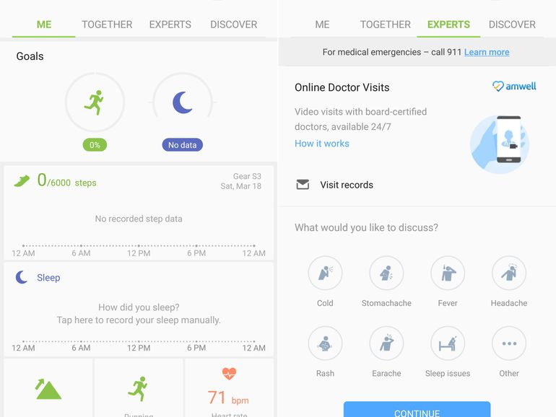

#### Figure 2: Samsung Health user interface.[15]

Samsung health allows for easy calorie tracking by being able to add your meals to your daily planned, doing this by being able to select products from there large database of well-known branded food products and not having to worry about entering each piece of nutritional information separately really has led to easy nutritional tracking in this area. Samsung health also boasts the community aspect of health and fitness, being able to share your daily step achievement or running times with friends really give the user a drive to further better themselves physically and in terms of their health. The community factor is large factor in these apps as it has been proven to be one of the most influential parts of getting people to stick to their health and fitness regimes along with tracking their workouts and following a routine, all which Samsung Health provides.[14]

# 4. Machine Learning.

## 4.1. User Data Analysis.

For this app, one feature which could be implemented is the analysis of user entered data using machine learning and artificial intelligence. For E.g. over the course of three weeks a user enters their workout / exercise data and using machine learning to analyse their workout, the user can be given feedback on their workout, giving beneficial advice to the user to improve.

## 4.2. Exercise Form Analysis.

Using image and video analysis, linked we machine learning, a feature which could be used to check a user’s form when completing an exercise could be implemented. For E.g. a user who is currently doing squatting exercises can record themselves completing a squat and using the video analysis / machine learning the app can analyse their form and let them know if it is correct or needs improving or correction and how to correct it.

This could be implemented by training an AI with correct form data and incorrect data to give it the ability to tell the difference but also be able to provide feedback on how to correctly complete this exercise.

# 5. Implementation of Technology.

## 5.1. Front-end technologies.

For this app, there are two ways in which it could be developed,

* Xamarin – Microsoft owned application development framework.
* Ionic 4 – UI toolkit for creating mobile and web-based apps using angular.
* Web based - website with mobile interface.

### 5.1.1. Xamarin.

Xamarin is a Microsoft owned application development framework being used by many large and established companies to develop their mobile apps. As of 2017 1.4 million developers were using Xamarin across 120 countries. It is very popular for its cross platform codability. Meaning code once and it is useable by IOS, Android and MS Windows. It extends the .NET developer platform created by Microsoft and as such uses a shared C# code base and thus provides tools and libraries specifically for developing applications Android, IOS, tvOS, watchOS, macOS.

Companies such as 3M, AT&T and HP have used this platform to develop many of their apps due to its coding practices, time saving and effectiveness in terms of development, without reducing the quality of the product.

Visual studio, a well-established and efficient IDE is used to develop Xamarin, meaning Xamarin can also be developed on macOS and is well supported.

In terms of development Xamarin utilizes the Model / View / Controller or MVC design pattern. Doing this allows the developer to determine which parts of the application will be using native user interface components for each platform E.g. IOS Android and allows the application to be split into two components, core and user-interface, this is very helpful as it allows the developer to easily manage which parts of the application need to be developed directly for a specific platform and which can be cross platform.

Utilizing this also means the applications user-interface can be developed using native user interfaces for the platform. E.g. on IOS you can use the UIKit API’s to create a native looking app, also utilizing Xamarin’s IOS designer to create your UI visually. Vice versa, on Android you can use Android.View to achieve the same results. Also, Xamarin can access and make use of every native UI on the platform meaning even better usability.

Using this feature of Xamarin would allow the best possible user experience to be created for each platform, whilst also still utilizing the core cross platform component of Xamarin to develop the cross-platform code and minimise development time. Meaning the app would benefit from the great user experience on each platform.

Xamarin would be the best solution for development of this mobile app as of the time of this research document being created. [1,2]

### 5.1.2. Ionic 4

Ionic 4 is an opensource Javascript framework which allows the development of web-based mobile apps also known as hybrid apps for many platforms. It was created by a company called Drifty in 2013 and was originally released as a framework built on top of Angular Js and Apache Cordova. But with the latest release the user can choose between web frameworks such as React and Vue Js and including angular.

One of the main advantages of using Ionic is that it is pretty much code once and can be deployed everywhere. Your app can be deployed as a progressive web app on many hosting services such as Googles Firebase. It can also be installed natively on mobile devices through there platforms app stores utilizing Cordova or Capacitor to compile the app down into the respective platforms code and into an executable for it to be able to be installed directly on the device.

Another big advantage of using Ionic 4 with angular is the sheer number of libraries, or modules as they are called in angular that are available to use. This can reduce development time for some complex features or just simplify normally time consuming but simple work. For E.g. there is a Google Firebase module that contains all the functions needed to do with user authentication. This module makes it that easy that it is as simple as passing it the email and password and it sorts out all the backend work itself.

One thing with using Ionic though is its user experience isn’t as up to scratch, but it is close, as that of an app which is programmed and coded natively for that platform. But what we lose in small amounts in the user experience side is gained by the massively cross platform nature of the framework being able to be everywhere means it will not be limited to one market such as android or apple thus the potential for a big user base is high.

All in all, I believe Ionic is also a very big contender for the use in the development of this application, due to its massive functionality applications and simplistic approach. [16]

## 5.2. Machine Learning.

For the machine learning part of this project I believe Python would be the best language to achieve the desired results. It is currently the most used language in the machine learning sector and comes with many libraries aimed at making machine learning and data science more accurate and easier to use than ever before.

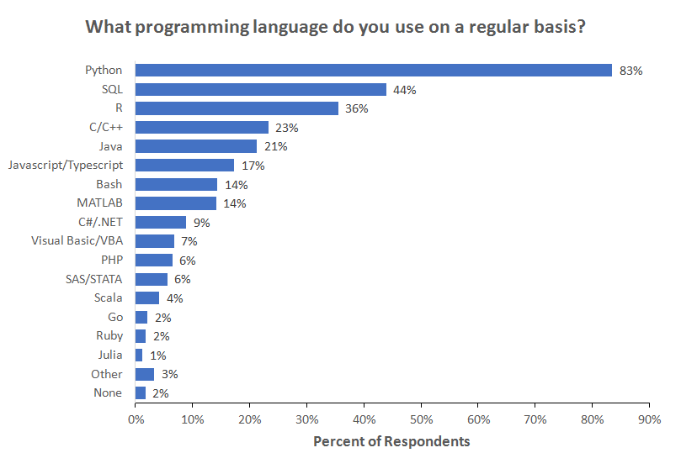

#### Figure 3: Most used programming languages in machine learning 2018 (Kaggle.com) [10].

### 5.2.1. Pandas.

This is a data science library for python. Pandas allows the easy import and processing / cleaning of data in python. It provides data frames, which is its way of storing imported data from formats such as csv files. It then allows the easy manipulation of this data including providing criteria in which to clean the data such as blank cells etc. [4]

### 5.2.2. Plotly.

This python graphing library allows the easy creation of interactive graphs, publication quality graphs, to help provide visualizations of key data to the user. Graphs it included are line plots, scatter plots, bar charts and histograms etc. This will be a key part of the project as it is important to display data to the user in a clean, easy and understandable manner.[5]

### 5.2.3. Scikit Learn.

This is a machine learning library for python. Sickie Learn provides the ability to perform machine learning algorithms such as regression, clustering and classification, on data which will be vital to the projects machine learning aspects.[6]

### 5.2.4. Tensor Flow.

This is an end to end python machine learning library. Its key feature is performing high-end numerical computations. It can manage deep neural networks in areas such as image recognition and analysis which will be beneficial to the exercise form checker feature planned to be implemented in this app. It also provides algorithms which aid in creating a responsive application such as voice expression which could be leveraged in this project.[7]

### 5.2.5. Keras.

This is an open sourced python library used for construction neural networks in machine learning projects. It can run Deeplearning4j, MX Net and many more machine learning architectures. This library makes it easy for machine learning beginners to design and develop a neural network. A neural network will be key with the image / video analysis side of this project.[7]

### 5.2.6. OpenCV.

OpenCV is an open sourced library designed for python to be used with computer vision i.e. image processing. OpenCV gives a developer the ability to create python code which can read and write images. It can detect faces and features such as shapes like circles rectangles etc for E.g. a coin in an image and text recognition in an image such as road signs, number plates and number plates on cars. This library will be useful for the exercise for checker feature of this app as some form of image processing will have to implemented.[9]

## 5.3. Cloud and Database Infrastructure.

### 5.3.1 Google Cloud Services.

Google cloud services is designed to be a one stop shop for all your cloud infrastructure needs. It can be scaled up and down depending on your needs and can host a variety of backend application frameworks such Java, Python, PHP and GO. It also can host a database of my choice such as MySQL. Using Google cloud services would be ideal as it means I can keep every part of my backend process in the one place easily connecting with each other. [13]

### 5.3.2 AWS Amplify.

Like Google, AWS is a one stop shop for my hosting needs and with AWS Amplify being specifically designed for hosting mobile apps and their backend processing, it might be the ideal cloud solution to use. Due to lack of experience with AWS it could be an issue but from research it appears to be easy to use so that should not be a problem. Using the Amplify framework, a set of libraries and various other components can be used to build out a mobile backend and allow integration with my app on IOS, Android or Web based app. Using the GraphQL language as a query language such as SQL, data on the servers can be synced in real time to the mobile device, making the app more efficient and faster. Overall AWS Amplify looks like the right choice for this project, but it will still need to be tested out.[12]

### 5.3.3 Googles Firebase.

Googles Firebase is a hosting solution built into the Google Cloud Services but built with mobile development in mind. As a hosting solution it covers all my needs, from providing solutions for user management and creation, non-relational database for storing data which is created by my users and what they call firestore which is a storage solution for storing files such as images etc which could be created by your users. With its functionality being widely developed with the angular framework it could be a great solution to use with Ionic as they pair quite nicely. [17]

# 6. Testing.

Testing will be an important part of this project as there are many features that will be developed that need to be checked in many scenarios to make sure that all results are accurate and as intended. This will be done in two ways including automation testing with the selenium framework and manual user testing.

## 6.1. Automation Testing.

Using the Selenium framework, a regression suite of tests will be created to accurately test the app and all its features on a constant basis during development. This will help ensure the integrity of the app but also reduce manual testing time of some of the more basic features of the app such as the user interface and system.

## 6.2. Manual User Testing.

Using IT Carlow’s gym centre members as a testing pool will be a way of unbiasedly testing and gaining valuable feedback on how the app works and identifying some of its flaws and strong points. For E.g. a select few individuals will be given the app to be used daily with their workout routine and following a select period of usage, feedback, data and usage statistics will be retrieved to identify how to improve the app and what bugs need to be fixed.

# 7. Conclusion.

## 7.1 Mobile App Framework.

From the research carries out at the time this document was being created, it seems that Ionic is the best choice to use with this project. It has a quick uptake time meaning it can be learned a lot quicker than other frameworks such as Xamarin giving me more time for development. But also, its integration with Firebase makes it the best choice.

## 7.2 Machine Learning Development.

From researching the machine learning part of this project, it is obvious that Python will have to be used to complete these goals. Python is the most used machine learning and data science language and has many already defined libraries which make accurate and fast machine learning development easy. Due to these factors and with pythons easy and readable code layout, it is decided that it will be used for the machine learning development. For the actual framework to be used with python, I have chosen Tensorflow due to its wide use today and providing so many functions and so on that work so well with generating a machine learning model to suite your needs.

## 7.3 Cloud Infrastructure for Mobile Backend.

From the research carried out, there are many options available as a solution but what I am going to go with is Googles Firebase due to its integration with Ionic which make them a great pair to work with.

# 8. Table of Figures.

Figure 1: MyFitnessPal user interface. [11]

Figure 2: Samsung Health user interface. [15]

Figure 3: Most used programming languages in machine learning 2018. (Kaggle.com) [10]

# 9. References.

1. En.wikipedia.org. (2019). *Xamarin*. [online] Available at: https://en.wikipedia.org/wiki/Xamarin#Xamarin_platform [Accessed 19 Oct. 2019].
2. GoodWorkLabs: Big Data | AI | Outsourced Product Development Company. (2019). *8 Benefits of Xamarin App Development | GoodWorkLabs*. [online] Available at: https://www.goodworklabs.com/advantages-of-xamarin-app-development/ [Accessed 19 Oct. 2019].
3. Hackernoon.com. (2019). *MongoDB vs MySQL Comparison: Which Database is Better?*. [online] Available at: https://hackernoon.com/mongodb-vs-mysql-comparison-which-database-is-better-e714b699c38b [Accessed 24 Oct. 2019].
4. Pandas.pydata.org. (2019). *Python Data Analysis Library — pandas: Python Data Analysis Library*. [online] Available at: https://pandas.pydata.org/ [Accessed 7 Oct. 2019].
5. Plot.ly. (2019). *plotly*. [online] Available at: https://plot.ly/python/ [Accessed 29 Oct. 2019].
6. Scikit-learn.org. (2019). *scikit-learn: machine learning in Python — scikit-learn 0.22.dev0 documentation*. [online] Available at: https://scikit-learn.org/dev/index.html [Accessed 29 Oct. 2019].
7. Hackernoon.com. (2019). *Top 8 Python Libraries for Machine Learning & Artificial Intelligence*. [online] Available at: https://hackernoon.com/top-8-python-libraries-for-machine-learning-and-artificial-intelligence-y08id3031 [Accessed 29 Oct. 2019].
8. YouTube. (2019). *MyFitnessPal App Review and Tutorial*. [online] Available at: https://www.youtube.com/watch?v=Mz14fbiL3wU [Accessed 29 Oct. 2019].
9. Anon, (2019). [online] Available at: https://www.quora.com/What-is-openCV [Accessed 30 Oct. 2019].
10. Hayes, B. (2019). *Programming Languages Most Used and Recommended by Data Scientists |*. [online] Businessoverbroadway.com. Available at: https://businessoverbroadway.com/2019/01/13/programming-languages-most-used-and-recommended-by-data-scientists/ [Accessed 30 Oct. 2019].
11. Under Armour. (2019). *Now You Can Track Your Steps in MyFitnessPal! | MyFitnessPal*. [online] Available at: https://blog.myfitnesspal.com/now-you-can-track-your-steps-in-myfitnesspal/ [Accessed 31 Oct. 2019].
12. Amazon Web Services, Inc. (2019). *AWS Amplify*. [online] Available at: https://aws.amazon.com/amplify/?nc2=h_ql_sol_use_ms [Accessed 31 Oct. 2019].
13. Google Cloud. (2019). *Cloud Solutions  |  Google Cloud*. [online] Available at: https://cloud.google.com/solutions/#application-development [Accessed 31 Oct. 2019].
14. Choudhary, P. (2019). *Samsung Health app review*. [online] Best Apps Guru. Available at: http://bestappsguru.com/samsung-health-app-review/ [Accessed 31 Oct. 2019].
15. Cipriani, J. (2019). *10 tips and tricks to get the most out of Samsung Health*. [online] CNET. Available at: https://www.cnet.com/how-to/tips-and-tricks-to-get-the-most-out-of-samsung-health/ [Accessed 31 Oct. 2019].
16. En.wikipedia.org. 2020. *Ionic (Mobile App Framework)*. [online] Available at: <https://en.wikipedia.org/wiki/Ionic_(mobile_app_framework)> [Accessed 31 October 2019].
17. En.wikipedia.org. 2020. *Firebase*. [online] Available at: <https://en.wikipedia.org/wiki/Firebase> [Accessed 31 Oct 2019].

# 10. Appendix

## Declaration

* I declare that all material in this submission e.g. thesis/essay/project/assignment is entirely my/our own work except where duly acknowledged.
* I have cited the sources of all quotations, paraphrases, summaries of information, tables, diagrams or other material; including software and other electronic media in which intellectual property rights may reside.
* I have provided a complete bibliography of all works and sources used in the preparation of this submission.
* I understand that failure to comply with the Institute’s regulations governing plagiarism constitutes a serious offense.

**Student Name:** Kevin Quinn

**Student Number:** C00216607

**Signature:**



**Date**: 20/04/2020