使用说明51WS3 General Three Generations Meteorological Module

Instructions
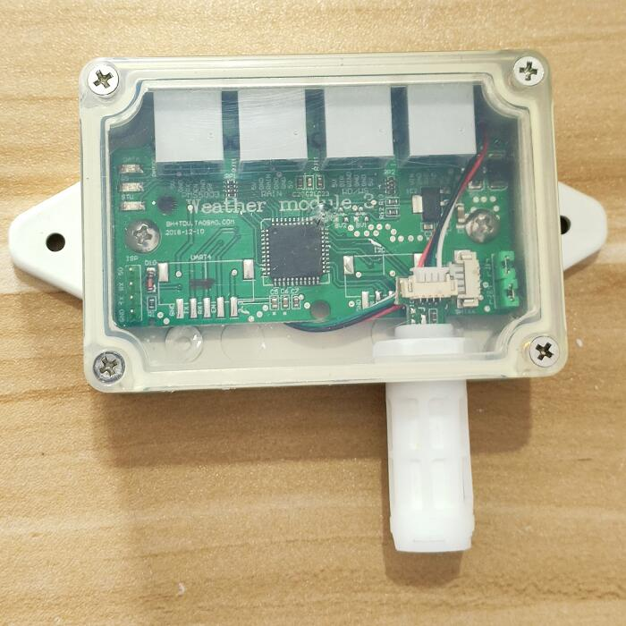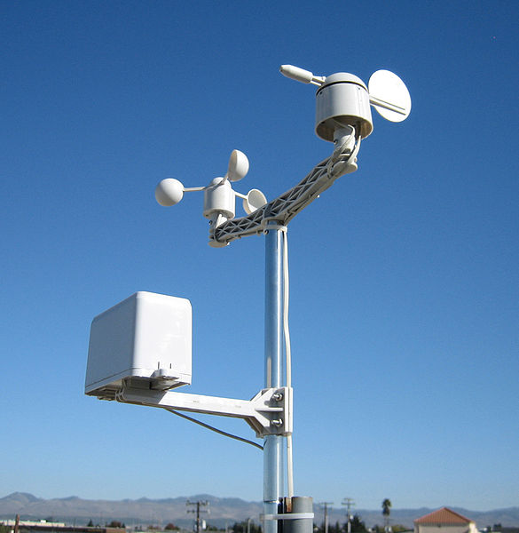
51WS3 three generation meteorological module, matching WX2018 wind speed, direction and rainfall sensor

This module is the third generation of high-precision meteorological measurement module, supports professional measurement mode, supports secondary development applications, and supports APRS data.
Supports measurement of wind direction, wind speed, rainfall, temperature, humidity, and air pressure
Support PMS5003\PMS5003ST particle sensor, automatic identification PMS5003 PMS3003 PMS5003ST
Support for outputting APRS data format (Inch)
Support professional measurement mode (metric)
Support BH1750 light sensor (customized)
Support data verification
Support 2 kinds of baud rate data output, 9600 and 2400
Wind speed maximum response frequency 1000Hz
Support 8K CPU, big data operation,

Support secondary development and protocol customization
Operating voltage: DC 5V reverse power protection, micro power consumption: 5V / 0.1A, size: 24 * 69 * 100 mm

Integrated imported temperature and humidity, air pressure two-in-one sensor
Integrated PE waterproof sensor shield

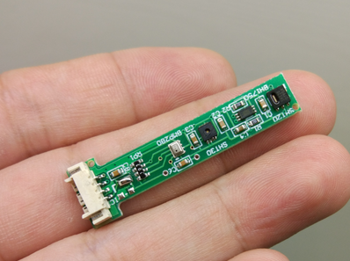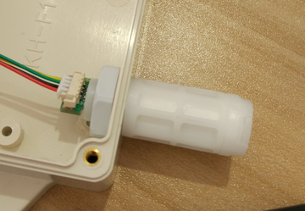
Imported SHTXX series temperature and humidity sensor, BOSS BMP280 air pressure sensor, special PE waterproof protection cover

SHT20 temperature and humidity sensor (for three generations of interface boards)
Temperature measurement range: -40 degrees - 125 degrees
Temperature measurement error: +-0.3 degrees
Resolution: 0.1 degrees Celsius
Humidity measurement range: 0%-100%
Humidity measurement error: +-3%
Resolution: 0.1%
Power consumption: 300μA
Working voltage: 3.3V
Communication method: 12C
Size: 2.4 × 3.0 × 1.1mm3

BMP280 high precision atmospheric pressure sensor
Air pressure range 300-1100hPa (9000 meters to -500 meters above sea level)
Relative accuracy: ± 012hPa (equivalent to 1 meter)
Power consumption: 2.7uA
Working voltage: 3.3V
Communication method: 12C
Size: 2.0 × 2.5 × 0.95mm3

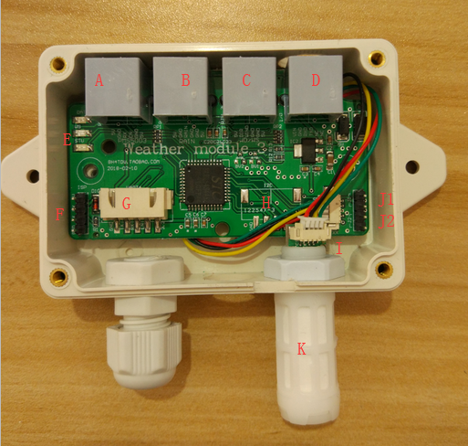

three generation meteorological module, matching WX2018 wind speed, direction and rainfall sensor

Number|Interface Description
A-PMS5003, PMS5003ST
B-rainfall
C-wind speed and direction
D-data output
E-indicator
F-ISP upgrade port
G-general expansion port A
H-general expansion port B
I-I2C temperature and humidity pressure interface
J1-metric jumper
J2-data port 2400/9600 rate jumper
K-PE sensor cover

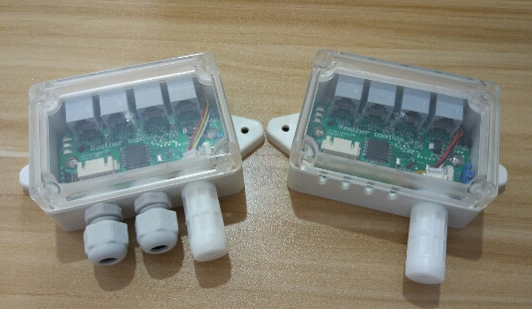

Fully sealed housing Semi-sealed housing
The 51WS5 is available in two housing styles, depending on the occasion.
Fully sealed housing, you need your own cable clamp, self-clamping crystal head
Semi-sealed housing for direct wiring

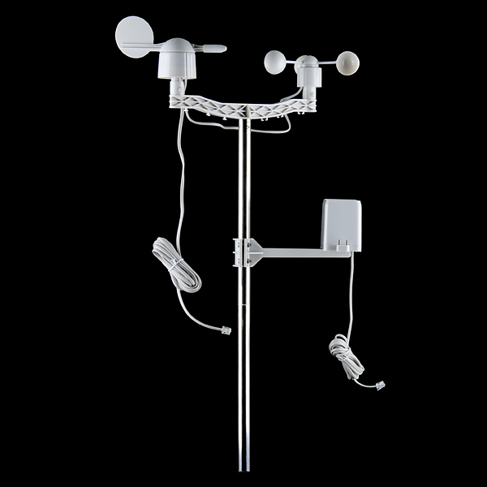
Installation of an outdoor weather kit

Rain sensor interface, rain sensor is passive switch, rain bucket reverses once = 0.33mm
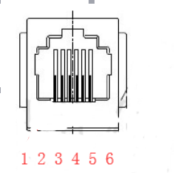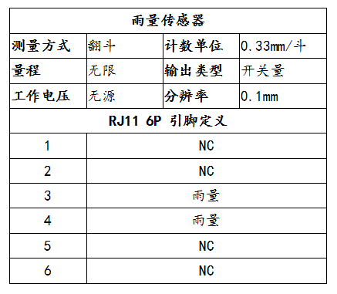

Wind speed and direction interface
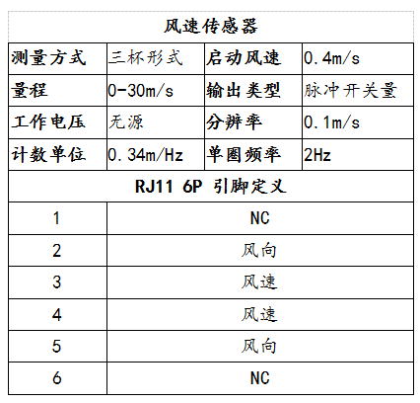
Wind speed is the passive switch quantity, wind speed sensor, one turn = 2 pulses = 2HZ
Wind speed calculation formula: m/s=wind speed hz * 0.34
Wind direction: resistance network, equivalent to step potentiometer
There is a N\S\W\E direction mark on the wind direction housing. When installing, mark N and point to the north.

PM2.5 air quality sensor module interface: This interface is used to connect PMS5003, PMS5003ST sensor
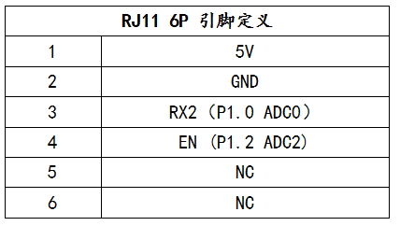

DATA data output interface：
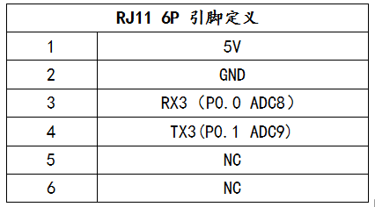
Note: RX3 can be left floating and cannot be connected to 5V level, otherwise it will cause abnormal wind direction measurement.
Generally used, only need to connect 5V TX3 GND 3 lines
note:
JP1 short circuit = ARS inch mode, JP1 open circuit = professional metric mode
JP2 short circuit = 2400 rate, JP2 open circuit = 9600 rate
Output one measurement data at intervals of 0.5 seconds.

Universal expansion interface A\B for customer ordering：
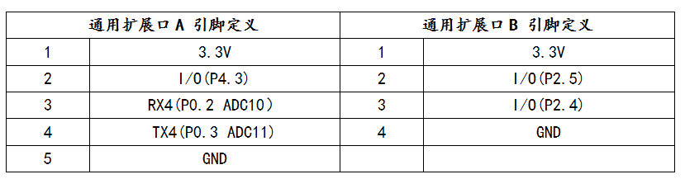
扩展口B,支持光照传感器(BH1750) GND IO1=SDA IO2=SCL 3.3V

Set the interface and ISP upgrade interface:
1=5V 2=RX 3=TX 4=GND
This interface is used to set parameters and is also used for ISP upgrade firmware.
At the same time, the interface will have some debug data output, 9600 rate

Indicator light:
DAT flashes synchronously when sending data
TX samples with wind speed, synchronous flashing
RX with rain sensor, synchronous flashing

51WS3 weather interface module data storage and calculation instructions
Rainfall: The 51WS3 weather interface board has a built-in 1440-byte rain-specific data buffer that records the rain sample value per minute.
After rolling calculation, the rainfall value of the previous minute, the first hour, and the first 24 hours is obtained.
Wind speed: The 51WS3 weather interface board has a built-in 300-byte wind speed dedicated data buffer to record real-time wind speed samples per second.
After rolling calculation, the real-time wind speed, the average wind speed in the first 1 minute, and the highest wind speed in the first 5 minutes are obtained.
Temperature: Read temperature, humidity and pressure data every 5 seconds

APRS data output format (imperial, default)：
c000s000g000t082r000p000h48b10022*3C
Output 38 bytes every 0.5 seconds, including newline at the end of the data (OD, OA)
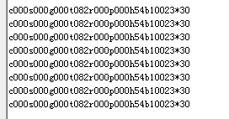
DATA debug port 9600/2400 rate
data analysis:
C000: wind direction angle, unit: degree.
S000: wind speed in the first minute, unit: miles per hour
G000: the highest wind speed in the first 5 minutes, in miles per hour
T086: temperature (Fahrenheit)
R000: rainfall in the previous hour (0.01 inches)
P000: rainfall (0.01 inches) in the first 24 hours
H53: humidity (00% - 99%)
B10020: air pressure (0.1 hpa)
*20 checksum, all character XOR results between c and * (excluding *)

Note 1:
The interface board will automatically detect whether the air pressure gauge, temperature and humidity sensor are installed, and the sensor data that is not installed will display “...”.
For example, if the temperature and humidity sensor and the air pressure piece are not installed, the output data is:
C000s000g000t...r000p000h..b.....

Three generations of meteorological modules support automatic identification of particulate matter sensors PMS5003 PMS5003ST
Default data format with checksum data format: c000s000g000t086r000p000h45b09963*31

When it is detected that the PMS5003 is installed, the data is output:
Contains PM2.5 and check data format: c000s000g000t082r000p000h43b09985, 027,035,040,023,032,040,*14

Professional measurement data output format (metric)：
Short JP1 is JP1=0 inch, open JP1, ie JP1=1 metric

After power-on, enter the professional measurement mode to facilitate secondary development.
DATA data interface 9600, 2400 rate
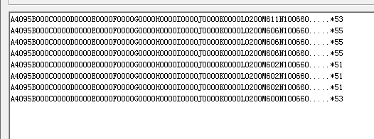

Professional measurement data format:
A4095B000C0000D0000E0000F0000G0000H0000I0000J0000K0000L0200M611N10066O.....*53
Output 74 bytes every 0.5 seconds, including line breaks at the end of the data (OD, OA)

data analysis:
A4095: Wind direction measures AD value in real time (0-4095)
B000: Wind direction angle value (16 directions)
C0000: real-time wind speed frequency 1Hz
D0000: Real-time wind speed 0.1M/S
E0000: Average wind speed in the previous minute 0.1m/s
F0000: The highest wind speed in the first 5 minutes 0.1m/s
G0000: Real-time rain bucket, 0-9999, loop count
H0000: The number of rain buckets in the previous minute, 0-9999
I0000 : The first 1 minute of rainfall 0.1mm
J0000: The previous hour's rainfall 0.1mm
K0000: The first 24 hours of rainfall 0.1mm
L0200: Temperature (Celsius), 0.1 degree, below zero, the first digit displays the symbol "-".
M611: Humidity 0.1 (0% = 99%)
N10066 air pressure (0.1 hpa)
O..... Illumination, automatic identification, installed in the I2C expansion port
*53 checksum, all character XOR results between A and * (excluding *)
51WS3 calibration adjustment function
Hardware connection: connect 51 series universal download line (optional)
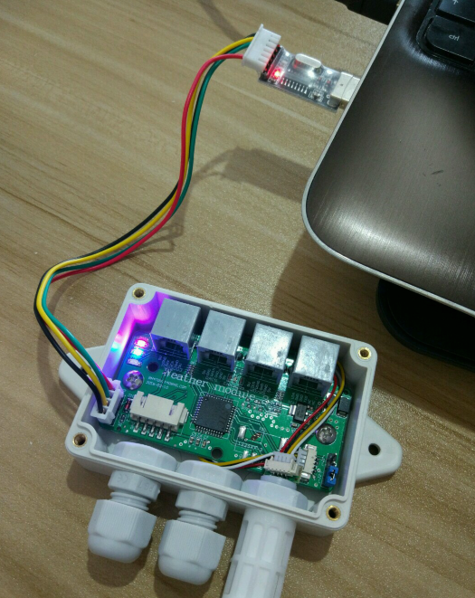

51WS3 calibration adjustment function

The 51WS3 supports the calibration adjustment data function, which can be used when the original data value needs to be adjusted in some special circumstances.
The factory default of 51WS3 is that the temperature, humidity and air pressure are all raw data output, that is, no increase or decrease.

1. Connect the USB to TTL data cable (optional), connect 51WS3, open the universal serial port debugging software, and select the correct port number, the rate is 9600.
2, send the command AT+SET=T+000H+000B+0000 Enter, that is, the setting is completed.
Note: All setup commands must be + Enter (ENTER).

Command: AT+VER=? Enter
Description: Display the current firmware version number

Command: AT+SET=T+000H+000B+0000 Enter
Description: Addition and subtraction of temperature, humidity and barometric raw data

Detailed instructions
AT+SET=T+000H+000B+0000
T+000 means temperature +00.0 degrees (unit: Celsius), calibration range +-99.9
Note: This calibration value is metric Celsius.
H+000 means humidity +00.0%, calibration range +-99.9
When calibrating addition, if the measured humidity + calibration value exceeds 99.9%, it is fixed at 99.9%.
When calibrating subtraction, the subtraction is allowed if the humidity > correction value is measured.
B+000 means air pressure +000.0hpa, calibration range +-999.9hpa

Example:
Raw data: c000s000g000t082r000p000h49b09957
Settings: AT+SET=T+000H-080B-1000 Enter
New data: c000s000g000t082r000p000h41b08957

51WS3支持校准调整数据功能，当在一些特殊环境下，需要调整原始数据值时，可以使用该功能。
51WS3出厂默认是温度、湿度、气压均为原始数据输出，即不加也不减。

- 连接USB转TTL数据线（选配），连接51WS3，打开通用串口调试软件，选择正确的端口号，速率9600。
- 发送指令 AT+SET=T+000H+000B+0000 回车 ，即设置完毕
注意：所有的设置命令都要+回车（ENTER键）。

命令：AT+VER=? 回车
说明：显示当前固件版本号

命令：AT+SET=T+000H+000B+0000 回车
说明：对温湿度、气压原始数据进行加减操作

指令详解
AT+SET=T+000H+000B+0000
T+000 表示温度 +00.0度（单位：摄氏度），校准范围+-99.9
注意：这个校准值，是公制摄氏度。
H+000 表示湿度度 +00.0%，校准范围+-99.9
校准加法时，如果测量湿度+校准值，超过99.9%，则固定为99.9%
校准减法时，如果测量湿度>校正值，才允许相减。
B+000 表示气压 +000.0hpa，校准范围+-999.9hpa

举例：
原始数据：c000s000g000t082r000p000h49b09957
设置： AT+SET=T+000H-080B-1000 回车
新数据： c000s000g000t082r000p000h41b08957

