Class 4 R Intro
Kris Price
2026-01-15
x <- 1:50
plot(x, sin(x))
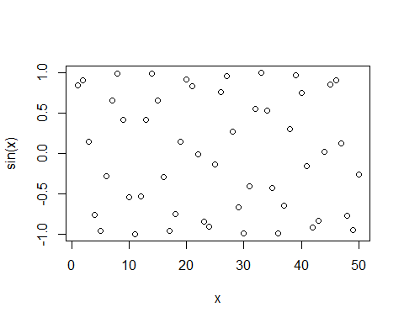
plot(x, sin(x), typ = "l", col = "pink", lwd = 2)
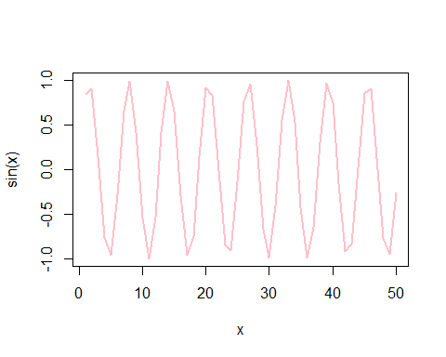
log(10, base = 10)
## [1] 1

