KENDRIYA VIDYALAYA, BAILEY ROAD, PATNA



COMPUTER SCIENCE PROJECT

TEST TAKING APPLICATION

SAIFUR RAHMAN, KUMAR SARTHAK, KISHAN AKHAURY  
XII B

BOARD Roll: 7634808, -793, -791

SESSION: 2015-16

CERTIFICATE

It is to certify that Saifur Rahman, Kumar Sarthak and Kishan Akhaury, students of class XII B has successfully completed the project entitled “Test Taking Application” under the guidance of Miss Sarwari Begum during the year 2015-16 in partial fulfilment of Computer Science Practical examination conducted by AISSCE, New Delhi.

____________________ _______________________

Signature of External Signature of Computer

Examiner Teacher

Acknowledgement

I sincerely like to thank my Computer Teacher for her guidance, support and advice to complete my work successfully. I also thank Mr. S. Vallabhan for providing all the facilities in the Computer Lab. that helped me to complete this project.

I would also like to thank my parents for their continuous corporation in completing the project.

And, lastly I would thank my classmates for their corporation and support at different stage of project.

CONTENTS

Certificate

Acknowledgement

Contents

Requirements

Header Files

Interface Design

Code

Bibliography

INTRODUCTION

This Test Taking Application is automated system for taking MCQ type tests and generation of report card of applicants after examination.

This application is an automated system that keeps the track of records of marks of applicants easily and effectively. It is developed for solution of keeping record of questions, marks and automated report of student marks with rank and application settings.

This application takes record of MCQ type questions and applicants registered for the test.

The application can also be altered in different ways to change settings to suit different types of tests.

REQUIREMENTS

**HARDWARE REQUIREMENTS**

Tools/Platform

Processor : Intel Core I series

HDD : 100 MB

RAM : 512 MB

Language : Turbo C++ 3.0

Platform : MS-DOS

**WHY C++**

C++ is an object oriented language with all feature of object oriented. It also support file handling for data storage. Therefore it is very easy to use file with object oriented paradigm.

**SOFTWARE REQUIREMENT SPECIFICATIONS**

Introduction

Main objective of the system is to improve efficiency and quality of service by designing and developing user friendly, efficient system.

Information Description

The system will help the teacher for taking test, keeping marks, provide rank, registers the applicants and to edit details of applicants in the way that there will be minimal human interference and high user friendliness and less effort taking. Reducing duplication during manual processing and managing records. The user will be given sufficient menu options for data entry, report or other miscellaneous task.

The whole processing in old system is manual, which results in complexity

and at times result in unnecessary duplication and wastage of resources. Information retrieval is a time consuming process.

New system will provide more flexibility, easier to take test of the students and store their performance. Records can be stored, retrieved, deleted or updated with less effort. User interface is simple and operator requires less hardware/software knowledge.

HEADER FILES

iostream.h :- For basic input and output .

conio.h:- For using clrscr().

stdlib.h:- For randomise() function.

string.h:- To perform string related functifon.

fstream.h:-To perform file stream function.

stdio.h:- For standard I/O operation.

time.h:-To use time in generating random numbers.

iomanip.h:-To format the output.

INTERFACE

DESIGN

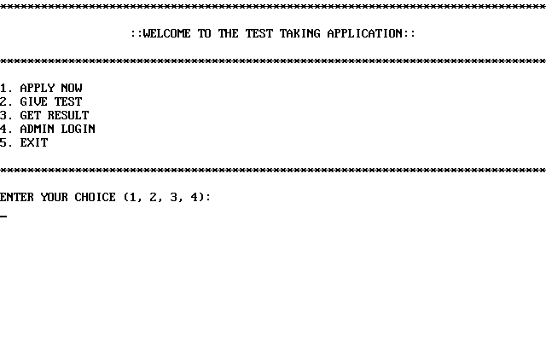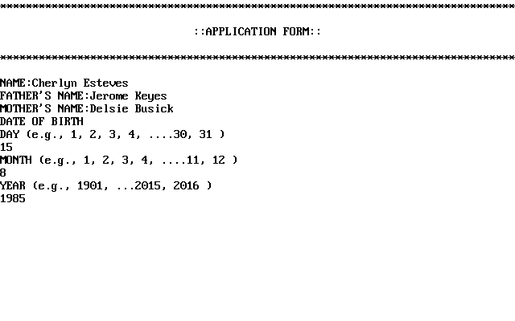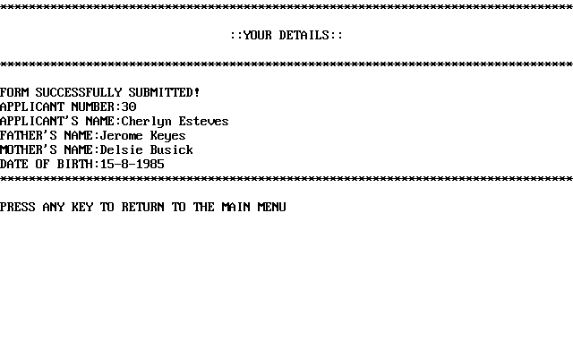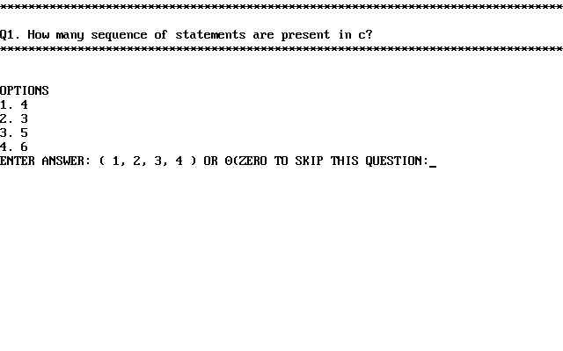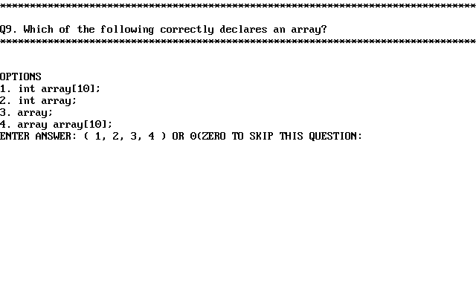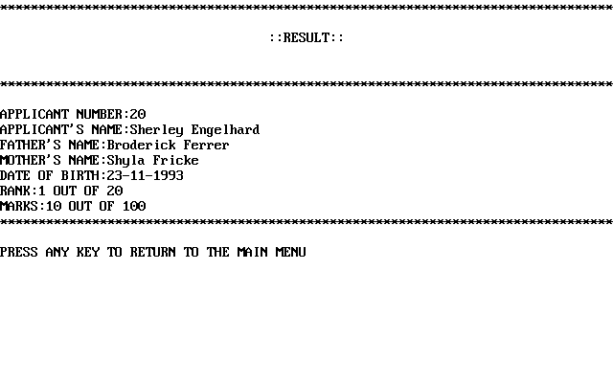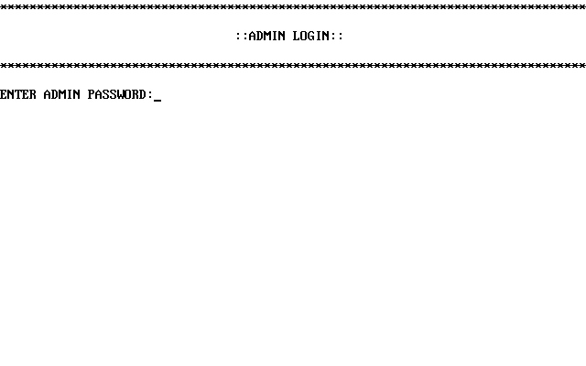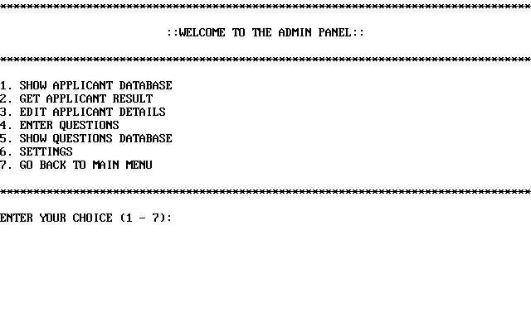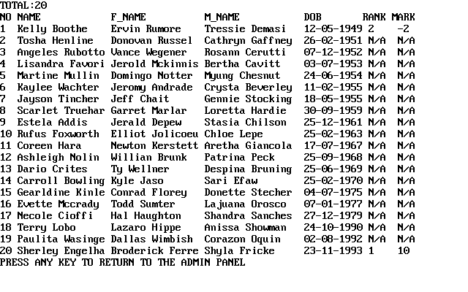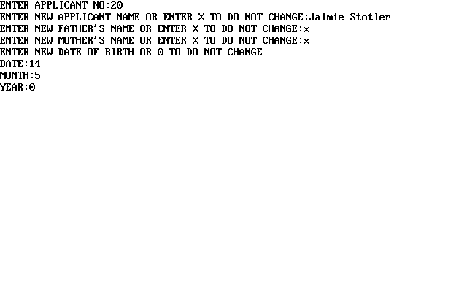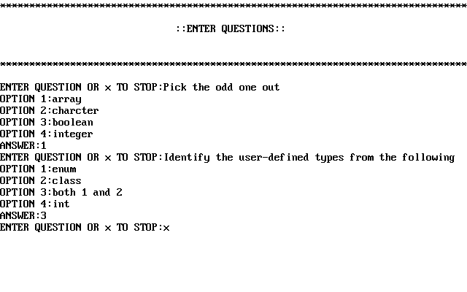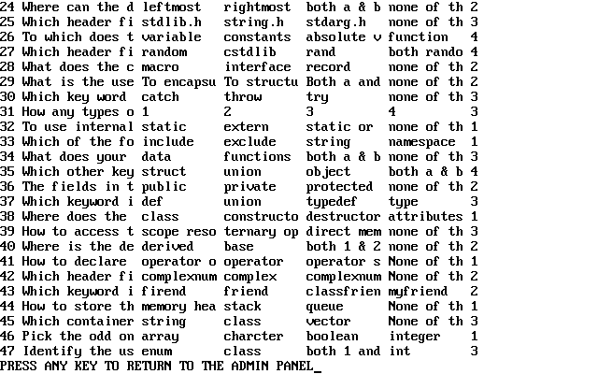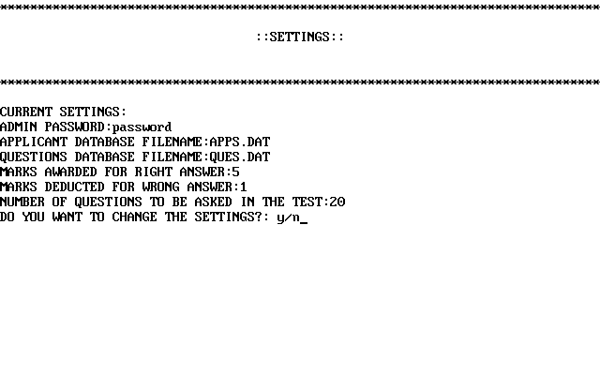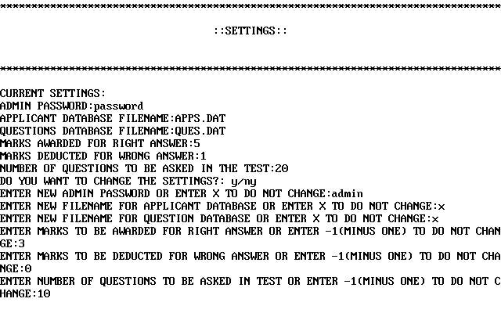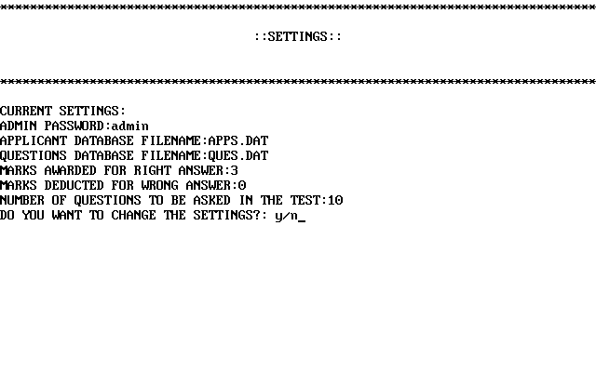

CODE

//***************************************************************

// HEADER FILE USED IN PROJECT

//***************************************************************

#include<iostream.h>

#include<conio.h>

#include<stdlib.h>

#include<string.h>

#include<fstream.h>

#include<stdio.h>

#include<time.h>

#include<iomanip.h>

//***************************************************************

// FUNCTION PROTOTYPES

//***************************************************************

void main();

void show_applicant_database();

void edit_applicant();

void enter_questions();

void show_questions_database();

void assign_rank();

void settings();

//***************************************************************

// GLOBAL VARIABLES

//***************************************************************

int main_menu_choice;

int dd,dm,dy;

char na[50], fa[50], ma[50];

int no_of_applicants=0;

int apno, get_d, get_m, get_y;

char pass[20];

int admin_menu_choice;

int ed_apno, ed_new_dob_d, ed_new_dob_m, ed_new_dob_y;

char ed_new_name[50], ed_new_faname[50], ed_new_maname[50];

int pos;

int no_of_questions=0;

char add_q[100], add_o1[100], add_o2[100], add_o3[100], add_o4[100];

int add_a;

int t_apno, t_dob_d, t_dob_m, t_dob_y;

int pos2;

int marks[500];

int pos3;

int negative_mark=1;

int positive_mark=5;

int no_of_ques_to_ask=20;

char password[30]="password";

char app_file_name[30]="APPS.DAT";

char ques_file_name[30]="QUES.DAT";

int new_negative_mark;

int new_positive_mark;

int new_no_of_ques_to_ask;

char new_password[30];

char new_app_file_name[30];

char new_ques_file_name[30];

//***************************************************************

// CLASSES USED IN THE PROJECT

//***************************************************************

//***************************************************************

// APPLICANTS CLASS (TO SAVE APPLICANTS)

//***************************************************************

class Applicants {

int applicant_no;

char name[50];

char father_name[50];

char mother_name[50];

int dob_day;

int dob_mon;

int dob_year;

int marks;

int rank;

public:

int get_applicant_no(){ return applicant_no; }

int get_dob_d() { return dob_day; }

int get_dob_m() { return dob_mon; }

int get_dob_y() { return dob_year; }

void get_name() { cout<<name; }

void get_faname() { cout<<father_name; }

void get_maname() { cout<<mother_name; }

int get_marks() {return marks;}

int get_rank() {return rank;}

void set_marks(int mk) { marks=mk; }

void set_rank(int rn) { rank=rn; }

void set_applicant_no(int ap) { applicant_no=ap; }

void set_dob_d(int dd) { dob_day=dd; }

void set_dob_m(int dm) { dob_mon=dm; }

void set_dob_y(int dy) { dob_year=dy; }

void set_name(char na[]){ strcpy(name,na); }

void set_maname(char ma[]){ strcpy(mother_name,ma); }

void set_faname(char fa[]){ strcpy(father_name,fa); }

void get_short_name(){

if(strlen(name)<15)

{ cout.width(15); cout.fill(' '); cout<<name; }

else

cout.write(name,15);

}

void get_short_faname(){

if(strlen(father_name)<15)

{ cout.width(15); cout.fill(' '); cout<<father_name; }

else

cout.write(father_name,15);

}

void get_short_maname(){

if(strlen(mother_name)<15)

{ cout.width(15); cout.fill(' '); cout<<mother_name; }

else

cout.write(mother_name,15);

}

};

void calc_no_of_applicants(){

ifstream fin4calc;

fin4calc.open(app_file_name,ios::in|ios::binary);

fin4calc.seekg(0,ios::end);

no_of_applicants= fin4calc.tellg()/sizeof(Applicants);

fin4calc.close();

}

//***************************************************************

// QUESTIONS CLASS (TO SAVE QUESTIONS)

//***************************************************************

class Questions{

int id;

char ques[100];

char opt1[100];

char opt2[100];

char opt3[100];

char opt4[100];

int ans;

public:

void set_id(int i) { id=i; }

void set_ques(char q[]) { strcpy(ques,q); }

void set_opt1(char o1[]) { strcpy(opt1,o1); }

void set_opt2(char o2[]) { strcpy(opt2,o2); }

void set_opt3(char o3[]) { strcpy(opt3,o3); }

void set_opt4(char o4[]) { strcpy(opt4,o4); }

void set_ans(int a) { ans=a; }

int get_id() { return id; }

void get_ques() { cout<<ques;}

void get_opt1() { cout<<opt1; }

void get_opt2() { cout<<opt2; }

void get_opt3() { cout<<opt3; }

void get_opt4() { cout<<opt4; }

int get_ans() { return ans; }

void get_short_ques(){

if(strlen(ques)<15)

{ cout.width(15); cout.fill(' '); cout<<ques; }

else

cout.write(ques,15);

}

void get_short_opt1(){

if(strlen(opt1)<10)

{ cout.width(10); cout.fill(' '); cout<<opt1; }

else

cout.write(opt1,10);

}

void get_short_opt2(){ if(strlen(opt2)<10)

{ cout.width(10); cout.fill(' '); cout<<opt2; }

else

cout.write(opt2,10);

}

void get_short_opt3(){

if(strlen(opt3)<10)

{ cout.width(10); cout.fill(' '); cout<<opt3; }

else

cout.write(opt3,10);

}

void get_short_opt4(){ if(strlen(opt4)<10)

{ cout.width(10); cout.fill(' '); cout<<opt4; }

else

cout.write(opt4,10);

}

};

//***************************************************************

// STATE CLASS (TO SAVE SETTINGS)

//***************************************************************

class State{

int max_marks;

int negative_mark;

int positive_mark;

int no_of_ques_to_ask;

char password[30];

char app_file_name[30];

char ques_file_name[30];

public:

int get_negative_mark(){ return negative_mark; }

int get_positive_mark(){ return positive_mark; }

int get_no_of_ques_to_ask(){ return no_of_ques_to_ask; }

char* get_password(){ return password; }

char* get_app_file_name(){ return app_file_name; }

char* get_ques_file_name(){ return ques_file_name; }

void set_negative_mark(int nm){ negative_mark=nm;}

void set_positive_mark(int pm){ positive_mark=pm;}

void set_no_of_ques_to_ask(int nq){ no_of_ques_to_ask=nq;}

void set_password(char pw[]){ strcpy(password, pw); }

void set_app_file_name(char af[]){ strcpy(app_file_name, af); }

void set_ques_file_name(char qf[]){ strcpy(ques_file_name, qf); }

};

//***************************************************************

// FUNCTION TO CALCULATE NUMBER OF QUESTIONS IN THE FILE

//***************************************************************

void calc_no_of_questions(){

ifstream fin4calc_q;

fin4calc_q.open(ques_file_name,ios::in|ios::binary|ios::ate);

no_of_questions= fin4calc_q.tellg()/sizeof(Questions);

fin4calc_q.close();

}

//***************************************************************

// FUNCTION REGISTER APPLICANT TO THE FILE

//***************************************************************

void apply_now() {

Applicants t_applicant;

ofstream fout;

t_applicant.set_marks(-500);

t_applicant.set_rank(-1);

clrscr();

fout.open(app_file_name, ios::app|ios::binary);

cout<<"********************************************************************************"<<endl;

cout<<" ::APPLICATION FORM:: "<<endl;

cout<<"********************************************************************************"<<endl;

cout<<"NAME:";

gets(na);

t_applicant.set_name(na);

cout<<"FATHER'S NAME:";

gets(fa);

t_applicant.set_faname(fa);

cout<<"MOTHER'S NAME:";

gets(ma);

t_applicant.set_maname(ma);

cout<<"DATE OF BIRTH"<<endl;

do{

cout<<"DAY (e.g., 1, 2, 3, 4, ....30, 31 )"<<endl;

cin>>dd;

}

while(!((dd>0)&&(dd<32)));

t_applicant.set_dob_d(dd);

do{

cout<<"MONTH (e.g., 1, 2, 3, 4, ....11, 12 )"<<endl;

cin>>dm;

}

while(!((dm>0)&&(dm<13)));

t_applicant.set_dob_m(dm);

do{

cout<<"YEAR (e.g., 1901, ...2015, 2016 )"<<endl;

cin>>dy;

}

while(!((dy>1900)&&(dy<3000)));

t_applicant.set_dob_y(dy);

calc_no_of_applicants();

t_applicant.set_applicant_no(no_of_applicants+1);

fout.write((char*)&t_applicant, sizeof(t_applicant));

fout.close();

calc_no_of_applicants();

clrscr();

cout<<"********************************************************************************"<<endl;

cout<<" ::YOUR DETAILS:: "<<endl;

cout<<"********************************************************************************"<<endl;

cout<<"FORM SUCCESSFULLY SUBMITTED!"<<endl;

cout<<"APPLICANT NUMBER:"<<t_applicant.get_applicant_no()<<endl;

cout<<"APPLICANT'S NAME:";

t_applicant.get_name();

cout<<endl;

cout<<"FATHER'S NAME:";

t_applicant.get_faname();

cout<<endl;

cout<<"MOTHER'S NAME:";

t_applicant.get_maname();

cout<<endl;

cout<<"DATE OF BIRTH:"<<t_applicant.get_dob_d()<<"-"<<t_applicant.get_dob_m()<<"-"<<t_applicant.get_dob_y()<<endl;

cout<<"********************************************************************************"<<endl;

cout<<"PRESS ANY KEY TO RETURN TO THE MAIN MENU";

getch();

main();

}

//***************************************************************

// FUNCTION TO TAKE THE TEST OF REGISTERED APPLICANTS

//***************************************************************

void give_test(){

Applicants test_applicant;

fstream fin;

fin.open(app_file_name,ios::in|ios::out|ios::binary);

clrscr();

calc_no_of_questions();

if(no_of_questions<no_of_ques_to_ask)

{

cout<<"********************************************************************************"<<endl;

cout<<"INSUFFICIENT QUESTION IN DATABASE. CONTACT ADMINISTRATOR"<<endl;

cout<<"********************************************************************************"<<endl;

cout<<"PRESS ANY KEY TO RETURN TO THE MAIN MENU";

getch();

main();

}

cout<<"ENTER YOUR APPLICANT NUMBER:"<<endl;

cin>>t_apno;

cout<<"ENTER DATE OF BIRTH"<<endl;

cout<<"ENTER DAY:";

cin>>t_dob_d;

cout<<"ENTER MONTH:";

cin>>t_dob_m;

cout<<"ENTER YEAR:";

cin>>t_dob_y;

int flag=0;

while (!fin.eof())

{

pos2=fin.tellg();

fin.read((char*)&test_applicant,sizeof(test_applicant));

if(test_applicant.get_applicant_no()==t_apno&&test_applicant.get_dob_d()==t_dob_d&&test_applicant.get_dob_m()==t_dob_m&&test_applicant.get_dob_y()==t_dob_y)

{

flag=1;

cout<<endl;

break;

}

}

if(flag==1)

{

Questions t_obj;

ifstream t_ques;

t_ques.open(ques_file_name,ios::in|ios::binary);

time_t t;

int seedval= (unsigned) time (&t);

srand(seedval);

int marks=0;

int qno;

int ans;

for(int i=0; i<no_of_ques_to_ask;i++)

{

qno=rand()%no_of_questions+1;

while(t_ques.read((char*)&t_obj, sizeof(t_obj)))

{

if(t_obj.get_id()==qno)

{

clrscr();

cout<<"********************************************************************************"<<endl;

cout<<"Q"<<i+1<<". ";

t_obj.get_ques();

cout<<endl;

cout<<"********************************************************************************"<<endl;

cout<<endl;

cout<<"OPTIONS"<<endl<<"1. ";

t_obj.get_opt1();

cout<<endl;

cout<<"2. ";

t_obj.get_opt2();

cout<<endl;

cout<<"3. ";

t_obj.get_opt3();

cout<<endl;

cout<<"4. ";

t_obj.get_opt4();

cout<<endl;

cout<<"ENTER ANSWER: ( 1, 2, 3, 4 ) OR 0(ZERO TO SKIP THIS QUESTION:";

cin>>ans;

if (ans==0)

{

;

}

else if(t_obj.get_ans()==ans)

{ marks = marks + positive_mark;}

else{ marks = marks - negative_mark;}

break;

}

}

t_ques.seekg(0);

}

test_applicant.set_marks(marks);

fin.seekg(pos2);

fin.write((char*)&test_applicant,sizeof(test_applicant));

t_ques.close();

fin.close();

}

if(flag==0)

{

clrscr();

cout<<"********************************************************************************"<<endl;

cout<<"APPLICANT NOT FOUND!"<<endl;

cout<<"********************************************************************************"<<endl;

}

assign_rank();

cout<<"PRESS ANY KEY TO RETURN TO THE MAIN MENU";

getch(); main();

}

//***************************************************************

// FUNCTION TO SHOW RESULT OF THE REGISTERED APPLICANTS

//***************************************************************

void get_result(){

Applicants t2_applicant;

ifstream fin;

fin.open(app_file_name,ios::in|ios::binary);

clrscr();

cout<<"ENTER YOUR APPLICANT NUMBER:"<<endl;

cin>>apno;

cout<<"ENTER DATE OF BIRTH"<<endl;

cout<<"ENTER DAY:";

cin>>get_d;

cout<<"ENTER MONTH:";

cin>>get_m;

cout<<"ENTER YEAR:";

cin>>get_y;

int flag=0;

while(fin.read((char *)&t2_applicant,sizeof(t2_applicant))){

if(t2_applicant.get_applicant_no()==apno&&t2_applicant.get_dob_d()==get_d&&t2_applicant.get_dob_m()==get_m&&t2_applicant.get_dob_y()==get_y)

{

clrscr();

cout<<"********************************************************************************"<<endl;

cout<<" ::RESULT:: "<<endl<<endl;

cout<<"********************************************************************************"<<endl;

cout<<"APPLICANT NUMBER:"<<t2_applicant.get_applicant_no()<<endl;

cout<<"APPLICANT'S NAME:";

t2_applicant.get_name();

cout<<endl;

cout<<"FATHER'S NAME:";

t2_applicant.get_faname();

cout<<endl;

cout<<"MOTHER'S NAME:";

t2_applicant.get_maname();

cout<<endl;

cout<<"DATE OF BIRTH:"<<t2_applicant.get_dob_d()<<"-"<<t2_applicant.get_dob_m()<<"-"<<t2_applicant.get_dob_y()<<endl;

if(t2_applicant.get_rank()!=-1)

{ calc_no_of_applicants();

cout<<"RANK:"<<t2_applicant.get_rank()<<" OUT OF "<<no_of_applicants<<endl; }

else { cout<<"RANK NOT ASSIGNED"<<endl; }

if(t2_applicant.get_marks()!=-500)

{ cout<<"MARKS:"<<t2_applicant.get_marks()<<" OUT OF "<<no_of_ques_to_ask*positive_mark<<endl;

cout<<"********************************************************************************"<<endl;

}

else { cout<<"MARKS NOT ASSIGNED"<<endl;

cout<<"********************************************************************************"<<endl;

}

flag=1;

break;

}

}

if(!flag){

clrscr();

cout<<"********************************************************************************"<<endl;

cout<<"APPLICANT NOT FOUND!"<<endl;

cout<<"********************************************************************************"<<endl;

}

fin.close();

cout<<"PRESS ANY KEY TO RETURN TO THE MAIN MENU";

getch(); main();

}

//***************************************************************

// FUNCTION TO GIVE ADMINISTRATOR CONTROLS TO THE USER

//***************************************************************

void admin_login(){

clrscr();

cout<<"********************************************************************************"<<endl;

cout<<" ::ADMIN LOGIN:: "<<endl;

cout<<"********************************************************************************"<<endl;

cout<<"ENTER ADMIN PASSWORD:";

gets(pass);

if(strcmp(pass,password)==0)

{

clrscr();

cout<<"********************************************************************************"<<endl;

cout<<" ::WELCOME TO THE ADMIN PANEL:: "<<endl;

cout<<"********************************************************************************"<<endl;

cout<<"1. SHOW APPLICANT DATABASE"<<endl;

cout<<"2. GET APPLICANT RESULT"<<endl;

cout<<"3. EDIT APPLICANT DETAILS"<<endl;

cout<<"4. ENTER QUESTIONS"<<endl;

cout<<"5. SHOW QUESTIONS DATABASE"<<endl;

cout<<"6. SETTINGS"<<endl;

cout<<"7. GO BACK TO MAIN MENU"<<endl<<endl;

cout<<"********************************************************************************"<<endl;

cout<<"ENTER YOUR CHOICE (1 - 7):";

cin>>admin_menu_choice;

switch(admin_menu_choice){

case 1 : show_applicant_database();

break;

case 2 : get_result();

break;

case 3: edit_applicant();

break;

case 4: enter_questions();

break;

case 5 : show_questions_database();

break;

case 6 : settings();

break;

case 7 : main();

break;

default: cout<<"WRONG CHOICE!";

cout<<"PRESS ANY KEY TO RETURN TO THE MAIN MENU";

getch();

main();

}

}

else

{

clrscr();

cout<<"********************************************************************************"<<endl;

cout<<"ACCESS DENIED!"<<endl;

cout<<"********************************************************************************"<<endl;

cout<<"PRESS ANY KEY TO RETURN TO THE MAIN MENU";

getch();

main();

}

getch();

main();

}

//***************************************************************

// FUNCTION TO SHOW ALL ENTRIES IN THE APPLICANT FILE

//***************************************************************

void show_applicant_database(){

Applicants t3_applicant;

ifstream fin;

fin.open(app_file_name, ios::binary|ios::in);

calc_no_of_applicants();

clrscr();

cout<<"TOTAL:"<<no_of_applicants<<endl;

cout.setf(ios::left);

cout<<setw(3)<<"NO"<<setw(16)<<"NAME"<<setw(16)<<"F_NAME"<<setw(16)<<"M_NAME"<<setw(11)<<" DOB"<<setw(5)<<"RANK"<<setw(5)<<"MARK"<<endl;

while(fin.read((char*)&t3_applicant,sizeof(t3_applicant)))

{

cout<<setw(3)<<t3_applicant.get_applicant_no();

cout<<setw(16);

t3_applicant.get_short_name();

cout<<' ';

cout<<setw(16);

t3_applicant.get_short_faname();

cout<<setw(16);

cout<<' ';

t3_applicant.get_short_maname();

cout<<' ';

cout.setf(ios::right);

cout<<' '<<setw(2)<<setfill('0')<<t3_applicant.get_dob_d()<<"-"<<setw(2)<<setfill('0')<<t3_applicant.get_dob_m()<<"-"<<setw(4)<<setfill('0')<<t3_applicant.get_dob_y()<<' '<<setfill(' ');

cout.setf(ios::left);

if(t3_applicant.get_rank()!=-1)

{ cout<<setw(5)<<t3_applicant.get_rank(); }

else { cout<<setw(5)<<"N/A"; }

if(t3_applicant.get_marks()!=-500)

{ cout<<setw(4)<<t3_applicant.get_marks()<<endl; }

else { cout<<setw(4)<<"N/A"<<endl; }

}

fin.close();

cout<<"PRESS ANY KEY TO RETURN TO THE ADMIN PANEL";

getch();

admin_login();

}

//***************************************************************

// FUNCTION TO EDIT DETAILS OF REGISTERED APPLICANTS

//***************************************************************

void edit_applicant(){

Applicants ed_obj;

fstream ed_file;

ed_file.open(app_file_name,ios::in|ios::out|ios::binary);

clrscr();

cout<<"ENTER APPLICANT NO:";

cin>>ed_apno;

int flag_ed=0;

while(!ed_file.eof())

{

pos=ed_file.tellg();

ed_file.read((char*)&ed_obj,sizeof(ed_obj));

if(ed_obj.get_applicant_no()==ed_apno)

{

cout<<"ENTER NEW APPLICANT NAME OR ENTER X TO DO NOT CHANGE:";

gets(ed_new_name);

if((strcmp(ed_new_name,"x")!=0)&&(strcmp(ed_new_name,"X")!=0))

{

ed_obj.set_name(ed_new_name);

}

cout<<"ENTER NEW FATHER'S NAME OR ENTER X TO DO NOT CHANGE:";

gets(ed_new_faname);

if((strcmp(ed_new_faname,"x")!=0)&&(strcmp(ed_new_faname,"X")!=0))

{

ed_obj.set_faname(ed_new_faname);

}

cout<<"ENTER NEW MOTHER'S NAME OR ENTER X TO DO NOT CHANGE:";

gets(ed_new_maname);

if((strcmp(ed_new_maname,"x")!=0)&&(strcmp(ed_new_maname,"X")!=0))

{

ed_obj.set_maname(ed_new_maname);

}

cout<<"ENTER NEW DATE OF BIRTH OR 0 TO DO NOT CHANGE"<<endl;

cout<<"DATE:";

cin>>ed_new_dob_d;

if(ed_new_dob_d!=0)

{

ed_obj.set_dob_d(ed_new_dob_d);

}

cout<<"MONTH:";

cin>>ed_new_dob_m;

if(ed_new_dob_m!=0)

{

ed_obj.set_dob_m(ed_new_dob_m);

}

cout<<"YEAR:";

cin>>ed_new_dob_y;

if(ed_new_dob_y!=0)

{

ed_obj.set_dob_y(ed_new_dob_y);

}

ed_file.seekg(pos);

ed_file.write((char*)&ed_obj, sizeof(ed_obj));

flag_ed=1;

clrscr();

cout<<"APPLICANT DETAILS SUCCESSFULLY CHANGED!"<<endl;

break;

}

}

if(!flag_ed)

{

clrscr();

cout<<"********************************************************************************"<<endl;

cout<<"APPLICANT NOT FOUND!"<<endl;

cout<<"********************************************************************************"<<endl;

}

ed_file.close();

clrscr();

cout<<"PRESS ANY KEY TO RETURN TO THE ADMIN PANEL";

getch();

admin_login();

}

//***************************************************************

// FUNCTION TO ENTER QUESTIONS INTO THE FILE

//***************************************************************

void enter_questions(){

Questions t_question;

ofstream fout;

char ask='y';

calc_no_of_questions();

clrscr();

fout.open(ques_file_name, ios::app|ios::binary);

cout<<"********************************************************************************"<<endl;

cout<<" ::ENTER QUESTIONS:: "<<endl<<endl;

cout<<"********************************************************************************"<<endl;

while(ask!='n'){

cout<<"ENTER QUESTION OR x TO STOP:";

gets(add_q);

if(strcmp(add_q,"X")==0)

{

ask='n';

continue;

}

if(strcmp(add_q,"x")==0)

{

ask='n';

continue;

}

t_question.set_ques(add_q);

cout<<"OPTION 1:";

gets(add_o1);

t_question.set_opt1(add_o1);

cout<<"OPTION 2:";

gets(add_o2);

t_question.set_opt2(add_o2);

cout<<"OPTION 3:";

gets(add_o3);

t_question.set_opt3(add_o3);

cout<<"OPTION 4:";

gets(add_o4);

t_question.set_opt4(add_o4);

cout<<"ANSWER:";

cin>>add_a;

t_question.set_ans(add_a);

t_question.set_id(++no_of_questions);

fout.write((char*)&t_question, sizeof(t_question));

}

fout.close();

calc_no_of_questions();

clrscr();

cout<<"PRESS ANY KEY TO RETURN TO THE ADMIN PANEL";

getch();

admin_login();

}

//***************************************************************

// FUNCTION TO SHOW ALL ENTRIES IN THE QUESTION FILE

//***************************************************************

void show_questions_database(){

Questions t3_question;

ifstream fin;

fin.open(ques_file_name, ios::binary|ios::in);

calc_no_of_questions();

clrscr();

cout<<"TOTAL:"<<no_of_questions<<endl;

cout.setf(ios::left);

cout<<setfill(' ')<<setw(3)<<"ID"<<setw(16)<<"QUES"<<setw(11)<<"OPT1"<<setw(11)<<"OPT2"<<setw(11)<<"OPT3"<<setw(11)<<"OPT4"<<setw(2)<<"ANS"<<endl;

while(fin.read((char*)&t3_question,sizeof(t3_question)))

{

cout<<setw(3)<<t3_question.get_id();

cout<<setw(16);

t3_question.get_short_ques();

cout<<' ';

cout<<setw(11);

t3_question.get_short_opt1();

cout<<' ';

cout<<setw(11);

t3_question.get_short_opt2();

cout<<' ';

cout<<setw(11);

t3_question.get_short_opt3();

cout<<' ';

cout<<setw(11);

t3_question.get_short_opt4();

cout<<' ';

cout<<setw(2);

cout<<t3_question.get_ans()<<endl;

}

fin.close();

cout<<"PRESS ANY KEY TO RETURN TO THE ADMIN PANEL";

getch();

admin_login();

}

//***************************************************************

// FUNCTION TO ASSIGN RANK TO APPLICANTS

//***************************************************************

void assign_rank(){

int big, pos, temp;

Applicants t_app_obj;

fstream t_app_file;

t_app_file.open(app_file_name, ios::in|ios::out|ios::binary);

int i=0;

int marks_array[100];

while(t_app_file.read((char*)&t_app_obj, sizeof(t_app_obj)))

{

marks_array[i]=t_app_obj.get_marks();

i++;

}

calc_no_of_applicants();

for(i=0;i<no_of_applicants;i++)

{

big = marks_array[i];

pos=i;

for(int j=i+1;j<no_of_applicants;j++)

{

if(marks_array[j]>big)

{ big = marks_array[j];

pos=j;

}

}

if(i!=pos)

{ temp = marks_array[i];

marks_array[i] = marks_array[pos];

marks_array[pos] = temp;

}

}

t_app_file.clear();

t_app_file.seekg(0);

while (!t_app_file.eof()) {

pos3=t_app_file.tellg();

t_app_file.read((char*)&t_app_obj, sizeof(t_app_obj));

for(i = no_of_applicants; i>-1;i--)

{

if(t_app_obj.get_marks()==-500)

{

t_app_obj.set_rank(-1);

break;

}

else if(t_app_obj.get_marks()==marks_array[i])

{

t_app_obj.set_rank(i+1);

break;

}

}

t_app_file.seekg(pos3);

t_app_file.write((char*)&t_app_obj, sizeof(t_app_obj));

}

t_app_file.close();

}

//***************************************************************

// FUNCTION TO INITIALISE SETTINGS FROM CONFIGURATION FILE

//***************************************************************

void configure(){

State config_obj;

fstream config_file;

config_file.open("config.dat",ios::in|ios::binary);

cout<<config_file;

if(config_file){

config_file.read((char*)&config_obj,sizeof(config_obj));

strcpy(password, config_obj.get_password());

positive_mark=config_obj.get_positive_mark();

negative_mark=config_obj.get_negative_mark();

no_of_ques_to_ask=config_obj.get_no_of_ques_to_ask();

strcpy(app_file_name,config_obj.get_app_file_name());

strcpy(ques_file_name,config_obj.get_ques_file_name());

}

config_file.close();

}

//***************************************************************

// FUNCTION EDIT SETTINGS

//***************************************************************

void settings(){

clrscr();

cout<<"********************************************************************************"<<endl;

cout<<" ::SETTINGS:: "<<endl<<endl;

cout<<"********************************************************************************"<<endl;

cout<<"CURRENT SETTINGS:"<<endl;

cout<<"ADMIN PASSWORD:"<<password<<endl;

cout<<"APPLICANT DATABASE FILENAME:"<<app_file_name<<endl;

cout<<"QUESTIONS DATABASE FILENAME:"<<ques_file_name<<endl;

cout<<"MARKS AWARDED FOR RIGHT ANSWER:"<<positive_mark<<endl;

cout<<"MARKS DEDUCTED FOR WRONG ANSWER:"<<negative_mark<<endl;

cout<<"NUMBER OF QUESTIONS TO BE ASKED IN THE TEST:"<<no_of_ques_to_ask<<endl;

cout<<"DO YOU WANT TO CHANGE THE SETTINGS?: y/n";

char ch;

cin>>ch;

if(ch=='y'||ch=='Y')

{

State config_obj;

ofstream config_file;

config_file.open("config.dat",ios::out|ios::trunc|ios::binary);

cout<<"ENTER NEW ADMIN PASSWORD OR ENTER X TO DO NOT CHANGE:";

gets(new_password);

if((strcmp(new_password,"x")!=0)&&(strcmp(new_password,"X")!=0))

{

config_obj.set_password(new_password);

}

else

{

config_obj.set_password(password);

}

cout<<"ENTER NEW FILENAME FOR APPLICANT DATABASE OR ENTER X TO DO NOT CHANGE:";

gets(new_app_file_name);

if((strcmp(new_app_file_name,"x")!=0)&&(strcmp(new_app_file_name,"X")!=0))

{

config_obj.set_app_file_name(new_app_file_name);

}

else

{

config_obj.set_app_file_name(app_file_name);

}

cout<<"ENTER NEW FILENAME FOR QUESTION DATABASE OR ENTER X TO DO NOT CHANGE:";

gets(new_ques_file_name);

if((strcmp(new_ques_file_name,"x")!=0)&&(strcmp(new_ques_file_name,"X")!=0))

{

config_obj.set_ques_file_name(new_ques_file_name);

}

else

{

config_obj.set_ques_file_name(ques_file_name);

}

cout<<"ENTER MARKS TO BE AWARDED FOR RIGHT ANSWER OR ENTER -1(MINUS ONE) TO DO NOT CHANGE:";

cin>>new_positive_mark;

if(new_positive_mark!=-1)

{

config_obj.set_positive_mark(new_positive_mark);

}

else

{

config_obj.set_positive_mark(positive_mark);

}

cout<<"ENTER MARKS TO BE DEDUCTED FOR WRONG ANSWER OR ENTER -1(MINUS ONE) TO DO NOT CHANGE:";

cin>>new_negative_mark;

if(new_negative_mark!=-1)

{

config_obj.set_negative_mark(new_negative_mark);

}

else

{

config_obj.set_negative_mark(negative_mark);

}

cout<<"ENTER NUMBER OF QUESTIONS TO BE ASKED IN TEST OR ENTER -1(MINUS ONE) TO DO NOT CHANGE:";

cin>>new_no_of_ques_to_ask;

if(new_no_of_ques_to_ask!=-1)

{

config_obj.set_no_of_ques_to_ask(new_no_of_ques_to_ask);

}

else

{

config_obj.set_no_of_ques_to_ask(no_of_ques_to_ask);

}

config_file.write((char*)&config_obj,sizeof(config_obj));

config_file.close();

configure();

}

admin_login();

}

//***************************************************************

// THE MAIN FUNCTION OF THE PROGRAM

//***************************************************************

void main(){

clrscr();

configure();

clrscr();

cout<<"********************************************************************************"<<endl;

cout<<" ::WELCOME TO THE TEST TAKING APPLICATION:: "<<endl;

cout<<"********************************************************************************"<<endl;

cout<<"1. APPLY NOW"<<endl;

cout<<"2. GIVE TEST"<<endl;

cout<<"3. GET RESULT"<<endl;

cout<<"4. ADMIN LOGIN"<<endl;

cout<<"5. EXIT"<<endl<<endl;

cout<<"********************************************************************************"<<endl;

cout<<"ENTER YOUR CHOICE (1, 2, 3, 4):"<<endl;

cin>>main_menu_choice;

switch(main_menu_choice)

{

case 1 :

apply_now();

break;

case 2 : give_test();

break;

case 3 : get_result();

break;

case 4 : admin_login();

break;

case 5 : exit(0);

}

}

BIBLIOGRAPHY

Computer Science with C++ -Sumita Arora

StackOverflow.com

GitHub.com

Floobits.com