Task Design Document

Task:1 Definition of the structure of grid for creating a grid.

Task:2 Validation corresponding to grid data.

Task:3 Updating the existing grid data.

Task:4 Get a Grid/Route

Task:5 Given Two points get the optimal path
-input:- start and end node
-output:-optimal route

Assumption 1: Getting a web content of Graph Grid and inputs for optimal paths

WebContent structure for POST, PUT request;

WebDataModel:{
“grid”:{$ Grid}
“startPoint”:
“endPoint”:
}

Grid:{
“id”:
“edges”:[$ Edges]
}

Edge: {
“startPoint”:””,
“endPoint”:[],
“l”:[],
“s”;[]
}

Note: edges will contain list of Edge;
In Edge:
startPoint will be start of edges;
endPoint will be list of all adjecent Node;
l will be list of length of adjecent Nodes in respective order;
s will be list of speed to travel the adjecent Nodes in respective order;

WebDataModel:
startPoint will be start point of the query;
endPoint will be destination of the query;

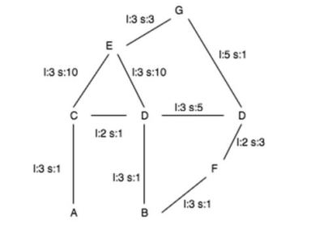
H

WebDataModal will be as follow for above graph grid;
{
"grid":{
"id":1,
"edges":[
{
"startPoint":"A",
"endPoint":["C"],
"l":[3],
"s":[1]
},
{
"startPoint":"C",
"endPoint":["A","E","D"],
"l":[3.0,3.0,2.0],
"s":[1.0,10.0,1.0]
},
{
"startPoint":"E",
"endPoint":["C","D","G"],
"l":[3.0,3.0,3.0],
"s":[10.0,10.0,3.0]
},
{
"startPoint":"D",
"endPoint":["C","E","H","B"],
"l":[2.0,3.0,3.0,3.0],
"s":[1.0,10.0,5.0,1.0]
},
{
"startPoint":"G",
"endPoint":["E","H"],
"l":[3.0,5.0],
"s":[3.0,1.0]
},
{
"startPoint":"H",
"endPoint":["G","D","F"],
"l":[5.0,3.0,2.0],
"s":[1.0,5.0,3.0]
},
{
"startPoint":"B",
"endPoint":["D","F"],
"l":[3.0,3.0],
"s":[1.0,1.0]
},
{
"startPoint":"F",
"endPoint":["D","B"],
"l":[2.0,3.0],
"s":[3.0,1.0]
}
]
},
"startPoint":"A",
"endPoint":"B"
}

refer :- test.json file

Validation:-
Json data should denote correct Graph with all the required value of l and s.

Controller and OutPut:-

Controller can return Grid, but in current code, list is return in the respective path order

return of the above test case:
[
"A",
"C",
"E",
"D",
"B"
]
that means Optimal path will be:-
A->C->E->D->B

