नल

पानी

साँप

रस्सी

गमला

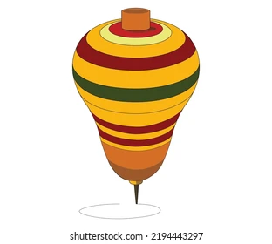

लट्टू

टमाटर

धागा

