

Assessment

Module-5

Rana, Karan

CSIT_230SP21

Instructor: Dr. G.E. Antoniou

TA: Dev Dave

4,4,2021

**Problem 1:**

Write a MIPS Assembly program to ADD the numbers: 1, 2, 3, 4, 5, 6 (as in ex–1)

• Use ONLY the instructions: add and li

• The result of the addition (in decimal) should be in register: $t1

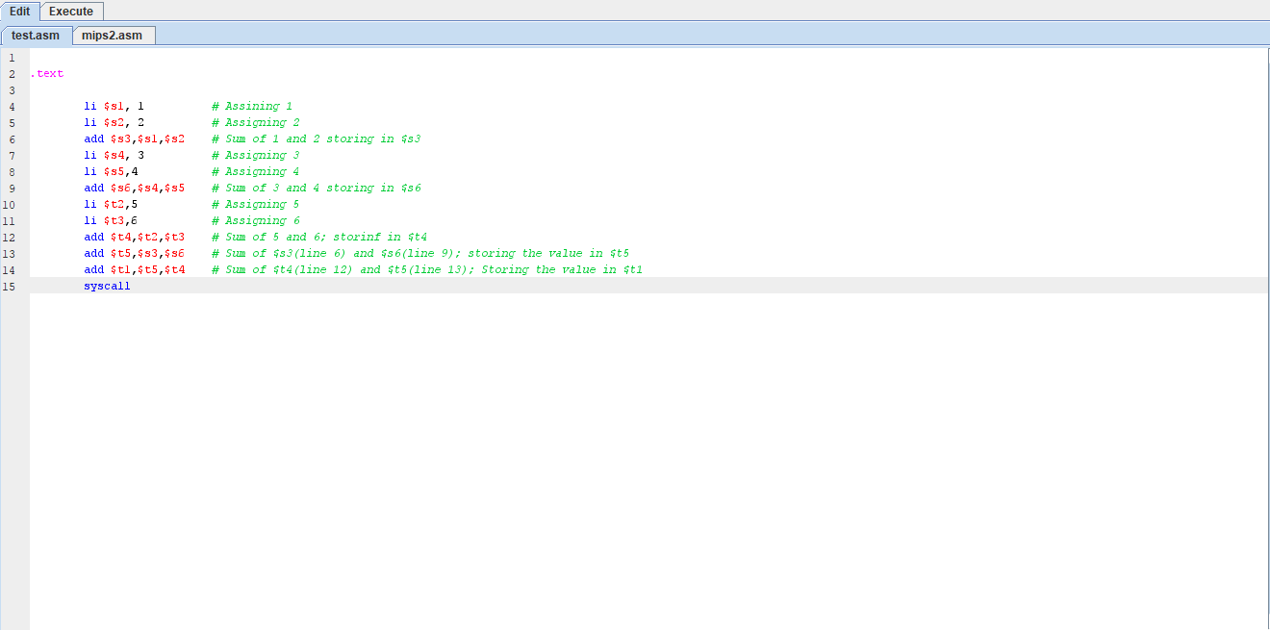

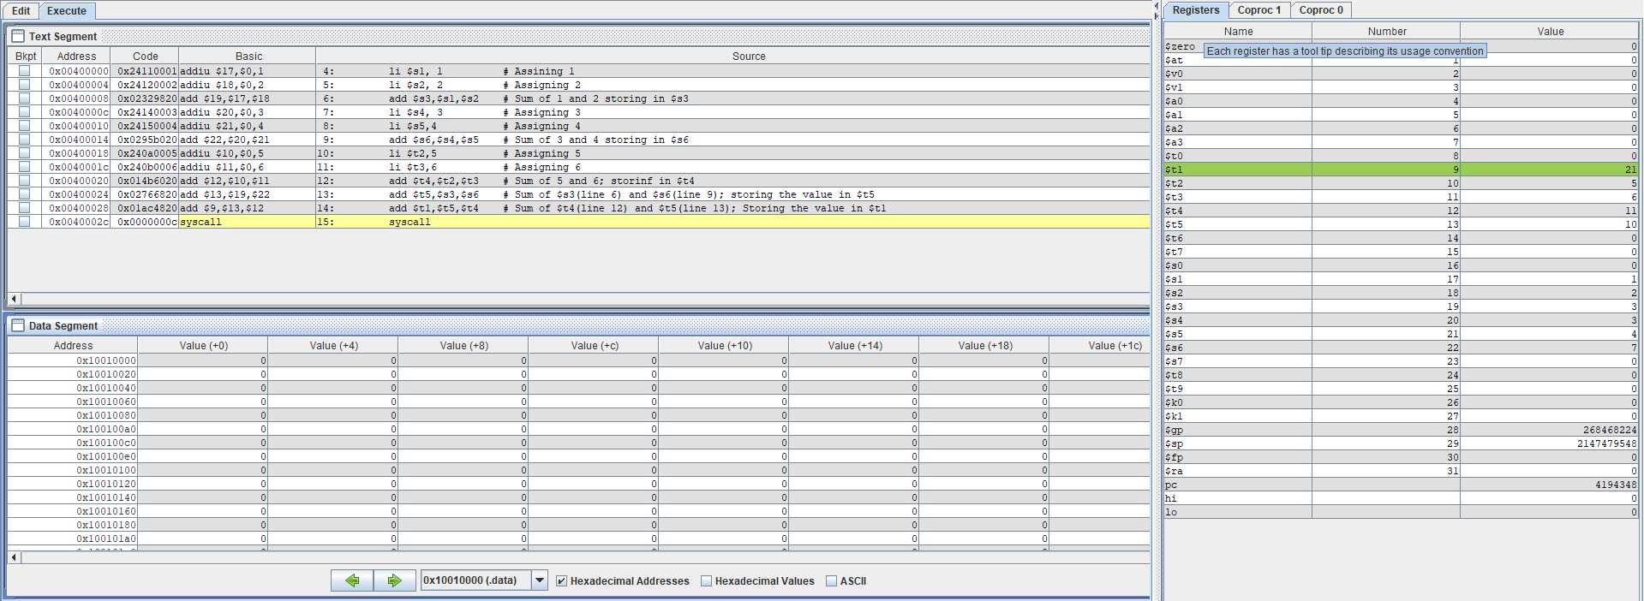

**Problem 2:**

Write a MIPS Assembly program to ADD the numbers: 1, 2, 3, 4, 5, 6, 7, 8, 9.

• Use ONLY the instructions: add and li

• Use any $t, $s registers

• The result of the addition (in decimal) should be in register: $t0

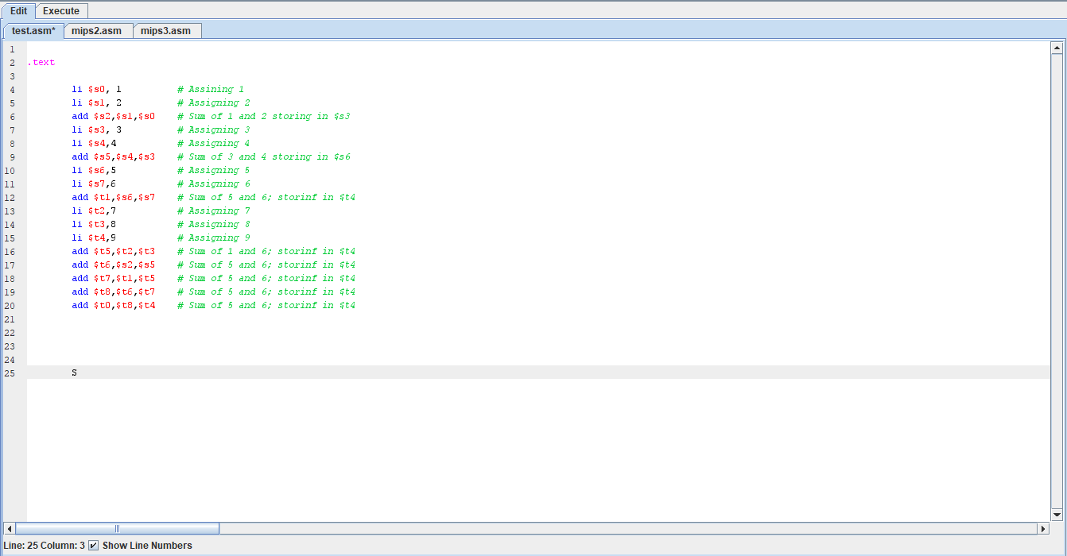

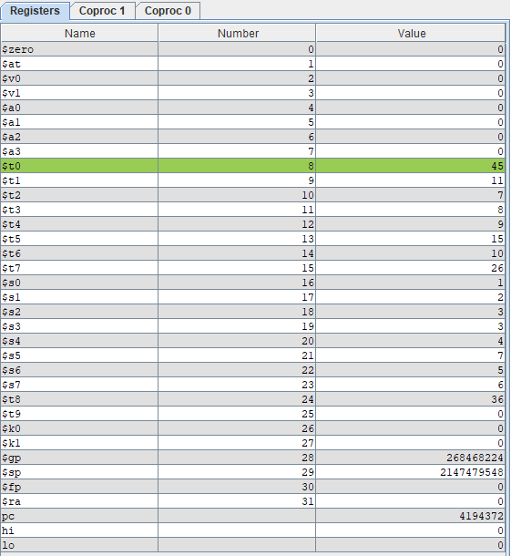

**Problem 3:**

Write a MIPS Assembly program to ADD the numbers: 1, 2, 3, 4, 5, 6 (as in ex–2)

• Use ONLY the instructions: addi and li

• The result of the addition (in decimal) should be in register: $t1

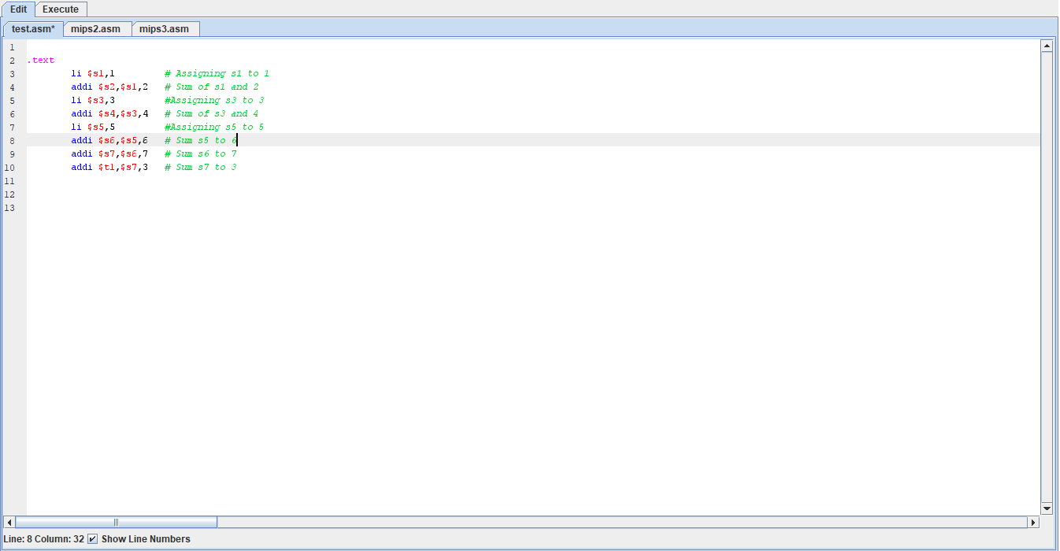

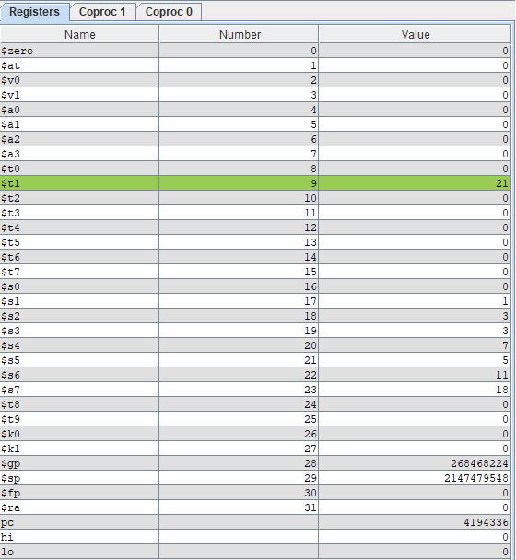

**Problem 4:**

Write a MIPS Assembly program to ADD the numbers: 1, 2, 3, 4, 5, 6 (as in ex–3)

• Use ONLY the instructions: addi and li ... and ONLY the register: $t0

• The result of the addition (in decimal) should be in register: $t0

