

**Assessment Module: 6**

**Rana, Karan**

**CSIT_230_03SP21**

Instructor: Dr. G.E. Antoniou

TA: Dev Dave

4,4,2021

**Problem 1:**

.data

prompt1: .asciiz "Enter first integer: "

prompt2: .asciiz "Enter second integer: "

prompt3: .asciiz "Enter third integer: "

message: .asciiz "The sum of the three integers is: "

.text

#prompt the user to enter first integer

li $v0,4

la $a0, prompt1

syscall

#Get the first integer

li $v0,5

syscall

#Store the result in $t0

move $t0,$v0

#prompt the user to enter second integer

li $v0,4

la $a0, prompt2

syscall

#Get the second integer

li $v0,5

syscall

#Store the result in $t1

move $t1,$v0

#prompt the user to enter third integer

li $v0,4

la $a0, prompt3

syscall

#end

#Get the third integer

li $v0,5

syscall

#Store the result in $t2

move $t2,$v0

#Adding three integers and keeping $t3

add $t1,$t1,$t0

add $t3,$t1,$t2

#Display message

li $v0,4

la $a0,message

syscall

#Print the sum

li $v0,1

move $a0,$t3

syscall

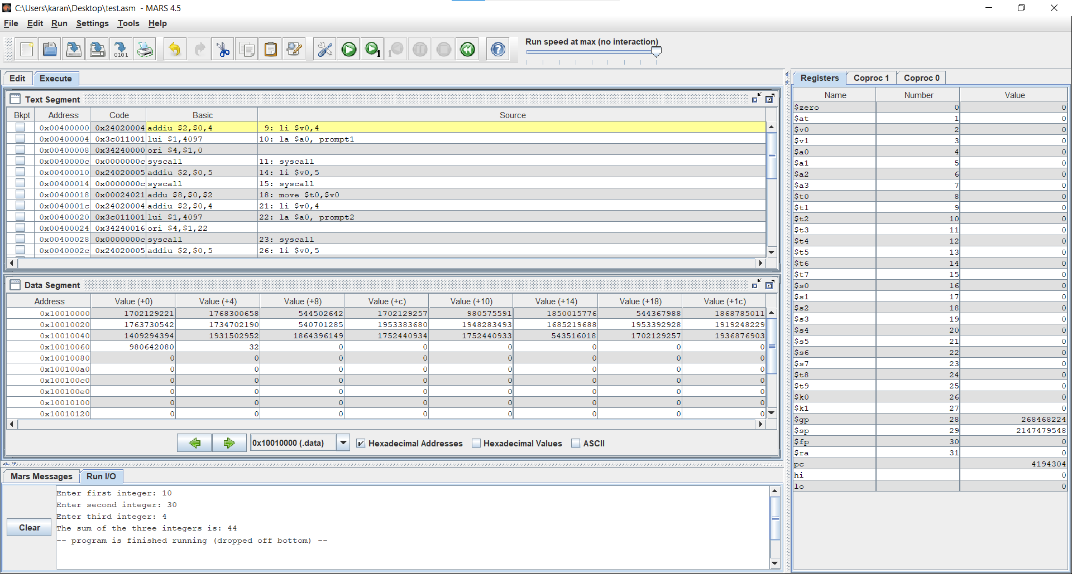

**Problem 2:**

.data

x: .asciiz "Enter x:"

n: .asciiz "Enter n:"

y: .asciiz "Enter y:"

str: .asciiz "Equation:"

.text

main:

li $v0,4

la $a0,x

syscall

li $v0,5

syscall

move $t0, $v0

li $v0,4

la $a0,n

syscall

li $v0,5

syscall

move $t1, $v0

li, $v0,4

la $a0,y

li $v0,5

syscall

move $t2, $v0

li $v0, 4

la $a0, str

syscall

mul $t0, $t0, $t0

mul $t2, $t2, $t2

mul $t1, $t1, $t2

mul $t0, $t0, $t1

move $a0, $t0

li $v0,1

syscall

li $v0,10

syscall

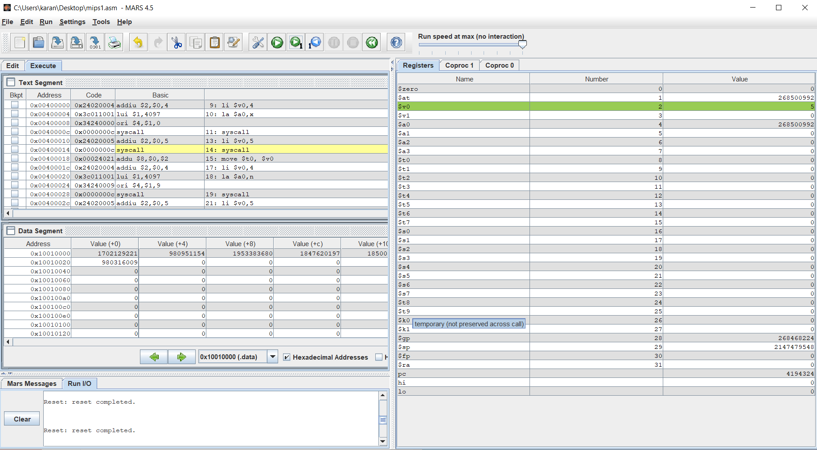

**Problem 3:**

.data

prompt: .asciiz"\nResult is: "#prompt for string

.text

main:

li $s0,3

li $s1,2

li $s2,1

mul $s5,$s0,$s0

mul $s5,$s5,$s0

mul $s6,$s1,$s1

mul $s6,$s6,$s1

mul $s5,$s0,$s0

mul $s5,$s5,$s0

mul $s6,$s1,$s1

mul $s6,$s6,$s1

mul $s7,$s2,$s2

mul $s7,$s7,$s2

add $t0,$s5,$s6

add $t0,$t0,$s7

li $v0,4

la $a0,prompt

syscall

move $a0,$t0

li $v0,1

syscall

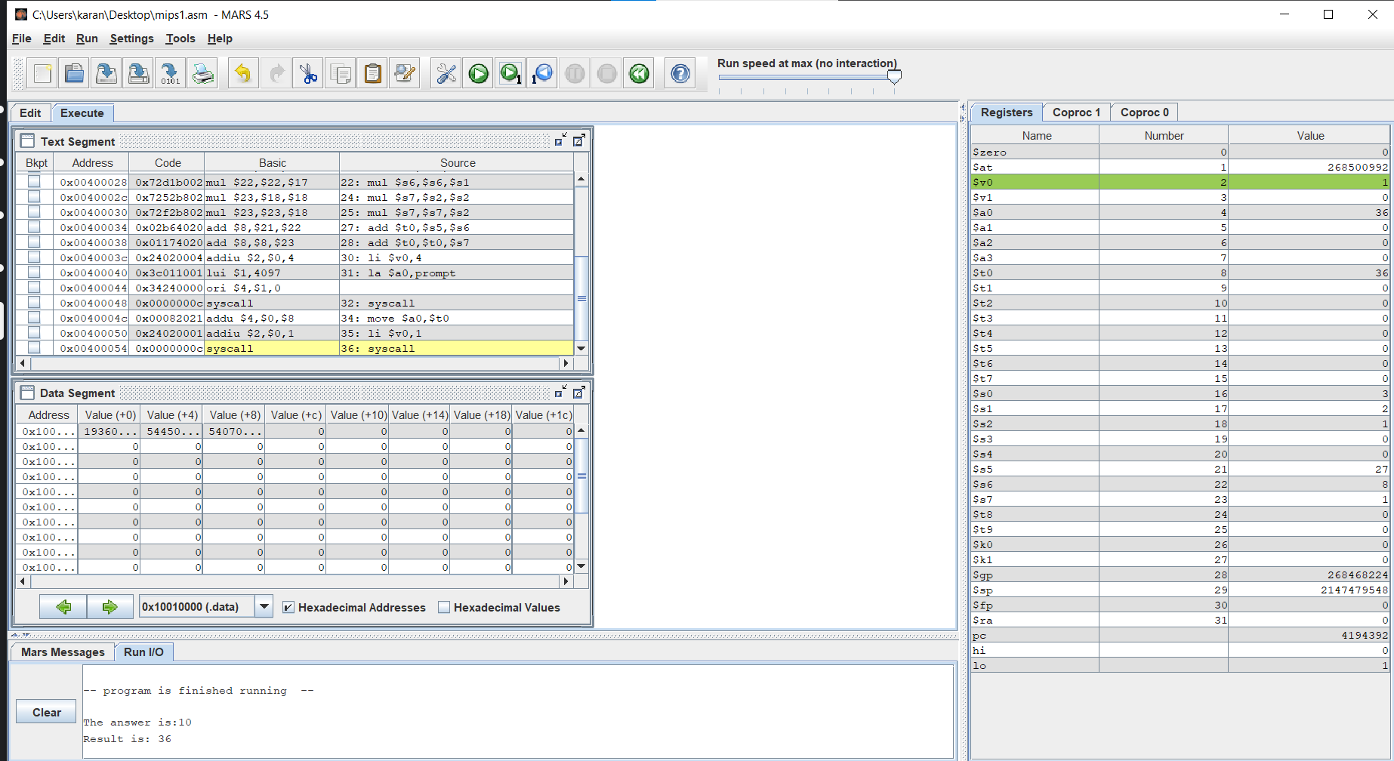

**Problem 4:**

.data

prompt: .asciiz "Enter the 3x3 matrix from row 1 to row 2 to row 3 :"

answer: .asciiz "The Determinant is : "

.text

li $v0,4

la $a0, prompt

syscall

li $v0,5 # THIS LOOPS 9 times to get all the user input

syscall

move $t0,$v0

li $v0,5

syscall

move $t1,$v0

li $v0,5

syscall

move $t2,$v0

li $v0,5

syscall

move $t3,$v0

li $v0,5

syscall

move $t4,$v0

li $v0,5

syscall

move $t5,$v0

li $v0,5

syscall

move $t6,$v0

li $v0,5

syscall

move $t7,$v0

li $v0,5

syscall

move $t8,$v0

jal determ

li $v0,4

la $a0, answer

syscall

move $a0,$s7

li $v0,1

syscall

li $v0,10

syscall

determ:

mult $t4,$t8

mflo $s1

mult $t5,$t7

mflo $s2

sub $s2,$s1,$s2

mult $s2,$t0

mflo $s2

mult $t3,$t8

mflo $s3

mult $t5,$t6

mflo $s4

sub $s4,$s3,$s4

mult $s4,$t1

mflo $s4

sub $s4,$s2,$s4

mult $t3,$t7

mflo $s5

mult $t4,$t6

mflo $s6

sub $s6,$s5,$s6

mult $s6,$t2

mflo $s6

add $s7, $s4,$s6

jr $ra

#end

