CSIT230_SP21

M7-HW

1)

.data

DISPLAY: .asciiz"Result is:"

.text

MAIN:

addi $s1,$zero,1

addi $s0,$zero,0

LOOPA:

beq $s1,5,EXITA

add $s0,$s0,$s1

addi $s1,$s1,1

j LOOPA

EXITA:

li $v0,4

la $a0,DISPLAY

syscall

li $v0,1

move $a0,$s0

syscall

END:nop

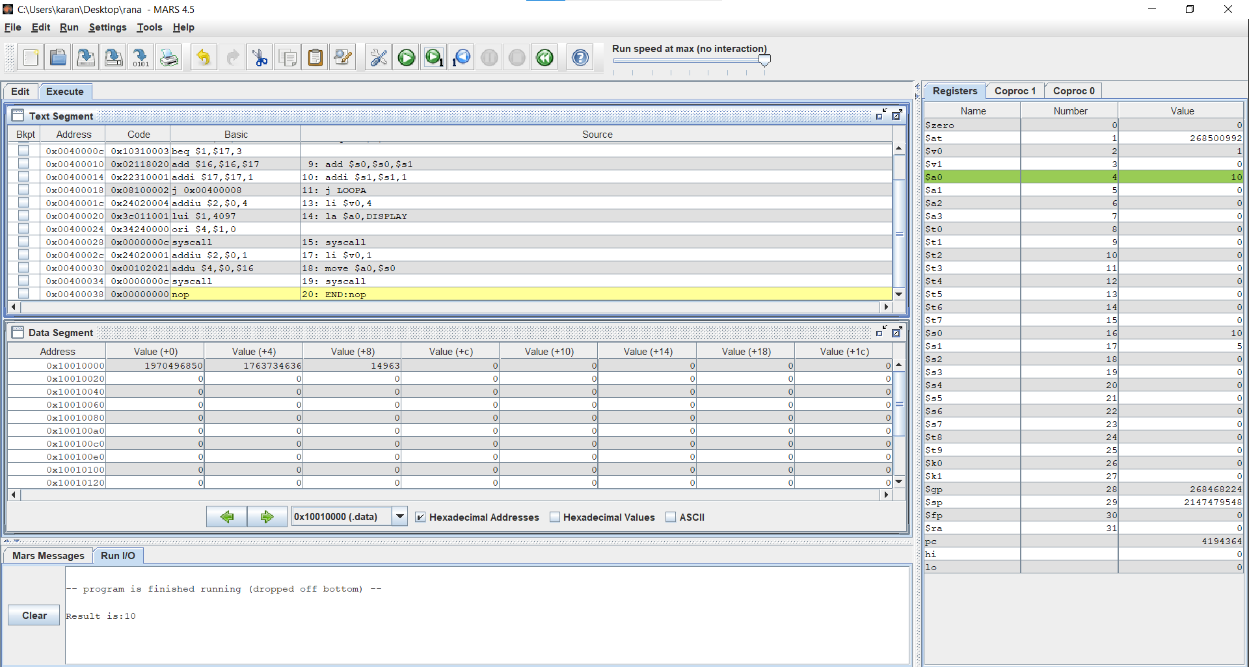

(b)

.data

DISPLAY: .asciiz"Result is "

.text

MAIN:

addi $s1, $zero,1

addi $s0, $zero,0

LOOPA:

beq $s1,4,EXITA

addi $s2, $zero,1

LOOPB:

beq $s2,4,EXITB

addi $s0,$s0,1

add $s0,$s0,$s1

add $0,$s0,$s2

addi $s2,$s2,1

j LOOPB

EXITB:

addi $s1,$s1,1

j LOOPA

EXITA :

li $v0,4

la $a0,DISPLAY

syscall

li,$v0,1

move $a0,$s0

syscall

END: nop

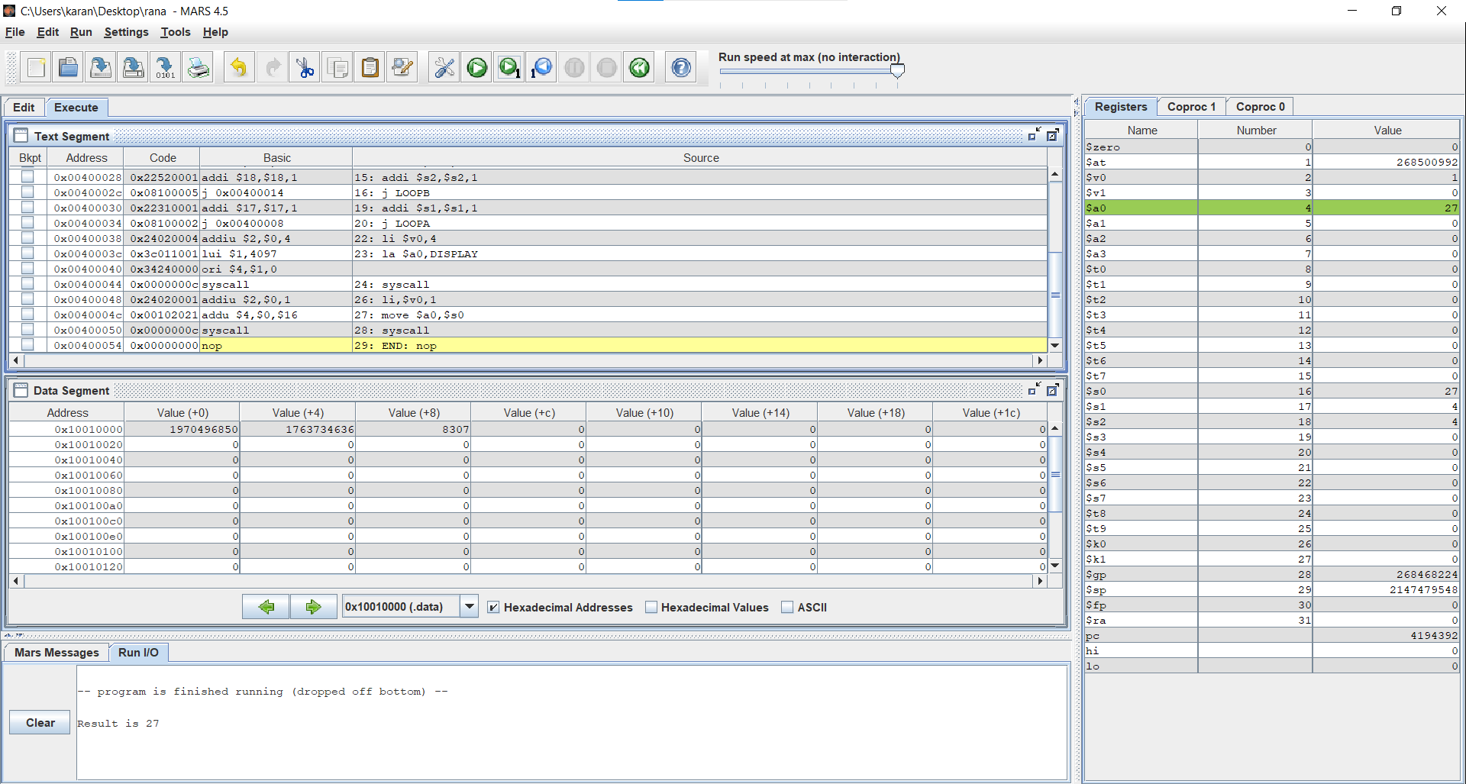

(c)

.data

DISPLAY: .asciiz"Result is "

.text

MAIN:

addi $s1,$zero,1

addi $s0,$zero,0

LOOPA:

beq $s1,3,EXITA

addi $s2,$zero,1

LOOPB:

beq $s2,3,EXITB

addi $s3,$zero,1

LOOPC:

beq $s3,3,EXITC

addi $s0,$s0,1

add $s0,$s0,$s1

add $s0,$s0,$s2

add $s0,$s0,$s3

addi $s3,$s3,1

j LOOPC

EXITC: addi $s2,$s2,1

j LOOPB

EXITB: addi $s1,$s1,1

j LOOPA

EXITA:

li $v0,4

la $a0,DISPLAY

syscall

li $v0,1

move $a0,$a0

syscall

END:nop

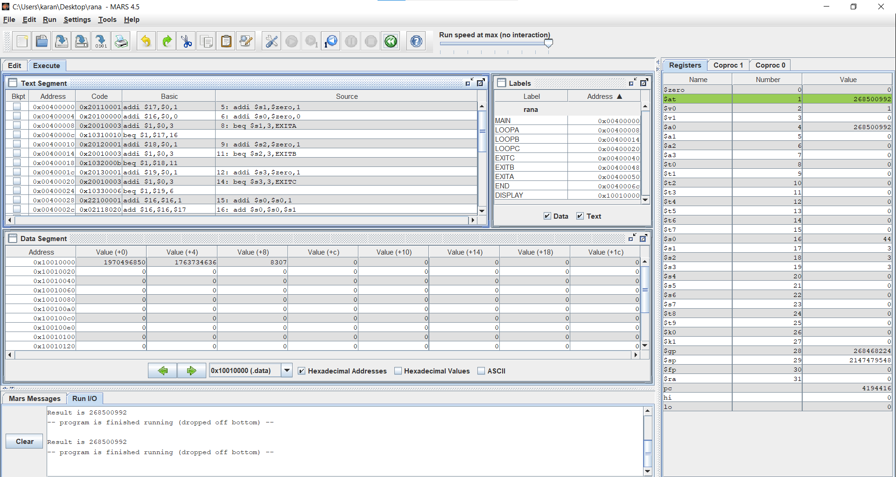

(d)

.data

DISPLAY: .asciiz"Result is: "

.text

MAIN: addi $s1,$zero,1

addi $s0, $zero,0

LOOPA: beq $s1,3,EXITA

addi $s2,$zero,1

LOOPB: beq $s2,3,EXITB

addi $s3,$zero,1

LOOPC: beq $s3,3,EXITC

addi $s4,$zero,1

LOOPD: beq $s4,3,EXITD

addi $s0,$s0,1

add $s0,$s0,$s1

add $s0,$s0,$s2

add $s0,$s0,$s3

add $s0,$s0,$s4

addi $s4,$s4,1

j LOOPD

EXITD: addi $s3,$s3,1

j LOOPC

EXITC: addi $s2,$s2,1

j LOOPB

EXITB: addi $s1,$s1,1

j LOOPA

EXITA:

li $v0,4

la $a0,DISPLAY

syscall

li $v0,1

move $a0,$s0

syscall

END:nop

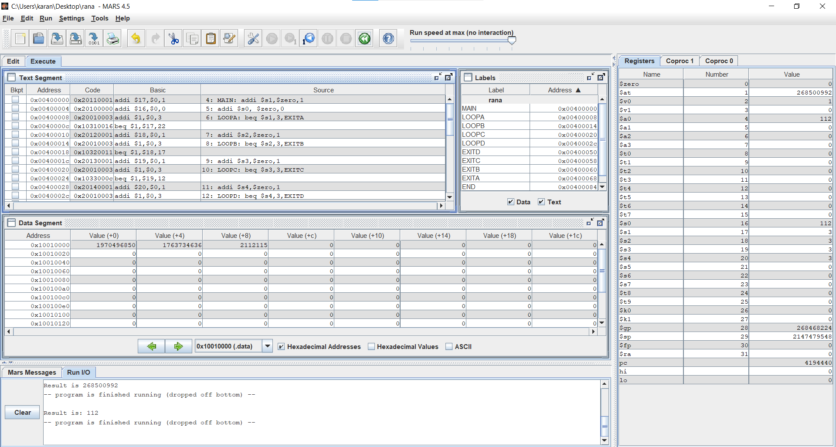

PART 2

.data

msg: .asciiz" Answer of this expression is: "

.text

main:

addi $t0,$zero,0

addi $t1,$zero,3

addi $t2,$zero,3

addi $t3,$zero,0

addi $s0,$zero,0

while:

beq $s0,2,exit

add $t3,$t3,$t1

add $t3,$t3,$t2

add $t1,$t1,$t1

addi $s0,$s0,1

j while

exit:

addi $s0,$zero,0

addi $t1,$zero,9

while1:

beq $s0,2,exit1

add $t3,$t3,$t1

add $t3,$t3,$t2

mul $t2,$t2,$t2

addi $s0,$s0,1

j while1

exit1:

li $v0,4

la $a0,msg

syscall

li $v0,1

addi $a0,$t3,0

syscall

