

**Information Technology**

Instructor: Dr. G.E. Antoniou

Day, Month, Year

Day

CSIT230_SP21

Department of CSIT

M8

Rana, Karan

**1)**

la $s0, 0xFFFF0010

li $t1,1

li $t2,2

li $t3,3

sw $t1, ($s0)

sw $t2, 4($s0)

sw $t3, 8($s0)

move $t4,$t1

move $t5,$t2

move $t6,$t3

add $t7,$t4,$t5

add $t7,$t7,$t6

sw $t7, 12($s0)

move $t8,$t7

li $v0,1

move $a0,$t8

syscall

**2)**

.data

arrayA: .word 2, 3

arrayB: .word 4, 5

arrayC: .word 0, 0

sentence: .asciiz

newLine: .asciiz

.text

addi $t0,$zero,0

li $s0,0

findSum :

lw $t1,arrayA($t0)

lw $t2,arrayB($t0)

add $s0,$t1,$t2

sw $s0,arrayC($t0)

beq $t0,4,finishLoop

add $t0,$t0,4

j findSum

finishLoop :

li $v0,4

la $a0,sentence

syscall

li $t0,0

printArrayC :

lw $t1,arrayC($t0)

li $v0,1

move $a0,$t1

syscall

beq $t0,4,endProgram

li $v0,4

la $a0,newLine

syscall

add $t0,$t0,4

j printArrayC

endProgram :

li $v0,10

syscall

**3)**

.data

h: .word 1,0,0,0, -2,1,0,0, 1,-2,1,0, 0,1,-2,1, 0,0,1,-2, 0,0,0,1

x: .word 1, 3, 1, 2

y: .word 0:6

newLine: .asciiz "\n"

.text

main:

li $t0, 0

OuterLoop:

bge $t0, 6, EndOuterLoop

li $t1, 0

InnerLoop1:

bge $t1, 1, EndInnerLoop1

li $t2, 0

li $t6, 0

InnerLoop2:

bge $t2, 4, EndInnerLoop2

mul $t3, $t0, 4

add $t3, $t3, $t2

mul $t3, $t3, 4

lw $t4, h($t3)

mul $t3, $t2, 1

add $t3, $t3, $t1

mul $t3, $t3, 4

lw $t5, x($t3)

mul $t4, $t4, $t5

add $t6, $t6, $t4

addi $t2, $t2, 1

b InnerLoop2

EndInnerLoop2:

mul $t3, $t0, 1

add $t3, $t3, $t1

mul $t3, $t3, 4

sw $t6, y($t3)

addi $t1, $t1, 1

b InnerLoop1

EndInnerLoop1:

addi $t0, $t0,1

b OuterLoop

EndOuterLoop:

la $t0, y

li $t1, 1

DisplayLoop:

bgt $t1, 6, Exit

li $v0, 1

lw $a0, 0($t0)

syscall

li $v0, 4

la $a0, newLine

syscall

addi $t1, $t1, 1

add $t0, $t0, 4

b DisplayLoop

Exit:

li $v0, 10

syscall

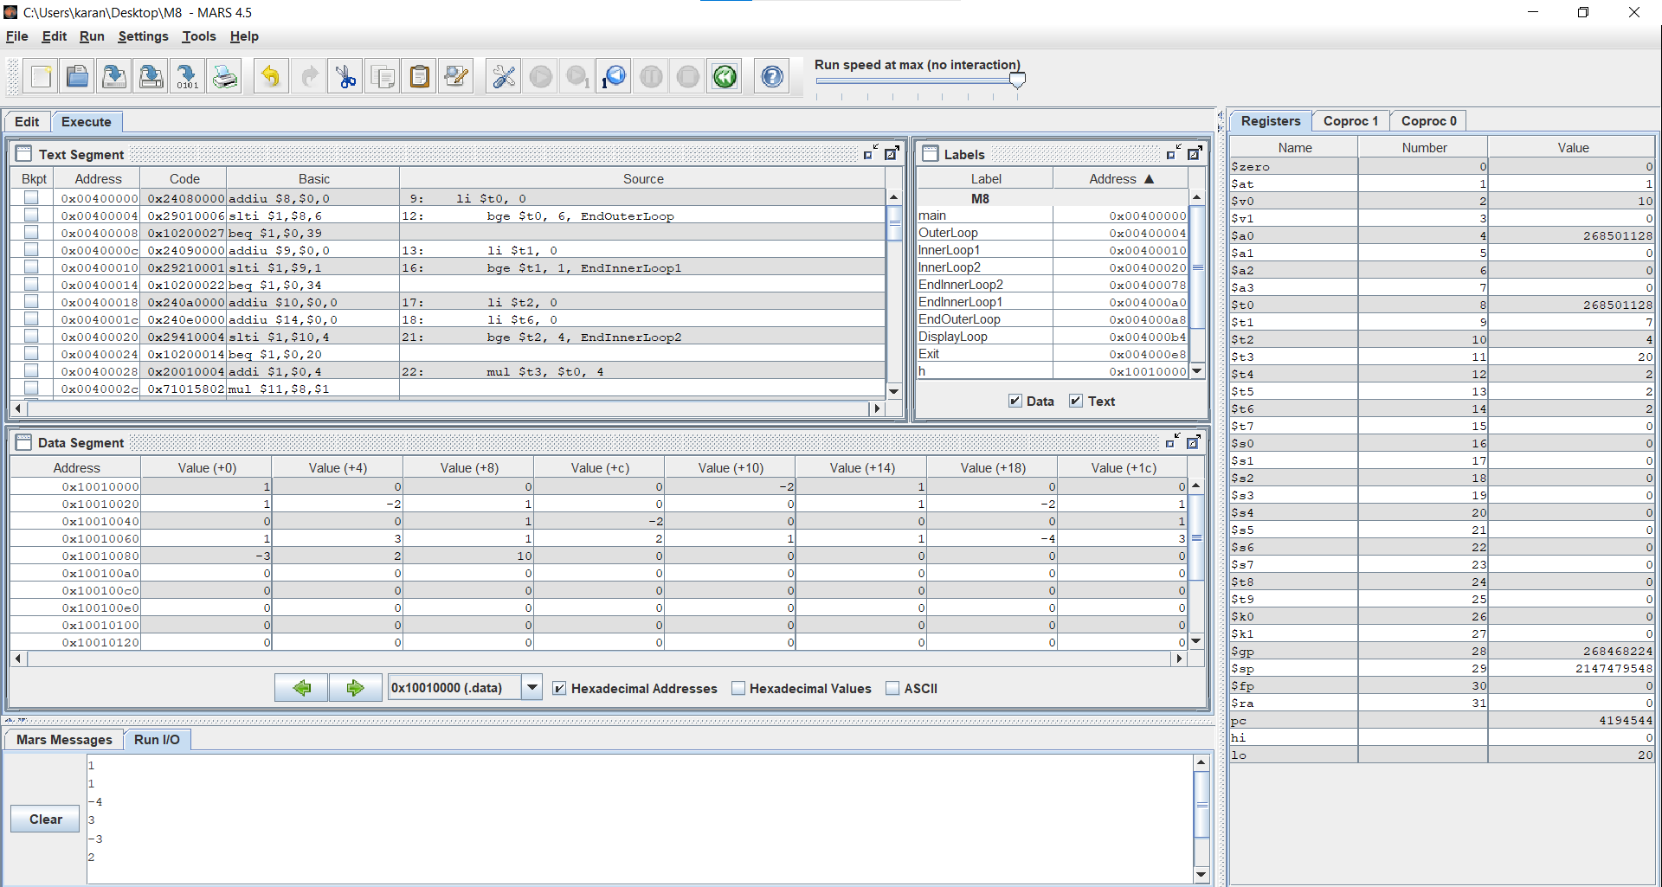

**4)**

.data

a: .word 5,1,2,3,4

x: .word 1

.word 2

.word 3

y: .word 0:1

.word 0:1

.word 0:1

A: .word 0:3

.word 0:3

.word 0:3

X: .word 0:1

.word 0:1

.word 0:1

message:.asciiz

space: .asciiz

newline: .asciiz

.text

main:

la $a0,a

la $a1,A

lw $t0,($a0)

sw $t0,($a1)

li $t1,4

sll $t1,$t1,2

add $t1,$t1,$a1

sw $t0,($t1)

li $t1,8

sll $t1,$t1,2

add $t1,$t1,$a1

sw $t0,($t1)

add $a0,$a0,4

lw $t0,($a0)

li $t1,3

sll $t1,$t1,2

add $t1,$t1,$a1

sw $t0,($t1)

li $t1,7

sll $t1,$t1,2

add $t1,$t1,$a1

sw $t0,($t1)

add $a0,$a0,4

lw $t0,($a0)

li $t1,6

sll $t1,$t1,2

add $t1,$t1,$a1

sw $t0,($t1)

add $a0,$a0,4

lw $t0,($a0)

li $t1,1

sll $t1,$t1,2

add $t1,$t1,$a1

sw $t0,($t1)

li $t1,5

sll $t1,$t1,2

add $t1,$t1,$a1

sw $t0,($t1)

add $a0,$a0,4

lw $t0,($a0)

li $t1,2

sll $t1,$t1,2

add $t1,$t1,$a1

sw $t0,($t1)

la $a0,x

la $a1,X

lw $t0,($a0)

sw $t0,($a1)

add $a0,$a0,4

lw $t0,($a0)

li $t1,1

sll $t1,$t1,2

add $t1,$t1,$a1

sw $t0,($t1)

add $a0,$a0,4

lw $t0,($a0)

li $t1,2

sll $t1,$t1,2

add $t1,$t1,$a1

sw $t0,($t1)

li $a0,3

la $a1,A

la $a2,X

la $a3,y

jal MatrixMul

li $v0,4

la $a0,message

syscall

la $a0,y

li $a1,3

li $a2,1

jal printMatrix

li $v0, 10

syscall

MatrixMul:

li $t0,0

mulr_loop1: li $t1,0

mulr_loop2: li $t3,0

li $t7,0

mulr_loop3: mul $t2,$t0,$a0

add $t2,$t2,$t3

sll $t2,$t2,2

add $t4,$t2,$a1

lw $t4,($t4)

mul $t2,$t3,1

add $t2,$t2,$t1

sll $t2,$t2,2

add $t5,$t2,$a2

lw $t5,($t5)

mul $t4,$t4,$t5

add $t7,$t7,$t4

add $t3,$t3,1

beq $t3,$a0,mulr_next1

j mulr_loop3

mulr_next1:

mul $t2,$t0,1

add $t2,$t2,$t1

sll $t2,$t2,2

add $t3,$t2,$a3

sw $t7,($t3)

add $t1,$t1,1

beq $t1,1,mulr_next2

j mulr_loop2

mulr_next2: add $t0,$t0,1

beq $t0,$a0,return_MatrixMul

j mulr_loop1

return_MatrixMul: jr $ra

printMatrix :

li $t0,0

move $t2,$a0

oloop:

li $t1,0

iloop:

lw $a0, ($t2)

li $v0,1

syscall

add $t2,$t2,4

add $t0,$t0,1

add $t1,$t1,1

beq $t1,1,print_next

la $a0,space

li $v0,4

syscall

j iloop

print_next: la $a0,newline

li $v0,4

syscall

beq $t0,3,printingover

j oloop

printingover: la $a0,newline

li $v0,4

syscall

jr $ra

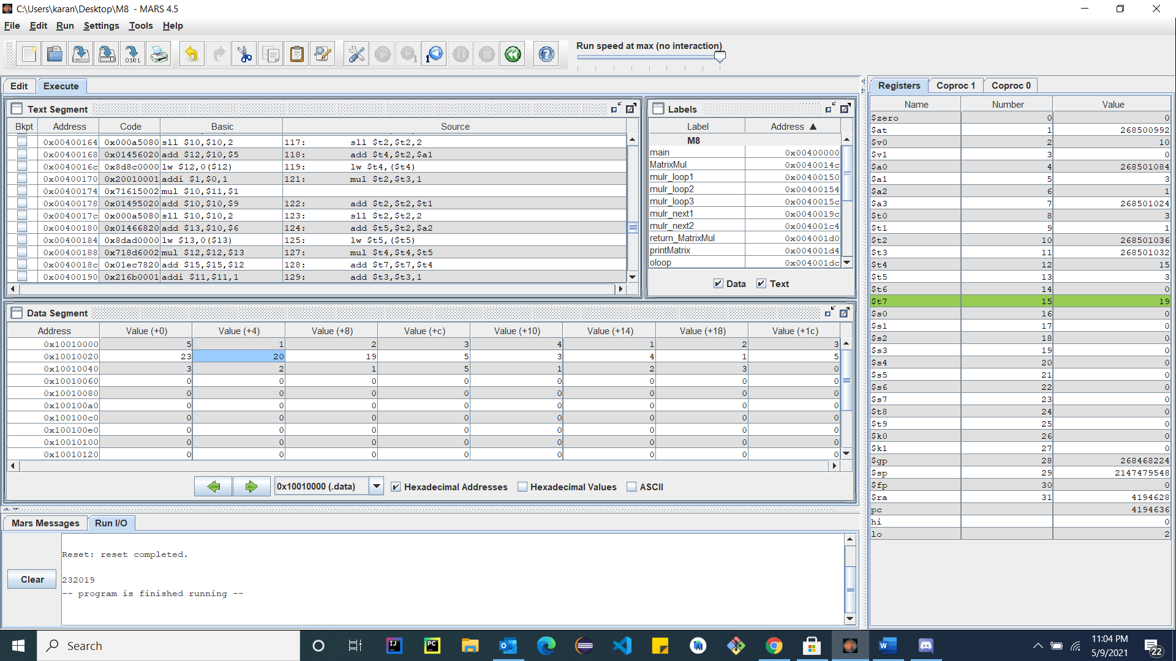

**5)**

.data

X:  
X0: 8 1 6  
X1: 3 5 7  
X2: 4 9 2

.text  
li $t0,0 # The final det

li $s0,0  
li $s1,4  
li $s2,8

# The first computation  
lw $t1,X0($s0)  
lw $t2,X1($s1)  
lw $t3,X2($s2)  
lw $t4,X2($s1)  
lw $t5,X1($s2)  
mul $t2,$t2,$t3  
mul $t4,$t4,$t5  
sub $t2,$t2,$t4  
mul $t1,$t1,$t2

add $t0,$t0,$t1

# The Second computation  
lw $t1,X0($s1)  
lw $t2,X1($s0)  
lw $t3,X2($s2)  
lw $t4,X2($s0)  
lw $t5,X1($s2)  
mul $t2,$t2,$t3  
mul $t4,$t4,$t5  
sub $t2,$t2,$t4  
mul $t1,$t1,$t2

sub $t0,$t0,$t1

# The Third computation  
lw $t1,X0($s2)  
lw $t2,X1($s0)  
lw $t3,X2($s1)  
lw $t4,X2($s0)  
lw $t5,X1($s1)  
mul $t2,$t2,$t3  
mul $t4,$t4,$t5  
sub $t2,$t2,$t4  
mul $t1,$t1,$t2

add $t0,$t0,$t1  
# print to console  
move $a0,$t0  
li $v0,1  
syscall

#exit the program:  
li $v0,10  
syscall

