

Department of CSIT

Information Technology

Module 3

Rana, Karan

CSIT230_03SP

Problem 1

A heart rate monitor measures an individual’s heart rate and blood pressure. Both

sensors output zero (0) if they are within safety range. An alarm will sound if either

sensor indicates an unsafe condition is present. Set–up the appropriate truth table, simplify (minimally) using K-maps. Implement, using Logisim, the simplified logic circuit with optimal number of logic gates.

|  |  |
| --- | --- |
| X | Y |
| 0 | 0 |
| 0 | 1 |
| 1 | 0 |
| 1 | 1 |

|  |  |  |
| --- | --- | --- |
| X or Y | 0 | 1 |
| 0 | 0 | 1 |
| 1 | 1 | 1 |

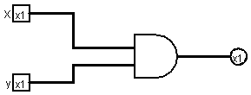

Problem 2

Three light-emitting diodes (LEDs) [one Red, one Green, one Blue] turn on when a number 0–7 is passed through. Red turns on with even numbers, green turns on with odd numbers, blue turns on with multiples of 3. Zero means they are all off, seven means they are all on. Set–up the appropriate truth table, simplify (minimally) using K-maps. Implement, using Logisim, the simplified logic circuit with optimal number of logic gates.

We know that even numbers turn on Red = 2,4,6

We know that odd numbers turn on green = 1,3,5

We know that blue numbers turn on blue = 3,6

|  |  |  |  |
| --- | --- | --- | --- |
| X/Y/Z | X | Y | Z |
| 0 | 0 | 0 | 0 |
| 1 | 0 | 0 | 1 |
| 2 | 0 | 1 | 0 |
| 3 | 0 | 1 | 1 |
| 4 | 1 | 0 | 0 |
| 5 | 1 | 0 | 1 |
| 6 | 1 | 1 | 0 |
| 7 | 1 | 1 | 1 |

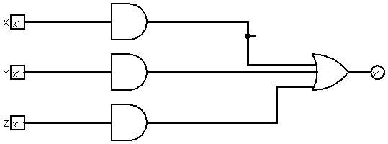

Problem 3

A teacher is grading the students in 4 subjects (Math, Spelling, English, and History) to see whether or not they will graduate. If a student passes Math and Spelling, they will graduate. If a student passes either English or History, they will graduate. All other students will not graduate.

Set–up the appropriate truth table, simplify (minimally) using K-maps. Implement, using Logisim, the simplified logic circuit with optimal number of logic gates.

Math and Spelling = Graduate

English or History = Graduate

Rest = not graduate

|  |  |  |  |  |
| --- | --- | --- | --- | --- |
| Math | Spelling | English | History | Graduate |
| 0 | 0 | 0 | 0 | 0 |
| 0 | 0 | 0 | 1 | 0 |
| 0 | 0 | 1 | 0 | 0 |
| 0 | 0 | 1 | 1 | 1 |
| 0 | 1 | 0 | 0 | 0 |
| 0 | 1 | 0 | 1 | 0 |
| 0 | 1 | 1 | 0 | 0 |
| 0 | 1 | 1 | 1 | 1 |
| 1 | 0 | 0 | 0 | 0 |
| 1 | 0 | 0 | 1 | 0 |
| 1 | 0 | 1 | 0 | 0 |
| 1 | 0 | 1 | 1 | 1 |
| 1 | 1 | 0 | 0 | 1 |
| 1 | 1 | 0 | 1 | 1 |
| 1 | 1 | 1 | 0 | 1 |
| 1 | 1 | 1 | 1 | 1 |

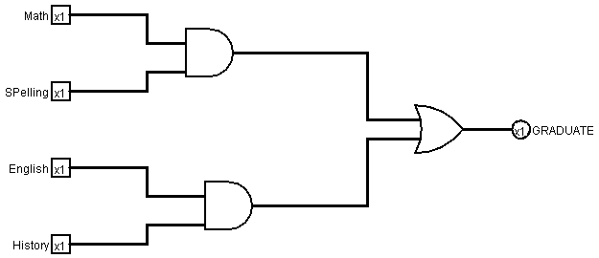

Problem 4

Design a digital logic circuit (LookUp Table or LUT) with three inputs, x, y and z, and the three outputs, A, B, and C. When the binary input is 0, 1, 2, or 3, the binary output is 2 greater than the input. When the binary input is 4, 5, 6, or 7, the binary output is 2 less than the input.

Set–up the appropriate truth table, simplify (minimally) using K-maps. Implement, using Logisim, the simplified logic circuit with optimal number of logic gates.

|  |  |  |  |  |  |
| --- | --- | --- | --- | --- | --- |
| X | Y | Z | A | B | C |
| 0 | 0 | 0 | 0 | 1 | 0 |
| 0 | 0 | 1 | 0 | 1 | 1 |
| 0 | 1 | 0 | 1 | 0 | 0 |
| 0 | 1 | 1 | 1 | 0 | 1 |
| 1 | 0 | 0 | 0 | 1 | 0 |
| 1 | 0 | 1 | 0 | 1 | 1 |
| 1 | 1 | 0 | 1 | 0 | 0 |

|  |  |  |  |  |  |
| --- | --- | --- | --- | --- | --- |
| 1 | 1 | 1 | 1 | 0 | 1 |

We know that 