2b.

ac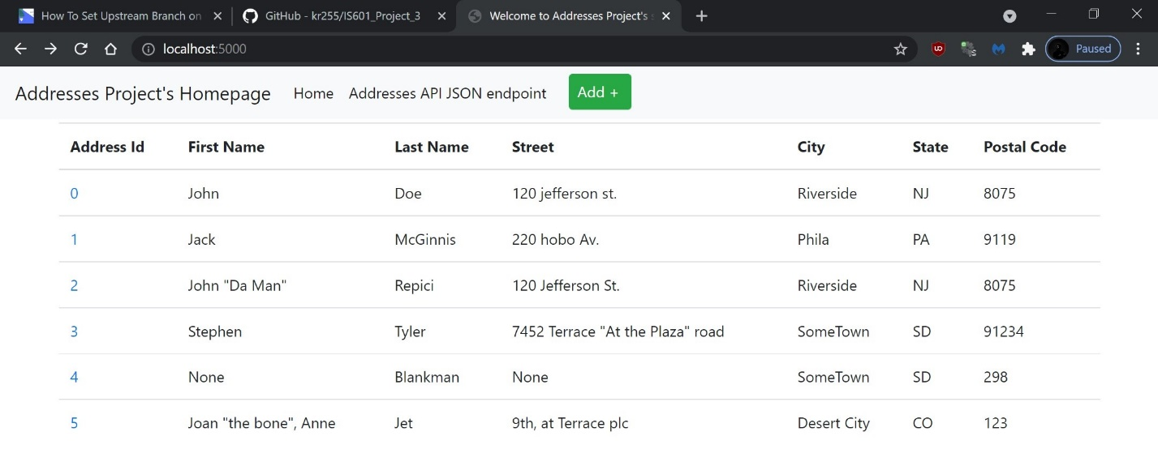

2c.

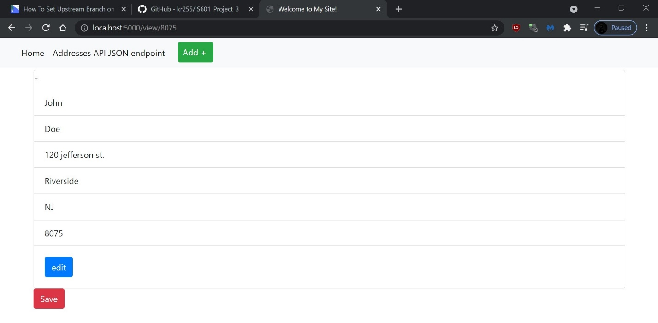

2d.

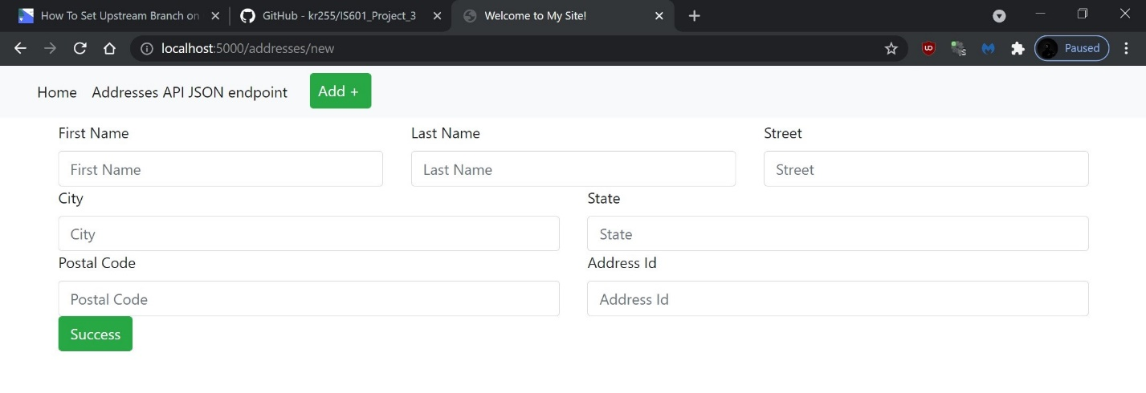

2d.

2e.

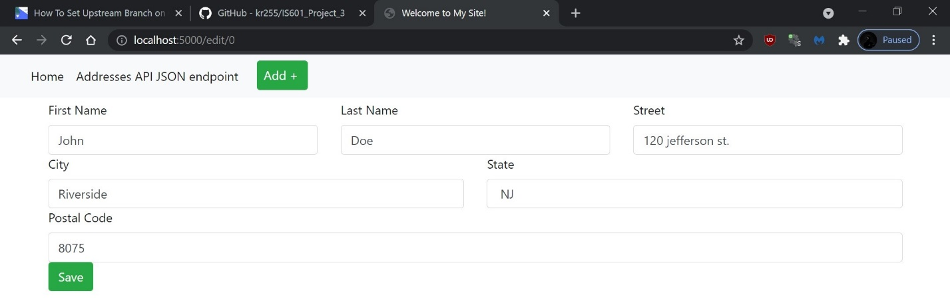

2e.

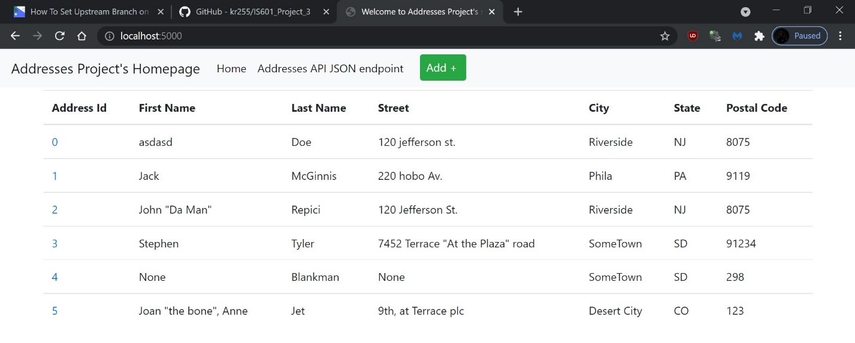

2f.

