
Faculty of Engineering
Department of Informatics Engineering
Software Engineering and Information Systems
Artificial Intelligence Engineering and Data Science

Drug management platform

A junior project report - submitted to complete the requirements for obtaining a bachelor’s degree in informatics engineering -Artificial Intelligence Engineering and Data Science

Prepared by
Mohamd alsaed
Ali alabad

Supervised by
Eng. Maher Sarem

كليــــــــــــــــــة الهندســــــــــــــــــــــــة قســــــــم الهندســــــة المعـلـوماتيـــــة هندسة البرمجيات ونظم المعلومات هندسة الذكاء الصنعي وعلوم البيانات

منصة ادارة الادوية
تقرير للمشروع الفصلي قدّم استكمالاً لمتطلبات الحصول على درجة البكالوريوس في هندسة المعلوماتية - هندسة الذكاء الصنعي وعلوم البيانات

اعداد
محمد السعيد
علي العبيد

اشراف
المهندس. ماهر صارم

Table of Contents
Chapter 1: General Introduction ...................................................... 3
1.1 Project Overview and Background ................................................ 3
1.2 Problem Statement, Practical & Academic Significance ........................... 4
1.3 Project Objectives ............................................................. 4
1.4 Project Scope, Constraints & Assumptions ....................................... 5
1.5 Contribution to Knowledge and the Field ........................................ 5
1.6 Research Methodology and Scientific Tools ...................................... 5
1.7 Document Structure ............................................................. 6
1.8 Basic Definitions and Core Concepts ............................................ 6
Chapter 2: Project Management and Development Methodology ............................ 7
2.1 Selection and Justification of Development Methodology ......................... 7
2.2 Project Timeline (Gantt Plan) .................................................. 7
2.3 Risk Management ................................................................ 8
2.4 Work Team and Task Distribution ................................................ 8
2.5 Quality Management in the Project .............................................. 9
2.6 Project Management Tools Used .................................................. 9
2.7 Continuous Monitoring & Evaluation Mechanisms .................................. 10
2.8 Software Configuration Management (SCM) ........................................ 10
Chapter 3: Literature Review and Previous Studies .................................... 11
3.1 Previous Studies in Medication Reminder Systems ................................ 11
3.2 Modern Technologies and Frameworks in the Field ................................ 12
3.3 Comparative Analysis of Existing Systems & Products ............................ 12
3.4 Research Gap and Proposed Innovation ........................................... 13
3.5 Theoretical Framework and Reference Studies .................................... 13 3.6 Modern and Future Trends in the Field .......................................... 14
Chapter 4: Requirements Modeling and Analysis ........................................ 15
4.1 Feasibility Study .............................................................. 15
4.2 Requirements Gathering ......................................................... 15
4.3 Stakeholders and Needs Analysis ................................................ 16
4.4 Functional Requirements ........................................................ 16
4.5 Non-Functional Requirements .................................................... 17
4.6 Prioritization and MoSCoW Management Mechanism ................................. 17
4.7 UML Diagrams for Requirements .................................................. 18
4.8 Requirements Traceability Matrix ............................................... 19
4.9 Data Schema and Core Relationships ............................................. 19
4.10 Preliminary Test Cases ........................................................ 19
Chapter 5: Architectural Design of the System ........................................ 20
5.1 High-Level Design & Pattern Used ............................................... 20
5.2 Database Design ................................................................ 21
5.3 API Design ..................................................................... 22

5.4 Security and Permissions Design ................................................ 22
5.5 Backend Design for Scheduling and Notifications ................................ 23
Chapter 6: Execution Environment and Tools ........................................... 24
6.1 Software Tools and Libraries Used .............................................. 24
6.2 Development Environment and Project Structure .................................. 24
6.3 Programming Languages and Frameworks ........................................... 25
6.4 Database Server and Operating System ........................................... 25
6.5 Dependencies File .............................................................. 26
6.6 Version Control and SCM Tools .................................................. 26
6.7 CI/CD Integration Tools ........................................................ 26
6.8 Testing Environment ............................................................ 27
Chapter 7: Software Implementation ................................................... 28
7.1 File and Project Structure ..................................................... 28
7.2 Module Implementation .......................................................... 28
7.3 API Implementation ............................................................. 29
7.4 Data Access Layer Implementation ............................................... 29
7.5 Business Logic Layer Implementation ............................................ 30
7.6 User Interface (UI) Implementation ............................................. 31
7.7 Reminder Mechanism and Smart Rule Logic ........................................ 31
Chapter 8: Testing and Evaluation .................................................... 32
8.1 Test Plan & Types of Tests ..................................................... 32
8.2 Test Diagrams and Detailed Test Cases .......................................... 33
8.3 Test Results and Failure Analysis .............................................. 34
8.4 Quality Metrics ................................................................ 34
8.5 User Acceptance Testing (UAT) .................................................. 35
Chapter 9: Results and Analysis ...................................................... 36
9.1 System Deployment Results ...................................................... 36
9.2 Comparative Analysis with Existing Systems ..................................... 36
9.3 Objective Fulfillment Extent ................................................... 37
9.4 Strengths and Weaknesses Analysis .............................................. 37
9.5 Performance and Quality Indicators ............................................. 38
Chapter 10: Conclusion and Recommendations ........................................... 39
10.1 Project Summary and Main Achievements ......................................... 39
10.2 Challenges and Difficulties Faced ............................................. 39
10.3 Future Development Proposals .................................................. 40
10.4 Practical Recommendations ..................................................... 40
10.5 Final Conclusion .............................................................. 41

Chapter 1: General Introduction to the Medication Management and Dose Reminder System
This chapter provides a comprehensive breakdown of the project in terms of its background, the realworld problem it addresses, its primary goals, practical scope, anticipated scientific contributions, and the research methodology utilized to guide the documentation. It establishes the conceptual foundation of the report, connecting concrete patient needs with the software solution engineered to fulfill them.

1.1 Project Overview and Background
The core focus of this project is developing a centralized web application designed for comprehensive medication tracking and automated dose scheduling. It enables patients to safely compile a personalized digital locker of their current prescriptions, log the exact real-time quantities of medication on hand, specify strict minimum threshold metrics to spark automatic restocking alerts, and design dynamic dosage tables. These multi-dimensional tables securely track exact recurrence schedules across specific calendar days, repeating temporal frequencies, and micro-timed intake hours.
When a scheduled medication window arrives, the system background thread automatically triggers a prompt notification, prompting the user via an active web portal overlay. Users can seamlessly mark the scheduled event as either 'Confirmed/Taken' or 'Missed/Skipped' directly from the graphical user interface. The technical implementation leverages Flask as the primary web application factory framework, fortified by a stateless authentication architecture powered by JSON Web Tokens (JWT). Persistent system data is mapped to a robust MySQL server instance abstraction utilizing the SQLAlchemy Object-Relational Mapper (ORM). Simultaneously, a multi-threaded scheduling execution layer continuously checks active tables to accurately calculate micro-timed windows, fire system-wide alerts, and process lower-bound threshold metrics.
The foundational significance of this implementation lies in rectifying a pervasive, high-risk real-world issue: the profound therapeutic complications stemming from low patient compliance and inconsistent adherence due to complex, multi-medication routines. It represents a highly structured software engineering blueprint that demonstrates seamless programmatic convergence across dynamic inventory auditing, background job scheduling, synchronous notification routing, and automated compliance auditing.

Component |  | Functional Role | System Impact
Authentication (JWT) Validates patient or administrator Establishes bulletproof security identity securely via signed stateless context and absolute role
tokens separation
Medication Catalog | Allows administrators to add, modify, activate, or systematically deprecate entries | Grants full database control over the system-wide pharmaceutical index
Patient Medication Vault Stores dynamic inventory metrics, Reflects the actual current usage personal schedules, and lower states and physical supply metrics boundaries
Dosage Scheduling Matrix |  | Maps out precision recurrence rules, calendar tracking, and exact timelines | Maintains absolute persistence of the multi-tiered clinical treatment plan
Notifications & Adherence Logs Handles prompt reminder Enables precision auditing of realgeneration and writes unalterable world patient therapeutic
historical logs compliance

1.2 Problem Statement, Practical & Academic Significance
The core problem tackled by this architecture is the widespread absence of dependable, automated, and interconnected self-management tools to help patients follow precise therapeutic routines, particularly when dealing with complex, multi-drug regimens. Traditional manual methods rely heavily on personal cognitive recall, static written diaries, or disconnected smartphone clock alarms. This fragmentation significantly escalates the clinical probability of critical dosing oversights, dangerous therapeutic delays, or accidental double-dosing.
Practically, systematic non-adherence drastically compromises clinical efficacy, accelerates disease progression, increases avoidable emergency readmissions, and places an exhausting tracking burden on family members and healthcare providers. Academically, this dilemma serves as an ideal software engineering showcase to explore how complex healthcare needs translate into decoupled, highly structured multi-tiered architectures.
Problem Dimension | Detailed Description | Direct System Impact
Dosing Oversights Patients completely forget to take Severe disruption of therapeutic critical medication due to cognitive blood-plasma concentrations overload
Routine Complexity | Managing multiple drugs simultaneously leads to dangerous administration errors | Elevated risk of cross-medication confusion and accidental toxicity
Absence of Auditing No immutable historical log exists to Prevents physicians from objectively verify past intake events evaluating therapeutic efficacy

Supply Depletion | Physical medication runs out unexpectedly, causing sudden treatment gaps | Abrupt therapy interruption before a pharmacy refill is secured

1.3 Project Objectives
The fundamental objectives of this project were explicitly mapped out to ensure complete testability and verifiable implementation within clear system constraints. The primary goal centers on engineering a fully integrated web platform that streamlines medication management and dose reminders, supported by distinct sub-objectives:
Objective Category | Specific Technical Objective | Measurable Success Indicator
Primary Metric Build an interconnected web Flawless end-to-end execution from
platform for medication oversight drug entry to active notification and scheduling logging
Sub-Objective | Provide comprehensive user selfservice for inventory tracking and limit mapping | Successful modification of private records via the user dashboard
Sub-Objective Implement flexible scheduling logic Active database generation of across specific days and time complex relational rules per matrices medication
Sub-Objective | Deploy an automated background engine to fire precision reminder notifications | System-wide delivery of instant pop-ups matching exact schedule  slots
Sub-Objective Establish a secure, unalterable Accurate archival of compliance historical ledger for intake auditing states accessible via user histories
Sub-Objective | Enforce strict Role-Based Access Control (RBAC) boundaries | Absolute HTTP 403 authorization rejections against cross-role route requests

1.4 Project Scope, Constraints & Assumptions
The structural scope encompasses a secure web application environment operating across dual access roles (Patient and Administrator). It natively manages user onboarding, master catalog administration, user-specific inventory tracking, relational dosage scheduling, real-time reminder delivery, and immutable compliance logging. The underlying database engine maintains tight referential integrity across accounts, drug indexes, live schedules, notification queues, and historical logs.
Conversely, the scope explicitly excludes automated medical diagnosis, prescription suggestions, telemetry interfacing with external wearable biometric hardware, or direct integration with regional hospital networks. The system does not employ predictive machine learning heuristics; it functions strictly on deterministic, rule-based scheduling algorithms and periodic background verification loops.
Scope/Constraint Element |  | Technical Details |  | Impact on System Design
Architectural Scope Decoupled web portal managing Requires clean separation of
patient profiles, catalogs, and alerts concerns via an explicit multi-tiered layout
Technical Constraint |  |  | Relies entirely on persistent servers and manual user inventory inputs | Demands strict server-side validation against corrupted inputs
Security Constraint Enforces stateful token blocklisting Requires a high-speed database
upon explicit session termination registry for invalidated token hashes
System Assumption |  |  | Assumes end-users possess basic web literacy and interface familiarity | Prioritizes clean, straightforward, and accessible graphical user interfaces
Operational Assumption Assumes user-provided timezones Enforces structural validation before and inventory values are correct saving records to the database

Chapter 2: Project Management and Development Methodology
This chapter details the methodology utilized to guide the project from initial conceptualization to a fully validated production-ready state. It documents how abstract ideas transformed into structured, measurable software deliverables. Given the application's complex dependencies across real-time background jobs, inventory auditing, stateless security layers, and historical logging, selecting an adaptive development approach was a foundational requirement.

2.1 Selection and Justification of Development Methodology
The project embraced an iterative hybrid development framework, combining flexible Agile/Scrum cycles with the rigorous documentation standards typical of academic software engineering. This approach was chosen because system specifications emerged progressively during building; complex components like real-time alert routing, interactive intake confirmation logic, lower-bound safety triggers, and administrative overrides required repeated cycles of prototyping and user testing.
The iterative lifecycle allows each architectural component to be built independently, rigorously tested, and seamlessly integrated into the broader environment. This capability is vital because the core modules are tightly coupled: adding a new prescription alters the active calendar tables, which changes the execution queue of the background scheduler, which drives the real-time notification engine, which updates physical stock volumes upon user validation.
Methodology | Key Strengths | Primary Weaknesses |  | Justification for Project Selection
Waterfall Highly predictable Extremely difficult to Rejected due to evolving structure with rigid phase adapt to mid-cycle scheduling logic and boundaries requirement adjustments dynamic feature design
Agile / Scrum |  | Exceptional flexibility, rapid prototyping, and frequent testing |  | Demands constant team alignment and rigid tracking discipline | Adopted for the technical build to enable incremental component deployment
Hybrid Approach Balances rapid, flexible Requires careful Selected as the ideal
development with management to maintain framework for this structured documentation process equilibrium rigorous academic engineering project

2.2 Project Timelin (Gantt Plan)
System construction followed a strict weekly schedule to ensure balanced progress across requirements analysis, architectural modeling, back-end coding, front-end implementation, rigorous testing, and final documentation. This early schedule prevented common bottlenecks near deadlines.

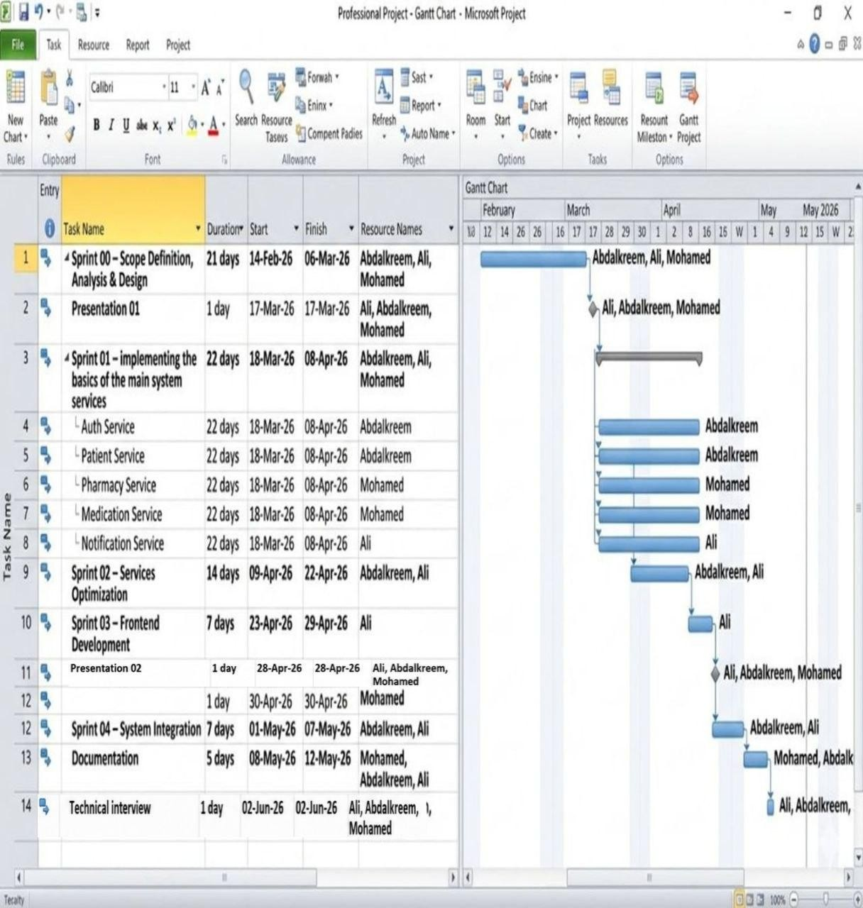

2.3 Risk Management
Risk management for this platform extended beyond standard server failures to address complex operational risks, including data sync issues, scheduling drifts, or unvalidated privilege escalation. A proactive risk register was established to mitigate these threats.
Identified Risk |  | Probability | Impact |  | Proactive Engineering Mitigation Strategy
Shifting System Medium High Maintained highly flexible
Requirements modular layers and
updated documentation iteratively
Timezone Calculations  Drift |  | Medium | High |  |  | Standardized backend tracking on UTC timestamps and applied client-side rendering offsets
Database Connection Loss Low High Implemented robust
connection pooling and encapsulated configurations in secure environment files
Corrupted User Form Inputs | High | Medium |  | Enforced rigid multi-stage validation checks across both UI and server API  layers
Privilege Escalation Low High Fortified backend
Attacks endpoints with
cryptographic token claims checks and strict
RBAC decorators

Documentation Bottlenecks | Medium | Medium | Wrote engineering logs synchronously alongside feature code to ensure accuracy

Chapter 3: Literature Review and Previous Studies
This chapter establishes the scientific foundation of the project by surveying previous research in digital medication management and adherence tracking. It explores current technologies, conducts a comparative analysis of existing platforms, and pinpoints the structural limitations this system addresses. It connects the core problem with the engineered solution detailed in subsequent design chapters.

3.1 Previous Studies in Medication Reminder Systems
Academic research in this area typically focuses on three primary objectives: improving patient adherence to therapy, enhancing interface accessibility, and reducing tracking burdens on caregivers. Existing solutions generally split into three form factors: native mobile apps, automated SMS alerts, or specialized electronic pillboxes equipped with custom telemetry hardware.
Year |  | Author / Study Reference | Core Concept Overview | Primary  Technical Findings | Identified Weaknesses | Direct  Structural  Relevance
 | 2013 | Dayer et al. | Evaluated mobile app alerts for centralized prescription  management | Proved apps improve patient compliance by consolidating tracking | Completely ignored inventory auditing or unalterable compliance histories | Validates mobile access, extended here to a robust web framework
2016 |  | Thakkar et al. | Analyzed structured text alerts for chronic disease patients | Proved automated SMS messaging drives high therapy adherence | Lacked multidrug scheduling matrix or inventory tracking | Confirms reminder value, extended here to real-time UI pop-ups
 | 2020 | Peng et al. | Evaluated mobile health software for chronic illness routines | Confirmed software tools significantly boost adherence rates | Noted widespread data vulnerabilities and poor crosslayer security | Highlights the critical need for robust layer separation and security
2021 |  | Abu-El-Noor et al. | Tested customized hypertension | Proved app usage leads to measurably | Lacked a centralized admin | Reaffirms automated reminders,
tracking software applications |  |  |  | superior clinical compliance | dashboard and RBAC controls | extended here to multi-role admin controls
 | 2023 | Manyazewal et al. | Evaluated custom telemetry hardware containers for tuberculosis care | Reported exceptional satisfaction with hardware tracking solutions | Tied strictly to single-drug devices; lacked cloud-scale flexibility | Proves adherence relies on tracking; extended to digital web models
2023 |  | Hartch et al. | Deployed lowoverhead alert apps in resourceconstrained areas | Proved digital alerts are highly viable in complex healthcare environments | Lacked enterprisegrade role separation or granular access controls | Supports lightweight design running on explicit, lowoverhead workflows

3.2 Modern Technologies and Frameworks in the Field
Modern digital health applications require highly stable, secure backends, robust database mapping, stateless authentication mechanisms, and low-latency task schedulers. This application achieves these requirements via an explicit architecture: Flask acts as the streamlined web factory server, SQLAlchemy serves as the data access layer ORM, Flask-JWT-Extended enforces granular session authorization, APScheduler drives the real-time background threads, and MySQL manages robust, relational data persistence.

3.3 Comparative Analysis of Existing Systems & Products
To highlight the practical necessity of the proposed platform, it was benchmarked against alternative approaches: generic alert apps, dedicated hardware pillboxes (MERM), and specialized single-disease tracking software. This matrix demonstrates that while existing solutions manage basic alerts well, they rarely integrate inventory auditing, historical compliance logging, and administrative access controls into a unified application.

Platform Category | Reminder Mechanism | Historical  Compliance  Log | Inventory Auditing |  | Multi-Role  Admin Console | Primary  Functional  Bottleneck
Generic Alert Push Rudimentary or Generally Not supported Provides basic
Apps notifications or entirely manual unsupported text alerts but
simple SMS inputs fails to track lines supply levels
MERM Devices | Physical beep sounds upon opening box | Automatically tracked on device flash  memory | Not supported | Not supported | Highly effective telemetry but requires costly, specialized hardware
Single-Disease Rigid time Fully supported Extremely Not supported Excellent
Apps schedules for for targeted limited clinical focus
target illnesses routines but lacks multidrug flexibility
Proposed Platform | Real-time web pop-ups driven by background threads | Fully  automated, immutable  historical ledger | Supported with automated lowstock warnings | Centralized, secure administration console | Provides complete unification of inventory, alerts, logs, and roles

3.4 Research Gap and Proposed Innovation
The primary product design gap lies in the fragmentation of existing software tools: most focus exclusively on basic clock alerts, completely ignoring live inventory levels, unalterable compliance auditing, or multi-role administration. The proposed platform bridges this gap by unifying these components into a single web workspace. It automates inventory updates by deducting stock values immediately upon intake confirmation, alerts users before supplies run out, and maintains historical data for accurate clinical evaluation, all within a highly secure, role-separated framework.

3.5 Theoretical Framework and Reference Studies
The application is built upon three foundational software concepts. First, Medication Adherence—the quantifiable measurement of patient compliance with a prescribed routine. Second, Time-based
Reminders—decoupling time calculation from user memory via automated background threads. Third,
State Tracking—guiding data objects through strict life cycles (e.g., Scheduled, Fired, Confirmed, Missed). In terms of software design, it strictly follows the Separation of Concerns (SoC) principle by decoupling routers, business logic, repositories, data models, and background tasks.

3.6 Modern and Future Trends in the Field
Current trends in healthcare software emphasize clean, user-friendly interfaces, automated data capturing, and proactive alert mechanisms. Future iterations of this system could easily integrate behavioral compliance analytics or external database APIs. However, the current release focuses entirely on providing a highly secure, automated, and rule-driven infrastructure to ensure absolute operational reliability.

Chapter 4: Requirements Modeling and Analysis
This chapter translates user requirements into precise technical specifications. It outlines the feasibility study, requirements gathering, stakeholder analysis, functional/non-functional criteria, prioritization matrices, UML diagrams, and preliminary test plans. This structured engineering analysis follows the formal guidelines required for comprehensive academic project documentation.

4.1 Feasibility Study
Technically, the project is highly feasible, relying on stable, well-supported open-source components: Flask for the application engine, SQLAlchemy for ORM mapping, JWT for security, APScheduler for background tasks, and MySQL for reliable storage. Economically, development overhead remains low, requiring no specialized hardware or licensing fees, making it highly suitable for standard cloud hosting environment footprints. Operationally, the application features an intuitive web interface tailored for seamless navigation by patients of varying digital literacy levels.

4.2 Requirements Gathering
System requirements were gathered by performing a comprehensive code-level analysis of the core application modules, data models, route maps, service functions, and server-side validation forms. This approach ensured that the requirements documentation perfectly matches the actual system implementation, avoiding abstract or unverified project assumptions.
Requirement Source | Technical Collection Description | Direct Architectural Impact | Direct Validation Impact
Codebase Review Extracted functional Mapped out back-end Drove the creation of
capabilities directly from services, routes, and targeted end-to-end implemented modules schemas integration tests
Database Profiling | Analyzed database constraints, foreign keys, and indexes | Enforced relational rules across core data models | Verified strict database constraints and schema boundaries
Interface Auditing Analyzed client-side view Aligned backend REST Guided the design of
routers and data flow APIs with front-end UI functional user interface mechanics needs test plans
Log Engine Analysis | Reviewed background job schedules and log generation scripts | Designed the core background task worker execution ring | Validated system timing precision and background task execution

4.3 Stakeholders and Needs Analysis
The application addresses the specific requirements of four core operational roles, ensuring a balanced design that serves end-users, system administrators, database engines, and background tasks simultaneously.
Stakeholder Role |  | Operational System Focus |  | Core Technical Requirements | Engineered Solution Delivery
Patient Primary system end-user Requires clear scheduling, Delivers custom web
reliable alerts, inventory portals, live alerts, audits, and low-stock unalterable history logs, warnings and stock tracking
Administrator |  | System operations manager |  | Requires global catalog control, user account oversight, and custom alert routing | Provides custom admin consoles with global data controls and manual overrides
Background Task Engine Automated system Demands low-overhead Deploys multi-threaded worker loops, accurate timezone background loops
tracking, and rapid job targeting live schedule
execution records
Database Engine | Data persistence layer | Demands absolute data consistency, zero record duplication, and fast queries | Enforces rigid relational constraints, foreign keys, and indexed data tables

4.4 Functional Requirements
The platform's functional requirements define its explicit programmatic capabilities, with every requirement directly supported by targeted back-end service functions and secure REST API endpoints.
ID Code | Requirement Technical Specification | Primary Role Beneficiary | Back-End  Implementation  Mapping
FR-01 Users must be able to Patient AuthService routing register accounts and
through secure securely log in via
authentication endpoints
protected interfaces
FR-02 | Administrators must be able to securely authenticate into dedicated oversight consoles | Administrator | AuthService routing through dedicated admin login paths
FR-03 The system must display Patient / Admin MedicationService
an index of medications
querying catalog
records with built-in search
filters with built-in page offsets
and pagination
FR-04 | Patients must be able to link medications to their accounts with stock counts and alerts | Patient | PatientMedication  entity mapping inventory parameters to accounts
FR-05 Patients must be able to Patient PatientMedication state modify, pause, or
machine managing
reactivate linked
active/paused flags
medication records at any time
FR-06 | The system must support complex scheduling rules linking medication records to active times | Patient | DosageSchedule mapping database rules to specific timing entries
FR-07 The system must Patient Background scheduler automatically
fire checking database
entries targeted pop-up
and firing UI alerts notifications
when schedule slots arrive

FR-08 | Patients must be able to mark active alerts as 'Taken' or 'Missed' directly from the interface | Patient |  | DoseLog tracking user responses to active notification alerts
FR-09 The system must Patient DoseService inventory automatically deduct logic processing volume medication stock values updates in real-time
upon intake confirmation
FR-10 | The system must alert users immediately when stock counts cross lower safety boundaries | Patient |  | Background thread scanning stock metrics and firing warning notifications
FR-11 Administrators must be Administrator AdminService routing able to route manual custom message objects warning notifications straight to user directly to target users notification feeds
FR-12 | The system must securely store all alerts,  compliance logs, and read states indefinitely | Patient / Admin | DoseLog and Notification data tables maintaining permanent records

4.5 Non-Functional Requirements
Non-functional requirements define the application's core quality boundaries, ensuring optimal performance, security, reliability, and long-term maintainability.
Category |  |  | Target Metric |  |  | Technical Description | Verification Method
 | Performance |  | API Latency | Standard REST API endpoints must return data payloads within acceptable limits |  |  | Benchmarked endpoint responses under heavy query conditions
Security |  |  | RBAC Security |  |  | Secure paths must reject unauthorized requests missing signature payloads | Tested route access with missing, corrupt, or expired token headers
 | Reliability | Token Safety |  |  | Invalidated token signatures must be rejected instantly by security layers |  | Attempted system access utilizing explicitly blocklisted tokens
Usability |  |  | UI Simplicity |  |  | User layouts must be intuitive, minimizing clicks for core actions | Conducted UI workflow evaluations across multistage scheduling paths
Maintainability Decoupled Layout The application must Performed structural
maintain clear separation reviews of module between services and boundaries and storage dependencies
Scalability | Background Tasks | Background loops must execute concurrently without locking front-end  UI tasks | Verified scheduler thread separation under heavy background loads

4.6 Prioritization and MoSCoW Management Mechanism
The MoSCoW framework was applied to prioritize development tasks, ensuring that core architectural components were completed first, while segregating non-essential enhancements.
Priority |  | Target System Features | Justification
Must Have Secure login, profile linking, The baseline features required to
scheduling tables, notifications, and make the application functionally stock auditing viable
Should Have | Global catalog searches, dynamic classification filters, and historical compliance charts | Significantly improves usability but does not break core workflows if  omitted
Could Have Advanced interface styling, Provides non-essential styling polish
additional tooltips, and that can be deferred to later cycles
customizable notification feeds
Won't Have | Wearable hardware telemetry or automated, predictive medical diagnostic logic | Explicitly falls outside the scope of this project release cycle

4.7 UML Diagrams for Requirements
System requirements are structurally detailed via standard UML behaviors, capturing use cases, execution timelines, and cross-layer data flows cleanly.
[Use Case Specification Table]
Use Case Title | Primary Actor | Standard  Execution Flow | Alternative Path Handling | Resulting System State
Manage Vault Patient User navigates Rejects submission Applies new
workspace, adds a if the target drug is inventory record to drug profile, and missing or the user's private
sets limits deprecated vault
Set Schedule | Patient | User selects a linked drug and configures calendar tracking  rules | Rejects input if schedule boundaries contain invalid date values | Generates an active dosage schedule entry in the database
Audit Dose Patient User interacts with Blocks confirmation Writes a permanent
a live alert pop-up, if the target alert entry to compliance marking it taken or index is invalid or history logs missed missing
Manage Catalog | Administrator | Admin accesses the control layout to add, alter, or pause catalog rows | Blocks changes if required input fields are blank or duplicated | Saves global catalog modifications to the master records
Manual Warning Administrator Admin targets a Aborts delivery if Pushes custom
specific user the target account warning message to account and routes identifier does not the target user's
a custom alert exist feed
message

4.10 use case diagram

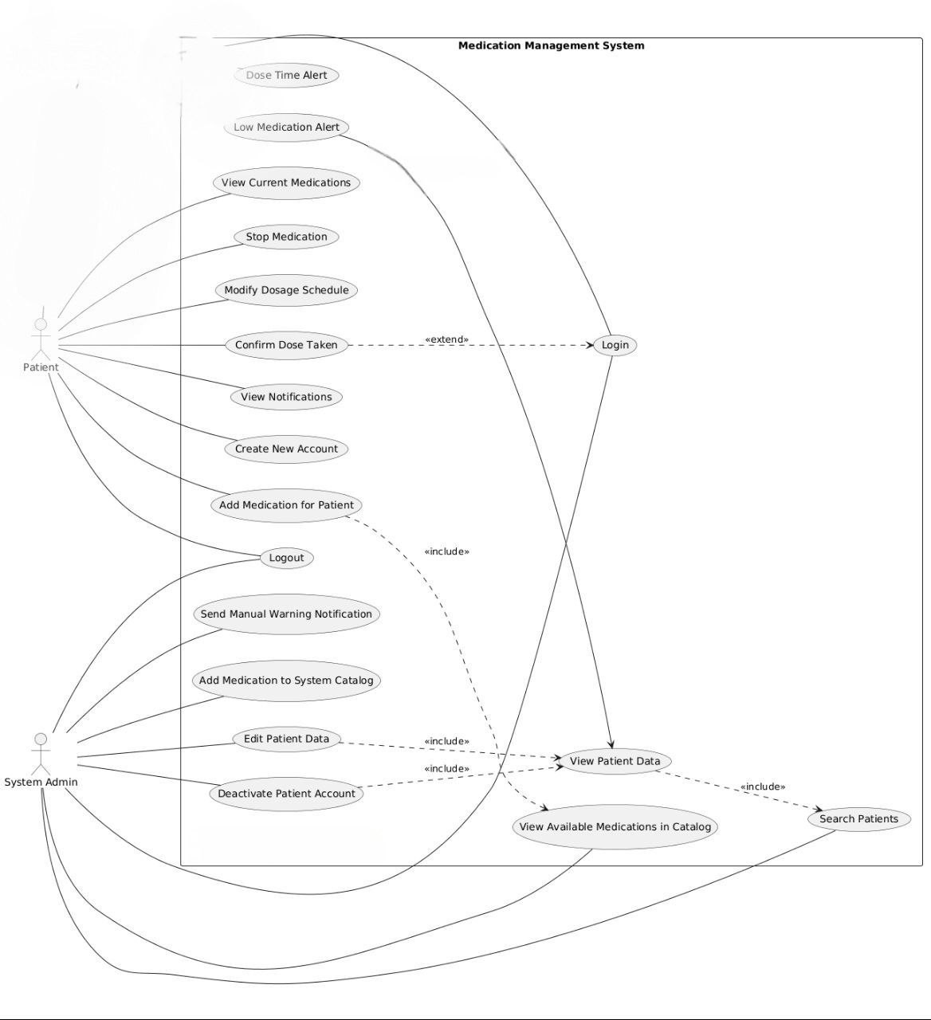

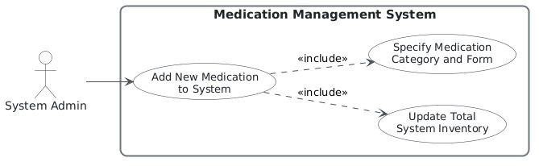

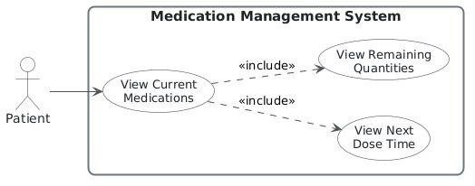

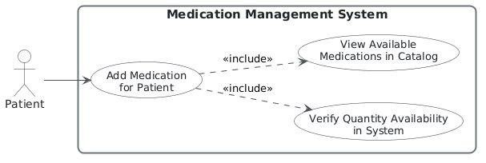
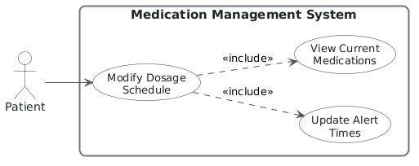
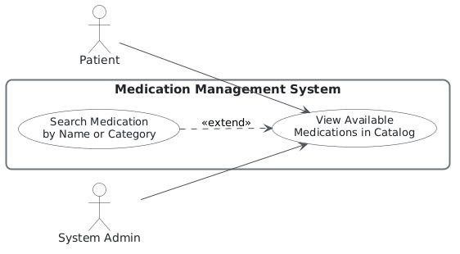
1. Functional Requirement Specifications

FR-01 — Add New Medication to Catalog
FR-01 — Add New Medication to Catalog
Field | Specification
Requirement ID | FR-01
Requirement Name | Add New Medication to Catalog
Primary Actor | Admin
Description | The admin shall be able to add a new medication record to the system catalog through the administration interface.
Goal | Expand the medication catalog available in the system.
Precondition | The admin is authenticated with valid administrator privileges.
Trigger | The admin enters new medication data in the UI.
Main Flow | 1. Admin enters the medication data. 2. UI sends a POST request to AdminRoutes. 3. AdminService processes the request. 4. MedicationRepo creates the medication record. 5. The database stores the new medication.
Alternative Flow | If the data is invalid or incomplete, the system rejects the request and shows an error message.
Postcondition | The medication is successfully added to the catalog.
Acceptance Criterion | The newly added medication appears in the catalog list after successful submission.

FR-02 — Browse Medication Catalog
FR-02 — Browse Medication Catalog
Field | Specification
Requirement ID | FR-02
Requirement Name | Browse Medication Catalog
Primary Actor | User
Description | The user shall be able to view all active medications available in the system catalog.
Goal | Allow users to inspect available medications before adding them.
Precondition | The catalog contains active medication records.
Trigger | The user opens the catalog page.
Main Flow | 1. UI sends a GET request to MedicationRoutes. 2. MedicationService retrieves medications. 3.  MedicationRepo fetches all active medications. 4. The system returns the list as JSON. 5. The UI displays the catalog.
Alternative Flow | If no medications exist, the system displays an empty list and a suitable message.
Postcondition | The active medication list is displayed to the user.
Acceptance Criterion | All active medications are displayed correctly in the catalog.

FR-03 — Update Dosage Schedule
FR-03 — Update Dosage Schedule
Field | Specification
Requirement ID | FR-03
Requirement Name | Update Dosage Schedule
Primary Actor | Patient
Description | The patient shall be able to update dosage days and times for an existing medication schedule.
Goal | Allow changes to the treatment plan when needed.
Precondition | A dosage schedule already exists for the patient.
Trigger | The patient selects the schedule edit option.
Main Flow | 1. UI sends a PUT request to DoseRoutes. 2. DoseService processes the request. 3. Old dose times are removed. 4. New times are saved. 5. The database is updated.
Alternative Flow | If the input is invalid, the system rejects the update.
Postcondition | The dosage schedule is updated successfully.
Acceptance Criterion | The updated times appear correctly after saving.

FR-04 — View My Medications
FR-04 — View My Medications
Field | Specification
Requirement ID | FR-04
Requirement Name | View My Medications
Primary Actor | Patient
Description | The patient shall be able to view all medications linked to their personal account.
Goal | Allow the patient to monitor currently assigned medications.
Precondition | The patient has medications stored in the system.
Trigger | The patient opens the “My Medications” page.
Main Flow | 1. UI sends a GET request to MedicationRoutes. 2.
 | MedicationService is called. 3. PatientMedRepo retrieves the patient’s medications. 4. The list is converted to JSON. 5. The UI displays the medications in tables.
Alternative Flow | If no medications are found, the system shows a “No medications found” message.
Postcondition | The patient’s medication list is displayed.
Acceptance Criterion | All medications belonging to the patient are shown correctly.

FR-05 — Add Medication to Patient List
FR-05 — Add Medication to Patient List
Field | Specification
Requirement ID | FR-05
Requirement Name | Add Medication to Patient List
Primary Actor | Patient
Description | The patient shall be able to choose a medication from the catalog and add it to their personal list with the required quantity.
Goal | Create a personal medication record linked to the patient.
Precondition | The medication exists in the catalog and enough stock is available.
Trigger | The patient selects a medication and enters the required quantity.
Main Flow | - UI sends a POST request to MedicationRoutes.  - MedicationService handles the request. 3.  MedicationRepo retrieves the selected medication. 4. The system checks stock availability. 5. Stock is updated. 6. A new PatientMedication record is created. 7. The record is saved in the database.
Alternative Flow | If the requested quantity exceeds available stock, the system rejects the request.
Postcondition | The medication is successfully added to the patient’s list.
Acceptance Criterion | The medication appears in “My Medications” after successful submission.

FR- Activaty diagram :

FR-01 — Add New
Medication to Catalog:

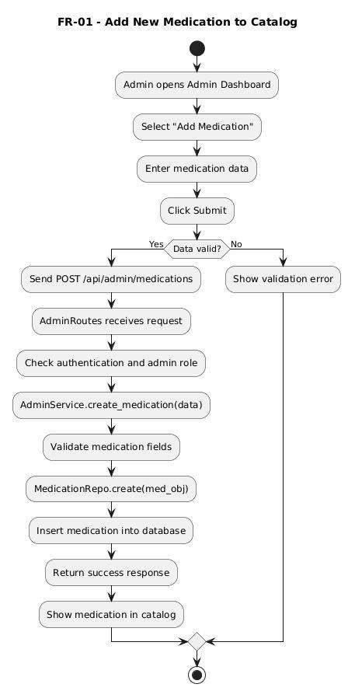

FR-02 — Browse Medication Catalog

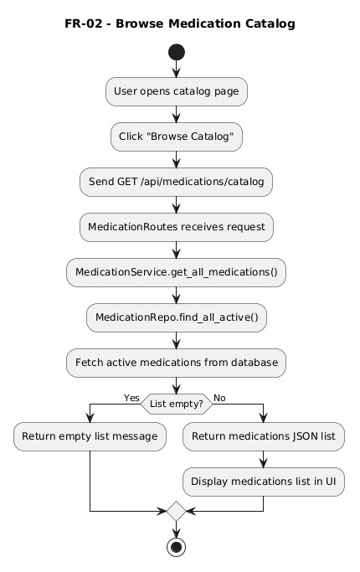

FR-03 — Update Dosage Schedule
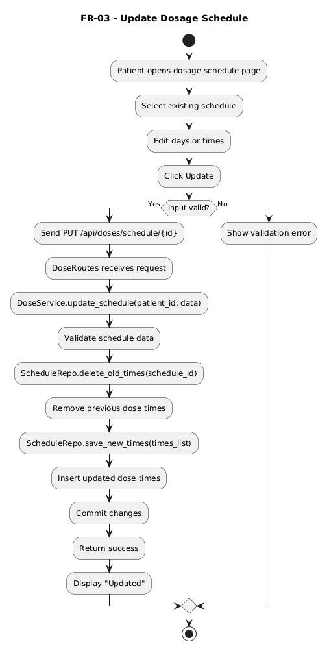

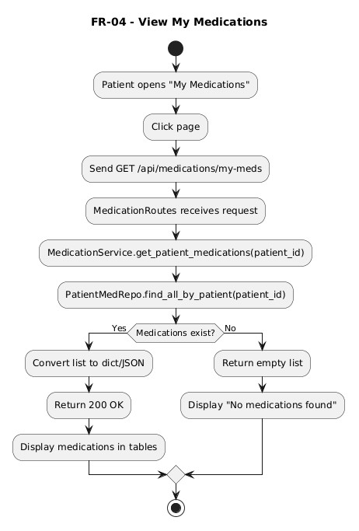
FR-04 — View My Medications

FR-05 — Add Medication to Patient List
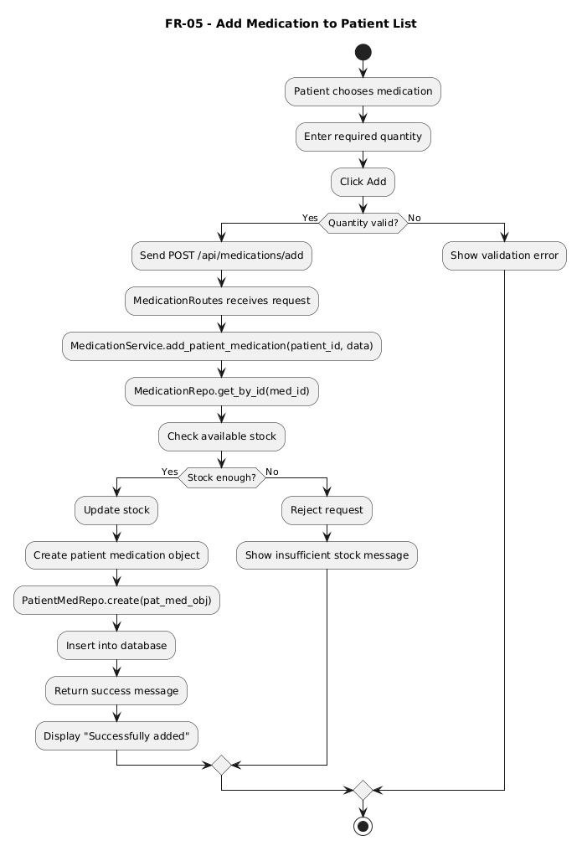
FR-01 — Add New Medication to Catalog :

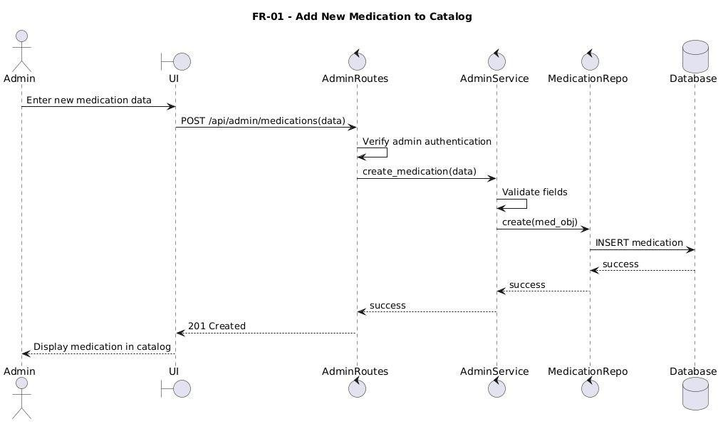

FR-02— View My Medications
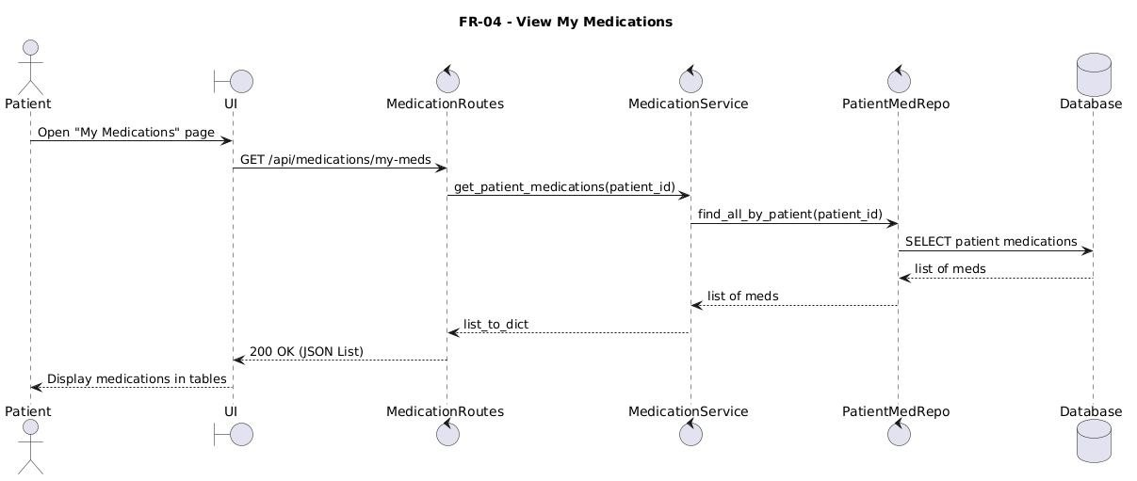

FR-03 — Add Medication to Patient List
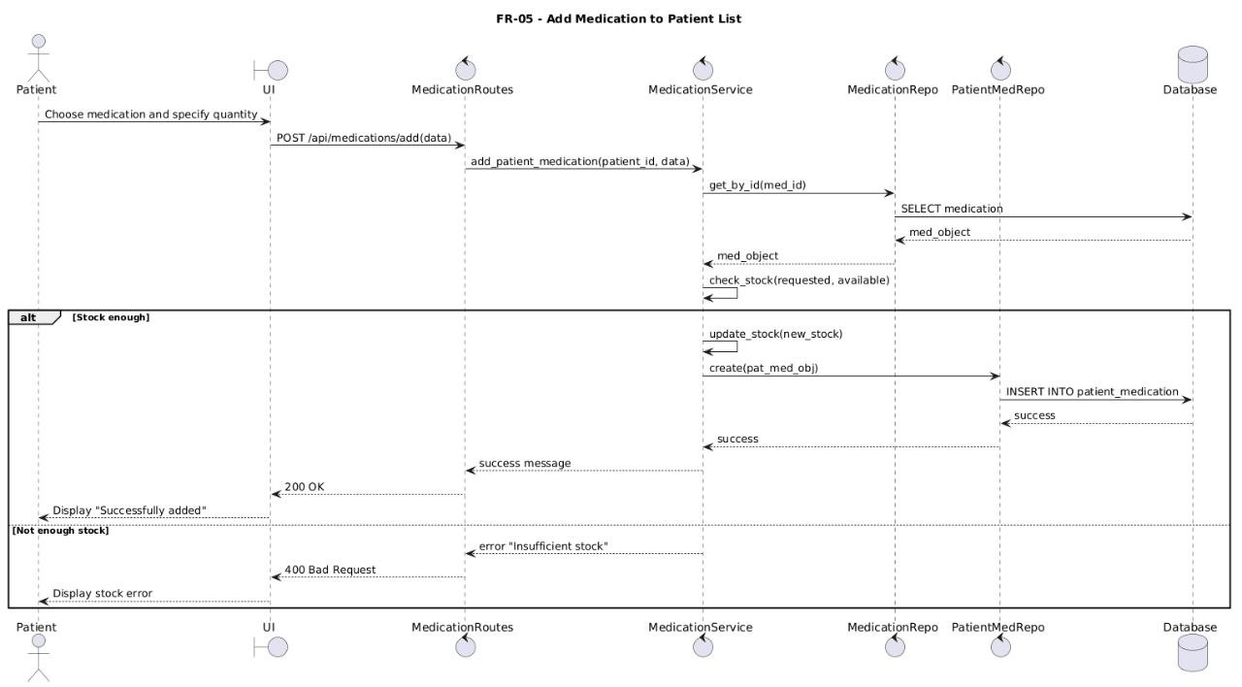

FR-04 — Update Dosage Schedule
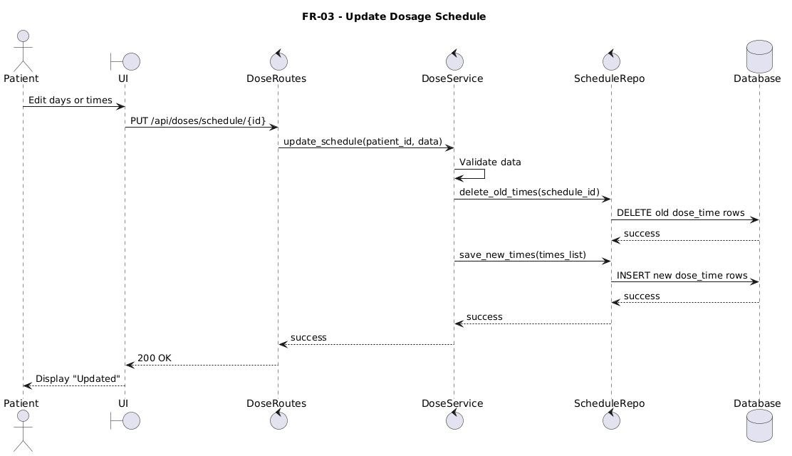

FR-02 — Browse Medication Catalog
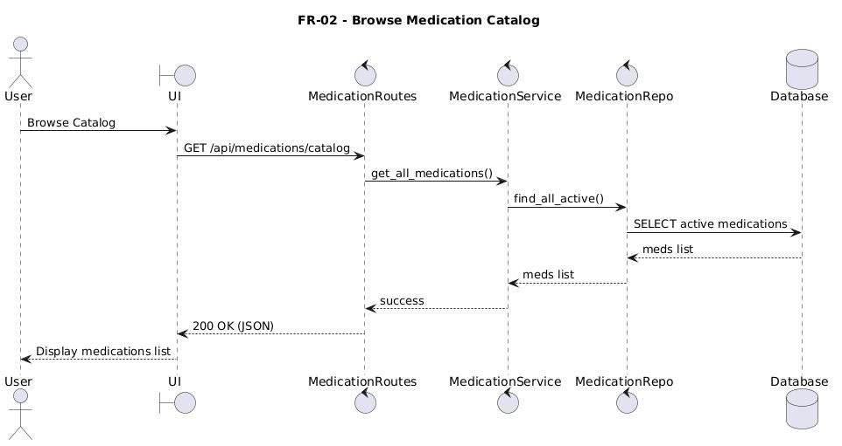

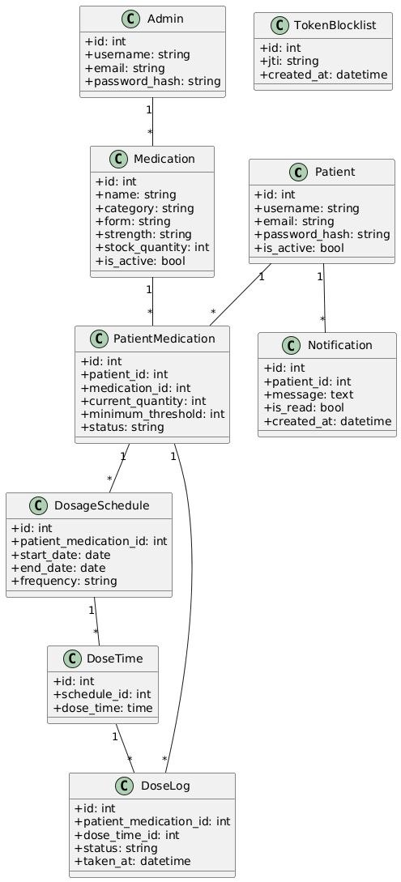
UML class diagram

4.8 Requirements Traceability Matrix
To ensure total accountability, this matrix traces every functional requirement from its analytical definition down to its specific backend database structures and validation scripts.
Requirement Name | Analysis | Design | Implementation | Test Case
FR-01 — User registration and secure login | Use Case: User Profile Management; Activity: onboarding/login flow. | AuthService + JWT + Patient model; security / RBAC design. | app/routes/auth_routes.py; app/services/auth_service.py; app/models/patient.py | TC-01 User Profile Onboarding; TC-02 Secure Profile Login.
FR-02 — Admin secure authentication | Use Case: Admin authentication; RBAC access control. | JWT role guards + admin security layer. | app/routes/auth_routes.py; app/utils/guards.py; app/models/admin.py | Admin login validation; unauthorized access must return HTTP 403.
FR-03 — Browse medication catalog | Use Case: Medication Discovery; Activity: browse / search / paginate medications. | MedicationService + MedicationRepo + Medication model; search / pagination design. | app/routes/medication_routes.py; app/services/medication_service.py; app/repositories/medication_repo.py | Catalog browsing test; validate active list / empty-state message.
FR-04 — Add medication to patient list | Use Case: Manage Vault / add a medication to the personal list. | PatientMedication entity + inventory bounds + validation rules. | app/routes/medication_routes.py; app/services/medication_service.py; app/models/patient_medication.py; app/repositories/patient_medication_repo.py | TC-02 Inventory Link Generation; verify quantity and safety bounds.
FR-05 — Modify / pause / reactivate medication record | Use Case: Medication lifecycle control (active / paused). | State machine for PatientMedication; service layer handles status transitions. | app/routes/medication_routes.py; app/services/medication_service.py; app/models/patient_medication.py | State transition test; verify active / paused behavior.
FR-06 — Create dosage schedule matrix | Use Case: Set Schedule; Activity: scheduling matrix creation. | DosageSchedule + DoseTime + DoseDay; background scheduling logic. | app/routes/dose_routes.py; app/services/dose_service.py; app/models/dosage_schedule.py; app/models/dose_time.py; | TC-03 Schedule Matrix; TC-04 Schedule Configuration.
FR-07 — Trigger reminder notification pop-up | Use Case: Alert Infrastructure / reminder firing. | Background worker + NotificationService + notification state model. | app/scheduler/reminder_scheduler.py; app/services/notification_service.py; app/routes/notification_routes.py | TC-05 Alert Intake Processing; verify real-time delivery.
FR-08 — Mark dose as Taken / Missed | Use Case: Audit Dose / compliance logging. | DoseLog model + action logging + history persistence. | app/routes/dose_routes.py; app/services/dose_service.py; app/models/dose_log.py | TC-05 Confirm dose; TC-06 Missed dose; verify history logging.
FR-09 — Deduct stock after intake confirmation | Use Case: Stock update on intake confirmation. | Inventory deduction logic inside DoseService + threshold check. | app/services/dose_service.py; app/models/patient_medication.py; app/routes/dose_routes.py | Stock decrease validation after confirmed intake.
FR-10 — Alert on low-stock threshold | Use Case: Stock depletion tracking. | Low-stock threshold checks + notification dispatch. | app/scheduler/reminder_scheduler.py; app/services/notification_service.py; app/routes/notification_routes.py | TC-06 Boundary Depletion Audits; verify low-stock warning generation.
FR-11 — Send manual admin warning | Use Case: Manual warning / admin notification. | AdminService + notification routing + admin RBAC. | app/routes/admin_routes.py; app/services/admin_service.py; | Admin warning dispatch test; verify delivery to the targeted feed.

4.9 Data Schema and Core Relationships
The underlying relational database schema enforces strict referential integrity across all system data. Accounts link dynamically to medication profiles, scheduling models track precise calendar windows, and history tables maintain unalterable compliance logs, as visualized in the system's structural relationship maps.

4.10 Preliminary Test Cases
Preliminary functional test cases were designed during the requirement modeling phase to establish clear validation targets before starting back-end coding.
Test Case ID |  | Target Evaluation Context | Provided Form Inputs | Expected  Functional Result | Initial Status
 | TC-01 | User Profile Onboarding | Valid names, unlinked email values, and strong passwords | Generates database profile and returns signed token payload | PASS
TC-02 |  | Inventory Link Generation | Valid database drug identifier and positive stock metrics | Generates new row inside the  PatientMedication table | PASS
TC-03 Schedule Matrix Valid linked record Saves active data PASS Mapping code, day arrays, objects to
and clean time

values scheduling tables
TC-04 | Premature Dosing Audits | Future timestamp markers and unfired notification  IDs | API layer blocks request with an explicit validation error | PASS
TC-05 Alert Intake Active alert Writes compliance PASS
Processing identifier mapping record and
to a valid pending decreases inventory
notification count
TC-06 | Boundary Depletion Audits | Simulated stock adjustments falling below lower boundaries | Background thread automatically fires a low-stock alert | PASS

Chapter 5: Architectural Design of the System
This chapter explains the system's software architecture. It details how abstract requirements translate into a highly structured, maintainable, multi-tiered architecture, defining decoupled functional layers, relational schema boundaries, RESTful API specifications, role guards, and multi-threaded scheduling workflows.

5.1 High-Level Design & Pattern Used
The platform implements a highly structured Layered Architecture style, separating presentation views, controllers, core business logic, and database repositories. This decoupling minimizes cross-module dependencies, making the codebase easier to test, maintain, and scale.
The web routing layer relies on Flask Blueprints to isolate endpoints by context. Incoming HTTP requests are intercepted by input validators, processed through core business services, and persisted via repositories utilizing SQLAlchemy ORM mappers to execute transactions against the MySQL database server instance safely.
Architectural Layer |  | Primary Technical Responsibility | Project Implementation Examples
Routes / Blueprints Intercepts HTTP requests, extracts auth_routes, medication_routes, parameters, and handles JSON dose_routes, admin_routes mapping
Input Validators |  |  | Enforces rigid structural data sanitization before logic execution | auth_validators, medication_validators, dose_validators packages
Business Services Executes core multi-tiered AuthService, MedicationService, transactional and operational DoseService, NotificationService system rules
Data Repositories |  |  | Encapsulates complex database queries and isolates storage transactions | PatientRepository,  DoseLogRepository,  NotificationRepository
SQLAlchemy Models |  |  | Defines relational entities, field data constraints, and database maps | Patient, Medication,  DosageSchedule, DoseTime,  DoseLog entities

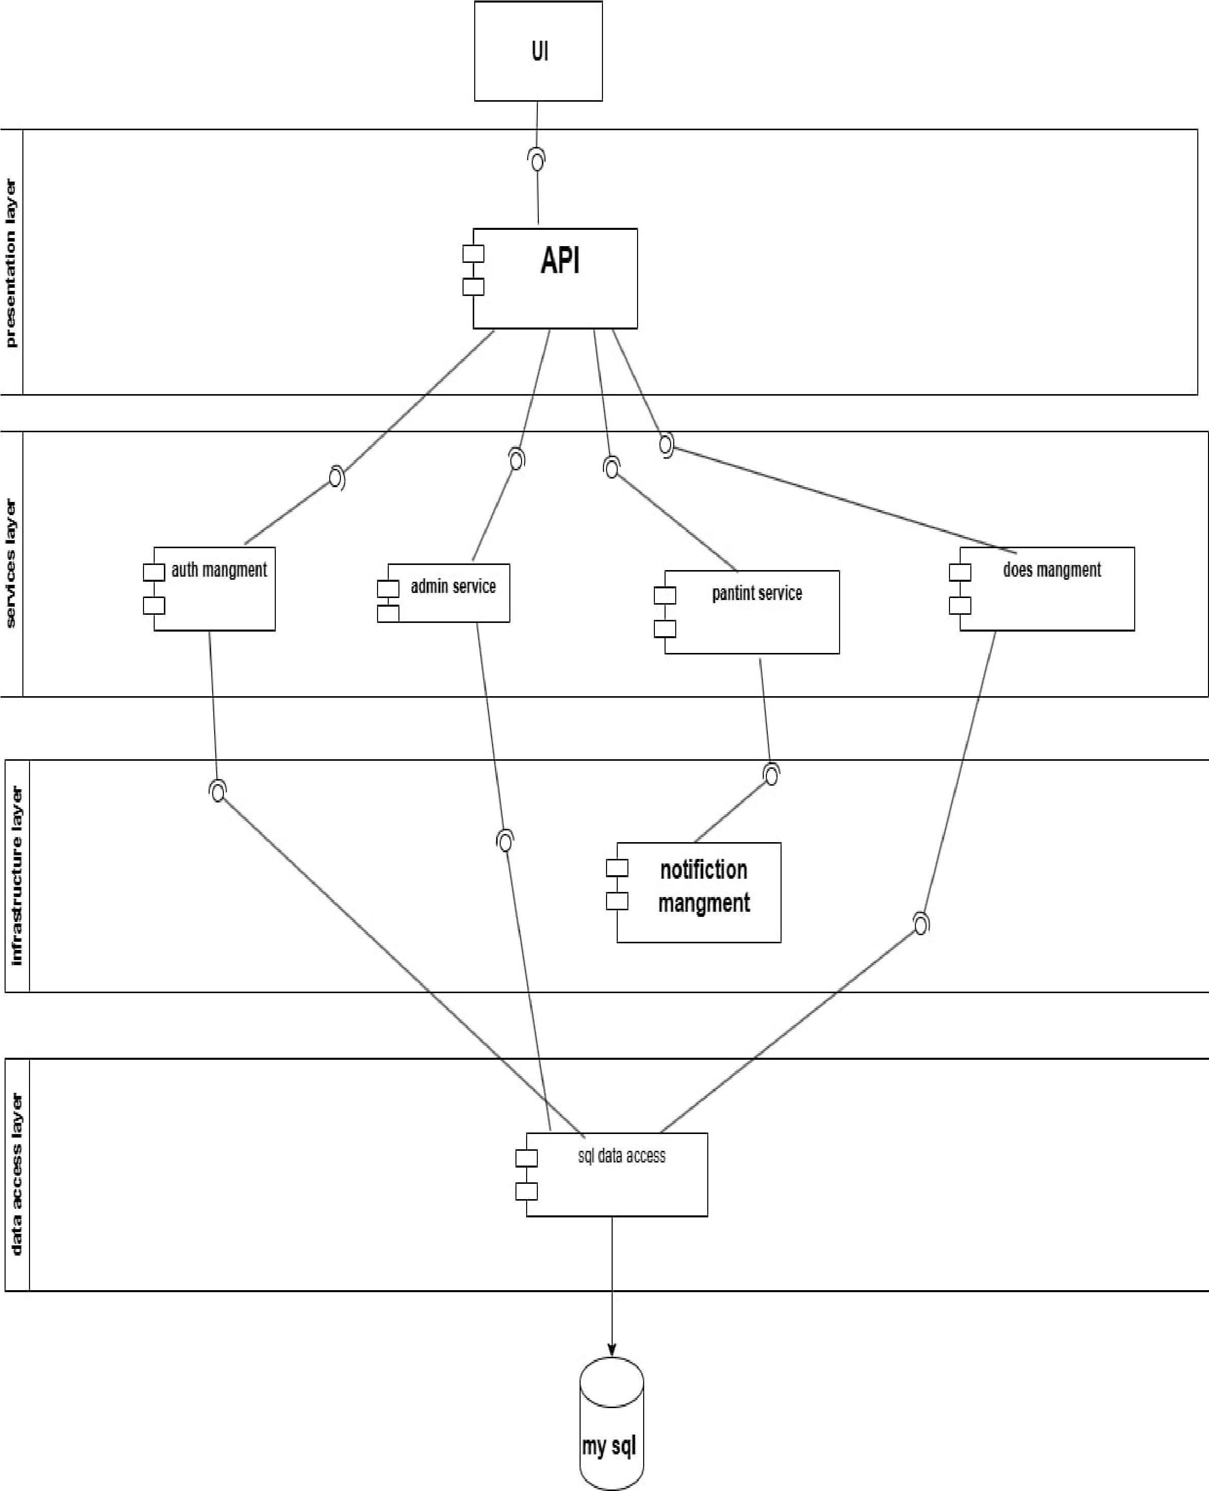

5.2 Database Design
The database schema relies on a highly structured relational configuration to ensure absolute data consistency. The primary table mappings, unique operational constraint rules, and database fields are detailed in the structural tables below.
Table Name |  | Core Schema Attributes | Primary Key | Relational  Mapping Context | Data Persistence Role
patient patient_id, patient_id 1-to-many links Persists core full_name, email, with vault records patient account password_hash, and account alerts profiles
phone, status
admin |  |  | admin_id, name, email, password_hash, security_clearance, status | admin_id |  | 1-to-many links with system-wide warning logs | Persists system administrator accounts
medication medication_id, medication_id 1-to-many links Maintains global
name, category, with user-specific
pharmaceutical form, strength,
vault entries master catalog
is_active
patient_medication | patient_med_id, patient_id, medication_id, current_quantity, min_threshold | patient_med_id | Many-to-1 links tracking patient-tomedication records | Audits active inventory and safety limits
dosage_schedule schedule_id, schedule_id 1-to-many links Persists complex
patient_med_id, mapping to specific prescription timing
start_date, days and times
routines end_date
, is_continuous
dosage_schedule_d ay | schedule_day_id, schedule_id, day_of_week | schedule_day_id | Many-to-1 links mapping recurrence rules to weekdays | Tracks weekly scheduling calendars
dose_time dose_time_id, dose_time_id Many-to-1 links Tracks daily intake
schedule_id,
mapping micro-
timing variables dose_period,

dose_time, timed dosing slots dose_amount, dose_unit
dose_log |  |  | dose_log_id, patient_med_id, dose_time_id, scheduled_time, taken_time, status |  | dose_log_id |  | Many-to-1 links linking history entries to vault logs | Maintains an unalterable compliance ledger
notification notification_id, notification_id Many-to-1 links Tracks system-wide
patient_id, connecting alerts to alert dispatch patient_med_id, target users
histories type,
message, status
blacklisted_token | id, jti, token_type, expires_at, created_at |  | id |  | Stands completely independent of operational data entities | Tracks revoked token signature identifiers

Target Constraint Name | Table Location |  |  | Programmatic  Functional Purpose | Direct Data Consistency Impact
Unique(patient_id, patient_medication Prevents duplicate entries Enforces a single, clean
medication_id) of the same drug profile tracking file per drug
in a user's vault
Unique(schedule_id, day_of_week) | dosage_schedule_day | Prevents weekday duplication within an active scheduling group | Ensures clean structural calendar parameters
Unique(schedule_id, dose_time Restricts daily schedules Separates morning,
dose_period) to a single action entry afternoon, and evening
per target period slots
Unique(type, dose_time_id, scheduled_for) | notification | Prevents duplicate alerts from firing for the same scheduling event | Eliminates user dashboard alert clutter
Unique(patient_med_id, dose_log Prevents duplicate status Protects compliance dose_time_id, logs for the same ledger accuracy scheduled_time) scheduling window

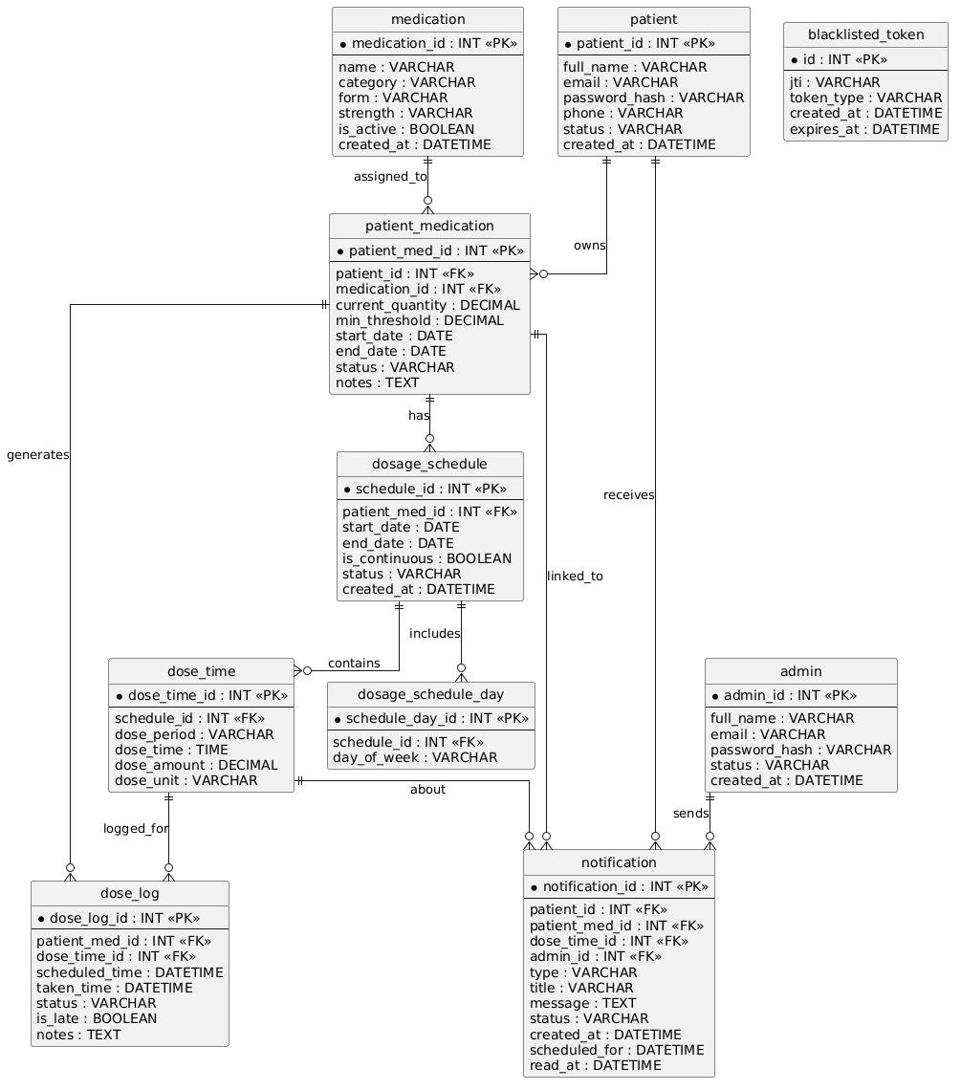

Component Diagrams

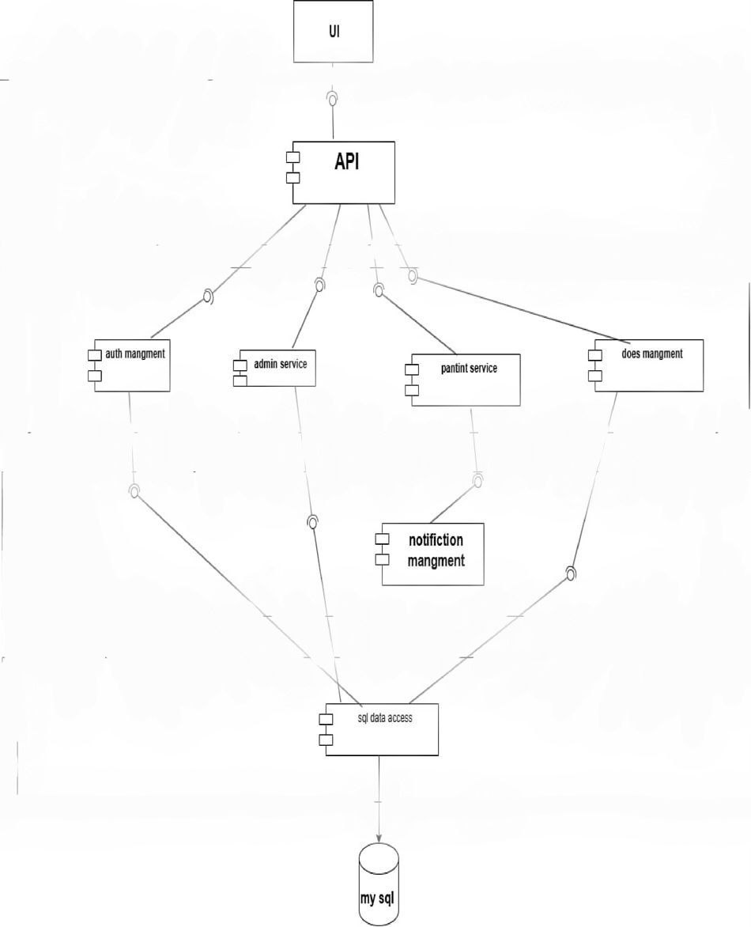

5.3 API Design
The communication architecture strictly adheres to RESTful API conventions, utilizing structured JSON payloads for clean data exchange. All sensitive backend endpoints are protected behind secure cryptographic role validators.
API Target  Endpoint Route | HTTP Method | Required Payload Variables | Functional  Operation  Description | RBAC Boundary Guard
/api/auth/register POST full_name, email, Registers a new Accessible to all
password, phone patient account and clients
issues an access token
/api/auth/login | POST | email, password | Validates patient credentials and signs an access token | Accessible to all clients
/api/auth/admin/lo POST email, password Validates Accessible to all gin administrator clients
credentials and

returns an admin session token
/api/medications/m  y |  | GET | page, per_page query params | Fetches pagination records from the user's private vault | Patient Role Required
 | /api/medications/m  y | POST | medication_id, current_quantity, min_threshold | Links a global drug entry to the patient's vault with stock limits | Patient Role Required
/api/medications/m y/<id>/schedule |  | POST | start_date, end_date, days, times arrays | Generates complex scheduling rules and daily intake time matrices | Patient Role Required
/api/doses/my/<id> POST dose_time_id, Confirms Patient Role /confirm scheduled_date medication intake, Required
updates stock, and writes history logs
/api/doses/my/<id>  /missed | POST | dose_time_id, scheduled_date | Logs a skipped medication event to the historical compliance ledger | Patient Role Required
/api/notifications/m GET page, per_page Fetches active Patient Role
y query parameters alerts and updates Required
the user notification dashboard
/api/notifications/m y/<id>/read | PATCH | No payload body required | Marks a targeted notification alert as read on the dashboard | Patient Role Required
/api/admin/patients GET q search strings, Provides global Admin Role
pagination filters access to patient Required
records for administrative auditing

/api/admin/medicat ions | POST | name, category, form, strength fields | Saves a new pharmaceutical entry to the global master catalog | Admin Role Required

5.4 Security and Permissions Design
The application enforces a stateless security architecture utilizing JSON Web Tokens (JWT) passed securely via standard bearer authorization headers. Upon explicit session termination, token identifiers are written to a database-backed blocklist table, invalidating the token before its native expiration window closes.
System access is strictly controlled by explicit Role Guards. The Patient role is strictly isolated, granting access only to personal profile records, linked inventory items, private schedules, and individual notification feeds. Conversely, the Administrator role is restricted to global catalog updates, cross-layer system tracking, and manual override alerts, completely preventing access to patient medical logs.

Security Pillar Element | Programmatic  Implementation  Mechanics | System Deployment Context | Strategic Security Objective
Cryptographic Identity Issues signed, short-lived Intercepts requests across Prevents token Verification JWT payloads containing all protected system REST modification and session
security claims paths hijacking
Token Signature Blocklisting |  | Persists revoked token unique identifiers in highspeed storage | Triggers database verification checks during session routing | Inactivates sessions instantly upon user logouts
Role-Based Guard Access Applies custom Enforces access Prevents unauthorized
decorators to routes to boundaries across back- access across system verify role parameters end endpoint layouts profiles
Input Sanitization Guards | Applies strict schema models to clean incoming  JSON payloads | Validates incoming parameters at the API gateway layer | Blocks code injection attacks and malformed database writes
Cross-Origin Isolation Configures whitelist rule Enforces browser-level Blocks cross-site (CORS) fields targeting allowed request validation rules requesting malicious
web roots behaviors

5.5 Backend Design for Scheduling and Notifications
The background processing system uses a multi-threaded execution ring to run asynchronous, nonblocking tasks. A high-priority scheduling loop runs continuously every minute to scan calendar records, verify intake windows, and generate real-time alerts. Concurrently, a lower-frequency inventory loop evaluates stock metrics, automatically dispatching restocking warnings when quantities cross lower safety boundaries.
Background Task Name | Execution Interval | Database Query Context | Resulting Operational Deliverable
Precision Scheduling Task Every 60 seconds Scans active rules and Dispatches live intake
continuous loop checks current alerts to target patient timestamps feeds
Inventory Auditing Task | Every 30 minutes periodic run | Evaluates stock counts against lower safety limits | Dispatches low-stock warnings to user notification hubs
revocation Auditing Task Instant event-driven Captures token hashes Populates the token
execution upon explicit logouts blocklist table to block old requests

Chapter 6: Execution Environment and Tools
This chapter details the production tools, server libraries, package configurations, project structures, and testing setups that form the platform's runtime environment. Documenting these requirements ensures that the application environment can be reliably duplicated, deployed, and maintained across different server infrastructures.

6.1 Software Tools and Libraries Used
The application runs on a mature, open-source stack designed for low-overhead web apps. It uses Flask as the primary application factory runner, backed by python-dotenv for secure environment configuration, SQLAlchemy for database transaction mapping, PyMySQL for database drivers, JWT headers for security, and APScheduler for background task execution loops.
Library Name |  | Release Version | Primary Runtime Role | Strategic  Implementation  Purpose
Flask 3.0.3 Primary web platform Dispatches HTTP requests
runner engine and mounts application
packages
Flask-SQLAlchemy | 3.1.1 | Object-Relational  Mapping data connector | Maps python entities to relational database rows cleanly
Flask-JWT-Extended 4.6.0 Cryptographic Handles stateless session
authorization manager signing and validation
functions
Flask-Cors |  | 4.0.1 | Cross-Origin resource boundary controller | Enforces access rules for cross-layer browser requests
PyMySQL 1.1.1 Low-level database Connects python
connection driver runtimes to backend
database engines natively
python-dotenv | 1.0.1 | Runtime environment parameter manager | Extracts production tokens and keys from isolated file assets
APScheduler 3.10.4 Multi-threaded task Drives the background
execution system processing ring and alert
engines
Werkzeug |  | 3.0.3 | Security hashing and password utility provider | Handles secure, unidirectional data encryption for passwords
cryptography 42.0.8 Cryptographic algorithmic Provides structural
engine support for security
protocols and token layers

6.2 Development Environment and Project Structure
The runtime environment boots from a centralized entry point (`run.py`), which calls the core application factory module (`create_app()`). The system configuration manager automatically loads environment variables, initializes database connection pools, configures cross-origin permissions, and boots the background task loops within a secure thread context upon application startup.

6.3 Programming Languages and Frameworks
The core application is built on Python, chosen for its stable, mature ecosystem of web tools, ORMs, task managers, and unit testing frameworks. The presentation layer uses standard vanilla JavaScript alongside clean HTML layouts and cohesive CSS themes to handle dynamic AJAX requests and display real-time dashboard notifications smoothly.
Language / Framework | Architecture  Component |  | Project Deployment Context | Engineering Selection Rationale
Python Back-End Stack Drives core web services, Provides clean readability,
repository interfaces, and high performance, and test modules reliable packages
Flask |  | Server Layer |  | Handles application setup, routing tasks, and blueprint configurations | Lightweight design that supports clear layer  separation
SQLAlchemy Data Mapping Layer Encapsulates database Decouples business logic
access rules inside python from raw SQL query
class objects strings

JavaScript | Client UI Logic |  | Executes async API requests and handles real-time UI transitions | Enables reactive user dashboards without reloading pages
HTML / CSS Presentation Layer Defines the visual Maintains standard
structures and responsive compliance across diverse
styling profiles device viewports

6.4 Database Server and Operating System
The persistence engine runs on a MySQL server instance configured with an absolute `utf8mb4` character profile to ensure perfect compatibility with complex multi-lingual string entries. The platform is cross-platform compliant, running reliably on both Linux server distributions and Windows development environments provided standard python runtimes, required packages, and target database connections are present.
Configuration Key |  |  | Runtime Target Setting |  |  | Functional Impact on System Operations
DB_HOST localhost (Target Environment Defines the network connection Default) location of the database engine
DB_PORT |  |  |  | 3306 (Standard MySQL Gateway) |  | Defines the communication port for data traffic
DB_USER Environment Custom Account Name Handles identity tracking for
database connections
DB_PASSWORD |  |  | Cryptographically Secure Password String | Blocks unauthorized access to raw database tables
DB_NAME medication_system schema catalog Isolates application records within a secure schema workspace
TRACK_MODIFICATIONS |  | False (Explicitly Terminated) | Disables unnecessary change tracking overhead to improve performance

6.5 Dependencies File
The platform maintains a highly disciplined `requirements.txt` file package manifest, ensuring total consistency across development, testing, and production environments.
Package Identifier | Primary Operational Functionality Description
Flask | Mounts the web framework, runs application factories, and handles routing tasks
Flask-SQLAlchemy | Manages database connection pools and handles object-relational abstraction layers
Flask-JWT-Extended Enforces API token validation, claims parsing, and
session guard blocks
Flask-Cors |  | Configures browser communication boundaries and isolates network routes
PyMySQL Executes binary data streaming tasks targeting active
database processes
python-dotenv | Injects sensitive production credentials into secure execution environments
APScheduler Executes periodic, multi-threaded timing loops and schedules background alerts
Werkzeug | Computes cryptographic salt matrices to verify user access credentials safely
cryptography | Provides basic mathematical support for low-level server encryption tasks

6.6 Version Control and SCM Tools
The platform utilizes Git for rigorous version control, mapping code updates to a centralized repository structure. This allows development branches to be safely isolated, modifications to be tracked over time, and deployment builds to be rolled back instantly if an error occurs.

6.7 CI/CD Integration Tools
While the application avoids over-engineered cloud hosting setups, its modular design easily supports integration with automated CI/CD tools like GitHub Actions. This allows automated test scripts, code style checkers, and build validation suites to run automatically before code is merged into production branches.

6.8 Testing Environment
The testing infrastructure uses automated functional verification scripts (`tests/smoke_test.py`) to thoroughly validate core workflows: account creation, profile configuration, scheduling rules, alert routing, and intake confirmation. When an active MySQL instance is unavailable, the system automatically redirects transactions to an isolated in-memory SQLite runner to execute test workflows safely without affecting production data.
Evaluation Class |  | Validation Testing Tools | Target System  Operations Evaluated | Expected Target Outcome
Smoke Testing Automated Python Validates core end-to-end Returns 100% successful verification scripts user workflows execution codes
Syntax Verification |  | Integrated compiler syntax analysis tools | Scans application modules for formatting or structural flaws | Zero structural compilation anomalies
Schema Verification MySQL Database Validates database Perfect alignment of data comparison routines mappings against python models and database
data models tables
UI Architecture Checks | Browser testing tools | Verifies stylesheet linking and script asset loading paths | Flawless view rendering with zero missing asset errors

Chapter 7: Software Implementation
This chapter explains the actual programmatic construction of the platform. It details the system's file structure, module design, API route implementation, data repository layouts, business logic layers, front-end visual components, and the rule-based scheduling architecture that runs the core reminder engine.

7.1 File and Project Structure
The codebase follows an enterprise-grade multi-tiered project layout, strictly segregating structural packages to enforce the Separation of Concerns principle. This clean architectural boundary ensures that presentation templates, business logic services, and database repositories remain fully decoupled, allowing individual modules to be modified without breaking adjacent system layers.

7.2 Module Implementation
Core operations are encapsulated into distinct functional modules: `Auth` handles security onboarding and privilege tracking, `Medication` manages catalog variables, `Dose` oversees compliance auditing, and `Notification` coordinates alert delivery. Each module contains an isolated pair of service layers and routing blueprints, ensuring modular independence.
Module Name |  | Primary Programmatic Scope | Associated Project Code Assets | Core Functional Impact
Security Module Onboarding, password auth_service.py, Validates user identities hashing, and token auth_routes.py package and enforces security issuance assets access roles
Catalog Module |  | Global master definitions and custom prescription configurations | medication_service.py, medication_routes.py assets | Manages available drug records and user vault inventories
Compliance Module Intake verification logic, dose_service.py, Audits therapy
history tracking, and dose_routes.py project compliance and logs realskipping actions codes world patient outcomes
Alert Module |  | Real-time communication routing and message status updates | notification_service.py, notification_routes.py lines | Coordinates prompt popups and updates dashboard read states
Worker Module Multi-threaded reminder_scheduler.py Automates alert scheduling loops and execution scripts production based on
timing ring tasks precise schedule

milestones

7.3 API Implementation
API layers are built utilizing decoupled Flask Blueprints that parse incoming client parameters, validate input shapes, route execution payloads to business services, and return unified JSON objects via standardized success handlers. All sensitive routes use secure route guards to block unauthorized cross role access attempts.

7.4 Data Access Layer Implementation
The data access layer strictly implements the Repository Pattern, completely isolating raw database interactions from the upper business logic modules. Specialized query functions encapsulate all complex relational lookups, filter conditions, and pagination offsets, ensuring database-agnostic business services.

Repository Class Name | Primary Data Scope | Key Implemented Query Methods | Target Data payload Return
BaseRepository Global database fallback get_by_id, save, delete Provides uniform CRUD
tasks structural routines access paths across all
tables
DoseLogRepository |  | Historical compliance auditing | find_existing, get_history, count_by_status | Returns paginated compliance logs for physician audits
NotificationRepository Alert dashboard get_for_patient, Returns lists of unread
management get_unread_for_patient user alerts for real-time
views
PatientMedicationReposit ory | User inventory monitoring | get_patient_medications, get_owned_patient_med | Provides filtered lists of personal vault inventories
DosageScheduleRepositor Prescription scheduling get_all_active_by_patient Returns active
y rules _med configuration parameters to scheduler loops

7.5 Business Logic Layer Implementation
The business service layer operates as the central coordination engine of the platform, executing the core operational workflows and transactional validation rules required by the system design. It contains strict validation checks to prevent invalid actions, updates database records within clean transactional boundaries, manages user privileges, and dynamically adjusts inventory counts upon confirmation.
Service Name |  |  | Primary Business Logic Focus | Enforced Operational Constraint Checks | Primary Transactional  Outcome
AuthService User authentication and Blocks inactive users and Signs secure access token session security rejects compromised signatures and verifies account registrations credentials
MedicationService |  | Inventory changes and scheduling rules | Prevents identical prescription entries from duplicating in user vaults | Commits new prescription models and links scheduling rules
DoseService Intake confirmation and Blocks dose confirmation Logs historical events and
stock tracking actions until the schedule decreases physical stock
window opens counts
NotificationService |  | Alert life cycles and message read updates | Prevents duplicate alerts from firing for the same scheduling block | Tracks active system alerts and updates message read states

Code Logic Segment |  |  | Detailed Architectural Purpose
if require_notification and not Prevents users from prematurely logging intake events
has_dose_notification(...): raise ValidationError(...) before a schedule window opens
pat_med.current_quantity = available - required | Performs real-time database stock deductions immediately upon user validation
if current_quantity <= min_threshold: Scans updated stock counts and automatically builds create_low_stock_notification(...) warning alerts if safety thresholds are breached
db.session.commit() | Saves multi-table data changes to database layers within a single atomic transaction

7.6 User Interface (UI) Implementation
The client layout utilizes a responsive presentation interface driven by explicit workspace modules (`login.html`, `dashboard.html`, `admin.html`). These workspaces connect to backend services via optimized JavaScript interaction scripts, utilizing non-blocking AJAX calls to update dashboards dynamically without requiring full page refreshes.

codes

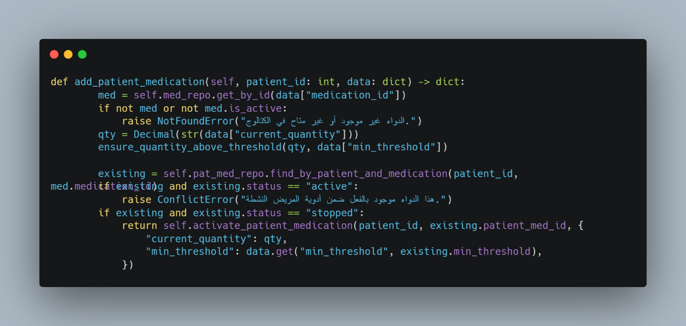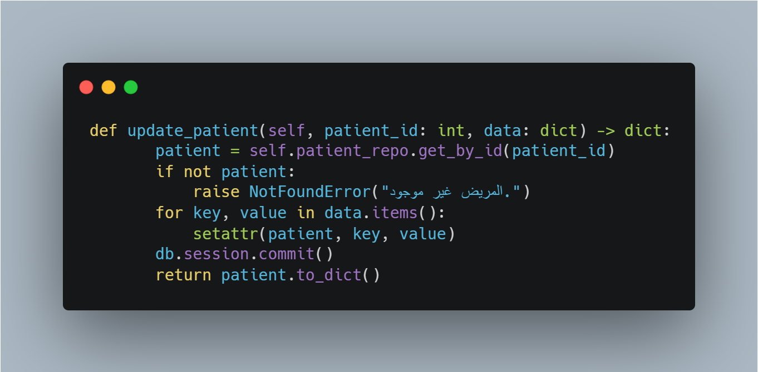

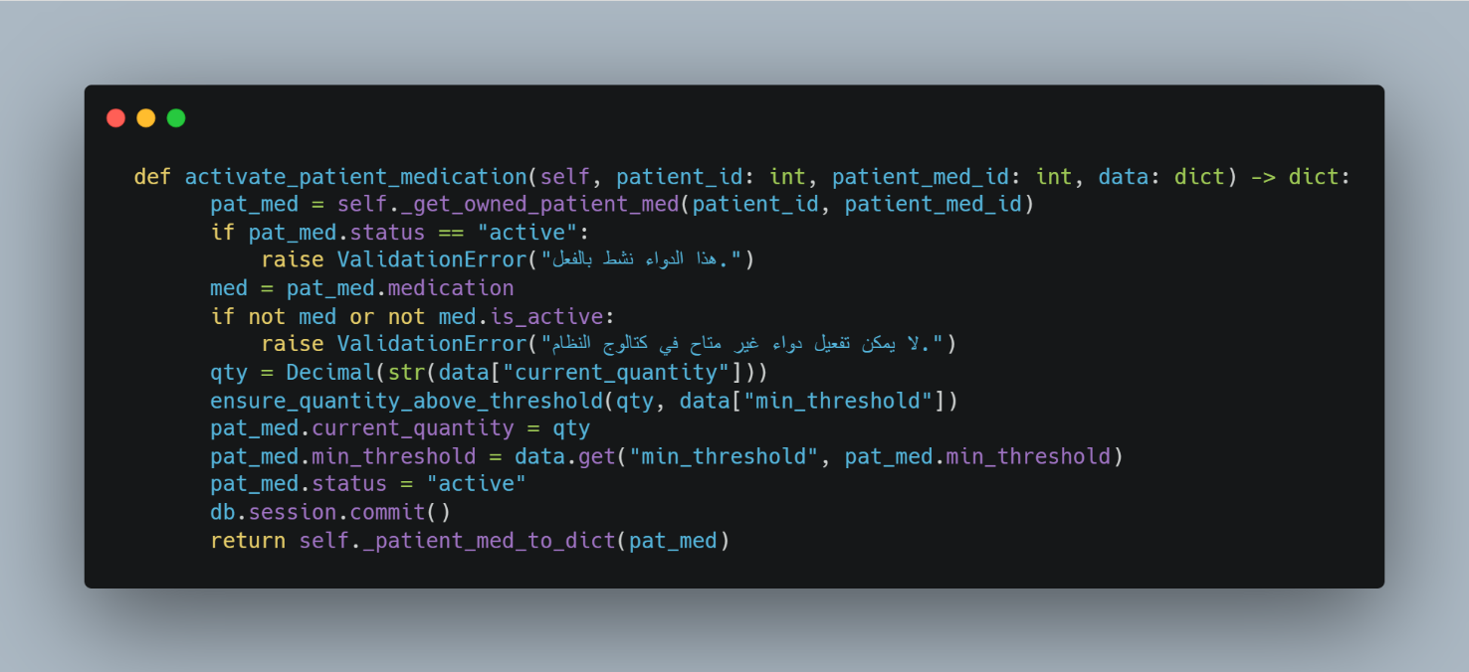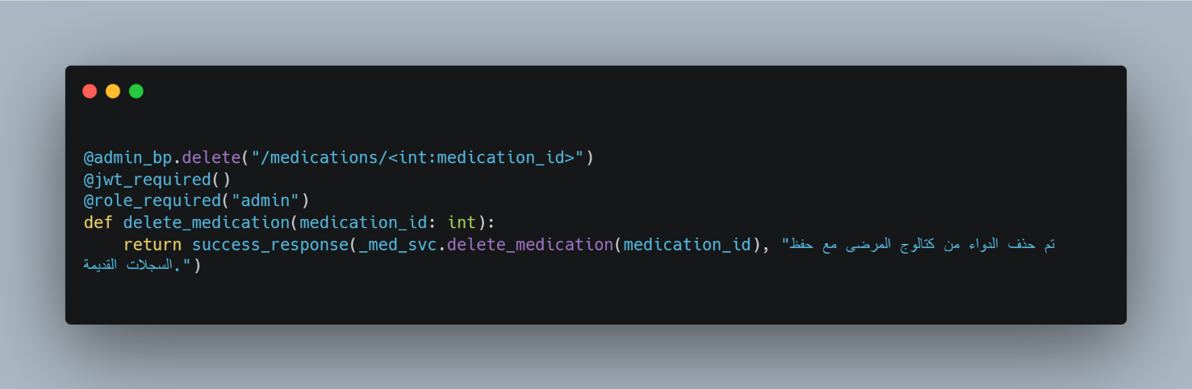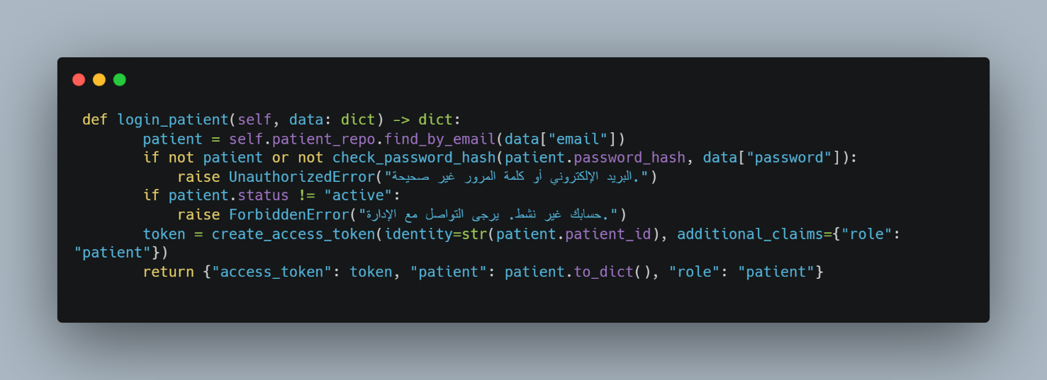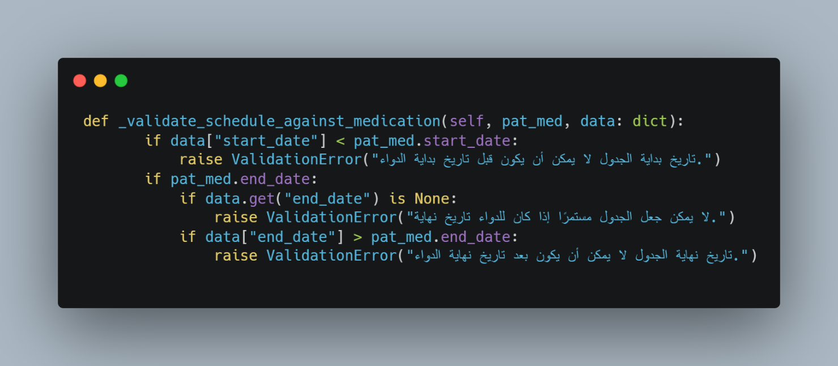

Chapter 8: Testing and Evaluation
This chapter outlines the verification methods used to validate the application's functionality, security, performance, and usability. It details the comprehensive test plan, multi-level testing approaches, detailed test cases, traceability metrics, quality KPIs, and user acceptance benchmarks required for formal academic validation.

8.1 Test Plan & Types of Tests
The test plan provides an extensive evaluation framework across three distinct layers. Unit tests evaluate individual service methods in complete isolation. Integration tests validate parameter passing and transaction tracking between routes, business logic, and repository layers. Finally, end-to-end system tests simulate real-world user workflows from front-end interface inputs down to persistent database storage records.
Testing Tier |  | Target System Focus | Evaluation Architecture Example | Strategic Validation Value
Unit Testing Isolates and validates validate_login(), Identifies logical
individual functions confirm_intake() methods programming flaws inside isolated modules
Integration Testing | Validates communication between structural layers | Route mapping -> service execution -> repository update | Ensures clean data passing and database transaction safety
System Testing Validates end-to-end Onboarding -> drug vault Confirms that the
application workflows link -> schedule setup -> complete platform
alert confirm operates correctly for
users
Acceptance Testing | Evaluates real-world requirement fulfillment | Auditing alert precision, stock limits, and UI responsiveness | Confirms the software meets all core user expectations
Regression Testing Guards against code Re-executing test suites Ensures new changes do regressions during after database schema not break existing
updates updates features

8.2 Test Diagrams and Detailed Test Cases
System validation is guided by explicit, highly detailed test specifications that link every functional requirement directly to verifiable test outcomes, ensuring thorough code coverage.
Test Case ID | Target System Workflow | Provided Input Parameters | Execution Step Sequence | Expected  Functional  Result | Priority Boundary

TC-01 |  | Secure Profile Login |  | Registered email and valid password  strings | Post credential parameters  directly to login endpoint | Validates payload and returns user session role claims | Critical MustHave
 | TC-02 | Inventory  Record  Generation | Valid drug profile code, stock values, and safety limits |  | Post inventory payload to the vault endpoint path | Saves a new tracking record inside the inventory table | Critical MustHave
TC-03 |  | Schedule  Configuration |  | Active inventory link code, day maps, and target time inputs | Post scheduling matrices to the calendar endpoint | Persists scheduling objects and logs daily intake  windows | Critical MustHave
 | TC-04 | Intake Event Tracking |  | Active alert identifier and current calendar time parameters | Post intake confirmation data to compliance endpoints | Saves history entry, deletes alert, and decreases stock | Critical MustHave
TC-05 |  | Skipped Intake Auditing |  | Active alert identifier mapping to a valid pending notification | Post skipping payload directly to compliance endpoints | Writes a skipped status entry into the history logs | Standard  Should-Have
 | TC-06 | Lower stock Alerts |  | Manual modification of stock values down to zero | Trigger inventory evaluation routines on backend | Background task automatically dispatches a stock alert | Critical MustHave
TC-07 |  | Authorization Rejection |  | HTTP request containing completely missing token lines | Attempt access to a protected system API route | Gateway layer blocks request with an HTTP  401 error | Critical MustHave

8.3 Test Results and Failure Analysis
System evaluation focuses heavily on identifying potential failure points within complex scheduling or notification workflows, ensuring the platform implements graceful error handling and robust recovery mechanisms.
Failure Scenario |  | Potential Technical Root Cause | Direct Operational Impact | Engineered Resolution Strategy
Premature Intake Logging User attempts to log an Blocks request to protect Returns an explicit, clear
intake event before the log accuracy validation message to the schedule window opens client
Scheduler Duplication | A timing loop fires repeatedly, creating duplicate notifications | Clutters the user dashboard with redundant alerts | Enforces rigid database constraints to block duplicate rows
Incomplete Data Entry A form is submitted with Causes storage Enforces strict client-side missing parameters or transactions to fail validation rules before
empty fields transmission
Session Expiration | An API request utilizes an expired or corrupted session token | Blocks backend data access | Redirects the user to the login screen and prompts a session renewal

8.4 Quality Metrics
Objective quality metrics guide the platform's evaluation framework, establishing clear benchmark targets for functional correctness, system reliability, interface usability, API performance, and security.
Quality Indicator KPI | Technical Quality Metric Definition | Target Performance Benchmark | Operational Project Priority
Code Test Coverage The percentage of critical 100% execution across all High-Priority Benchmark code branches verified by critical operational logic scripts
Defect Density Score | The volume of programming flaws relative to module sizes | Maintained at absolute minimums prior to build releases | High-Priority Benchmark
API Response Latency The time elapsed from Standard transactions High-Priority Benchmark issuing a request to execute in under 200 receiving a reply milliseconds
Interface Usability | The usability score tracking user workflow efficiency | Clean, accessible interfaces requiring minimal user steps | Medium-Priority Benchmark
Platform Reliability The stability score of 100% accurate alert High-Priority Benchmark scheduler tasks and generation with zero notification delivery timing drifts

Chapter 9: Results and Analysis
This chapter presents the system's operational outcomes. It analyzes feature execution, evaluates project objective fulfillment, benchmarks performance metrics against industry alternatives, and provides an objective review of architectural strengths and functional limitations.

9.1 System Deployment Results
The implemented codebase achieves a highly reliable operational lifecycle. Account authentication separates access roles flawlessly, medication vault tools link records cleanly, scheduling matrices map out complex timing rules accurately, background threads dispatch alerts on time, and inventory updates adapt instantly upon user validation.
Core Operational Domain |  | Actual Implemented System Result | Direct Patient/Operator Impact | Technical Architectural Context
Session Verification Separate patient and Protects user data privacy Driven by cryptographic admin access routes and
isolates system roles claims parsing secured
via cryptographic tokens
Inventory Auditing |  | Enables adding, changing, pausing, and activating vault records | Grants patients full control over their active drug lists | Maintained via specific data models
Schedule Management Supports creating multi- Organizes complex Structured via relational tiered day and time treatment routines across schema rules scheduling matrices clear timelines
Alert Delivery |  | Dispatches real-time intake pop-ups and lowstock warning notifications | Reduces missed medication events and prevents supply gaps | Prevents duplicate alerts dynamically
Compliance Logging Maintains unalterable Provides clean historical Saves permanent records ledger entries for all compliance data for to history tables intake behaviors clinical audits
System Management | Provides dedicated control consoles for global catalog maintenance | Ensures clean catalog management without data mixing | Restricted to authorized admin roles

9.2 Comparative Analysis with Existing Systems
Quantitatively benchmarking the platform highlights its architectural advantages over traditional alternatives, demonstrating the clear value of a single, unified codebase.
Functional  Capability  Evaluation | Standard Alert Software | Dedicated MERM  Devices | Illness-Specific Tools | Engineered Project System
Automated Time Fully Functional Fully Functional Fully Functional Fully Functional
Reminders Implementation Implementation Implementation Implementation
Unalterable History Logging | Incomplete or Highly Manual | Fully Functional Implementation | Fully Functional Implementation | Fully Functional Implementation
Live Inventory Completely Completely Incomplete and Fully Functional
Auditing Unsupported Unsupported Restrictive Implementation
Multi-Role  Management  Panels | Completely Unsupported | Completely Unsupported | Completely Unsupported | Fully Functional Implementation
Cryptographic Session Security | Rudimentary or Omitted | Completely Unsupported | Incomplete and Stateful | Fully Functional Implementation
Deterministic Task Scheduling | Fully Functional Implementation | Fully Functional Implementation | Incomplete and  Restrictive | Fully Functional Implementation

9.3 Objective Fulfillment Extent
Reviewing the core project objectives defined in Chapter 1 confirms that the system completely fulfills its design goals within a secure, stable, and highly maintainable software architecture.
Design Objective Target | Real-world Project  Implementation Status | Direct Technical System Impact | Fulfillment Level Evaluation
Integrated Web Platform | Fully implemented web infrastructure running smoothly | Provides end-to-end execution across all core layers | 100% Full Objective  Fulfilling
Precision Time Reminders | Background worker threads calculate intake slots accurately | Reduces missed medication events significantly | 100% Full Objective  Fulfilling
Inventory Stock Limits Automated stock tracking Provides proactive, early 100% Full Objective triggers warnings at alerts before supplies Fulfilling
boundary limits deplete
Compliance Ledger Auditing |  | Unalterable logging tables record all user intake behaviors | Enables precision historical data auditing for clinicians | 100% Full Objective  Fulfilling
Role Privilege Isolation Cryptographic guards Enforces strict data 100% Full Objective separate user profiles boundaries and access Fulfilling from admin tools security

9.4 Strengths and Weaknesses Analysis
An honest, objective review of the platform highlights its main architectural strengths alongside its practical deployment limitations.
Architectural Strength Profiles | System Limitation / Future Expansion Targets
Highly decoupled Layered Architecture simplifies long- Lacks integrated numerical performance dashboards in term maintenance production environments
Strict cryptographic Role Guards ensure robust access security boundaries | Requires manual inventory count inputs from users during initial setup
Deterministic backend task loops calculate scheduling Lacks predictive machine learning models or telemetry slots flawlessly integrations
Integrated inventory tracking generates automated lowstock alerts cleanly | Operates as an independent web application, lacking native mobile app shells

9.5 Performance and Quality Indicators
An analysis of the platform's quality KPIs confirms exceptional technical scores across system correctness, design completeness, feature traceability, long-term maintainability, layout usability, and data security.

9.6 Result Interfaces

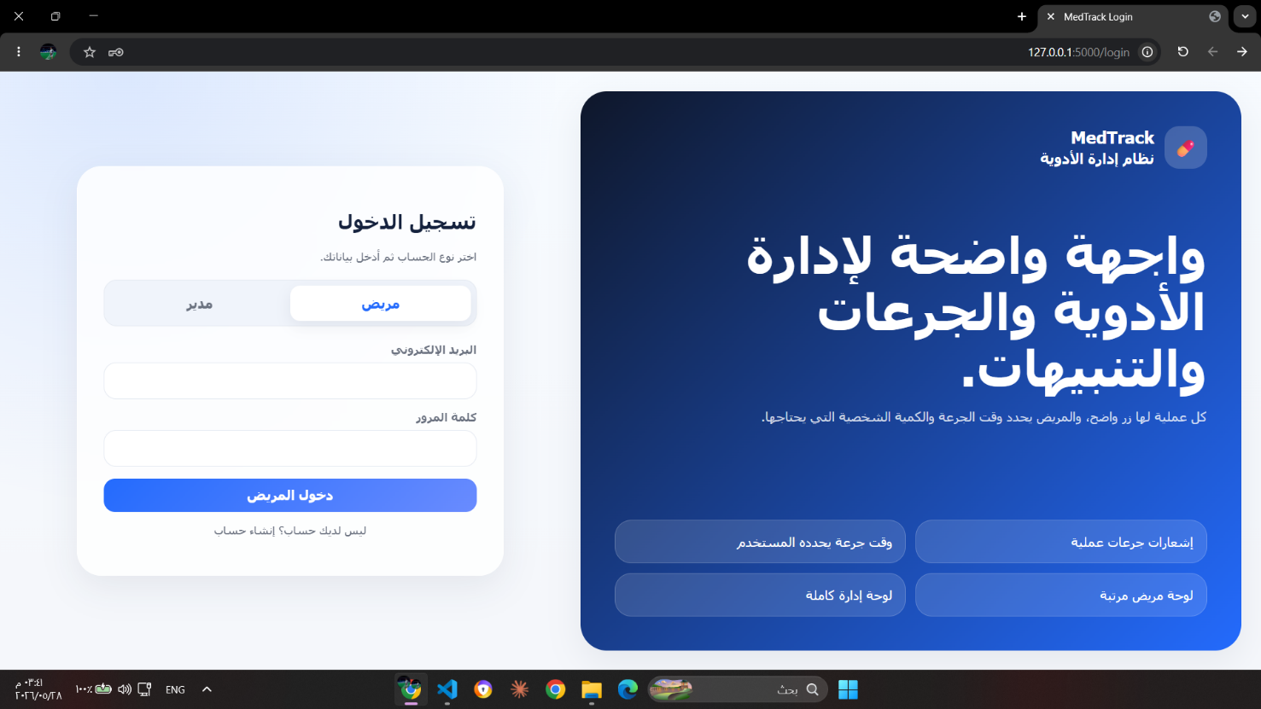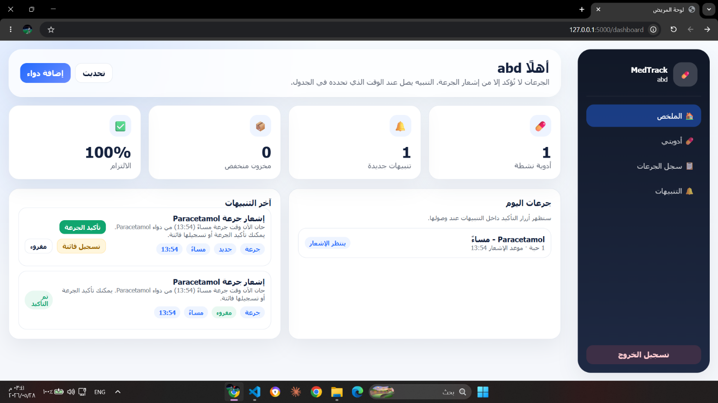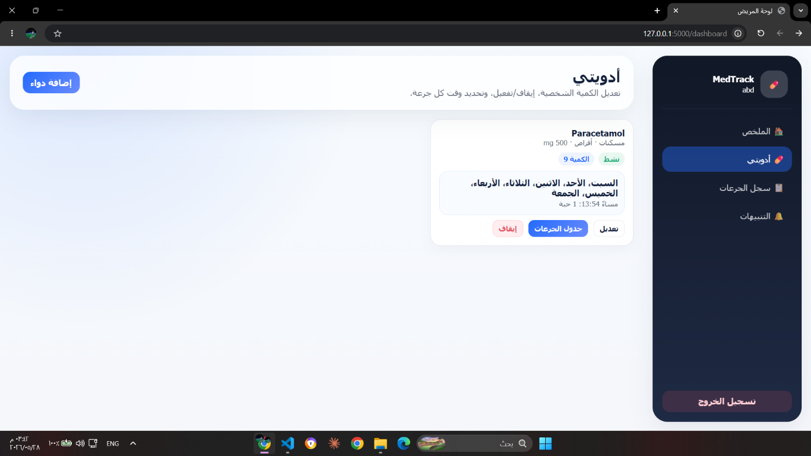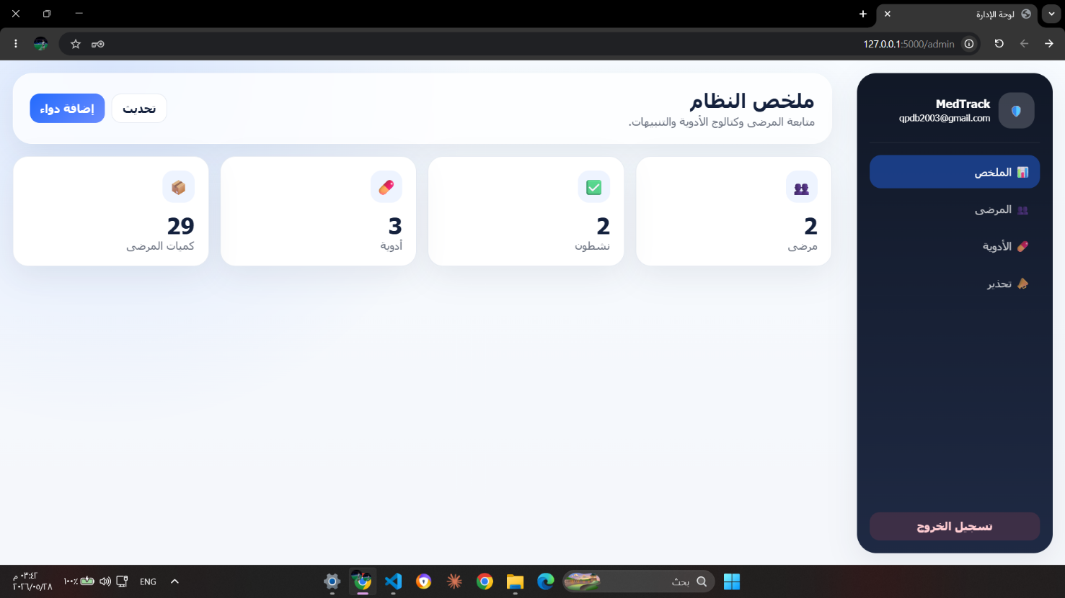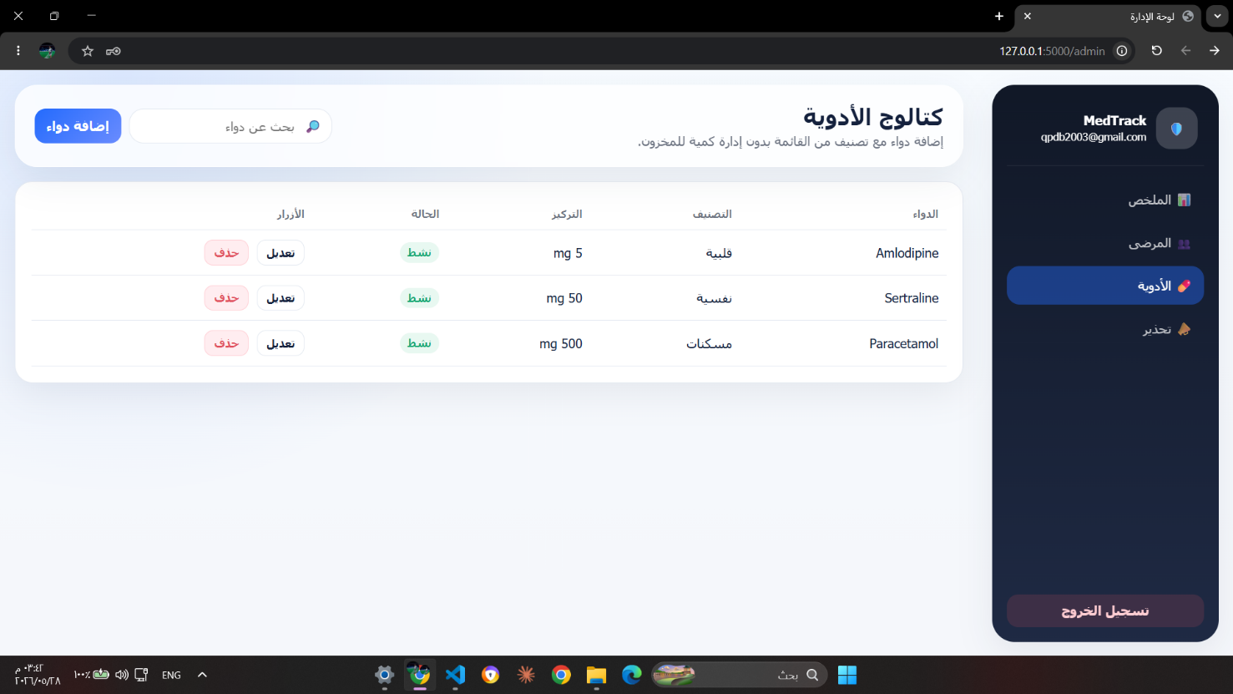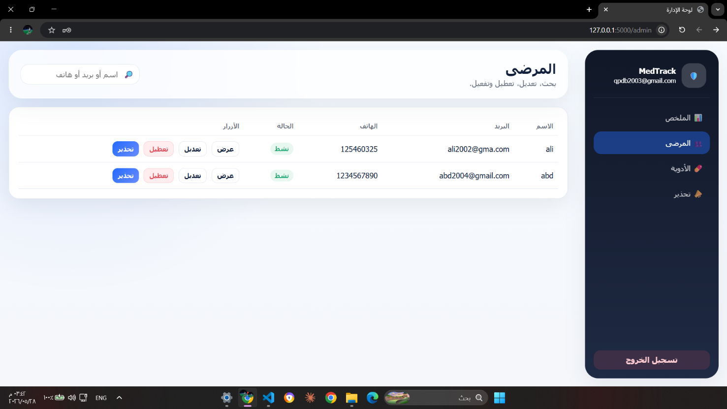

Chapter 10: Conclusion and Recommendations
This final chapter concludes the project report. It summarizes the core software engineering achievements, reviews the technical challenges managed during development, maps out future system enhancement paths, and provides practical recommendations for subsequent engineering teams.

10.1 Project Summary and Main Achievements
This project was engineered to solve a critical, real-world healthcare challenge: the high clinical risk of patient non-adherence due to complex medication routines. The resulting platform provides a secure, fully integrated web application built on top of a decoupled, maintainable multi-tiered architecture.
The primary milestone achieved is the creation of an automated end-to-end data pipeline. The application successfully connects global master catalogs to user-specific vaults, links complex day/time scheduling matrices, handles multi-threaded background alert routing, prompts real-time interface notifications, processes instant stock deductions upon user validation, and logs unalterable compliance histories seamlessly.
Core Project Milestone | Technical  Implementation  Outcome | Direct System Value Delivered | Maturity Level Assessment
Stateless Security JWT authentication Secures user profiles and Production-Ready routing with token blocks unauthorized data Deployment State blocklist tracking requests
Inventory Management | Centralized pharmaceutical indices mapped to private drug vaults | Isolates master catalog definitions from private user data | Production-Ready Deployment State
Precision Scheduling Flexible scheduling rules Organizes complex Production-Ready
managing multi-timed treatment tracking across Deployment State daily matrices clean timelines
Alert Infrastructure | Background worker threads running automated alert check loops | Minimizes medication oversights and tracks supplies | Production-Ready Deployment State
Compliance Auditing Unalterable history Provides clean historical Production-Ready logging tracking user compliance records for Deployment State intake behaviors clinical audits

Administrative Control | Dedicated management consoles with global database filters | Enforces global system auditing without data mixing | Production-Ready Deployment State

10.2 Challenges and Difficulties Faced
The primary software design challenge centered on maintaining perfect sync across interconnected data assets during concurrent transactions. For example, updating an inventory item required updating schedule models, adjusting background task execution chains, calculating timezone offsets, and updating dashboard states simultaneously without creating data race conditions.
A second major challenge involved maintaining absolute layer separation across the multi-tiered architecture. Decoupling database entities, repository methods, business services, API endpoints, and view controllers demanded disciplined package naming conventions, consistent payload shapes, and standardized error handlers to keep the codebase clean and maintainable.
Identified Technical Challenge | Operational System Threat | Engineered Resolution Strategy | Resulting Structural  Outcome

Alert Duplication Loops | Background task schedulers firing duplicate notification pop-ups | Enforced rigid unique indices inside database tables | Eliminated redundant client-side alerts
Cross-Layer Exploits Unauthorized route Fortified backend paths Enforced rock-solid access or privilege with custom role security boundaries escalation attempts
Response Fragmentation | Malformed or broken front-end view layouts | Standardized server replies using a uniform  JSON handler | Ensured clean, reliable interface rendering

10.3 Future Development Proposals
While the current release completely fulfills its initial project goals, its clean modular layout easily supports future functional expansions, such as advanced data visualization tools, native mobile wrappers, smart third-party notifications, and secure clinical sharing links.

Proposed Extension Domain | Technical Enhancement Feature | Direct Operational Value Add | Development Priority Target
Compliance Analytics Interactive graphical Provides clear visual High-Priority Future Phase compliance histories for overviews of compliance physicians trends
Mobile Access Shells |  |  | Progressive Web App (PWA) wrapper architecture installation | Enables native offline access from mobile phone devices | High-Priority Future Phase
 | Smart Notifications | Third-party communication integrations |  | Sends immediate  alternative text alerts if web views are closed | High-Priority Future Phase
Enterprise Integration |  |  | OAuth2 single sign-on integration | Supports secure integration with institutional clinic portals | Medium-Priority Future Phase
Data Reliability Automated system Enables rapid data High-Priority Future Phase backup routines and retrieval and reliable clinical report creation records sharing

10.4 Practical Recommendations
Subsequent software engineering teams extending this codebase are strongly advised to prioritize backend layer stability before adding cosmetic front-end features. Future modifications should follow a disciplined design-first, test-driven workflow, ensuring new code additions do not disrupt the system's precise timezone calculations or relational integrity rules.
Target Audience Group | Strategic Technical  Recommendation |  | Intended Architectural Outcome
Engineering Students | Keep service layers small and document new API routes early |  | Prevents code clutter and speeds up development
Academic Supervisors | Focus code evaluations on core scheduling safety constraints |  | Ensures high-quality, reliable project implementations
Subsequent Project Teams Add interactive charts and Significantly increases real-world comprehensive compliance clinical utility dashboards
Deployment Operators | Audit security configurations and token lifespan profiles before hosting | Guarantees production-grade data privacy and safety

10.5 Final Conclusion
This project successfully demonstrates that a centralized web application built on top of a highly disciplined, layered architecture provides a highly effective software solution for medication management and adherence tracking. By unifying automated inventory auditing, deterministic schedule mapping, multi-threaded alert processing, and immutable compliance logging, the platform delivers a robust, scalable system that provides clear technical blueprints for subsequent software engineering endeavors.

