# Summary Report – Craig Troop – 23 May 2025

## 1. Architecture

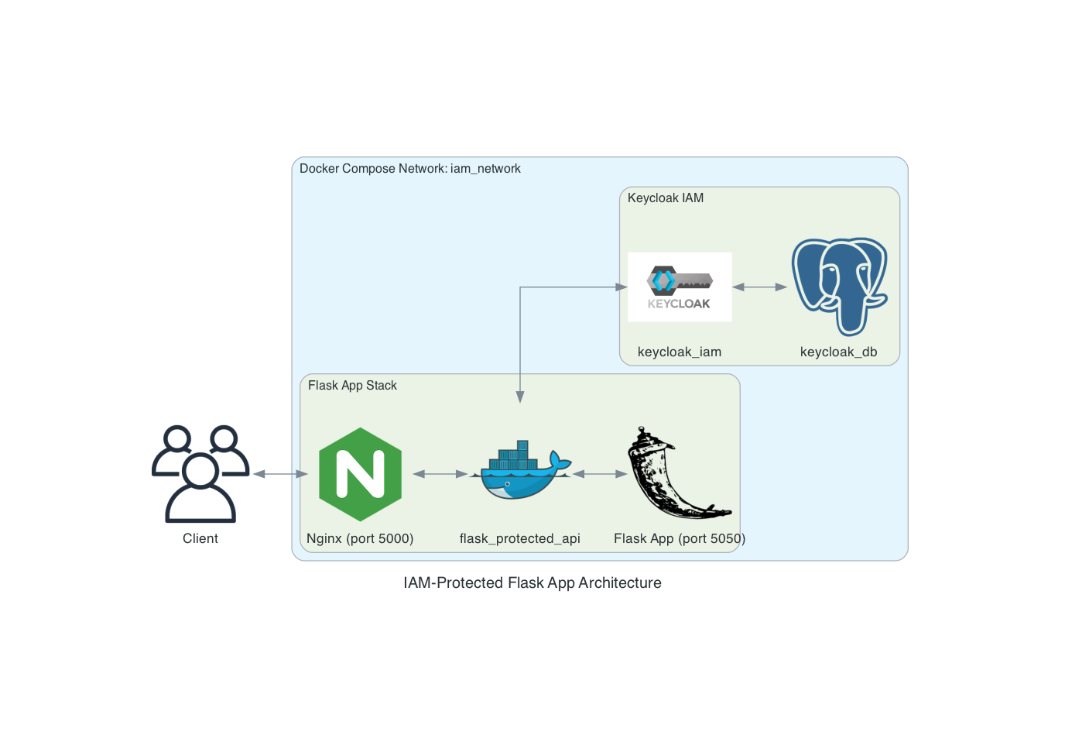

Architecture Diagram

### Key Components

| Component | Location | Function |
| --- | --- | --- |
| nginx | Flask Container | Reverse Proxy to protect Flask App |
| flask_protected_api | Flask Container | Exposes protected API endpoints |
| Flask App | Flask Container | Implements business logic, handles OAuth 2.0 and OIDC login flow, secures API routes with token-based access contol |
| KeyCloak | KeyCloak Container | IAM provider for user authentication, token issuance, and RBAC |
| KeyCloak DB | Postgres Container | Stores KeyCloak configuration, realm, client, user, and session data |

## 2. Testing Information

The command **make reset** will stop all containers, delete the keycloak configuration directory, prune the containers, and run the setup.sh bash script.

### Endpoints for testing

| URL | Purpose | Credentials |
| --- | --- | --- |
| http://localhost:5000 | Landing Page for Flask App | N/A |
| http://localhost:5000/login | Login Workflow | U: testuser  P: testpassword |
| http://localhost:8080 | KeyCloak Administration | U: admin P: admin |

### KeyCloak Configuration

Realm: hw8

Client: flask-api-client

User: testuser

Realm Roles: app_admin, app_user

Client Roles: task_reader, task_writer

## 3. OAuth 2.0 and OIDC Flows

### User Login Workflow

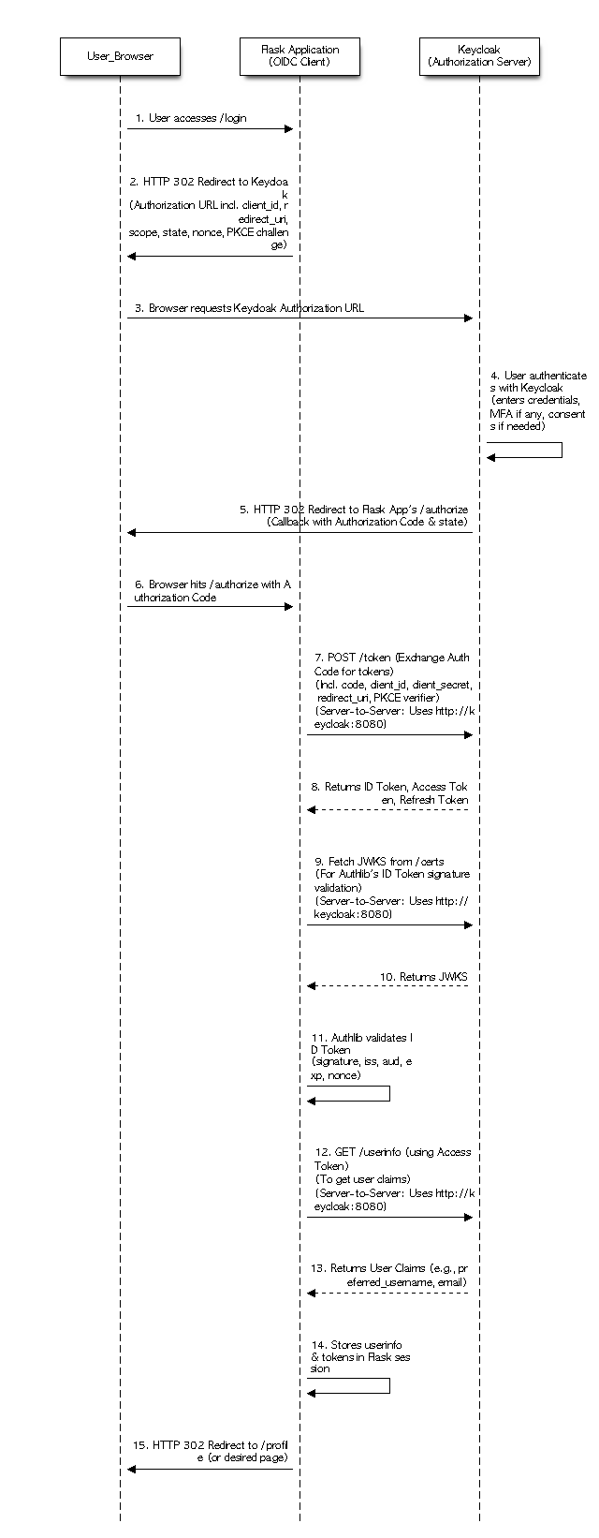

User Login Workflow Diagram

### Protected API Access Workflow

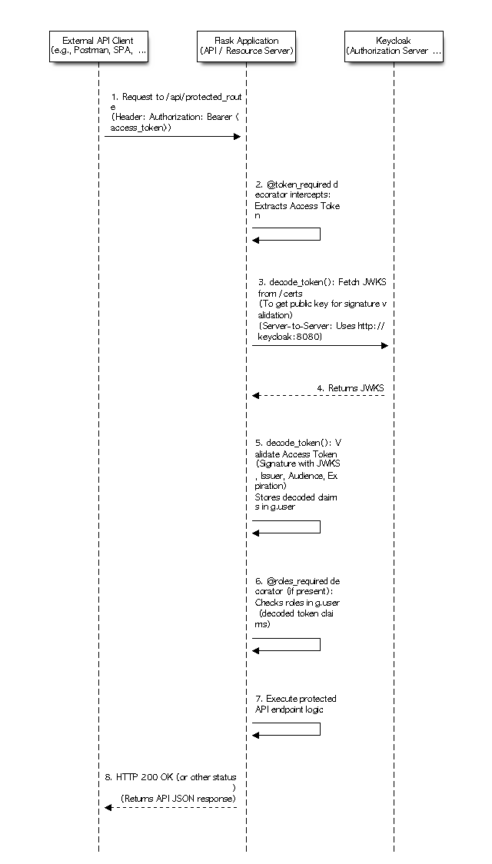

Protected API Access Workflow Diagram

## 4. Security Analysis

| Threat Category | Example | Impact | Mitigation Strategy |
| --- | --- | --- | --- |
| Spoofing | Malicious or malformed tokens accepted as valid | Protected endpoints are accessible to unauthenticated users | Validate issuer, audience, and expiration with jwt |
| Tampering | Decoding tokens with verify_signature=false | Forged tokens accepted | Validate signatures before decoding tokens |
| Repudiation | No audit logging of user actions (login, logout, token use) | No traceability | Log all token and user/admin activity |
| Information Disclosure | Exposed or hard-coded environment variables | Credential Leak | Use .env files with restricted permissions |
| Denial of Service | No rate limiting on endpoints | API resource exhaustion | Add request throttling and healthcheck isolation |
| Elevation of Privilege | Tokens include unverified role claims | Authorization bypass | Validate roles for realm and client resource access |

## 

## 5. Okta Case Study

The Okta breach is a good example of how to effectively manage third-party vendor access. Malicious acttors compromised a vendor workstation that had limited access to Okta resources. The malicious actors only had access for 25 minutes, and were unable to make any configuration changes or authenticate to user accounts (Day & Booker, 2024). The attacker was able to view some information on Slack and Jira pages for Okta customers, which indicates there is room for improvement in the security posture of those systems. The core Okta resources, however, were adequately protected by Okta’s robust security controls around their IAM solutions which appear to employ a hybrid of ZTA and DID.

## Some of Okta's downstream customers did notice attempts to compromise their services, but they had robust security controls in place to stop them (Mallarapu, 2025). Session cookies were a key component of this incident, which drove the decision to ignore session cookies in the design for this assignment. The cookies are set, but they are ignored by the API endpoints through the token_required decorator. This requires requests to the endpoint to explicitly include the authorization token in the header and adopts statelessness for API endpoints. This reduces the risk of CSRF and session-hijacking attacks since the tokens cannot be exploited through session cookies.

## 6. References

Day, K., & Booker, Q. (2024). Market Reactions to Cybersecurity Incidents: A Case Study Approach. *Issues in Information Systems*, 25(4), 260–276. https://doi.org/10.48009/4_iis_2024_121

Mallarapu, R. (2025). Week-8: Identity & Access Management (IAM) [Electronic]. The George Washington University.