Problem 1: While Loops
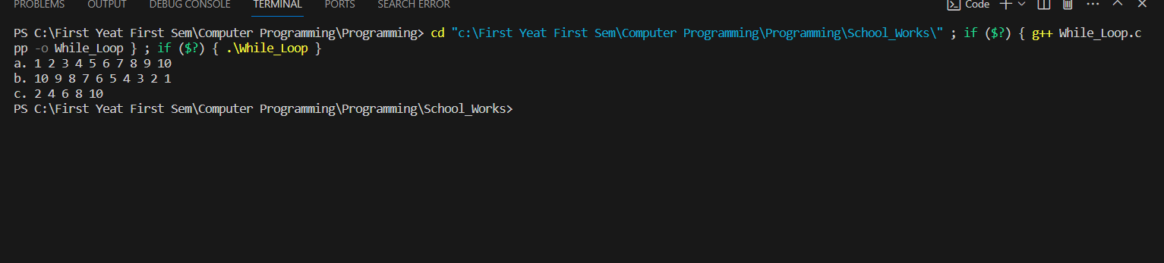
Here is my C++ Code:
#include <iostream>

using namespace std;

int main() {

int a = 1;
cout << "a. ";
while (a <= 10) {
cout << a << " ";
a++;
}
cout << "\n";

int b = 10;
cout << "b. ";
while (b >= 1) {
cout << b << " ";
b--;
}
cout << "\n";

int c = 2;
cout << "c. ";
while (c <= 10) {
cout << c << " ";
c += 2;
}
return 0;
}

Problem 2: Do While Loops
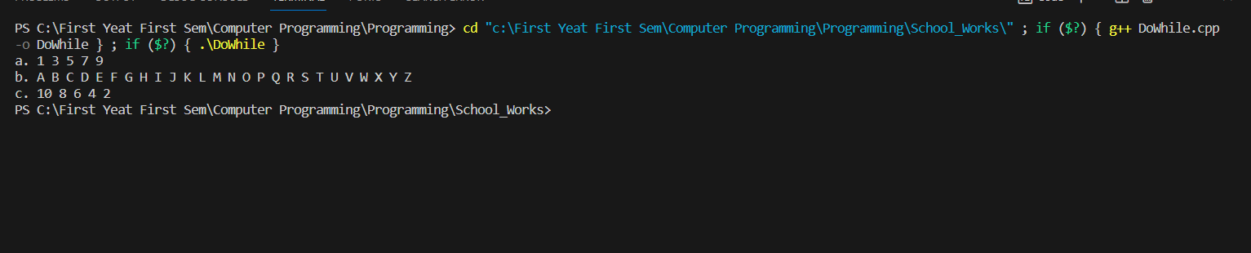
Here is my C++ Code:
#include <iostream>
using namespace std;

int main() {

int i = 1;
cout << "a. ";
do {
cout << i << " ";
i += 2;
} while (i <= 9);
cout << endl;

i = 65;
cout << "b. ";
do {
cout << (char)i << " ";
i++;
} while (i <= 90);
cout << endl;

i = 10;
cout << "c. ";
do {
cout << i << " ";
i -= 2;
} while (i >= 2);
cout << endl;

return 0;
}

Problem 3: For Loops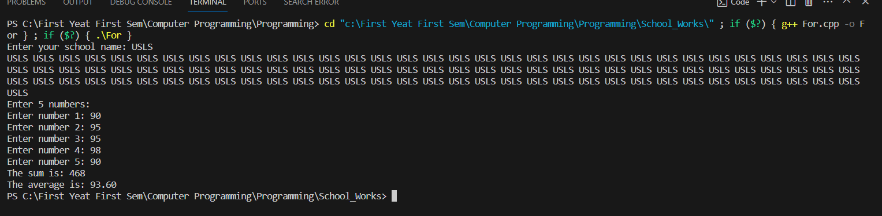Here is my C++ code:
#include <iostream>
#include <iomanip>

using namespace std;

int main() {

// Display the name 100x
string schoolName;
cout << "Enter your school name: ";
cin >> schoolName;

for (int i = 0; i < 100; i++) {
cout << schoolName << " ";
}
cout << endl;

// Ask the user to enter five numbers and display the sum and average using For Loop
int num[5];
float sum = 0;

cout << "Enter 5 numbers: " << endl;

for (int i = 0; i < 5; i++) {
cout << "Enter number " << i + 1 << ": ";
cin >> num[i];
sum += num[i];
}

float average = sum / 5;

cout << "The sum is: " << sum << endl;
cout << fixed << setprecision(2);
cout << "The average is: " << average << endl;

return 0;
}

