Q-TRACE
Quantum Threat & Reliability Analysis
for Cryptographic Evidence

Technical Project Report

SIH26141 — Quantum-Inspired Cyber Threat Detection
for Digital Signature Security
Smart India Hackathon 2026

Item | Value
Project name | Q-TRACE
Full name | Quantum Threat & Reliability Analysis for Cryptographic Evidence
Problem statement | SIH26141 — Quantum-Inspired Cyber Threat Detection for Digital Signature Security
Hackathon | Smart India Hackathon 2026
Reference protocol version | RQDS-TP-1.0 (project reference construction — not a standard)
API version | v1 (mounted at /api/v1)
Report date | 2026-09-25
Source of truth | Repository at the project root; benchmark artifact benchmarks/m5-reference.json
Team identification present in source | Git author “Gaurav Singh”; contributor branch namespace “sarkarhrit5-ops”. No formal team-roster file exists in the repository.

Detection in this project is quantum-simulation-backed, model-based statistical threat detection. It is not machine learning: no neural network, random forest, SVM, deep-learning model or trained classifier exists anywhere in the codebase.

Table of Contents
[Table of contents — in Microsoft Word, right-click here and choose “Update Field” to populate.]

Executive Summary

The problem
SIH26141 asks for quantum-inspired cyber-threat detection that protects digital signature security. Classical signature schemes (RSA, DSA, ECDSA) rest on hardness assumptions that a sufficiently large fault-tolerant quantum computer running Shor's algorithm would break. Quantum Digital Signatures (QDS) offer an alternative whose security rests on quantum mechanics rather than computational hardness, but practical QDS is hard to deploy and hard to evaluate. The problem statement therefore calls for a framework that can model quantum signature behaviour, model the threats against it, and detect tampering from observable evidence.

The approach actually implemented
Q-TRACE is a simulation-and-evidence platform, not a deployed cryptographic library and not a machine-learning system. It builds a small, fully-simulated teleportation-based reference protocol; subjects the simulated quantum channel to honest noise and to six modelled attacks; extracts only the evidence a real verifier could observe; and applies finite-sample statistics (exact Clopper–Pearson binomial intervals and an honest-null threshold) to decide whether an observed session is inconsistent with honest behaviour. A FastAPI backend exposes every stage, and a React web console (branded Q-TRACE) lets a judge drive the whole workflow.

What was actually implemented (verified against source)
- A verified quantum core: six Pauli eigenstates, the |Φ+⟩ Bell state, three-qubit teleportation with classical Bell-bit feed-forward Pauli correction, density-matrix representation, and projective measurement via the Born rule — executed on Qiskit 2.5.2 / Qiskit-Aer 0.17.2 and reproducibility-tested.
- A reference QDS-style protocol construction: SHA-256 canonical message binding, CSPRNG session id and nonce, a deterministic public state-sequence derivation over the six-state alphabet, single-shot teleportation per state, and a hash-sealed canonical transcript with an independent-reconstruction verifier.
- Five honest Pauli noise channels (identity, depolarizing, bit-flip, phase-flip, bit-phase-flip) and six attack models (forgery, impersonation, unauthorized verification, replay, intercept–resend, channel tampering), each with an explicit observable/ground-truth split.
- A detection engine that consumes observable evidence only, computes a mismatch rate with an exact Clopper–Pearson interval, and emits categorical findings with no security score.
- A calibration layer deriving a sample-size-specific threshold from honest-only data, an evaluation layer producing FAR/FRR/detection metrics and eight reference curves, and a security-interpretation layer with an assumption register, observability matrix, composition assessment and a claim checker that rejects forbidden security claims.
- A FastAPI backend (24 endpoints under /api/v1 plus three operational endpoints) and a React/TypeScript/Vite console with seven workflow pages.

Major capabilities
- Reproducible quantum-channel experiments: identical (circuit, shots, seed) triples give identical counts.
- Honest, label-free detection: the detector is structurally, statically and behaviourally prevented from seeing attack labels; two scenarios with identical observables but different ground truth produce identical detector output.
- Finite-sample statistical rigour: exact Clopper–Pearson intervals, an honest-null threshold with a split alpha budget, a Hoeffding cross-check, and an explicit primary-vs-diagnostic statistic policy.
- Transparent security posture: every forbidden over-claim (information-theoretic security, forgery bound, universal detection, optimality) is rejected by an in-repo claim checker.

Major limitations (stated plainly)
- Simulation-only. No quantum hardware is used or validated; all quantum behaviour is simulated.
- No secret signing key exists, therefore no unforgeability. A keyless full forgery verifies successfully; this is demonstrated, not hidden.
- No formal security proof, no forgery bound, no composability theorem, no information-theoretic guarantee.
- The quantum statistic detects only the two channel attacks (intercept–resend, channel tampering). The four protocol-layer attacks (forgery, impersonation, unauthorized verification, replay) are detected — if at all — by classical controls, and measured detection by the quantum statistic is 0.0 with FAR 1.0.
- No coherent/multi-qubit/adaptive adversary; individual attacks only, no quantum memory.
- Thresholds are sample-size and configuration specific and are not cryptographic security parameters.

Plain-English explanation
Imagine two people who want to check that a signed message really travelled untouched. Instead of trusting a secret password, the sender encodes the message into a short list of tiny quantum objects (qubits) chosen from six well-known states, and teleports each one to the receiver using a shared entangled pair. Anyone who secretly measures or tampers with a qubit in transit inevitably disturbs it in a way the receiver can notice when they measure it in the basis the protocol says to use. Q-TRACE simulates this whole conversation on a classical computer, deliberately adds honest noise and simulated attackers, and then asks a very careful question: “is the amount of disturbance we see bigger than what honest noise alone would produce?” It answers using plain statistics on counts — not AI — and it is honest about what that answer does and does not prove.

1. Problem Statement and Motivation

1.1 SIH26141 problem context
The Smart India Hackathon 2026 problem statement SIH26141, “Quantum-Inspired Cyber Threat Detection for Digital Signature Security” (repository file docs/research/SIH26141.pdf), asks for a framework that uses quantum-inspired techniques to detect cyber threats against digital signature security. The repository's own research synthesis (docs/research/consensus-research.md) recommends a non-machine-learning, threshold-based detection approach built on mismatch statistics, disturbance, projective verification and finite-size reasoning. Q-TRACE is the implementation of that recommendation.

1.2 Cybersecurity context
Digital signatures provide authenticity, integrity and non-repudiation. Nearly all deployed schemes are classical public-key constructions whose security is computational: an adversary with enough compute breaks them. This is the motivation for post-quantum and quantum cryptographic research, and the reason a threat-detection layer for signature infrastructure is valuable.

1.3 Why quantum computing matters — Shor's algorithm as background only
Shor's algorithm (1994) solves integer factorisation and discrete logarithms in polynomial time on a fault-tolerant quantum computer, which would break RSA, DSA and ECDSA. In this report Shor's algorithm appears strictly as background motivation for why quantum-resistant signature research matters.
Q-TRACE does NOT implement Shor's algorithm. There is no factorisation or discrete-log code anywhere in the repository (verified by search). Shor's algorithm is context, not a component.

1.4 Why RSA / DSA / ECDSA matter as context — and that Q-TRACE does not implement them
RSA, DSA and ECDSA are the incumbent schemes whose vulnerability motivates quantum signature research. They are discussed here only to frame the threat.
Q-TRACE does NOT implement RSA, DSA or ECDSA. No classical public-key cryptography, key generation, or signing with a private key exists in the codebase. The reference protocol holds no key material at all (backend/protocol/models.py:L188-190).

1.5 The role of QDS
Quantum Digital Signatures derive security from quantum mechanics (no-cloning, measurement disturbance) rather than computational hardness. Foundational and memory-free QDS literature (Bennett et al. 1993 teleportation; Dunjko–Wallden–Andersson 2014; Collins et al. 2014; Wallden et al. 2015) informs the design. Q-TRACE implements a project-specific reference construction inspired by these ideas for simulation and detection research — it is not an implementation of any named or standardised QDS protocol.

2. Project Objectives Mapped to the Implementation
The table maps each SIH-style objective to what the repository actually implements, with the code/test evidence and an honest status.
Requirement | How Q-TRACE addresses it | Evidence in code / tests | Status
Quantum-inspired signature substrate | Six Pauli eigenstates, |Φ+⟩ Bell pair, teleportation with Pauli feed-forward, density-matrix simulation | backend/quantum/states.py:L95-104; bell.py:L31-53; teleport.py:L85-127; correction.py:L74-79; density.py:L87-117; tests/quantum/* | Implemented
Message binding to quantum states | SHA-256 canonical binding → counter-mode nibble-rejection state sequence over the six-state alphabet | backend/protocol/binding.py:L56-99; encoding.py:L130-174; tests/protocol/test_encoding.py | Implemented (engineering choice, not a standard)
Threat modelling | Six attack models with explicit attacker capability and observable/ground-truth split | backend/attacks/*.py; tests/security/test_attacks.py | Implemented (individual attacks only)
Channel noise modelling | Five Pauli channels applied analytically to density matrices | backend/noise/base.py:L189-206; depolarizing/bit_flip/phase_flip/bit_phase_flip.py; tests/security/test_channels.py | Implemented
Threat detection from observable evidence | Mismatch rate + exact Clopper–Pearson interval; categorical findings; label-free by construction | backend/detection/{mismatch,statistics,engine,evidence}.py; tests/detection/test_separation.py | Implemented
Statistical calibration with finite samples | Honest-only calibration, honest-null quantile threshold, split alpha, Hoeffding cross-check | backend/calibration/{baseline,confidence,thresholds}.py; backend/security/finite_size.py; tests/calibration/* | Implemented
Evaluation / benchmarking | Benchmark harness with calibration/evaluation split, FAR/FRR, curves, robustness, discrimination, sample-size study | backend/evaluation/*; benchmarks/m5-reference.json; tests/evaluation/* | Implemented
Transparent security analysis | Assumption register, observability matrix, composition assessment, claim checker | backend/security/{assumptions,observability,composition,interpretation}.py; tests/security/* | Implemented
Serviceable API | FastAPI app factory, /api/v1 routes, Pydantic validation, in-memory store, error envelope | backend/api/app.py:L82-123; routes/*; tests/api/* | Implemented
Judge-facing console | React/TS/Vite console, seven workflow pages, observable-only handoff | frontend/src/pages/*; frontend/src/api/client.ts | Implemented
Unforgeability / formal QDS security | Not attempted: no secret key, no forgery game, no proof | backend/protocol/models.py:L188-190; backend/security/composition.py:L96-113; backend/attacks/forgery.py:L22-45 | Not implemented (by design)
Hardware validation | Not present; all quantum behaviour is simulated | backend/quantum/measure.py:L105-132 (Aer simulator only) | Not implemented

3. High-Level System Architecture
Q-TRACE is organised as a strict one-way dependency stack. Lower layers never import higher layers, and this direction is enforced by architecture tests. The declared order is backend.quantum → backend.protocol → backend.noise → backend.attacks → backend.simulation, with backend.detection, backend.calibration, backend.evaluation and backend.security layered above, and backend.api as the outermost application boundary.
backend/attacks/__init__.py:L19 ; backend/quantum/__init__.py:L15-18 ; tests/*/test_architecture.py
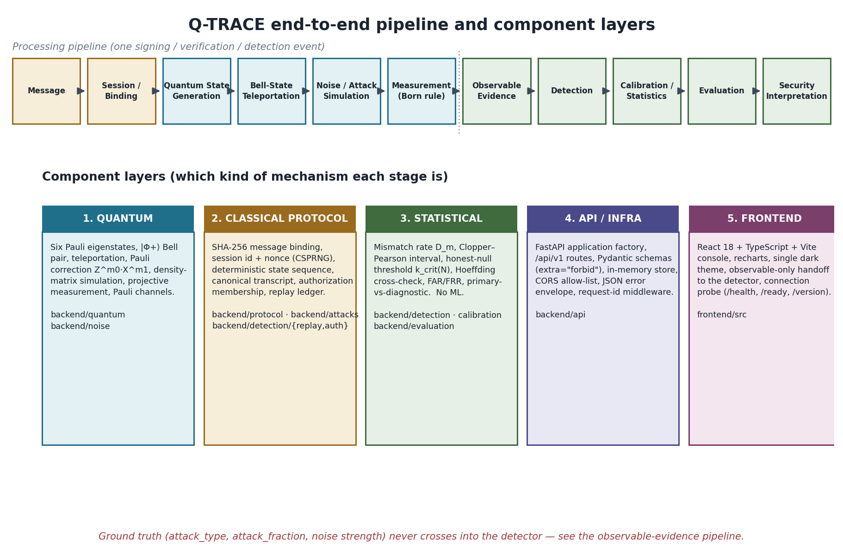
Figure 3.1 — Q-TRACE end-to-end pipeline and the five component layers. The dotted line separates quantum-channel stages from the statistical stages that consume only observable evidence.

3.1 The pipeline, stage by stage (simple language)
Stage | What happens (simple) | Layer
Message | A plain-text message is supplied (e.g. “transfer 100 units to account 7”). | Classical
Session / Binding | A session id and nonce are drawn from the OS CSPRNG; a SHA-256 binding ties message+session+nonce+version together. | Classical
Quantum State Generation | The binding deterministically expands (counter-mode SHA-256 + unbiased nibble rejection) into a sequence of six Pauli eigenstates. | Classical→Quantum
Bell-State Teleportation | Each state is teleported over a simulated |Φ+⟩ pair; the signer records the two public Bell bits per state. | Quantum
Noise / Attack Simulation | An honest Pauli channel and/or a modelled attack acts on the qubits the channel carries. | Quantum
Measurement | The verifier measures each received qubit in the basis the protocol derived; the Born rule gives P(expected). | Quantum
Observable Evidence | Only what a real verifier could see is kept: per-state probabilities/matches, counts, verification flags, authorization observations. | Statistical input
Detection | Consistency, authorization and replay checks plus a mismatch rate with a Clopper–Pearson interval produce categorical findings. | Statistical
Calibration / Statistics | Honest-only data yields a one-sided upper bound and a sample-size-specific rejection count k_crit(N). | Statistical
Evaluation | Disjoint-seed populations give FAR / FRR / detection rates, curves, robustness and discrimination results. | Statistical
Security Interpretation | Assumptions, observability, composition and a claim checker state what is and is not established. | Statistical/Policy

3.2 Component classification
- Quantum: states, Bell pair, teleportation, correction, density matrices, measurement, noise channels.
- Classical protocol controls: binding, session/nonce, state-sequence derivation, transcript, authorization membership, replay ledger.
- Statistical: mismatch rate, intervals, thresholds, metrics, evaluation.
- API / infrastructure: FastAPI app, routes, schemas, store, CORS, errors, logging.
- Frontend / presentation: React console pages and charts.

4. Quantum Model
This section states the quantum mathematics exactly as implemented, identifies the source location, and explains each equation's role. All linear algebra for channels and measurement is closed-form NumPy; Qiskit supplies circuit construction, Statevector/DensityMatrix coercion, and the Aer shot simulator.

4.1 Qubit states and the six Pauli eigenstates
A single qubit is a unit vector in C². The protocol's alphabet is the six eigenstates of the three Pauli operators. The Pauli matrices are defined at backend/quantum/states.py:L60-65 and the eigenstate table at L95-104.
Index | Label | Basis | Eigenvalue | State vector | Protocol id
0 | |0⟩ | Z | +1 | (1, 0) | Z+
1 | |1⟩ | Z | −1 | (0, 1) | Z−
2 | |+⟩ | X | +1 | (1/√2, 1/√2) | X+
3 | |−⟩ | X | −1 | (1/√2, −1/√2) | X−
4 | |+i⟩ | Y | +1 | (1/√2, i/√2) | Y+
5 | |−i⟩ | Y | −1 | (1/√2, −i/√2) | Y−

backend/quantum/states.py:L60-65 (PAULI_MATRICES), L95-104 (_DEFINITIONS), L104 (EIGENSTATE_LABELS)
Each row satisfies P|ψ⟩ = λ|ψ⟩ exactly (verified numerically). The alphabet used by the protocol is derived from this table so it cannot drift from the quantum core (backend/protocol/encoding.py:L78-84).

4.2 Bloch-sphere interpretation
The six states are the six axis points of the Bloch sphere (±x, ±y, ±z). The implementation does not require a Bloch-sphere object; the eigenstate table plus the basis-rotation measurement (Section 4.6) is the operational content. Where a geometric reading is useful: a Pauli channel shrinks or rotates the Bloch vector, and measurement in the wrong basis yields the uniform 0.5 probability.

4.3 The Bell state and entanglement
The shared entangled resource is the first Bell state |Φ+⟩, produced by H on q1 then CX(q1→q2):
|Φ+⟩ = (|00⟩ + |11⟩)/√2 (4.1)
backend/quantum/bell.py:L31-53 (bell_circuit), L56-58 (bell_amplitudes_exact), L66-68 (bell_density_matrix)
The circuit-produced statevector equals [1/√2, 0, 0, 1/√2] exactly; the density matrix |Φ+⟩⟨Φ+| has diagonal [0.5,0,0,0.5]. Entanglement here is the resource that makes teleportation possible; it carries no secret and provides no security by itself.

4.4 Teleportation and the Bell measurement
Teleportation uses three qubits: q0 the signature state, q1 Alice's half, q2 Bob's half. The exact gate sequence (backend/quantum/teleport.py:L85-127) is: initialise q0; compose the Bell circuit on (q1,q2); CX(q0,q1); H(q0); measure q0→m1 and q1→m0; conditionally correct q2; optionally rotate and measure q2.
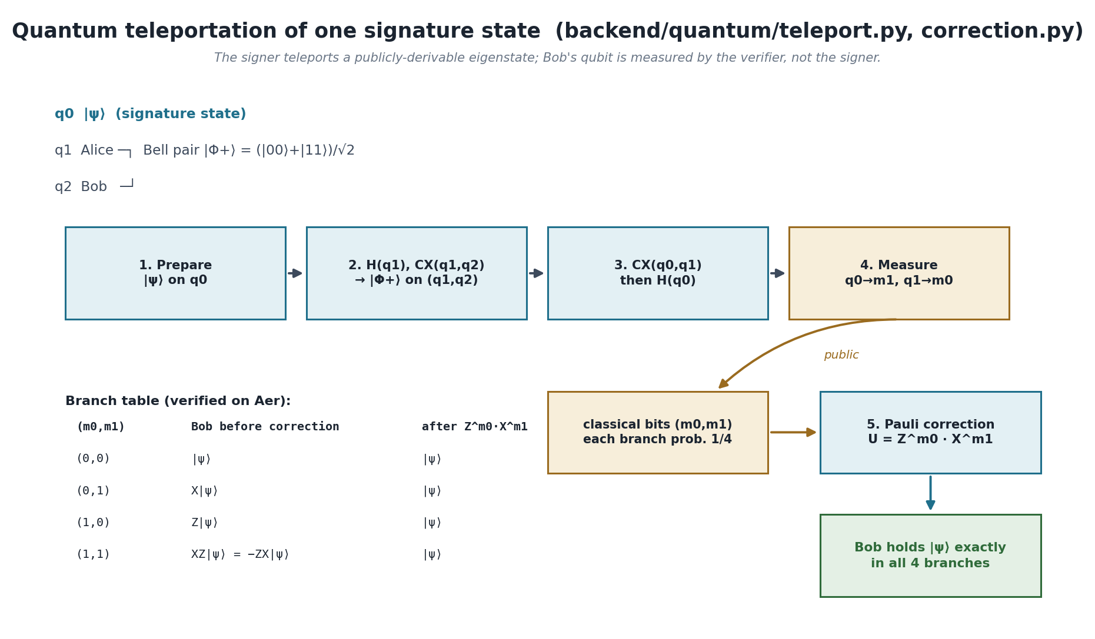
Figure 4.1 — Teleportation of one signature state with the verified four-branch table. The two classical Bell bits are public; the Pauli feed-forward is load-bearing.
The Bell measurement is the CX+H followed by computational-basis measurement of (q0,q1); it projects onto the four Bell outcomes, each with probability 1/4. The pre-measurement state factorises so that Bob's qubit is a Pauli image of |ψ⟩ per branch (backend/quantum/teleport.py:L148-168).

4.5 Classical correction bits and Pauli correction
The two measurement bits select a by-product Pauli; applying its inverse recovers |ψ⟩. The convention is U(m0,m1) = Z^m0 · X^m1 with Z on the left, so circuit order appends X first then Z (backend/quantum/correction.py:L7-19, L74-79, L107-137):
U(m0,m1) = Z^{m0} · X^{m1}, CORRECTION_TABLE = {(0,0):I, (0,1):X, (1,0):Z, (1,1):ZX} (4.2)
backend/quantum/correction.py:L74-79 (CORRECTION_TABLE), L95-104 (correction_unitary), L122-137 (append_conditional_correction)
The correction is implemented as genuine Qiskit classical feed-forward (if_test on the clbits), not as post-hoc relabelling. Empirically, without correction Bob's bit is wrong in two of four branches; with correction it is correct in all four.

4.6 Density-matrix representation and projective measurement
Mixed states (post-noise) are density matrices ρ with Tr ρ = 1. The projective measurement probability of the expected pure state is the Born rule with projector P_ψ = |ψ⟩⟨ψ|:
p_match = Tr(P_ψ · ρ), P_ψ = |ψ⟩⟨ψ| (4.3)
F = ⟨ψ| ρ |ψ⟩ (4.4)
backend/quantum/density.py:L75-78 (projector), L87-98 (p_match), L106-117 (fidelity_pure)
Equations 4.3 and 4.4 are the SAME quantity for a pure expected state — p_match ≡ F, identically, not approximately. The code states this explicitly and forbids reporting them as two independent pieces of evidence (backend/quantum/density.py:L14-23; backend/detection/fidelity.py:L37-51; backend/detection/features.py:L446-461).
Measurement in Pauli basis P is implemented by rotating P to Z (R_P P R_P† = Z) then measuring computationally; the measured bit b corresponds to eigenvalue (−1)^b. Rotations: Z→(), X→(H), Y→(S†,H) (backend/quantum/measure.py:L56-60). A state measured in the wrong basis gives probability exactly 0.5.

4.7 Role of each equation in the system
Equation | Meaning | Implementation | Role
4.1 | Maximally entangled resource | bell.py:L31-53 | Enables teleportation of each signature state
4.2 | By-product Pauli per Bell outcome | correction.py:L74-137 | Makes teleportation exact; load-bearing feed-forward
4.3 | Born-rule projective match probability | density.py:L87-98 | The per-state observable probability_expected
4.4 | Fidelity of ρ against pure ψ | density.py:L106-117 | Identical to 4.3; aggregated as mean fidelity (diagnostic)

5. Message Binding and the Reference QDS Protocol

5.1 Message hashing
The message hash is SHA-256 over the UTF-8 encoding of the NFC-normalised message text and nothing else. The algorithm is pinned to sha256 and any other algorithm raises.
message_hash = SHA256( utf8( NFC(message) ) ) (5.1)
backend/protocol/binding.py:L56-58 ; backend/protocol/canonical.py:L57, L142-157

5.2 Session id, nonce and the binding
session_id (128-bit) and nonce (256-bit) come from the OS CSPRNG via secrets; they are unpredictable, unique, never derived from the message, and not reproducible. The simulator seed is a separate, reproducible, security-meaningless integer and is never mixed into them.
message_binding = SHA256( canonical{ domain, protocol_version, session_id, nonce, message } ) (5.2)
backend/protocol/session.py:L57-64, L3-21 ; backend/protocol/binding.py:L61-99 ; backend/protocol/models.py:L77-78
The binding uses a canonical named-field encoding (not concatenation) with a domain-separation tag, so different field tuples cannot collide and arguments cannot be silently swapped.

5.3 Deterministic state sequence and the state alphabet
The binding digest seeds a counter-mode SHA-256 stream; nibbles are rejection-sampled to unbiased indices over the six-state alphabet:
block_k = SHA256( seed ‖ domain uint32_be(k) ); accept nibble < 12; index = nibble mod 6 (5.3)
backend/protocol/encoding.py:L130-143 (nibble_stream), L146-166 (derive_alphabet_indices), L169-174 (derive_state_sequence)
Because 12 = 2×6, each residue class appears exactly twice in the accepted range, so the mapping is unbiased over the six states (unlike a naive byte mod 6). The derivation is a pure function of (binding, count): no clock, no randomness, no global state.
ENGINEERING DESIGN CHOICE: the hash→state mapping is explicitly an engineering choice for the reference prototype, not a security construction and not a standardised QDS encoding. The code says so verbatim (backend/protocol/encoding.py:L9-10) and the docs repeat it (docs/protocol/reference-qds.md:L175-177, L474-477). It is a public deterministic PRF with no keyed/secret component.

5.4 Transcript generation and the signing lifecycle
Signing derives the state sequence, teleports each state (recording the two public Bell bits per state), and seals a 15-field canonical transcript whose hash is SHA-256 over every field except the hash itself. The session lifecycle in the protocol layer is exactly CREATED → SIGNED.
backend/protocol/signer.py:L119-160 ; backend/protocol/transcript.py:L81-99, L124-165 ; backend/protocol/models.py:L104-108
The transcript records states symbolically (which of the six eigenstates), never amplitudes; floats are structurally impossible in the canonical encoding.

5.5 Verification
The verifier never trusts the signer. It recomputes the hash and the binding, independently re-derives the state sequence, compares against the declared states, and per state applies the branch correction and measures in the derived basis. Acceptance requires all structural and measurement flags true. Every verification also appends the caveat that reference verification is structural: binding and consistency, not unforgeability.
backend/protocol/verifier.py:L188-380 (six checks), L353-356 (caveat), L3-15 (never-trust principle)

5.6 Cryptographic limitations (explicit)
- No secret signing key. Session and transcript hold no key material; sign() takes no key. (backend/protocol/models.py:L188-190; backend/attacks/forgery.py:L36-38)
- No formal forgery game and no adversary-advantage computation anywhere.
- No unforgeability. Because every ingredient is public and deterministic, a keyless full forgery verifies successfully — demonstrated by backend/attacks/forgery.py and verified by execution (accepted=True with arbitrary branch bits under the M2 reconstruction seam).
- No information-theoretic security proof. describe_protocol() returns formal_security_claim: false and standardized: false (backend/protocol/reference_qds.py:L187-200).
- Not an official Egreen Quanta or any named/standardised protocol (backend/protocol/reference_qds.py:L7-22).

6. Quantum Channel and Noise Model
Every honest noise model is a single-qubit Pauli channel applied analytically to a density matrix (never a sampled trajectory):
E(ρ) = p_I·ρ + p_X·XρX + p_Y·YρY + p_Z·ZρZ, p_I+p_X+p_Y+p_Z = 1 (6.1)
backend/noise/base.py:L20-29 (generic form), L189-206 (QuantumChannel.apply)
Channel | Probability table (p = strength) | p is an error prob.? | Physical reading | Effect / limitation
identity (none) | p_I=1 | — | no noise | E(ρ)=ρ
depolarizing | p_I=1−3p/4, p_X=p_Y=p_Z=p/4 | No (error prob = 3p/4) | blend toward I/2 | state-independent; T = p/2; p=1 → I/2
bit_flip | p_I=1−p, p_X=p | Yes | random X | invisible on X eigenstates
phase_flip | p_I=1−p, p_Z=p | Yes | random Z | invisible on Z eigenstates (and to Z-basis measurement)
bit_phase_flip | p_I=1−p, p_Y=p | Yes | random Y | invisible on Y eigenstates

backend/noise/depolarizing.py:L57-94 ; bit_flip.py:L40-60 ; phase_flip.py:L44-64 ; bit_phase_flip.py:L53-73
Depolarizing deliberately rejects p>1 (the coefficient of ρ would go negative). The three flip channels use require_unit_probability. The raw disturbance statistic is the trace distance:
T(ρ,σ) = ½ · Tr|ρ−σ| = ½ · Σ |eig(ρ−σ)| (6.2)
backend/noise/base.py:L331-342 (trace_distance)

6.1 Noise strength → measurement probability → mismatch probability
For depolarizing strength η, every reference state has projective match probability 1 − η/2, so a single projective measurement mismatches with probability η/2. This is the honest null's non-zero mean and is the bridge from a physical parameter to the statistic the detector uses.
p_match(honest, depolarizing η) = 1 − η/2 ; p_mismatch = η/2 (6.3)
backend/calibration/baseline.py:L13-18 ; verified: depolarizing p=0.02 → all states read probability_expected 0.99
For flip channels the match probability depends on whether the state's basis is the channel's fixed point (e.g. phase_flip leaves Z eigenstates untouched for every p), so the honest null is a Poisson-binomial mixture rather than a single binomial — the calibration layer detects this via a homogeneity diagnostic.

7. Attack Models
Six attacks are implemented. For each we state capability, what is modified, what is unchanged, the expected observable effect, the detection mechanism, whether the evidence is quantum-channel or classical-protocol, and a known limitation. Verified runner outputs are given where they are the honest summary.
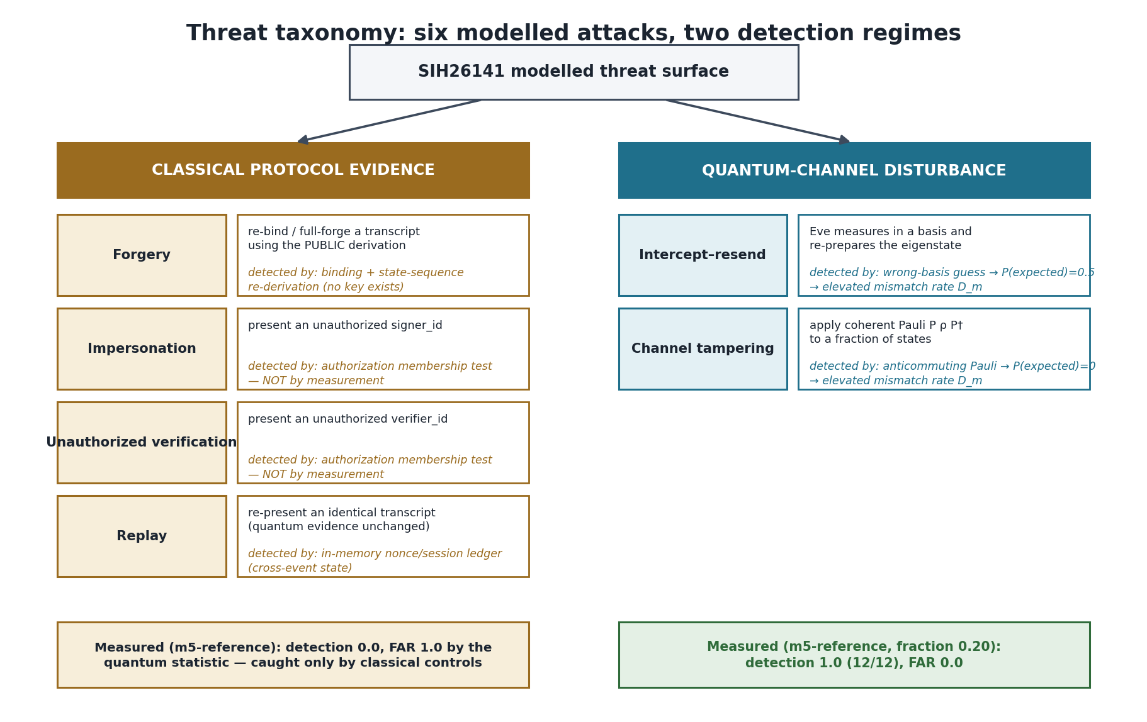
Figure 7.1 — Threat taxonomy. Four attacks are caught only by classical protocol controls; two produce quantum-channel disturbance.

7.1 Forgery (classical protocol evidence)
- Capability: the public canonicalisation and public state-sequence derivation; an obtained transcript (rebind mode). No key — none exists.
- Modified: message_hash/message_binding (rebind_only) or the entire transcript incl. invented branch bits (full_forge).
- Unchanged: the quantum channel (received states pass through) in rebind mode.
- Observable effect: binding/sequence inconsistency; under the runner, message_valid=False and (full_forge) state_sequence_valid=False.
- Detection: verifier's independent recomputation of binding and state sequence; detector consistency findings.
- Evidence type: classical protocol integrity — NOT quantum measurement.
- Limitation: full_forge verifies successfully against the reconstruction-based verifier (M2 seam); the protocol offers binding/integrity, not unforgeability.
backend/attacks/forgery.py:L78-213 ; L22-27, L36-45 (no key, no quantum forgery)

7.2 Impersonation (classical authorization evidence)
- Capability: present an unauthorized signer_id; re-seal the transcript.
- Modified: transcript.signer_id only.
- Unchanged: the quantum channel, verifier context, authorization context.
- Observable effect: none in the quantum evidence (mismatch 0, disturbance 0); only authorization.signer_authorized = False.
- Detection: authorization membership test on declared identifiers.
- Evidence type: classical authorization — a quantum measurement alone cannot detect this (backend/attacks/impersonation.py:L28-33).
- Limitation: no authentication/credential/certificate exists; signer_id is a name.

7.3 Unauthorized verification (classical authorization evidence)
- Capability: present an unauthorized verifier_id and rewrite both transcript and verifier context so addressing checks pass.
- Modified: transcript.verifier_id and verifier_context.verifier_id.
- Unchanged: quantum channel.
- Observable effect: authorization.verifier_authorized = False; quantum evidence clean.
- Detection: authorization membership test.
- Evidence type: classical authorization.
- Limitation: identities are modelled, not authenticated.

7.4 Replay (classical cross-event evidence)
- Capability: re-present an identical, valid transcript and nonce.
- Modified: nothing — the transcript is returned unchanged on purpose.
- Unchanged: everything; a single replayed event is indistinguishable from a fresh one on quantum evidence.
- Observable effect: the same nonce/session/created_at appearing in two events (a temporal, cross-event signal).
- Detection: in-memory ReplayRegistry ledger (nonce/session/transcript sets) in backend/detection/replay.py.
- Evidence type: classical protocol control requiring cross-event state — explicitly NOT quantum disturbance.
- Limitation: ledger is in-memory, single-process, not persisted; the attack layer deliberately does not implement a consumed-nonce store.
backend/attacks/replay.py:L13-28 ; backend/detection/replay.py:L3-13, L102-235

7.5 Intercept–resend (quantum-channel evidence)
- Capability: measure each intercepted qubit in a chosen/random basis and re-prepare the obtained eigenstate (genuine measure-and-reprepare).
- Modified: the received density matrices at the selected indices.
- Unchanged: transcript, verifier context, authorization.
- Observable effect: wrong-basis guesses give probability_expected = 0.5 (a coin flip); correct guesses give 1.0; mismatch rate rises.
- Detection: elevated mismatch rate D_m / disturbance; quantum measurement anomaly findings.
- Evidence type: quantum-channel disturbance.
- Limitation: individual (one-qubit) attack, single copy, no quantum memory, no coherent/adaptive strategy; a correct guess is physically indistinguishable from an honest channel for that state.
backend/attacks/intercept_resend.py:L98-183 ; L123-142 (Born-rule measure-and-reprepare)

7.6 Channel tampering (quantum-channel evidence)
- Capability: apply a coherent single Pauli P ρ P† to a fraction of the states in transit.
- Modified: the received density matrices at the selected indices.
- Unchanged: transcript, verifier context, authorization.
- Observable effect: an anticommuting Pauli drives probability_expected to 0 for that state; mismatch and disturbance rise with fraction.
- Detection: elevated mismatch rate D_m / disturbance.
- Evidence type: quantum-channel disturbance.
- Limitation: attacker applies a Pauli but does not measure; no partial/weak measurement, no multi-state coherent attack. Note the “XZ” option is operationally Y (global phase cancels).
backend/attacks/channel_tampering.py:L70-137 ; L112 (P ρ P†)

7.7 Verified end-to-end runner outputs (one fixed scenario)
Scenario | accepted | mismatch_count / 16 | mean_channel_disturbance | Authorized (signer/verifier)
honest baseline | True | 0 | 0.0 | True / True
depolarizing p=0.02 | False | 16 | 0.01 (= p/2) | True / True
bit_flip p=0.02 | False | 10 | 0.0125 | True / True
channel_tampering f=0.20, X | False | 3 | 0.1875 (=3/16) | True / True
intercept_resend f=0.50, random | False | 5 | 0.2209708691 | True / True
impersonation (eve) | True | 0 | 0.0 | False / True
unauthorized_verification (mallory) | True | 0 | 0.0 | True / False
replay (both modes) | True | 0 | 0.0 | True / True
forgery rebind_only | False | 0 | 0.0 | True / True
forgery full_forge | False | 11 | 0.0 | True / True

These are execution-verified values for state_count=16, seed 7, pinned identifiers. They show the clean split: channel attacks disturb the quantum evidence; protocol attacks do not.

8. Observable Evidence Model

8.1 Ground truth vs observable evidence
Every experiment produces two separate objects. ObservableExperimentData is what a detector may consume; GroundTruthMetadata (is_malicious, attack_type, attack_fraction, noise settings, seed) is what only the evaluation layer may read. The observable carries no attack type, no attack parameter, no noise strength and no is_malicious flag, and has no field referencing the ground truth.
backend/simulation/results.py:L5-31, L114-174 ; backend/attacks/base.py:L4-25
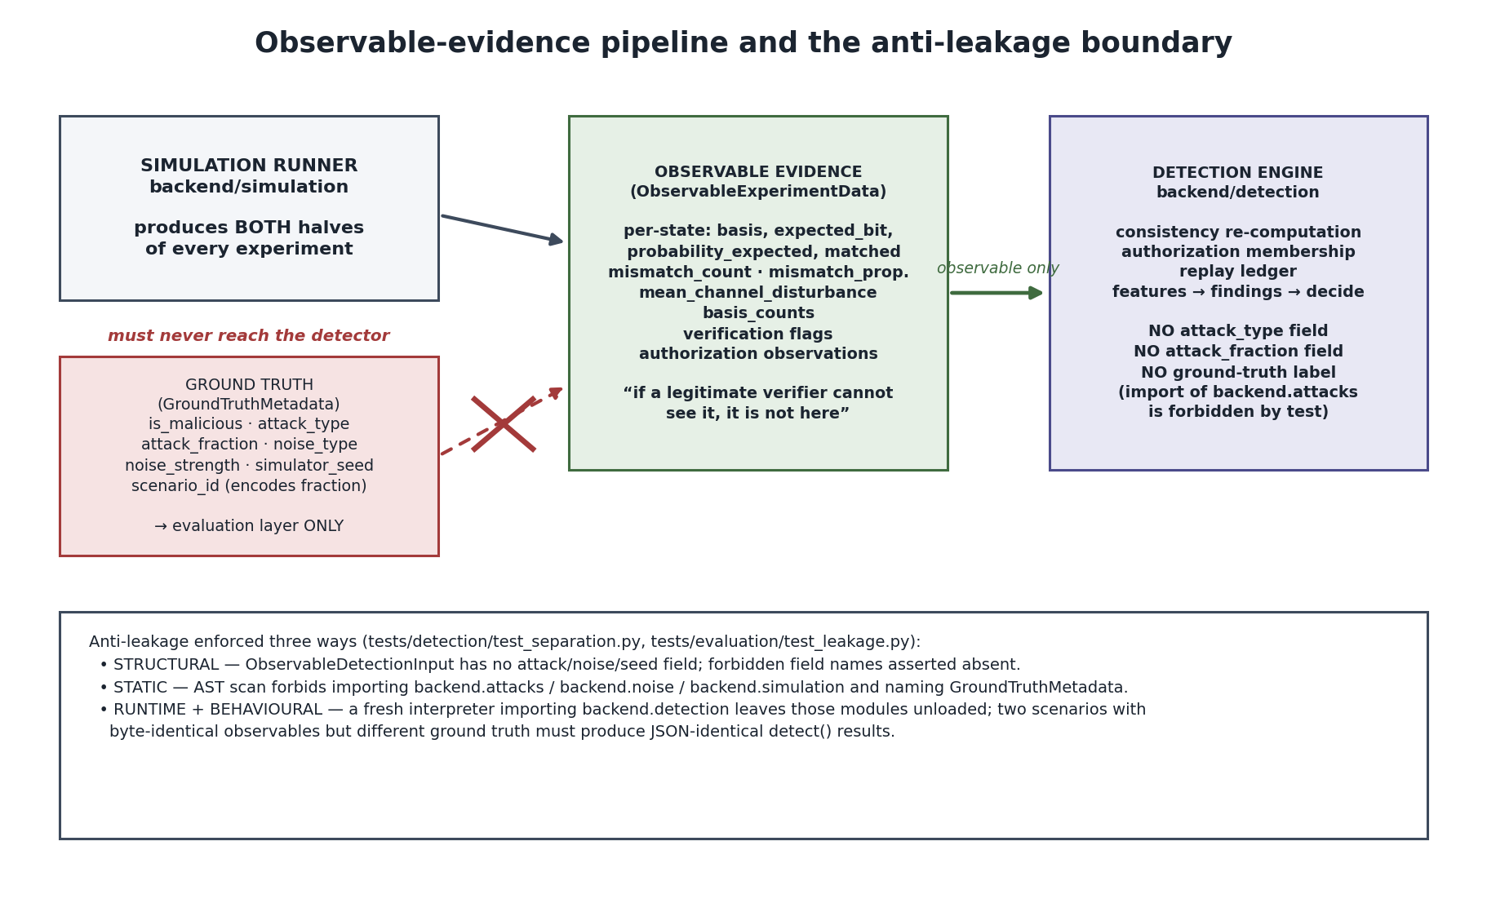
Figure 8.1 — The anti-leakage boundary. Ground truth is produced but blocked from the detector.

8.2 Why the detector must not receive labels
- attack_type / attack_fraction: reading them would let the detector “cheat”; the point is to infer from evidence.
- Hidden simulator labels and simulator-only metadata: scenario_id encodes the attack fraction (“a label leak in disguise”), simulator_seed and mean_channel_disturbance are simulator-only; a real verifier holds none of these. The engine instead derives disturbance from probability_expected, which the verifier itself computes and which is observable.
backend/detection/models.py:L33-56, L444-447

8.3 The anti-leakage architecture and how it is tested
- Structural: ObservableDetectionInput has no forbidden field; duck-typed from_observable avoids importing backend.simulation (which would pull in backend.attacks).
- Static: an AST scan of backend/detection forbids importing backend.attacks / backend.noise / backend.simulation and forbids naming GroundTruthMetadata or attack labels; a no-ML check forbids sklearn/tensorflow/torch/keras.
- Runtime: a fresh interpreter importing backend.detection must leave those modules unloaded.
- Behavioural: two scenarios with byte-identical observables but different ground truth must yield JSON-identical detect() results.
tests/detection/test_separation.py:L48-63, L166-228, L236-300 ; tests/evaluation/test_leakage.py

9. Detection Engine

9.1 Feature extraction
The engine computes each quantity exactly once and shares it, so no two components disagree. The feature catalogue declares 14 features; there is deliberately no composite security score and no weighted sum.
backend/detection/features.py:L91-237 (catalogue), L375-489 (extract_features), L23-28 (no score)

9.2 Mismatch rate (the primary statistic)
D_m = N_mismatch / N_valid (9.1)
Malformed records are excluded from the denominator (folding them in either way “is not honest”); if N_valid = 0 the rate is undefined, not zero. Each reported rate carries an exact Clopper–Pearson interval.
backend/detection/mismatch.py:L5-8, L89-153 ; backend/detection/statistics.py:L67-104

9.3 Projective match probability and fidelity are one quantity
Per state, F_i = p_match_i = probability_expected_i. The mean analytic fidelity is therefore the mean projective match probability — one number, not two. The code declares this redundancy explicitly and the report must not present them as independent quantum evidence.
F = ⟨ψ|ρ|ψ⟩ = Tr(P_ψ ρ) = p_match (per state, pure expected state) (9.2)
backend/detection/fidelity.py:L5-17, L37-51, L144-146 ; backend/quantum/density.py:L14-23 ; backend/detection/features.py:L446-461, L475-478

9.4 Disturbance and basis-wise statistics
D_v = N_disturbed / N_verification_states, disturbed ⟺ probability_expected < 1 − tolerance (1e-9) (9.3)
Because the reference is exact, D_v is a detection indicator (any nonzero deviation gives 1), while the magnitude is carried continuously by the fidelity. In the default projective-analytic mode D_v and D_m coincide and the engine emits a single quantum finding. Basis-wise statistics report per-basis counts, distributions and mismatch rates as diagnostics.
backend/detection/disturbance.py:L17-41, L109-120 ; backend/detection/features.py:L271-317

9.5 Integrity, replay and authorization evidence (classical)
- Integrity/consistency: the detector recomputes the transcript hash, the message binding, the protocol version, session addressing, state counts and the declared-vs-derived state sequence; it trusts none of them from the transcript.
- Replay: a pure membership test against an in-memory ledger of consumed session ids, nonces and transcript hashes; side-effect free unless consume is requested.
- Authorization: a membership test of presented signer/verifier ids against authorized sets; explicitly “not proof of identity”.
backend/detection/consistency.py:L123-405 ; backend/detection/replay.py:L102-235 ; backend/detection/authorization.py:L96-158

9.6 Decision logic and evidence generation
The Milestone-4 decision is categorical, not threshold-based: findings are grouped into families (integrity / authorization / quantum) and the overall status is CLEAR, a single-family violation, or MULTIPLE_FINDINGS. There is no security score and no p-value at this layer. Findings never attribute a cause (“noise and undetectable manipulation produce identical observations”). Statistical findings are non-blocking until calibrated.
backend/detection/decision.py:L161-197, L12-17, L200-233 ; backend/detection/evidence.py:L17-27, L135-162
PRIMARY vs DIAGNOSTIC is defined in the calibration layer: exactly one statistic is tested — the empirical verification mismatch rate D_m against the calibrated threshold; every other quantity is diagnostic, “reported, never adjudicated.”
backend/calibration/multiple_testing.py:L14-27, L61, L66-83

10. Statistical Calibration
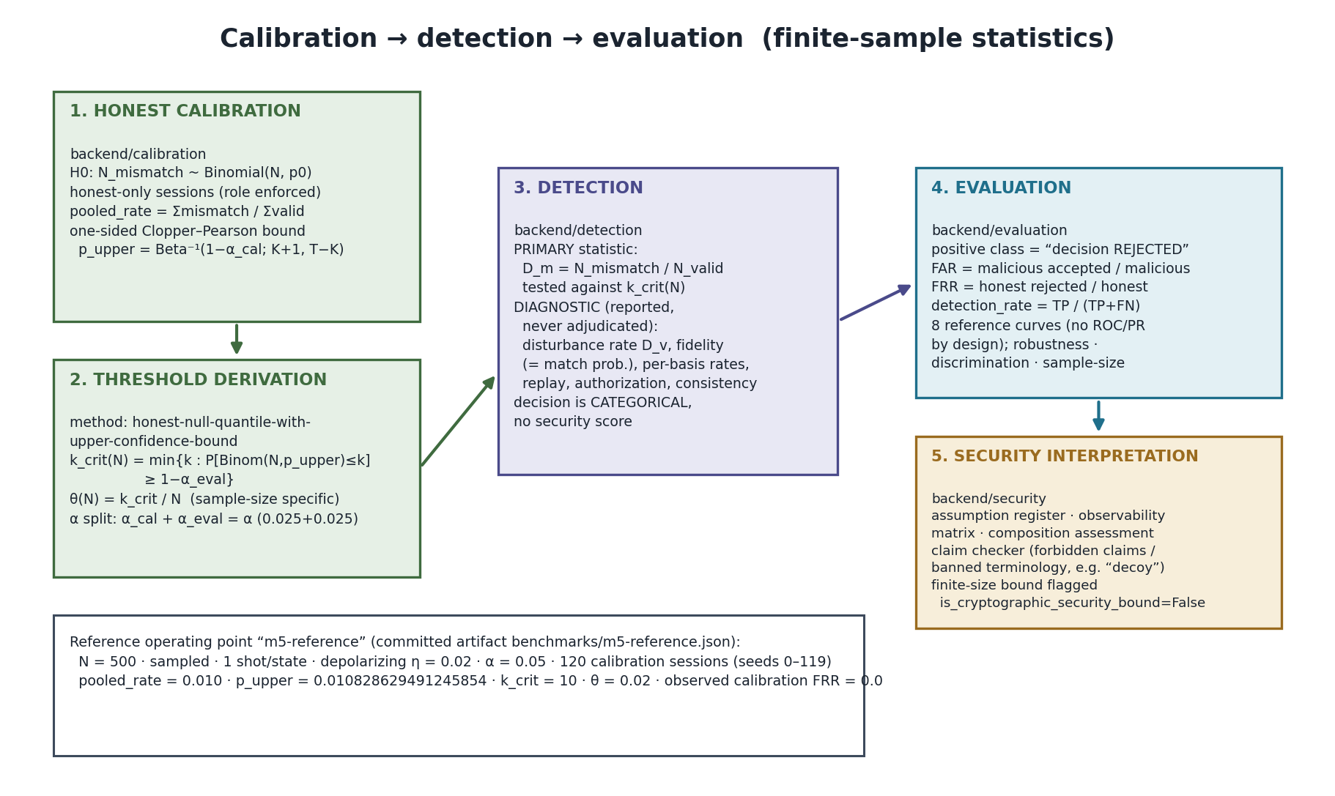
Figure 10.1 — Calibration → detection → evaluation. The honest null yields a one-sided upper bound, which yields a sample-size-specific rejection count; the detector tests the single primary statistic D_m against it, and evaluation and security interpretation follow.

10.1 Honest calibration dataset and the null hypothesis
Calibration consumes honest-only sessions (role enforced at the config type). The null hypothesis H0 is that the observed verification statistic is consistent with an authorised honest session under the specified channel; the statistical model is binomial:
H0: N_mismatch ~ Binomial(N, p0), p0 = η/2 for depolarizing η (10.1)
backend/calibration/baseline.py:L3-24, L204-302

10.2 Confidence intervals — Clopper–Pearson (implemented)
L = Beta⁻¹(α/2; k, n−k+1) (0 if k=0); U = Beta⁻¹(1−α/2; k+1, n−k) (1 if k=n) (10.2)
Implemented exactly via scipy.stats.beta.ppf, shared by detection and calibration; coverage is at least the stated confidence (conservative, never anti-conservative). One-sided upper and lower variants are also implemented.
backend/calibration/confidence.py:L19-30, L95-179 ; backend/detection/statistics.py:L67-104

10.3 Hoeffding (implemented as a cross-check only)
ε = sqrt( ln(m/α) / (2n) ), m = 2 (two-sided) or 1 (one-sided) (10.3)
Hoeffding is implemented but used only as a cross-check because it is uniformly looser than Clopper–Pearson; it never sets the threshold.
backend/security/finite_size.py:L212-231, L17-21, L243-246

10.4 Alpha and the calibration/evaluation split
The reference alpha is 0.05, split evenly: calibration_alpha = 0.025 (spent on the one-sided upper confidence bound) and evaluation_alpha = 0.025 (spent on the binomial quantile). The budget is split, not doubled. Calibration and evaluation use disjoint seed blocks (SEED_BLOCK_SIZE = 1,000,000) with an explicit disjointness assertion.
backend/calibration/models.py:L349-399 ; backend/calibration/operating_points.py:L52 ; backend/evaluation/datasets.py:L61-64, L189-206

10.5 Threshold derivation and sample-size dependence
p_upper = Beta⁻¹(1−α_cal; K+1, T−K); k_crit(N) = min{k : P[Binom(N,p_upper) ≤ k] ≥ 1−α_eval}; θ(N) = k_crit/N (10.4)
Rejection occurs when N_mismatch > k_crit. The threshold is stored with full provenance (calibration fingerprint, counts, config) and is sample-size specific by construction: applying it at another N raises rather than silently accepting. There is no default threshold anywhere.
backend/calibration/thresholds.py:L8-21, L96-120, L196-218, L221-237 ; backend/calibration/models.py:L402-453

10.6 Multiple-comparison policy
The reference policy is SINGLE_PRIMARY_WITH_DIAGNOSTICS: exactly one hypothesis test at level alpha; family_wise_alpha = None and correction = None. Holm–Bonferroni and Bonferroni are implemented but explicitly not used by the reference operating point (“with one test there is no family to correct for”). The family-wise error growth 1−(1−α)^k motivates the single-test rule.
backend/calibration/multiple_testing.py:L5-9, L61, L187-255

10.7 The reference operating point
Parameter | Value (committed artifact)
name | m5-reference
statistic | mismatch_rate
state_count N | 500
measurement_mode / shot_count | sampled / 1
reference noise | depolarizing η = 0.02
alpha | 0.05
calibration sessions / seeds | 120 / [0, 119]
pooled_rate | 0.010 (600 / 60000)
p_upper | 0.010828629491245854
critical_count k_crit | 10
threshold_rate θ | 0.02
observed calibration FRR | 0.0

benchmarks/m5-reference.json → operating_point, calibration

11. Threshold Interpretation

11.1 What the threshold means
θ(N) = k_crit/N is the mismatch-rate level above which an observed session is judged inconsistent with the honest null at the calibrated channel, sample size, measurement mode and shot count. It is a classification boundary for a finite-sample statistical test.

11.2 What the threshold does NOT mean
- It is not a cryptographic security parameter. The code refuses to label any finite-size bound as a security bound (constructing one with is_cryptographic_security_bound=True raises).
- It is not a forgery probability. FAR is the empirical share of malicious trials the rule accepted on this dataset — not a forgery bound.
- It is not optimal. No objective function was maximised; the operating point is “specified, not optimised”.
- It does not transfer across sample sizes or configurations.
backend/security/models.py:L109-117 ; backend/security/interpretation.py:L101-152 ; backend/calibration/operating_points.py:L1-6

11.3 False rejection / false acceptance and high noise
False rejection (FRR) is an honest session rejected; false acceptance (FAR) is a malicious trial accepted. Because the honest null mean is η/2, raising the honest noise beyond the calibrated channel pushes honest sessions above the threshold: measured honest FRR is 0.0 at η=0.02 but 0.5833 at η=0.05 and 1.0 at η=0.10. High noise therefore causes honest rejection — the operating point is conditional on its calibrated channel.
benchmarks/m5-reference.json → robustness.honest_frr_by_noise ; docs/security/M6_SECURITY_ANALYSIS.md (limitation 7)

11.4 Sample-size dependence (actual threshold table)
N | k_crit | θ(N) | expected FRR | simulated at this N?
100 | 3 | 0.03 | 0.02374892785243765 | true
250 | 6 | 0.024 | 0.020179355262698317 | true
500 | 10 | 0.02 | 0.022232768329606634 | true
1000 | 18 | 0.018 | 0.01483141553276468 | true
2500 | 38 | 0.0152 | 0.017578190585915365 | true
5000 | 69 | 0.0138 | 0.021089611519193974 | false (>4096 protocol cap)
10000 | 129 | 0.0129 | 0.02255099652565451 | false (>4096 protocol cap)

benchmarks/m5-reference.json → threshold table (single reference calibration, p_upper = 0.010828629491245854)

12. Evaluation and Benchmarking

12.1 Profiles and architecture
Two profiles exist: smoke (fast, “every number is too small to interpret”) and reference. The reference profile uses N=500, 120 calibration sessions, 12 evaluation trials per attack, sampled mode with 1 shot/state, depolarizing η=0.02, six attack types, and a sample-size design of 100…10000 (5000/10000 declared but not simulated because they exceed the protocol's MAX_STATE_COUNT=4096). The benchmark is reproduced by benchmarks/run_reference_benchmark.py, which writes the committed JSON/MD artifacts; nothing is read from a stored result or extrapolated.
backend/evaluation/benchmark.py:L337-436 ; benchmarks/run_reference_benchmark.py:L20-34

12.2 Metrics and the positive class
The positive class is “the verification decision rejected the session”. Hence tp = malicious rejected, fn = malicious accepted, fp = honest rejected, tn = honest accepted; under this convention FPR = FRR and FNR = FAR as identities of the convention (FAR and FPR are not the same underlying quantity). Undefined rates return None, never 0.0. ROC and PR curves are deliberately not produced.
backend/evaluation/models.py:L8-32 ; backend/evaluation/metrics.py:L53-66 ; backend/evaluation/curves.py:L24-31

12.3 Reproducibility and runtime
Session ids, nonces and timestamps are deterministically derived from each trial seed; seed blocks are disjoint with gaps; the transpile cache (compiled circuits only, never outcomes) is enabled during the run and reported in provenance. Reference run: runtime 1504.8553420000244 s (≈25.1 min), 479 scenarios, Python 3.13.5, cache hit_rate 0.9999842146803473.
backend/evaluation/harness.py:L91-102, L179-194 ; benchmarks/m5-reference.json → provenance

12.4 Attack-population results (actual, 12 trials each)
Attack | fraction | detection_rate | FAR | precision/recall/f1/accuracy
forgery | 0.0 | 0.0 | 1.0 | None / 0.0 / None / 0.0
impersonation | 0.0 | 0.0 | 1.0 | None / 0.0 / None / 0.0
unauthorized_verification | 0.0 | 0.0 | 1.0 | None / 0.0 / None / 0.0
replay | 0.0 | 0.0 | 1.0 | None / 0.0 / None / 0.0
intercept_resend | 0.2 | 1.0 | 0.0 | 1.0 / 1.0 / 1.0 / 1.0
channel_tampering | 0.2 | 1.0 | 0.0 | 1.0 / 1.0 / 1.0 / 1.0

benchmarks/m5-reference.json → attack_evaluation.by_attack_type
Read this table honestly: the quantum statistic detects the two channel attacks perfectly and detects none of the four protocol-layer attacks. The latter are the responsibility of classical controls (authorization / replay ledger / integrity), not of the quantum statistic.

12.5 Robustness (honest FRR by noise; detection by noise×attack)
Noise level (η) | honest FRR | detection intercept_resend | detection channel_tampering
none (0.0) | 0.0 | 1.0 | 1.0
low (0.005) | 0.0 | 1.0 | 1.0
medium (0.02) | 0.0 | 1.0 | 1.0
high (0.10) | 1.0 | 1.0 | 1.0

benchmarks/m5-reference.json → robustness.honest_frr_by_noise, robustness.detection_by_noise_and_attack
At η=0.10 the honest FRR is 1.0: that operating point is unusable for honest traffic. The usable calibrated levels are none/low/medium.

12.6 Sample-size study (fresh calibration + threshold per size)
N | calibration sessions (states) | k_crit | θ | p_upper | honest FRR | detection
100 | 24 (2400) | 5 | 0.05 | 0.016817738931232163 | 0.0 | 1.0
250 | 24 (6000) | 7 | 0.028 | 0.011726921713202328 | 0.0 | 1.0
500 | 12 (6000) | 13 | 0.026 | 0.014717439098661031 | 0.0 | 1.0
1000 | 6 (6000) | 20 | 0.02 | 0.012478702978778226 | 0.0 | 1.0
2500 | 3 (7500) | 48 | 0.0192 | 0.01428914228363267 | 0.0 | 1.0

benchmarks/m5-reference.json → sample_size

12.7 Discrimination experiment (noise vs attack at matched marginals)
Population pair | honest marginal D_m | malicious marginal D_m | matched? | distinguishable? | verdict
channel_tampering @0.05 vs honest η=0.05 | 0.02316666666666667 | 0.03383333333333333 | False | True | separated by basis-mismatch dispersion (rate 1.0)
intercept_resend @0.05 vs honest η=0.05 | 0.02316666666666667 | 0.0195 | True | False | “Not distinguishable under the current observable model.”

benchmarks/m5-reference.json → discrimination
The second row is an honest negative result the project reports verbatim: at matched marginal mismatch rates, intercept–resend at fraction 0.05 is not separable from honest noise using the current structural descriptor.

13. Security Interpretation

13.1 Assumptions
The assumption register lists 14 assumptions, each with a status of exact / satisfied / approximate / not-verified / violated and a consequence-if-violated. Homogeneity is exact for depolarizing (match probability 1−p/2 for every state “by algebra, not by assumption”) and approximate for flip channels (Poisson-binomial). “APPROXIMATE” is not a synonym for “SATISFIED”; there is no status meaning “probably fine”.
backend/security/assumptions.py:L66-121, L126-361 ; backend/security/models.py:L160-167

13.2 Observability
The observability matrix records, per threat, whether it causes quantum disturbance, whether the detector can see it quantum-mechanically, whether it requires a classical control, and the measured M5 detection/FAR. Protocol-layer attacks are “a threat to the protocol layer”, protected by classical controls, not by the quantum statistic.
backend/security/observability.py:L21-24, L95-232

13.3 Composition
The composition assessment evaluates each milestone component (M1–M6) with property evaluated, evidence source, assumption boundary, unresolved dependency and security conclusion. composition_summary() hard-codes formal_composition_theorem_present = False.
backend/security/composition.py:L58-235, L246

13.4 The claim checker
An in-repo checker rejects forbidden claims and banned terminology. Forbidden claims include “information-theoretically secure”, “formal forgery bound”, “detects all quantum attacks”, “the threshold is optimal”, and “FAR is the forgery probability”. Banned terminology includes “decoy”/“decoy-state” (a QKD mechanism this construction lacks). The allowed claim shape ends: “These are empirical rates on this dataset at this sample size and channel; they are not a formal forgery bound and they do not establish security.”
backend/security/interpretation.py:L101-152, L155-288, L401-438

13.5 Finite-size interpretation and boundaries
Finite-size quantities are confidence intervals, classification thresholds and empirical acceptance rates. A fourth kind — “formal cryptographic security bound” — is explicitly “not produced by this milestone”. Experimentally demonstrated: honest FRR at/below alpha at the calibrated channel, detection of the two channel attacks, non-detection of the four protocol attacks by the quantum statistic, robustness and sample-size behaviour. NOT formally proven: unforgeability, non-repudiation, transferability, any forgery bound, information-theoretic or composable security, adaptive-attack resistance, hardware behaviour, and generalisation beyond the reference configuration.
backend/security/models.py:L53-67 ; backend/security/composition.py:L58-235 ; backend/evaluation/reports.py:L60-89

14. Limitations
Limitation | Why it matters | Evidence | Impact | Possible future improvement
Simulation-only validation | No real quantum hardware; simulated disturbance may differ from physical devices | backend/quantum/measure.py:L105-132 (Aer only) | Results do not transfer to hardware | Run on real QPU / optical testbed
No secret signing key | Without a secret there is no unforgeability; anyone can forge | backend/protocol/models.py:L188-190; attacks/forgery.py | Not a deployable signature scheme | Add a keyed QDS construction with a formal model
No formal forgery bound | No adversary-advantage guarantee exists | security/composition.py:L105-108 | Security is empirical, not proven | Define a forgery game and prove/reduce
No universal attack coverage | Only six attack families modelled | attacks/base.py:L69-77; interpretation.py:L101-152 | Unknown attacks undetected | Extend the threat model
No coherent / adaptive adversary | Individual attacks only; no quantum memory, no multi-qubit coherent strategy | attacks/intercept_resend.py:L44-52; channel_tampering.py:L33-38 | Stronger adversaries unmodelled | Model collective/coherent attacks
Classical replay/identity controls | Replay and authorization are ledger/membership checks, in-memory and single-process | detection/replay.py:L102-235; observability.py replay note | Lost on restart; not distributed | Persistent, distributed nonce/session store
Finite-shot stochastic acceptance | Sampled mode outcomes are stochastic; a tie counts as a match | simulation/runner.py:L259-299 | Small-shot results vary | Increase shots / analytic mode
Threshold depends on sample size & config | θ(N) invalid at another N; high noise breaks honest traffic | calibration/thresholds.py; m5 robustness FRR=1.0 at η=0.10 | Operating point is conditional | Per-configuration calibration; adaptive thresholds
Noise/attack discrimination limits | intercept_resend @0.05 not separable from honest noise at matched marginals | m5-reference.json → discrimination | Low-intensity interception can hide in noise | Richer descriptors / more shots
No formal composability theorem | Components assessed, not composed under a theorem | security/composition.py:L246 | No end-to-end compositional guarantee | Prove a composition theorem

15. Frontend — the Q-TRACE Web Console
The console is React 18 + TypeScript + Vite with recharts charts and a single permanent dark theme (there is no light/dark switching in the shipped source). Navigation is state-based (no router library): a FrontPage gate then a seven-view workspace. The API client targets VITE_API_BASE_URL (default http://127.0.0.1:8000), calls operational endpoints at the root and business endpoints under /api/v1, and maps every non-2xx to the backend error envelope.
frontend/package.json ; frontend/src/api/client.ts ; frontend/src/state/AppContext.tsx ; frontend/src/state/chartPalette.ts
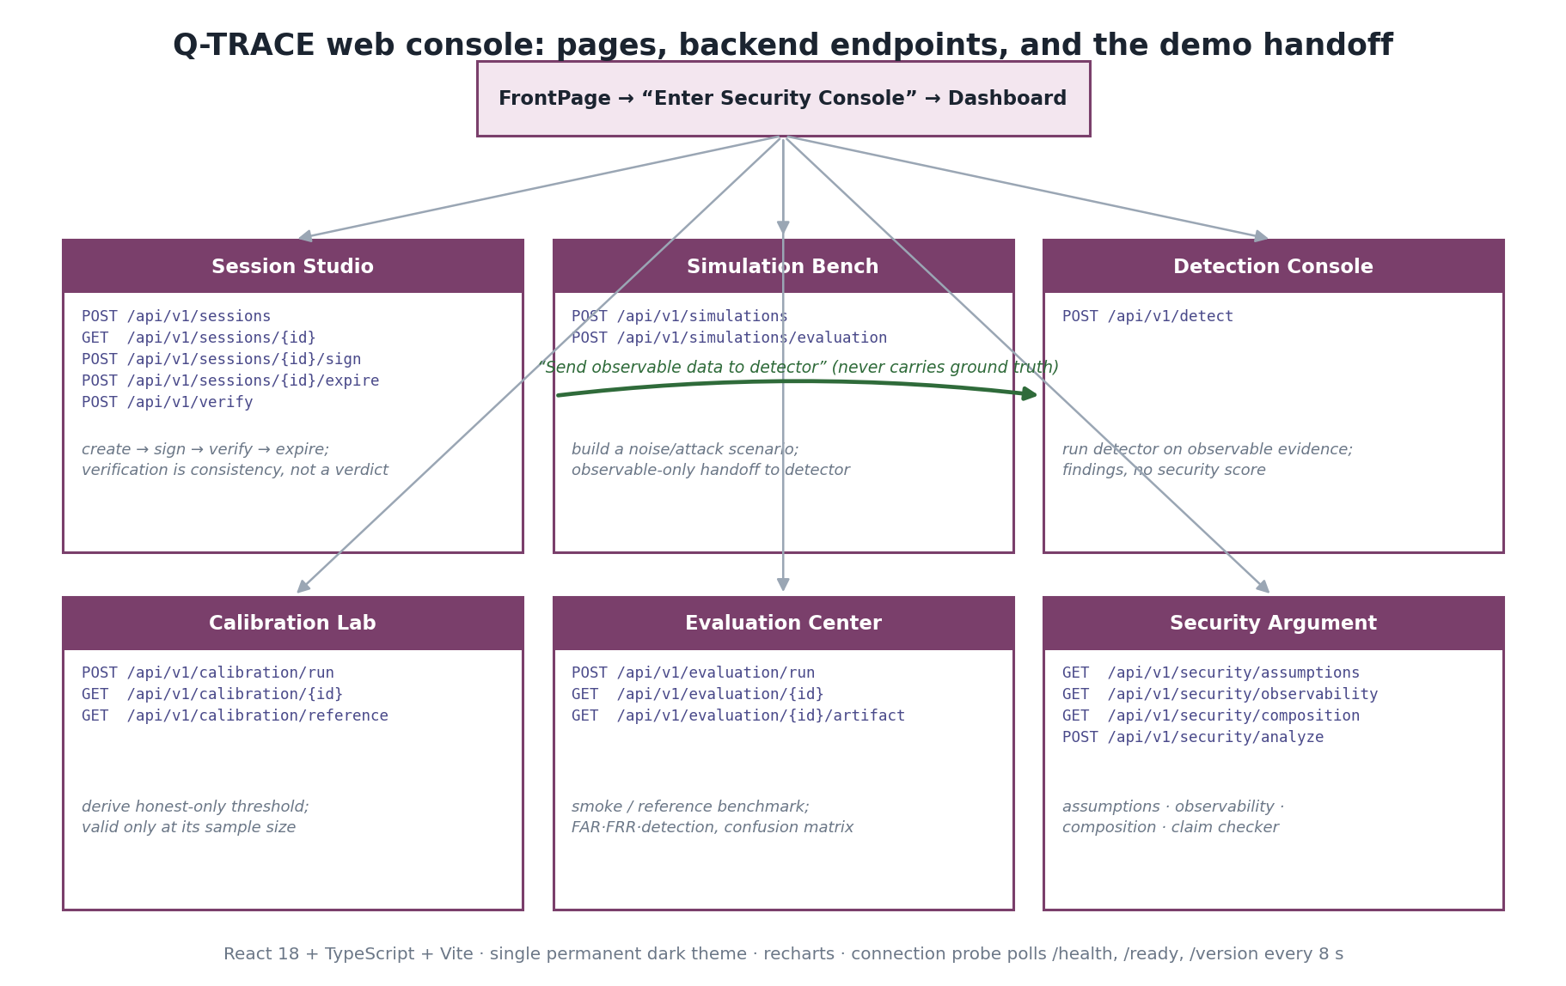
Figure 15.1 — Console pages, the backend endpoints each calls, and the observable-only handoff from Simulation Bench to Detection Console.
Page | Purpose | Inputs | Backend endpoint(s) | Outputs / what the user learns
FrontPage | Cinematic introduction and entry gate | none (no API calls; footer links open the backend's /docs and /health in browser tabs) | none | The 7-stage pipeline, the evidence-only disclaimer, and a footer with the Q-TRACE brand block plus real in-app and backend-documentation links
Dashboard (Console) | Operational overview | none | GET /api/v1/sessions; GET /api/v1/calibration/reference; GET /api/v1/security/observability; /health,/ready,/version | Readiness, counts, reference operating point, empirical detection/FAR per threat
Session Studio | Drive the signing lifecycle | message, signer_id, verifier_id, state_count; verify: transcript JSON etc. | POST/GET /api/v1/sessions; GET /{id}; POST /{id}/sign; POST /{id}/expire; POST /api/v1/verify | Session detail, transcript + hash, verification flags — consistency, not a security verdict
Simulation Bench | Build and run a noise/attack scenario | scenario id, ids, message, state_count, shot_count, seed, mode, noise type+strength, attack type+fraction+seed, eval toggle | POST /api/v1/simulations; POST /api/v1/simulations/evaluation | A “Running simulation…” spinner while the request is in flight; then per-state P(expected)/matched, mismatch & disturbance, authorization; observable-only handoff
Detection Console | Run the detector on observable evidence | DetectionRequest JSON; consume_replay toggle | POST /api/v1/detect | overall_status, findings with evidence items, diagnostic radar; no security score
Calibration Lab | Derive an honest-only threshold | config id, noise, state_count, mode, shots, sessions, seed start, confidence; or calibration id | POST /api/v1/calibration/run; GET /api/v1/calibration/{id}; GET /api/v1/calibration/reference | k_crit, p_upper, θ, intervals, homogeneity, operating point; validity is sample-size-bound
Evaluation Center | Run and inspect a benchmark | profile (smoke/reference); evaluation id | POST /api/v1/evaluation/run; GET /{id}; GET /{id}/artifact | Per-attack metrics, confusion matrices, FRR-by-noise, heatmap, full artifact
Security Argument | Read the security posture | noise_type, measurement_mode (assumptions tab); statements (claim checker) | GET /api/v1/security/assumptions; /observability; /composition; POST /api/v1/security/analyze | Assumption statuses, observability matrix, composition, ALLOWED/FORBIDDEN verdicts

15.1 Branding
The console is branded Q-TRACE. The logo asset is frontend/public/qtrace-logo.png; the HTML title is “Q-TRACE · Quantum Threat & Reliability Analysis for Cryptographic Evidence”; the shell header shows the logo, “Q-TRACE”, and the full name. The sidebar footer states the evidence-only positioning and that data is held in memory and lost on restart. The identifier “SIH26141” is deliberately kept as a small technical marker, not part of the console identity.
The FrontPage carries a dedicated footer (FrontFooter.tsx): a brand block with the logo, the full name, a one-line factual description of the framework, and the marker “RQDS-TP-1.0 · SIH26141”; three link columns that point only at things that actually exist — the console views (via the app's state navigation), on-page front-page sections, and the configured backend's own /docs (Swagger) and /health endpoints; an in-memory-prototype note; and a bottom bar reading “© 2026 Q-TRACE” and “SIH 2026 project prototype • Experimental research and demonstration platform”. No invented external URLs are used.
frontend/index.html ; frontend/src/components/Shell.tsx ; frontend/src/pages/FrontPage.tsx ; frontend/src/components/front/FrontFooter.tsx

16. Backend API
The API is a FastAPI application factory (create_app) with settings and store injection, no module-level globals and no lifespan hook. Business routers mount under /api/v1; the three operational routers mount at the root. CORS is an explicit allow-list (credentials disabled); a wildcard origin is refused unless explicitly opted in. Middleware order puts CORS outermost around a request-correlation middleware that enforces a Content-Length bound and emits one structured JSON log per request without bodies.
backend/api/app.py:L82-123 ; backend/api/version.py:L25-28 ; backend/api/config.py:L132-157 ; backend/api/middleware.py:L109-153

16.1 Endpoint table
Method | Route | Purpose | Input | Output
GET | /health | Liveness + versions + in-memory counts | none | HealthResponse
GET | /version | Version inventory (app/API/protocol/python/packages) | none | VersionResponse
GET | /ready | Component-import + store readiness probe | none | ReadyResponse
POST | /api/v1/sessions | Create reference signing session (201) | SessionCreateRequest | SessionView
GET | /api/v1/sessions | List sessions | none | SessionListResponse
GET | /api/v1/sessions/{id} | Fetch one session (applies TTL) | path id | SessionView
POST | /api/v1/sessions/{id}/sign | Sign session → transcript + hash | path id | SessionSignResponse
POST | /api/v1/sessions/{id}/expire | Move session to EXPIRED | path id | SessionView
POST | /api/v1/verify | Verify transcript (M2 verifier) | VerificationRequest | VerificationResponse
POST | /api/v1/simulations | Run scenario — observable only | SimulationRequest | SimulationResponse (no ground truth)
POST | /api/v1/simulations/evaluation | Run scenario — includes ground truth | SimulationRequest | SimulationEvaluationResponse
POST | /api/v1/detect | Run detector over observable input | DetectionRequest (extra=forbid) | DetectionResponse
POST | /api/v1/calibration/run | Derive threshold from honest-only data (201) | CalibrationRunRequest | CalibrationResponse
GET | /api/v1/calibration/reference | Reference methodology + recorded operating point | none | ReferenceCalibrationResponse
GET | /api/v1/calibration/{id} | Retrieve stored calibration | path id | CalibrationResponse
POST | /api/v1/evaluation/run | Run benchmark profile (201, synchronous) | EvaluationRunRequest {profile: smoke|reference} | EvaluationSummary
GET | /api/v1/evaluation/{id} | Retrieve evaluation summary | path id | EvaluationSummary
GET | /api/v1/evaluation/{id}/artifact | Retrieve full benchmark artifact | path id | EvaluationArtifactResponse
GET | /api/v1/security/assumptions | Assumption register | query noise_type, measurement_mode | AssumptionsResponse
GET | /api/v1/security/observability | Threat-observability matrix | none | ObservabilityResponse
GET | /api/v1/security/composition | Composition assessment | none | CompositionResponse
POST | /api/v1/security/analyze | Check statements vs forbidden-claim register | AnalyzeRequest | AnalyzeResponse

16.2 Storage, validation and errors
Storage is entirely in-memory (sessions, calibrations, evaluations, and a shared replay registry reused from backend.detection.replay); a restart loses everything. A session lifecycle enum with an explicit allowed-transition map guards state changes (illegal → 409). Expensive work runs outside the store lock; only publication takes it. Request bodies are double-validated: once by FastAPI/Pydantic and again against configured limits via configured_body. Errors use a universal envelope {error:{code,message,request_id,details}}; validation failures are 422; a catch-all returns 500 and logs the traceback without returning it.
backend/api/store.py:L51-81, L103-129, L176-251 ; backend/api/dependencies.py:L47-91 ; backend/api/errors.py:L41-61, L180-224
Documented-but-unused: ErrorCode.SERVICE_UNAVAILABLE (503) is defined but never raised, and the API reference's status table omits it. Reported as an implementation/documentation discrepancy, not reconciled.

17. Technology Stack (verified)
Category | Technology | Version | Where verified
Language | Python (CPython) | 3.13.5 | pyproject.toml requires-python>=3.13; benchmark provenance python=3.13.5
Quantum SDK | Qiskit | 2.5.2 | requirements.txt
Quantum simulator | Qiskit-Aer | 0.17.2 | requirements.txt
Numerics | NumPy | 2.5.3 | requirements.txt
Scientific | SciPy | 1.18.1 | requirements.txt (beta.ppf / binom in calibration & statistics)
Symbolic | SymPy | 1.14.0 | requirements.txt
Testing | pytest | 9.1.1 | requirements.txt
Web framework | FastAPI | 0.141.1 | requirements.txt
ASGI toolkit | starlette | 1.6.0 | requirements.txt
Validation | pydantic | 2.13.5 | requirements.txt
ASGI server | uvicorn | 0.53.0 | requirements.txt
Async | anyio | 4.14.2 | requirements.txt
Test HTTP | httpx2 | 2.12.0 | requirements.txt (starlette TestClient)
Frontend UI | React / react-dom | ^18.3.1 | frontend/package.json
Frontend lang | TypeScript | ^5.7.2 | frontend/package.json
Build tool | Vite (+ @vitejs/plugin-react) | ^5.4.11 / ^4.3.4 | frontend/package.json
Charts | recharts | ^2.15.0 | frontend/package.json
Icons | lucide-react | ^0.469.0 | frontend/package.json
Frontend tests | vitest | ^3.2.7 | frontend/package.json

No machine-learning dependency is present, by design (requirements.txt header, SIH requirement R7). No sklearn / tensorflow / torch / keras anywhere in backend or frontend.

18. Testing and Quality Assurance

18.1 Organisation
Tests mirror the backend packages: tests/{quantum, protocol, detection, calibration, evaluation, security, api}. Categories include unit/domain tests, per-layer architecture guards, milestone acceptance suites, API integration tests (FastAPI TestClient), wiring tests (AST/inspect guards that services are genuinely wired to settings and domain entry points), and negative tests (parametrized transcript-tampering lambdas).

18.2 Architecture and leakage guards
- Detection isolation: forbidden imports (backend.attacks/noise/simulation), forbidden field names, AST identifier scan, fresh-interpreter sys.modules check, and identical-observable behavioural tests.
- Calibration honesty: calibration configs/observations refuse non-CALIBRATION roles; evaluation refuses the CALIBRATION role; disjoint seed blocks asserted.
- Layering: detection must not import backend.quantum; API never imports qiskit; nothing imports the evaluation layer; ground-truth names confined to producers and the evaluation consumer.
tests/detection/test_separation.py ; tests/detection/test_architecture.py ; tests/evaluation/test_leakage.py ; tests/evaluation/test_architecture.py ; tests/api/test_architecture.py ; tests/calibration/test_architecture.py

18.3 Reproducibility tests
Determinism: identical seed_start and trial_count yield identical statistics, decisions, seeds and fingerprints; different seed blocks differ. Cache neutrality: the full benchmark run cached/uncached/cached produces field-identical reports except runtime_seconds and cache stats, and leaves the transpile cache disabled.
tests/evaluation/test_reproducibility.py

18.4 Mutation testing and coverage
Not present. No mutation-testing tooling (mutmut/cosmic-ray/etc.) exists; the word “mutation” in tests/protocol/test_negative.py refers to transcript-tampering negative tests. Coverage is not configured or measured (no --cov, no .coveragerc, no CI). Reported honestly rather than invented.

18.5 Test totals (measured)
Scope | Count | Note
Backend test functions (grep 'def test_') | 1,546 | api 370 · evaluation 273 · security 269 · protocol 216 · detection 159 · calibration 149 · quantum 110
Backend collected (project venv) | 1,848 | excludes tests/api (httpx missing in the measurement venv); parametrize multiplies cases
Frontend (vitest run) | 31 passed | 3 files: scenarioForm 17 · client 7 · frameDelta 7

Formulation to quote: 1,546 backend test functions; 1,848 collected excluding the API suite at measurement time; 31 frontend tests passing. No pass/fail aggregate beyond the frontend run is claimed.

19. Demo Workflow for Judges

Step 1 — Start the backend
- What to run: from the repo root, uvicorn backend.api.app:create_app --factory (or python -m uvicorn ...). Port 8000.
- Expected output: server up; GET /health returns status ok with api_version v1 and protocol_version RQDS-TP-1.0; GET /ready returns ready true.
- Presenter says: the API is a thin boundary over the engines; it adds no quantum or statistical dependency.

Step 2 — Start the frontend
- What to run: cd frontend; npm install; npm run dev. Port 5173 (whitelisted by default CORS).
- Expected output: the Q-TRACE FrontPage; connection probe flips to online once /health and /ready respond.

Step 3 — Session Studio
- Click: Session Studio → create. Input: message “transfer 100 units to account 7”, signer alice, verifier bob, state_count 16. Then Sign, then Verify.
- Expected output: session detail with nonce, message hash and binding; a signed transcript JSON with transcript_hash; verification accepted with all flags true and the structural caveat note.
- Presenter says: verification is consistency and binding, not unforgeability — there is no secret key.

Step 4 — Simulation Bench
- Click: Simulation Bench. Input: state_count 16, measurement mode sampled, shot_count 1; noise depolarizing strength 0.02; then a second run with attack channel_tampering fraction 0.2.
- Expected output: while the request is in flight the Run button shows a loading state and a “Running simulation…” spinner card appears; then the honest run shows P(expected)≈0.99 across states and a small mismatch, and the tampered run shows targeted states at P(expected)=0 and a higher mismatch count.
- Presenter says: the same physics, one honest and one attacked; the difference is observable disturbance.

Step 5 — Detection Console
- Click: “Send observable data to detector” from Simulation Bench, then run. Optionally toggle consume_replay.
- Expected output: honest → CLEAR or low-severity; tampered → a QUANTUM-family finding with evidence items (observed vs expected) and a Clopper–Pearson interval; no security score.
- Presenter says: the detector saw only observable evidence — no attack label was passed.

Step 6 — Calibration Lab
- Click: Calibration Lab → run. Input: state_count 100, sessions 8, depolarizing 0.02, confidence 0.95 (smoke scale).
- Expected output: k_crit, p_upper, θ and the validity warning that the threshold applies only at this sample size/mode/channel.
- Presenter says: thresholds are derived from honest data only and are finite-sample objects.

Step 7 — Evaluation Center
- Click: Evaluation Center → profile smoke → run (seconds). For a full run choose reference (minutes; synchronous).
- Expected output: per-attack detection/FAR bars, confusion matrices, FRR-by-noise table, and the full artifact.
- Presenter says: smoke numbers are too small to interpret; the committed reference artifact is the citable result.

Step 8 — Security Argument
- Click: each tab. In Claim Checker, submit “The system is 100% secure against all attacks.” and an honest empirical sentence.
- Expected output: FORBIDDEN for the first, ALLOWED for the second; the observability matrix shows the 2-vs-4 detection split.
- Presenter says: the project ships its own guard-rail against over-claiming.

20. Real-World Deployment Path

20.1 Current prototype (what exists today)
- Fully simulated quantum behaviour on a classical machine (Qiskit/Aer).
- In-memory storage; no persistence; restart loses all state.
- No authentication, no authorization beyond modelled membership sets, no TLS termination, no rate limiting, no audit log (documented as not implemented).
- Single-process replay ledger.

20.2 Future production system (proposed — not implemented)
- Real quantum hardware: replace the Aer/simulation seam with physical state preparation, transmission and measurement; re-validate the noise and disturbance model against device data.
- Identity and authentication: introduce real credentials/certificates so signer_id/verifier_id are authenticated, not declared.
- Key management: introduce a genuine keyed signature/QDS construction with secret material and a formal security model — this is what would enable unforgeability.
- Persistent storage: durable sessions, transcripts and calibrations.
- Distributed replay prevention: a shared, durable nonce/session consumption store across nodes.
- Monitoring and alerting on detection findings and calibration drift.
- Scaling: horizontal API workers with shared state; benchmark offloaded to batch compute.
- Formal security analysis: forgery game, advantage bounds, composability theorem, stronger (coherent/adaptive) adversary models.
None of the items in 20.2 are implemented. They are the deployment path, clearly separated from the current prototype.

21. Research Foundation
External factual claims are sourced from the repository bibliography (docs/research/references.md), reproduced in Appendix G. The scientific basis separates cleanly into established quantum principles, the project's engineering choices, simulation results, statistical evidence, and (absent) formal cryptographic claims.

21.1 Quantum teleportation
Teleportation of an unknown qubit using a shared EPR pair and two classical bits is established physics (Bennett et al., PRL 70, 1895 (1993) [R1]). Q-TRACE implements exactly this primitive in simulation; the implementation fact is that the correction and branch structure were verified numerically and on Aer.

21.2 QDS literature
Foundational QDS and the memory-free line of work motivate the design: QDS without quantum memory (Dunjko, Wallden, Andersson, PRL 112, 040502 (2014) [R2]); its experimental realization (Collins et al., PRL 113, 040502 (2014) [R3]); and QDS built from QKD components (Wallden, Dunjko, Kent, Andersson, PRA 91, 042304 (2015) [R4]/[R10]). These are the cited papers' properties; Q-TRACE transfers no security claim from them.

21.3 Statistical confidence intervals
Exact binomial intervals are Clopper–Pearson (Clopper & Pearson, Biometrika 26(4), 404 (1934) [R12]); the concentration cross-check is Hoeffding (Hoeffding, JASA 58(301), 13 (1963) [R11]); the implemented-but-unused multiple-comparison procedure is Holm (Holm, Scand. J. Statist. 6(2), 65 (1979) [R13]). These are statements about estimators, not about adversaries.

21.4 Classification of claims in this report
Kind | Meaning | Example in this report
SOURCE-DERIVED FACT | Taken from cited literature | Teleportation needs one EPR pair + 2 classical bits [R1]
IMPLEMENTATION FACT | Verified in code / by execution | p_match ≡ F for a pure expected state (density.py:L14-23)
ENGINEERING CHOICE | A design decision, not a standard | The hash→state nibble-rejection mapping (encoding.py:L9-10)
INTERPRETATION | A reading of evidence, hedged | “evidence of inconsistency, not attribution of a cause”
(absent) FORMAL CLAIM | Deliberately not made | No forgery bound, no IT-security proof

22. What Q-TRACE Actually Proves
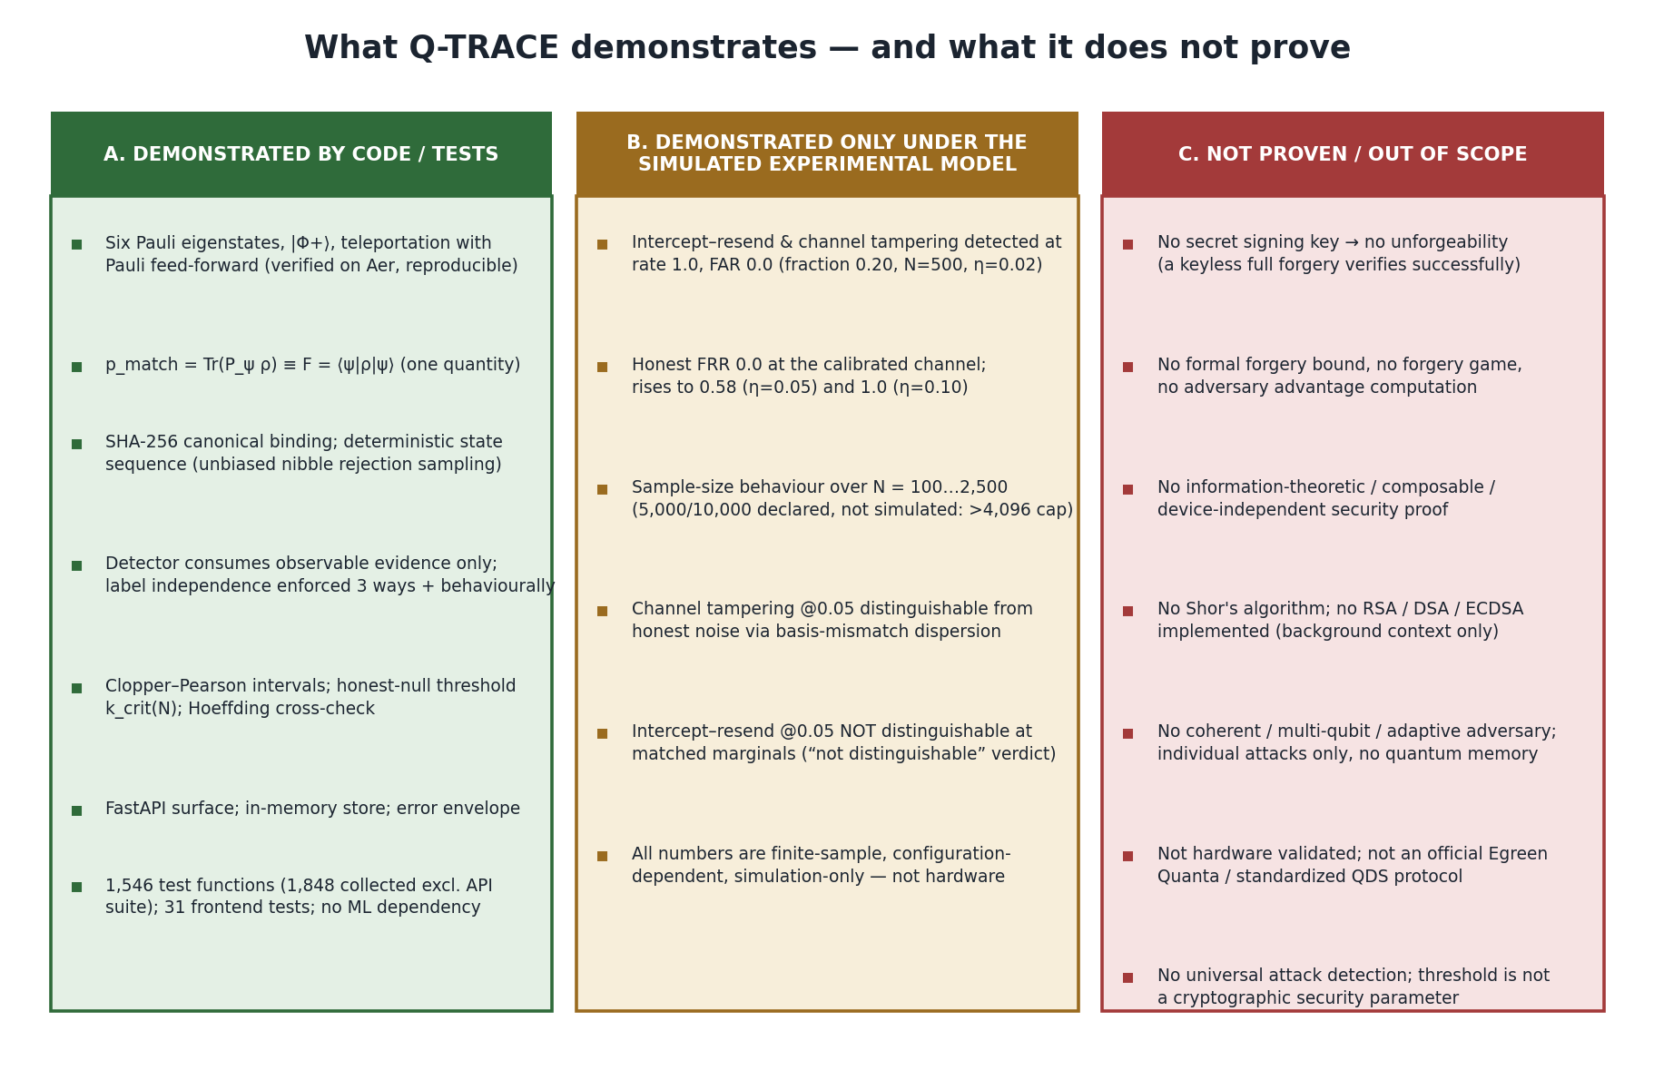
Figure 22.1 — Three-way classification of what is demonstrated and what is not proven.

A. Demonstrated by code / tests
- The quantum primitives are correct and reproducible: eigenstate table, |Φ+⟩, teleportation with feed-forward correction, Born-rule measurement (tests/quantum/*, verified on Aer).
- p_match = Tr(P_ψρ) ≡ F = ⟨ψ|ρ|ψ⟩ for a pure expected state (density.py; fidelity.py).
- Canonical binding and deterministic, unbiased state-sequence derivation (protocol tests).
- Detector label-independence, enforced structurally, statically, at runtime and behaviourally (test_separation.py).
- Exact Clopper–Pearson intervals and an honest-null, sample-size-specific threshold; Hoeffding cross-check (calibration, finite_size).
- The API surface, in-memory lifecycle, error envelope and CORS behaviour (tests/api/*).

B. Demonstrated only under the simulated experimental model
- Intercept–resend and channel tampering detected at rate 1.0 with FAR 0.0 at fraction 0.20, N=500, η=0.02 (m5-reference).
- Honest FRR 0.0 at the calibrated channel; 0.5833 at η=0.05; 1.0 at η=0.10.
- Sample-size behaviour over N=100…2,500 with per-size recalibration.
- Channel tampering @0.05 separable from honest noise via basis-mismatch dispersion; intercept–resend @0.05 not separable at matched marginals.
- All of the above are finite-sample, configuration-dependent and simulation-only.

C. Not proven / out of scope
- Unforgeability, non-repudiation, transferability (no secret key; keyless forgery verifies).
- Any formal forgery bound or adversary-advantage guarantee.
- Information-theoretic, composable, unconditional or device-independent security.
- Shor's algorithm and RSA/DSA/ECDSA (not implemented; background only).
- Coherent / multi-qubit / adaptive adversaries; quantum memory.
- Hardware validation; official/standardised QDS protocol status.
- Universal attack detection; threshold-as-security-parameter.

23. Final Technical Assessment

23.1 One-sentence technical definition
Q-TRACE is a quantum-simulation-backed, model-based statistical threat-detection and evidence platform for a teleportation-based reference signature construction: it simulates six-state Pauli encoding and Bell teleportation under honest Pauli noise and six modelled attacks, extracts only verifier-observable evidence, and applies exact finite-sample binomial statistics to decide whether an observed session is inconsistent with honest behaviour — while explicitly refusing to claim machine learning, formal security, or unforgeability.

23.2 The central innovation / idea
The central idea is discipline, not a new algorithm: separate ground truth from observable evidence so thoroughly that the detector cannot cheat; separate the one primary statistic from diagnostics so the decision cannot be quietly gerrymandered; and separate empirical measurement from formal proof so the report cannot over-claim. The quantum disturbance of intercept–resend and channel tampering becomes a measurable, calibratable signal, while protocol-layer threats are honestly routed to classical controls.

23.3 The evidence the system produces
Per-event: categorical findings with observed-vs-expected evidence items and exact confidence intervals, plus integrity/authorization/replay evidence. Per-experiment: FAR/FRR/detection rates, confusion matrices, eight reference curves, robustness and discrimination grids, and a sample-size study — all reproducible from a seed and committed as an artifact.

23.4 The strongest limitations
Simulation-only validation; absence of any secret key (hence no unforgeability); no formal forgery bound or composability theorem; the quantum statistic's blindness to the four protocol-layer attacks; and thresholds that are conditional on sample size and channel, with honest traffic rejected outright once noise exceeds the calibrated level.

24. Glossary
Term | Plain-English explanation
Qubit | The smallest unit of quantum information; a two-level system described by a unit vector (or density matrix).
Bell state | A maximally entangled two-qubit state; |Φ+⟩ = (|00⟩+|11⟩)/√2 is the one used here.
Teleportation | Moving an unknown qubit state to a distant qubit using shared entanglement plus two classical bits, without sending the qubit itself.
Pauli operator | The three basic single-qubit operations X, Y, Z (plus identity I); their eigenstates form the six-state alphabet.
Eigenstate | A state that a given operator leaves unchanged except for a scale factor (the eigenvalue); measuring an eigenstate in its own basis is deterministic.
Density matrix | A matrix description of a quantum state that can represent mixtures and noise, not just pure vectors.
Projective measurement | Measuring in a chosen basis; the probability of an outcome is the Born rule Tr(P ρ).
Fidelity | Overlap between the expected pure state and the actual (possibly mixed) state: F = ⟨ψ|ρ|ψ⟩. Here identical to the projective match probability.
Mismatch rate (D_m) | The fraction of verified states whose measurement did not match the expected outcome — the primary detection statistic.
Calibration | Measuring what honest behaviour looks like (from honest-only data) so a threshold can be set before judging real events.
False rejection (FRR) | An honest session wrongly rejected.
False acceptance (FAR) | A malicious trial wrongly accepted (empirical acceptance rate, not a forgery probability).
Replay | Re-presenting a previously valid transcript/nonce; detected by remembering what was already consumed, not by quantum disturbance.
Intercept–resend | An eavesdropper measures each qubit and re-sends a fresh one; wrong-basis guesses disturb the state detectably.
Finite-size analysis | Reasoning about statistics at a specific, finite sample size, with explicit confidence, instead of assuming infinite data.
QDS | Quantum Digital Signatures: signature schemes whose security rests on quantum mechanics rather than computational hardness.
Classical cryptography | Cryptography (e.g. RSA/DSA/ECDSA) whose security rests on hard math problems; broken by Shor's algorithm on a large quantum computer.
Shor's algorithm | A quantum algorithm that factors integers and solves discrete logs efficiently; the reason classical public-key crypto is at risk. Not implemented here.

Appendix A — Repository Structure
Path | Contents
backend/quantum/ | states, bell, teleport, correction, density, measure, cache (M1 quantum core)
backend/protocol/ | binding, canonical, encoding, session, signer, verifier, transcript, reference_qds, models (M2)
backend/noise/ | base + depolarizing, bit_flip, phase_flip, bit_phase_flip (honest channels)
backend/attacks/ | base + forgery, impersonation, unauthorized_verification, replay, intercept_resend, channel_tampering (M3)
backend/simulation/ | scenario, seed, runner, results (M3 experiment harness)
backend/detection/ | features, mismatch, fidelity, disturbance, consistency, authorization, replay, statistics, evidence, decision, engine, models (M4)
backend/calibration/ | baseline, confidence, thresholds, multiple_testing, operating_points, models (M5)
backend/evaluation/ | benchmark, harness, datasets, metrics, confusion, curves, sweeps, robustness, discrimination, reports, models (M5)
backend/security/ | assumptions, observability, composition, finite_size, threat_bounds, interpretation, models (M6)
backend/api/ | app, config, context, dependencies, errors, middleware, store, version + routes/ + schemas/ + services/ (M7)
frontend/ | React/TS/Vite console (M8): src/pages, src/components, src/api, src/state, src/lib
tests/ | 7 packages mirroring backend + api integration/wiring suites
benchmarks/ | m5-reference.json, m5-reference.md, run_reference_benchmark.py
docs/ | api/, protocol/, security/, research/ (incl. SIH26141.pdf, consensus-research.md, references.md)
README.md | Repository-root project overview: problem statement, architecture summary, setup and usage instructions

Appendix B — API Endpoint Reference
See Section 16.1 for the full method/route/purpose/input/output table. Operational endpoints (/health, /version, /ready) mount at the root; all business endpoints mount under /api/v1. Error envelope: {error:{code,message,request_id,details}} with codes BAD_REQUEST(400), NOT_FOUND(404), CONFLICT(409), PAYLOAD_TOO_LARGE(413), UNPROCESSABLE_ENTITY(422), INTERNAL_ERROR(500); SERVICE_UNAVAILABLE(503) is defined but never raised.

Appendix C — Attack Matrix
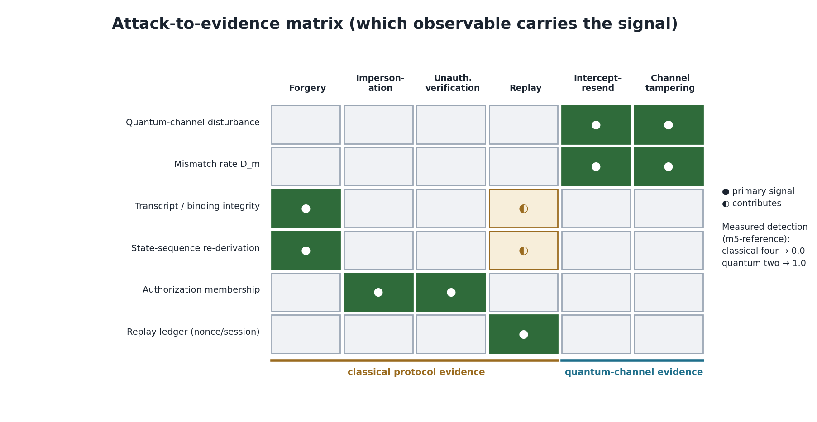
Figure C.1 — Attack-to-evidence matrix: which observable carries each attack's signal, with the measured detection split.
Attack | Quantum disturbance? | Detection mechanism | Measured detection / FAR (m5)
Forgery | No | Binding + state-sequence re-derivation (classical integrity) | 0.0 / 1.0 (quantum statistic)
Impersonation | No | Authorization membership test (classical) | 0.0 / 1.0 (quantum statistic)
Unauthorized verification | No | Authorization membership test (classical) | 0.0 / 1.0 (quantum statistic)
Replay | No | In-memory nonce/session ledger (classical, cross-event) | 0.0 / 1.0 (quantum statistic)
Intercept–resend | Yes | Elevated mismatch rate D_m (quantum) | 1.0 / 0.0
Channel tampering | Yes | Elevated mismatch rate D_m (quantum) | 1.0 / 0.0

Appendix D — Statistical Equations
# | Equation | Where implemented
5.1 | message_hash = SHA256(utf8(NFC(message))) | protocol/binding.py, canonical.py
5.2 | binding = SHA256(canonical{domain, version, session, nonce, message}) | protocol/binding.py
5.3 | block_k = SHA256(seed‖domainuint32(k)); accept nibble<12; idx = nibble mod 6 | protocol/encoding.py
4.1 | |Φ+⟩ = (|00⟩+|11⟩)/√2 | quantum/bell.py
4.2 | U(m0,m1) = Z^m0 · X^m1 | quantum/correction.py
4.3 | p_match = Tr(P_ψ ρ) | quantum/density.py
4.4 | F = ⟨ψ|ρ|ψ⟩ | quantum/density.py
6.1 | E(ρ) = Σ_p p_P · P ρ P | noise/base.py
6.2 | T(ρ,σ) = ½ Σ|eig(ρ−σ)| | noise/base.py
6.3 | p_match(honest, depol η) = 1 − η/2 | calibration/baseline.py
9.1 | D_m = N_mismatch / N_valid | detection/mismatch.py
9.3 | D_v = N_disturbed / N_valid; disturbed ⟺ p < 1−1e-9 | detection/disturbance.py
10.1 | H0: N_mismatch ~ Binomial(N, p0) | calibration/baseline.py
10.2 | Clopper–Pearson L,U via Beta quantiles | calibration/confidence.py, detection/statistics.py
10.3 | ε = sqrt(ln(m/α)/(2n)) (Hoeffding, cross-check) | security/finite_size.py
10.4 | p_upper; k_crit(N); θ(N)=k_crit/N; reject if N_mismatch>k_crit | calibration/thresholds.py
FWER | 1 − (1−α)^k | calibration/multiple_testing.py

Appendix E — Test and Benchmark Evidence
Test totals: 1,546 backend test functions (api 370, evaluation 273, security 269, protocol 216, detection 159, calibration 149, quantum 110); 1,848 collected in the project venv excluding the API suite (httpx absent at measurement time); 31 frontend vitest tests passing. Coverage and mutation testing are not configured. Benchmark evidence: benchmarks/m5-reference.json (runtime 1504.86 s, 479 scenarios, 37 disjoint seed blocks, cache hit_rate 0.99998) with the operating point, attack evaluation, robustness, sample-size, discrimination and threshold tables reproduced in Sections 10–12.

Appendix F — Implementation Evidence Index
Claim | File | Function / Class | Lines | What it proves
Six Pauli eigenstates | backend/quantum/states.py | _DEFINITIONS / get_eigenstate | L95-135 | Exact eigenstate table; P|ψ⟩=λ|ψ⟩
Bell state |Φ+⟩ | backend/quantum/bell.py | bell_circuit / bell_amplitudes_exact | L31-58 | Entangled resource equals (|00⟩+|11⟩)/√2
Teleportation circuit | backend/quantum/teleport.py | teleport_circuit | L85-127 | CX/H/measure + conditional correction sequence
Pauli correction convention | backend/quantum/correction.py | CORRECTION_TABLE / append_conditional_correction | L74-137 | U=Z^m0·X^m1 as real feed-forward
p_match ≡ F | backend/quantum/density.py | p_match / fidelity_pure | L14-23, L87-117 | Same overlap quantity two ways; not independent evidence
Born-rule measurement + rotations | backend/quantum/measure.py | add_basis_rotation / run_counts | L56-132 | Basis rotation to Z; single Aer execution path; reproducibility
SHA-256 canonical binding | backend/protocol/binding.py | compute_message_binding | L56-99 | Domain-separated named-field binding
Unbiased state-sequence derivation | backend/protocol/encoding.py | nibble_stream / derive_alphabet_indices | L130-166 | Rejection sampling unbiased over 6 states; engineering choice
No secret key | backend/protocol/models.py | Session / Transcript | L188-246 | No key field anywhere; unforgeability not claimed
Verifier never trusts signer | backend/protocol/verifier.py | ReferenceVerifier.verify | L188-380 | Independent recomputation; structural caveat
Pauli channel apply | backend/noise/base.py | QuantumChannel.apply | L189-206 | Analytic density-matrix channel, trace-preserving/Hermitian guarded
Measure-and-reprepare | backend/attacks/intercept_resend.py | _intercept | L123-142 | Genuine Born-rule interception, not random replacement
Coherent Pauli tampering | backend/attacks/channel_tampering.py | apply | L100-137 | P ρ P† on a selected fraction
Observable/ground-truth split | backend/simulation/results.py | ObservableExperimentData / GroundTruthMetadata | L114-174 | Detector-consumable vs evaluation-only halves
Mismatch rate | backend/detection/mismatch.py | analyse_mismatch | L89-153 | D_m with honest denominator hygiene
Exact binomial interval | backend/detection/statistics.py | exact_binomial_interval | L67-104 | Clopper–Pearson via scipy beta.ppf
Categorical decision, no score | backend/detection/decision.py | decide | L161-197 | Family-based status; no security score
Primary vs diagnostic | backend/calibration/multiple_testing.py | REFERENCE_PRIMARY_TEST / DIAGNOSTIC_METRICS | L14-83 | Exactly one tested statistic
Honest-null threshold | backend/calibration/thresholds.py | derive_threshold / critical_count | L96-218 | p_upper → k_crit(N) → θ(N); sample-size bound
Hoeffding cross-check | backend/security/finite_size.py | hoeffding_radius | L212-231 | sqrt(ln(m/α)/2n); looser, never the threshold
Claim checker | backend/security/interpretation.py | FORBIDDEN_CLAIMS / check_statement | L101-388 | Rejects over-claims and banned terminology
No composition theorem | backend/security/composition.py | composition_summary | L246 | formal_composition_theorem_present = False
App factory + CORS | backend/api/app.py | create_app | L82-123 | Factory DI; CORS allow-list outermost
In-memory store + replay reuse | backend/api/store.py | ApiStore | L103-129 | No DB; reuses M4 ReplayRegistry
Anti-leakage tests | tests/detection/test_separation.py | — | L48-300 | Structural/static/runtime/behavioural label independence

Appendix G — References
[R1] C. H. Bennett, G. Brassard, C. Crépeau, R. Jozsa, A. Peres, W. K. Wootters, “Teleporting an Unknown Quantum State via Dual Classical and Einstein-Podolsky-Rosen Channels,” Physical Review Letters 70, 1895–1899 (1993). DOI 10.1103/PhysRevLett.70.1895
[R2] V. Dunjko, P. Wallden, E. Andersson, “Quantum Digital Signatures without Quantum Memory,” Physical Review Letters 112, 040502 (2014). DOI 10.1103/PhysRevLett.112.040502
[R3] R. J. Collins, R. J. Donaldson, V. Dunjko, P. Wallden, P. J. Clarke, E. Andersson, J. Jeffers, G. S. Buller, “Realization of Quantum Digital Signatures without the Requirement of Quantum Memory,” Physical Review Letters 113, 040502 (2014). DOI 10.1103/PhysRevLett.113.040502
[R4] P. Wallden, V. Dunjko, A. Kent, E. Andersson, “Quantum Digital Signatures with Quantum-Key-Distribution Components,” Physical Review A 91, 042304 (2015). DOI 10.1103/PhysRevA.91.042304
[R5] IBM Quantum Learning, “Quantum Teleportation.” https://quantum.cloud.ibm.com/learning/en/modules/computer-science/quantum-teleportation
[R6] IBM Quantum, “Quantum Teleportation — Basics of Quantum Information.” https://qiskit.qotlabs.org/learning/courses/basics-of-quantum-information/entanglement-in-action/quantum-teleportation
[R7] IBM Quantum, “Qiskit SDK API Documentation.” https://docs.quantum.ibm.com/api/qiskit
[R8] Egreen Quanta LLP, “Quantum-Inspired Cyber Threat Detection for Digital Signature Security,” Smart India Hackathon Problem Statement 26141. Local: docs/research/SIH26141.pdf
[R9] Consensus Research Synthesis (project research synthesis). Local: docs/research/consensus-research.md. Note: claims must be traced to primary literature before being treated as established.
[R10] Same paper as [R4] (Wallden et al., PRA 91, 042304 (2015)), cited under a second number for finite-size reasoning; it is one paper, not two.
[R11] W. Hoeffding, “Probability Inequalities for Sums of Bounded Random Variables,” Journal of the American Statistical Association 58(301), 13–30 (1963). DOI 10.1080/01621459.1963.10500830
[R12] C. J. Clopper, E. S. Pearson, “The Use of Confidence or Fiducial Limits Illustrated in the Case of the Binomial,” Biometrika 26(4), 404–413 (1934). DOI 10.1093/biomet/26.4.404
[R13] S. Holm, “A Simple Sequentially Rejective Multiple Test Procedure,” Scandinavian Journal of Statistics 6(2), 65–70 (1979).
Claims NOT transferred from the literature: no forgery probability, security parameter or composability claim is transferred from [R1]–[R4]/[R10]; [R11]–[R13] are statements about estimators, not adversaries; the project derives no formal forgery bound (docs/research/references.md:L204-229).

