**Kumar Animesh Shekhar**

**500107110**

**Batch 5 AIML**

**Experiment 1**

**Q1. Write a Python program to perform basic arithmetic operations (addition, subtraction, multiplication, division, and modulus) on two numbers.**

* + Prompt the user to enter two numbers.
  + Perform the arithmetic operations and print the results.
  + Use appropriate operators and print formatting for clear output.

Code and Output:

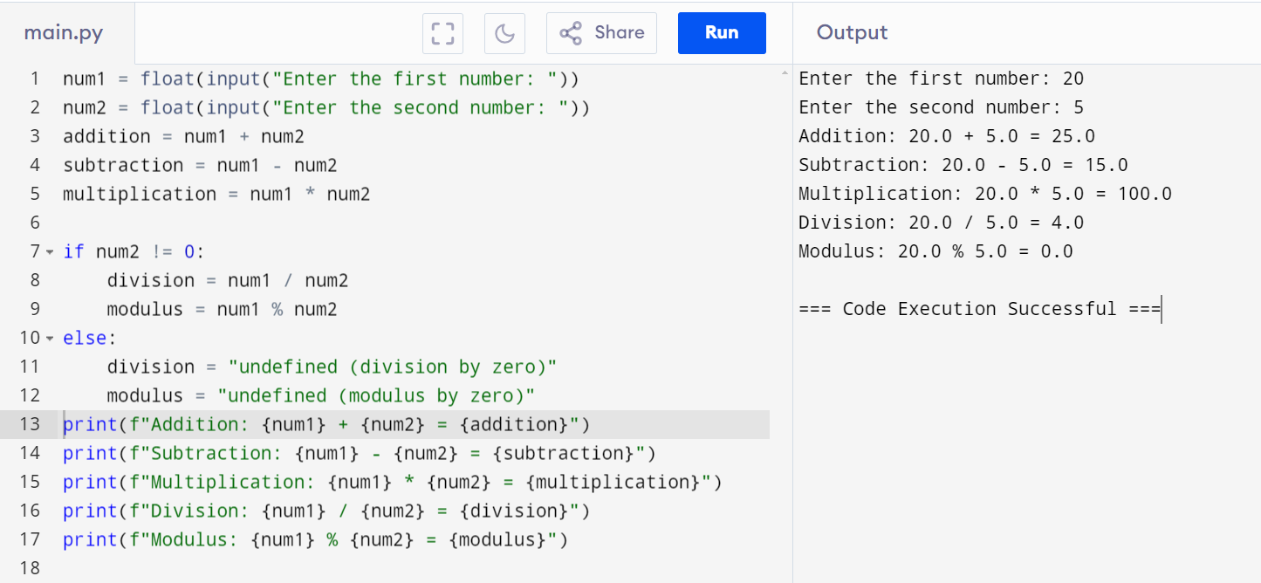

**Q2.  Create variables of different data types (integer, float, string, boolean) and perform basic operations on them.**

* + Assign values to variables of different data types.
  + Perform arithmetic operations on numeric data types.
  + Concatenate strings using the + operator.
  + Use logical operators to evaluate boolean expressions.

Code and Output:

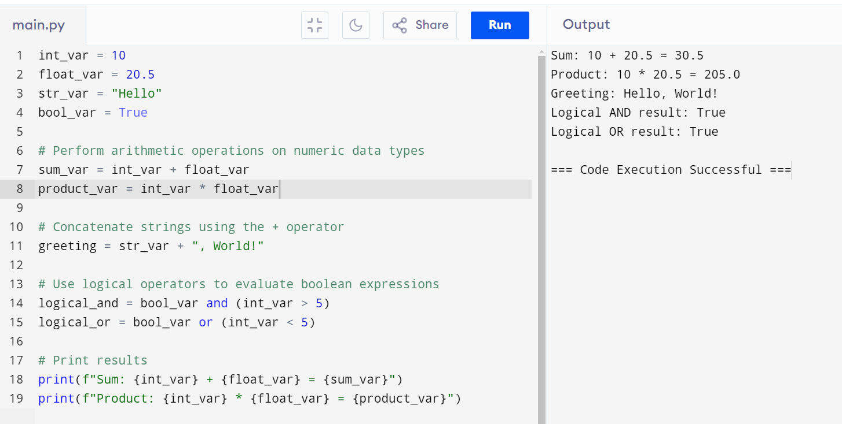

**Q3. Write a program to take user input, process it, and display the result.**

* + Prompt the user to enter their name.
  + Greet the user using their name.
  + Calculate and print the user's age based on their birth year.

Code and Output:

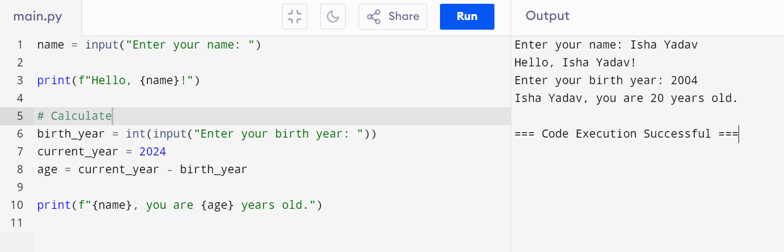

**Q4.  Write a program to check if a number is even or odd.**

* + Prompt the user to enter a number.
  + Use the modulus operator to determine if the number is even or odd.
  + Print the appropriate message.

Code and Output:

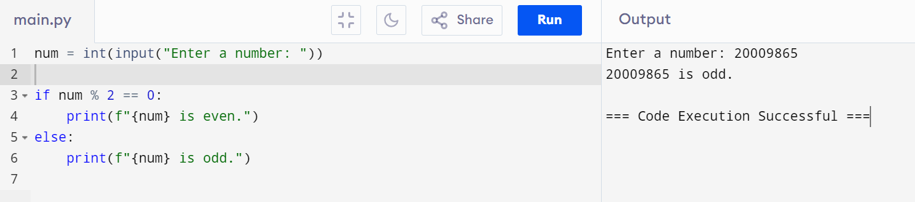

**Q5. Write a program to print the numbers from 1 to 10 using both for and while loops.**

* + Use a for loop to iterate through a range of numbers.
  + Use a while loop with a counter variable.

Code and Output:

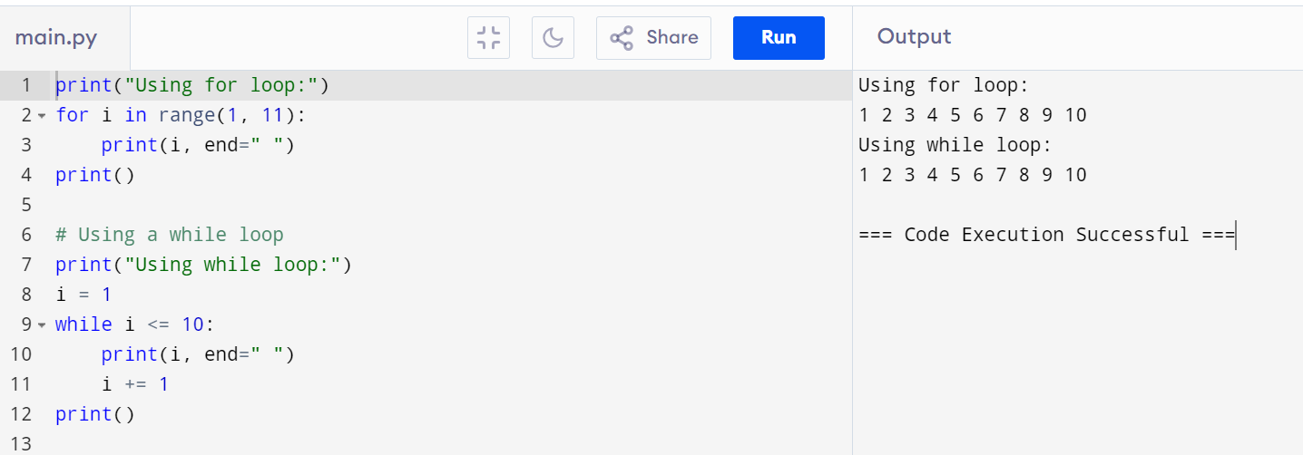

**Q6.  Create a list, access elements, modify elements, and perform list operations.**

* + Create a list of fruits.
  + Access elements using indexing.
  + Modify elements in the list.
  + Add and remove elements from the list.
  + Find the length of the list.
  + Sort the list in ascending and descending order.

Code and Output:

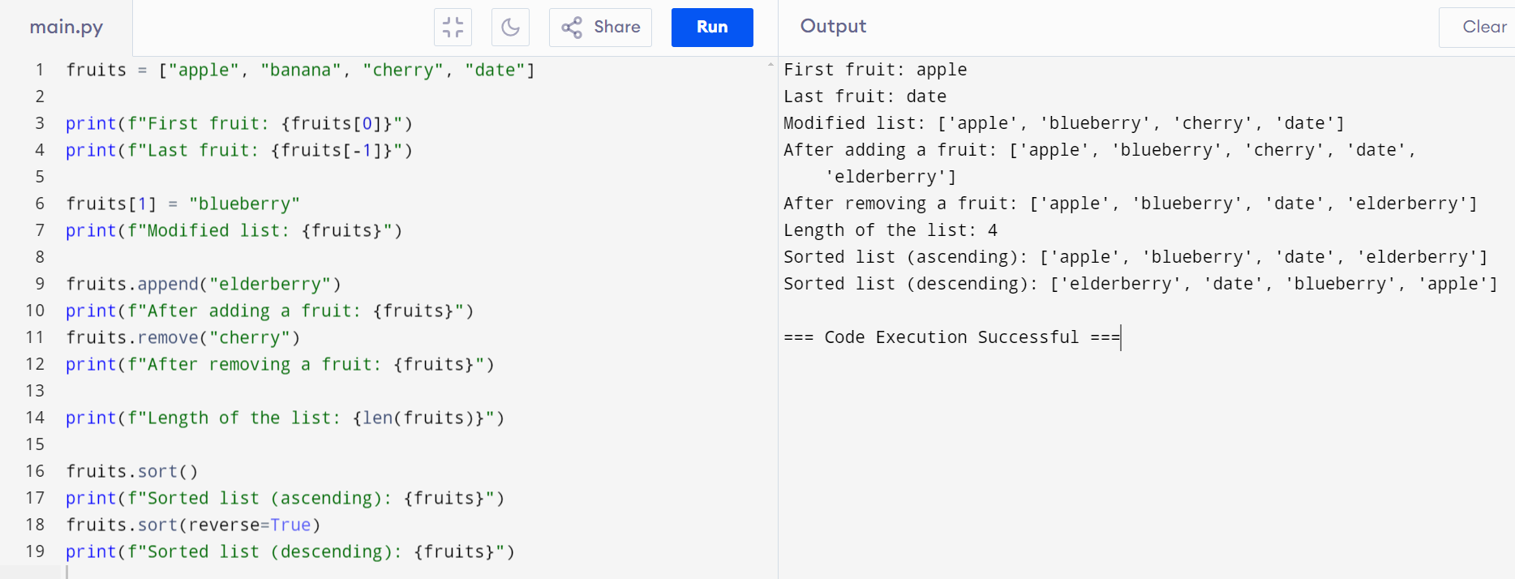

**Q7. Manipulate strings using various built-in functions.**

* + Create a string variable and find the length of the string.
  + Convert the string to uppercase and lowercase.
  + Check if a substring exists in the string.
  + Split the string into a list of words.

Code and Output:

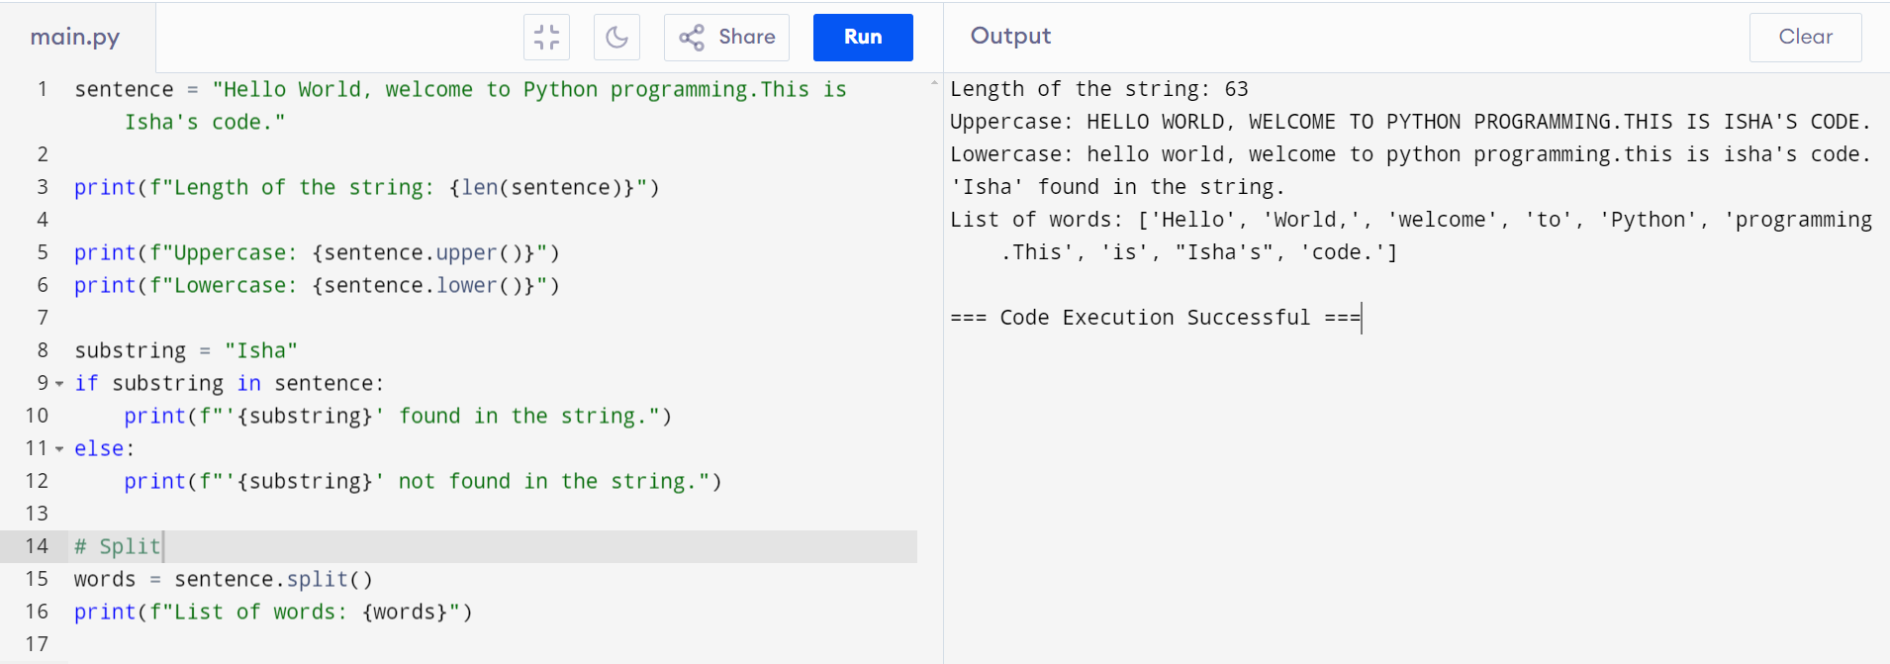

**Q8. Write a program to find the largest and smallest number in a list.**

**Code and Output:**

