**Predictive Analysis  
Lab-2**

**Kumar Animesh Shekhar**

**500107110**

**B-5 AIML**

**Q1.  Create and access tuples.**

* + **Create a tuple of colors.**
  + **Access elements using indexing.**
  + **Try to modify an element in the tuple (to demonstrate immutability).**
  + **Find the number of occurrences of a specific element in the tuple.**

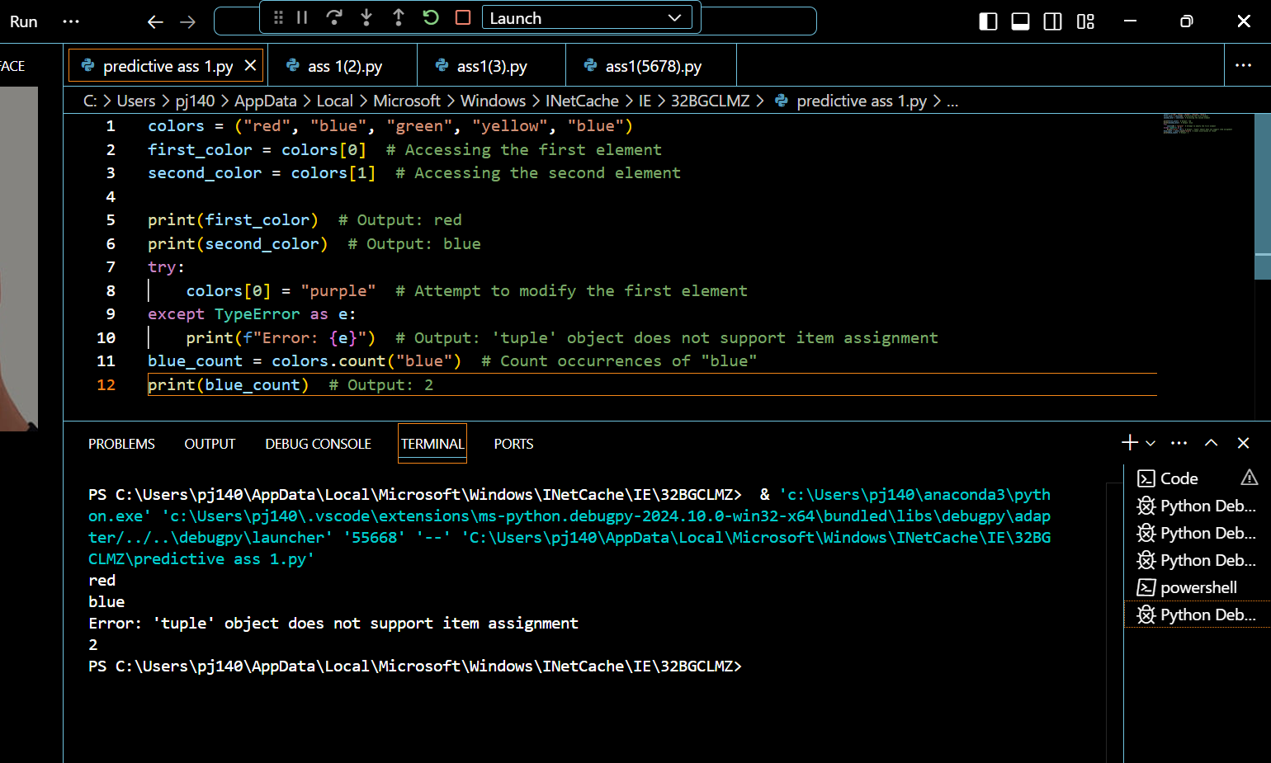

**Q2.  Create and manipulate dictionaries.**

* + Create a dictionary to store information about a person (name, age, city).
  + Access values using keys.
  + Add a new key-value pair to the dictionary.
  + Modify an existing value.
  + Check if a key exists in the dictionary.
  + Get a list of all keys and values.

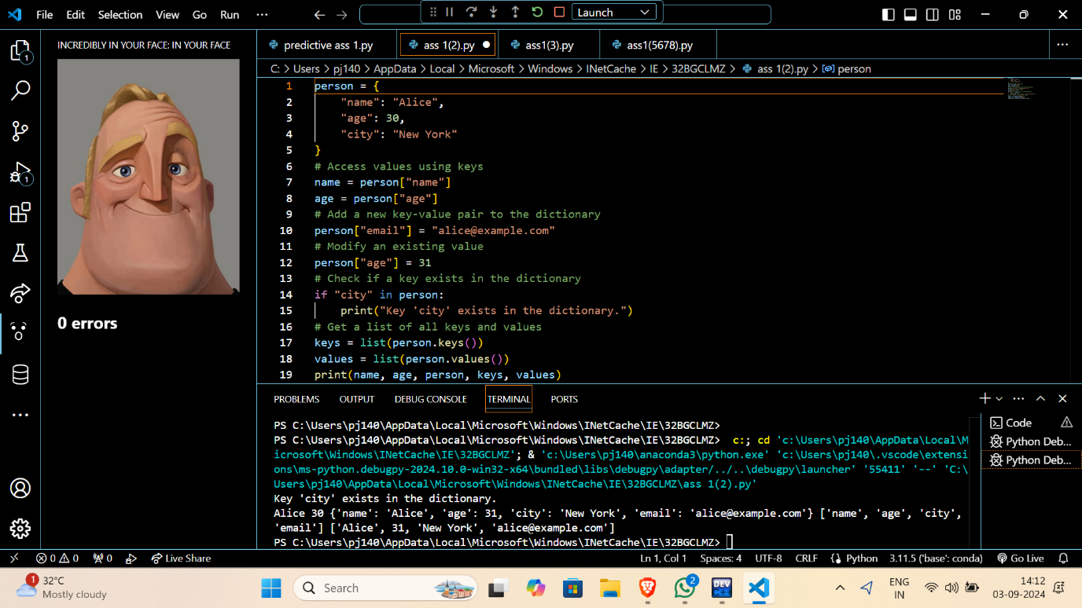

**Q3. Demonstrate the difference between mutable and immutable data types.**

* + Create a list and a tuple.
  + Try to modify an element in both the list and the tuple.
  + Observe the results and explain the difference.

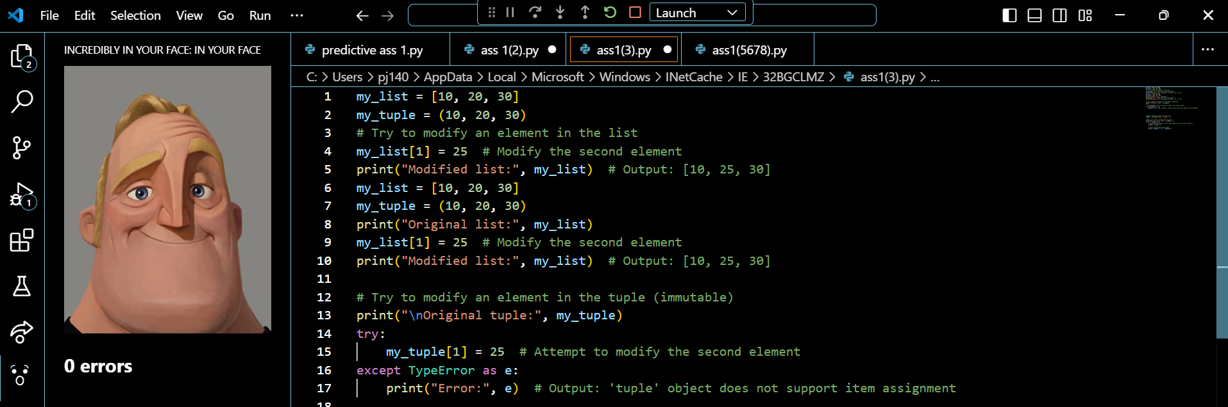

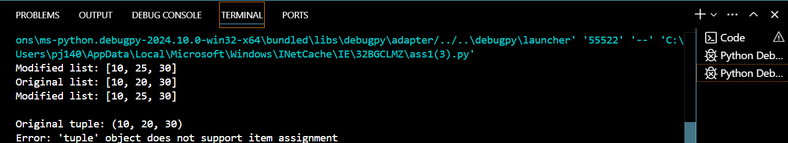

**Q4. Create a program to print the multiplication table of a number.**

* + Take a number as input from the user.
  + Use a for loop to iterate from 1 to 10.
  + Calculate the product of the input number and the current iteration.
  + Print the multiplication table.

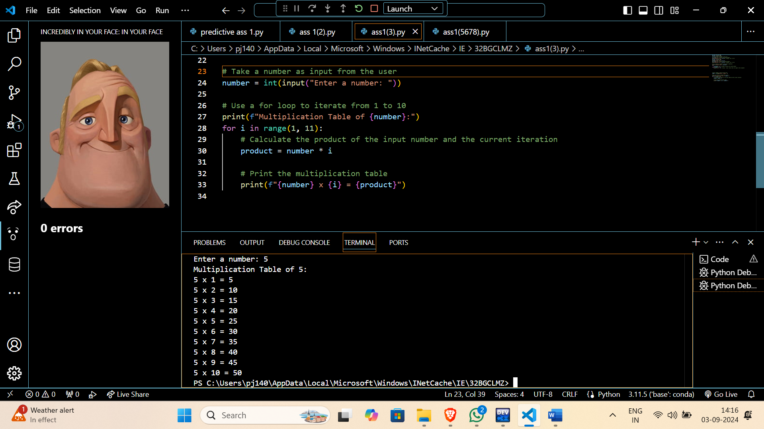

**Q5. Create a program to find the factorial of a number using a loop and conditional statements.**

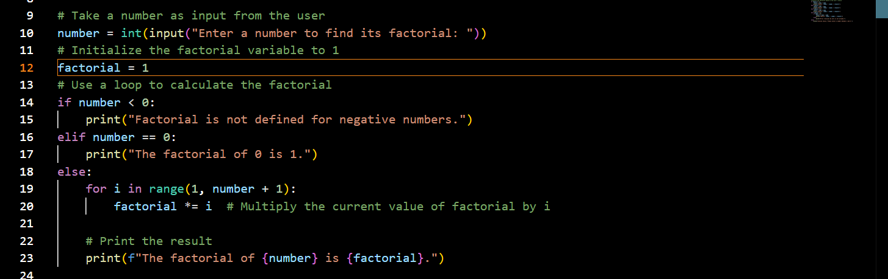



**Q6. Write a program to check if a given number is prime.**

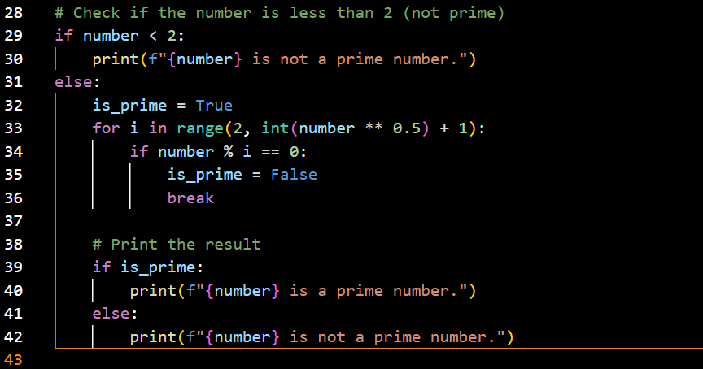



**Q7. Create a program to find the sum of all even numbers between 1 and 100.**

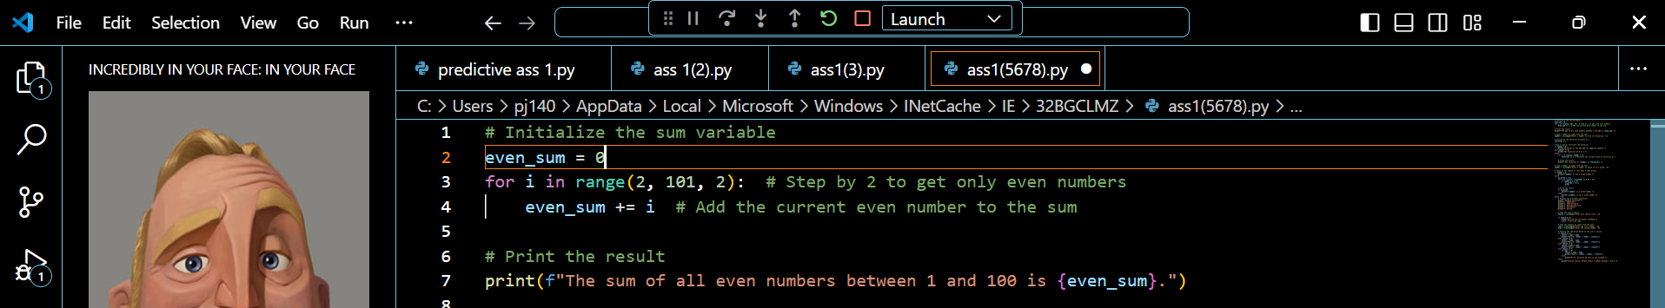

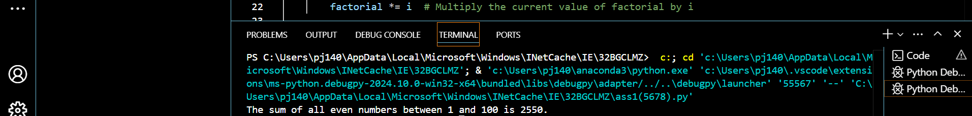

**Q8. Implement a simple calculator using conditional statements and loops.**

