**Predictive Analysis**

**Lab3**

**Kumar Animesh Shekhar**

**500107110**

**B-5 AIML**

**Q1. Array Creation and Manipulation:**

* Create different types of arrays (1D, 2D, 3D) using various methods (np.array, np.arange, np.linspace, etc.).
* Perform basic operations on arrays (indexing, slicing, reshaping, concatenation).
* Investigate array attributes like shape, size, dtype, ndim.
* Use methods like reshape, resize, flatten,

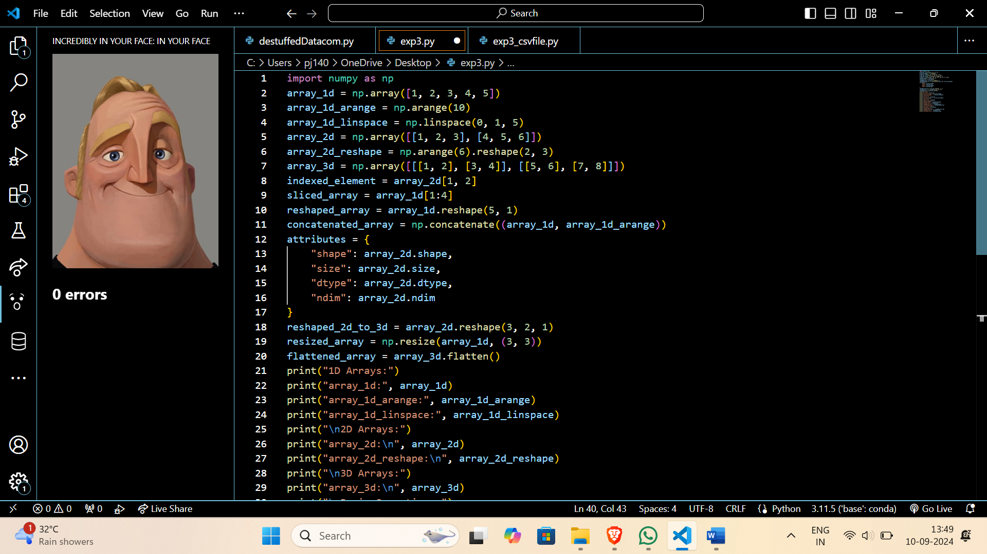

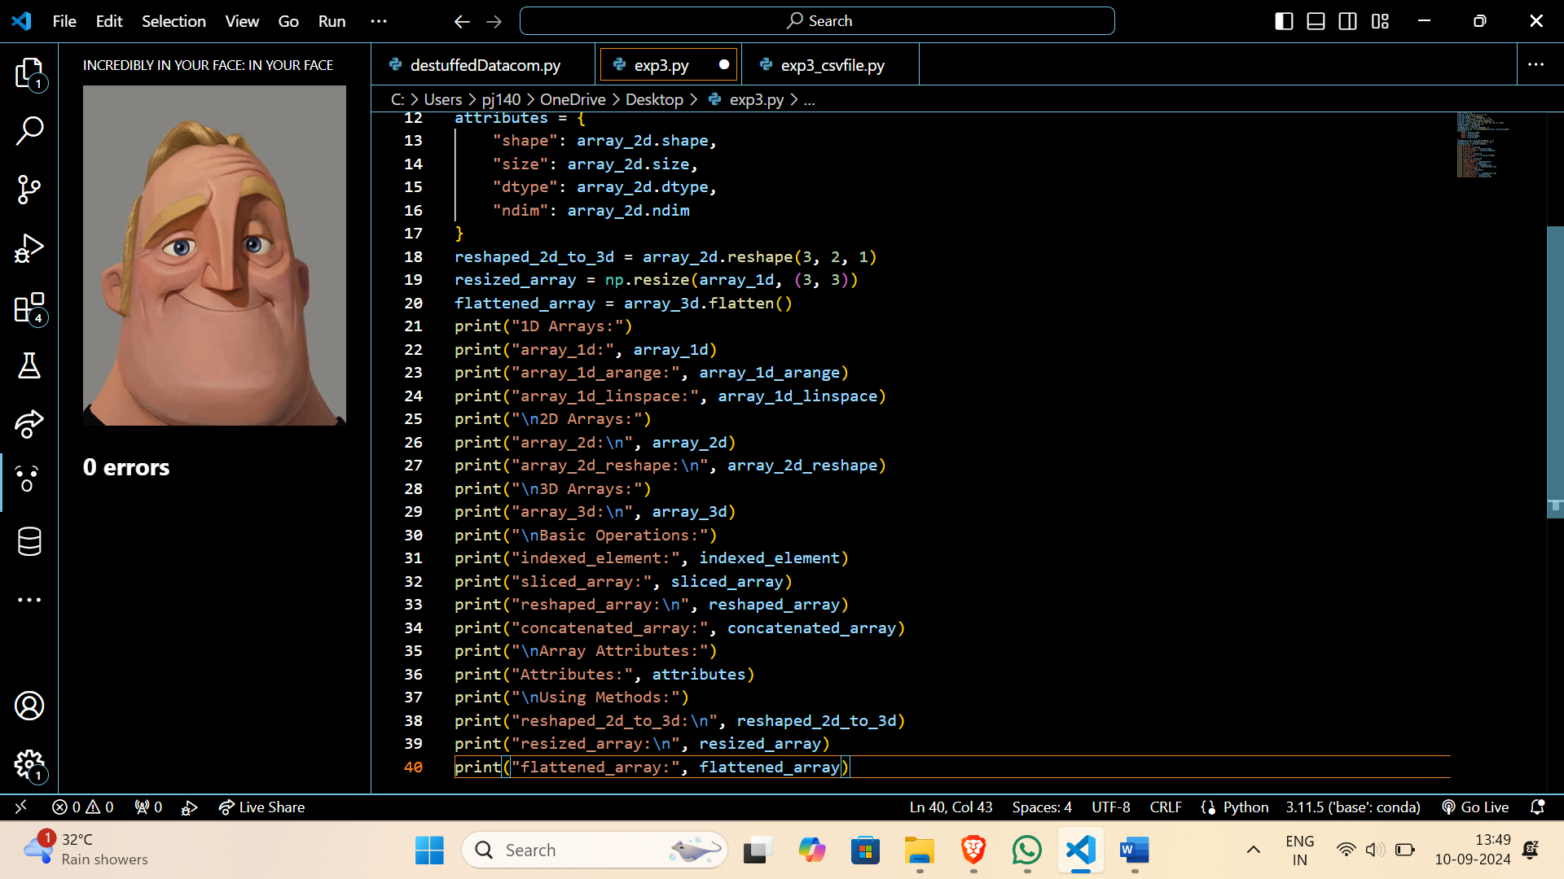

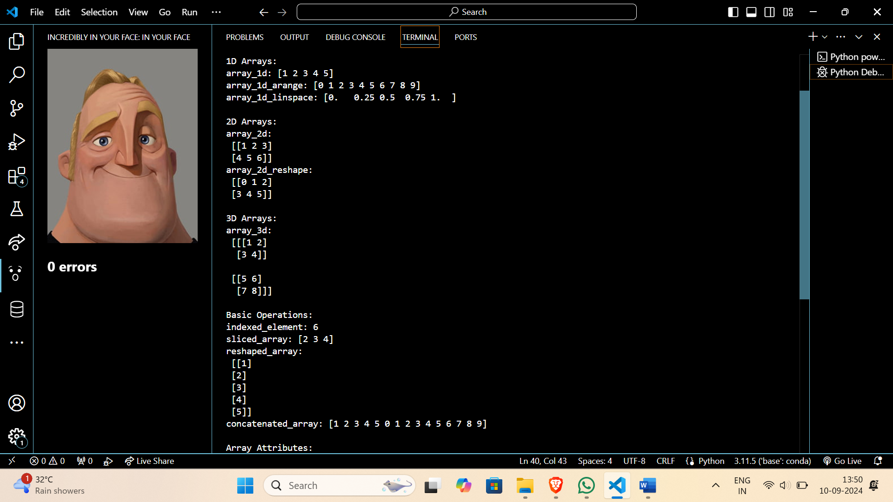

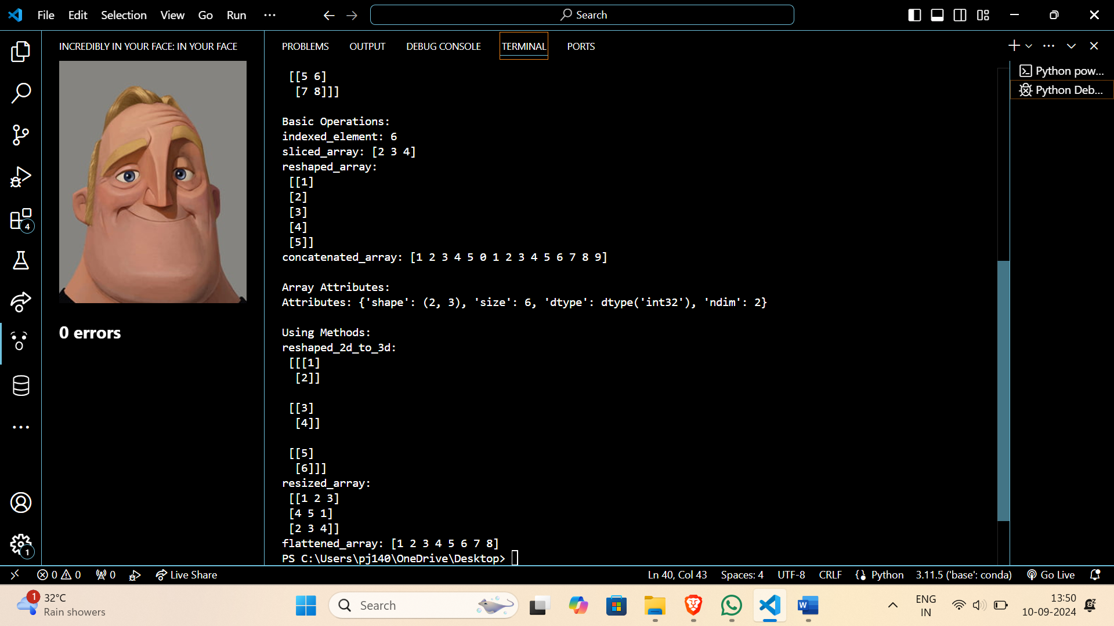

Q2. **Data Loading and Preprocessing:**

* Load a dataset (e.g., CSV, Excel) using NumPy.
* Clean and preprocess the data (handling missing values, normalization, standardization).
* Calculate mean, median, standard deviation, variance, and other statistical measures.

