**Kumar Animesh Shekhar**

**500107110**

**B-5 AIML**

**LAB 4 : Python Library Pandas**

**Q1.  Loading and Inspecting Data:**

·         Load various data formats (CSV, Excel, JSON) into Pandas DataFrames.

·         Explore DataFrame attributes like shape, columns, dtypes, head, tail, info, describe.

·         Practice selecting columns and rows using different methods (indexing, slicing, loc, iloc).

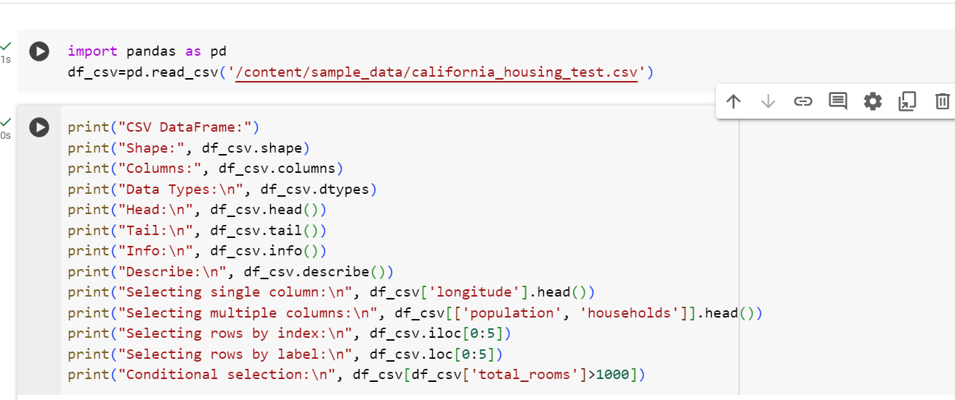

Output:

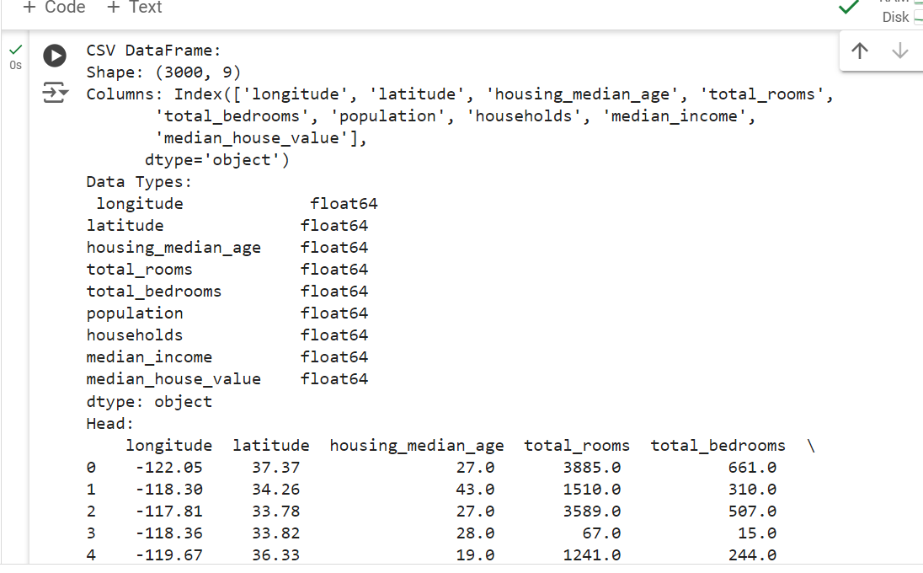

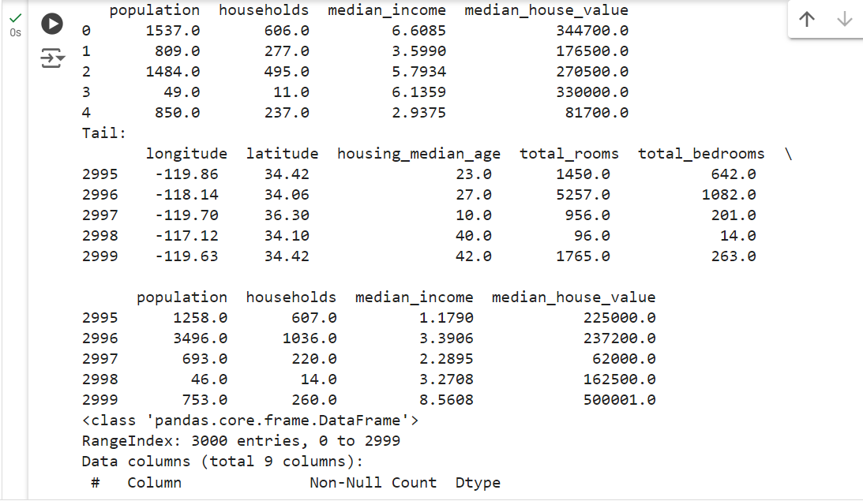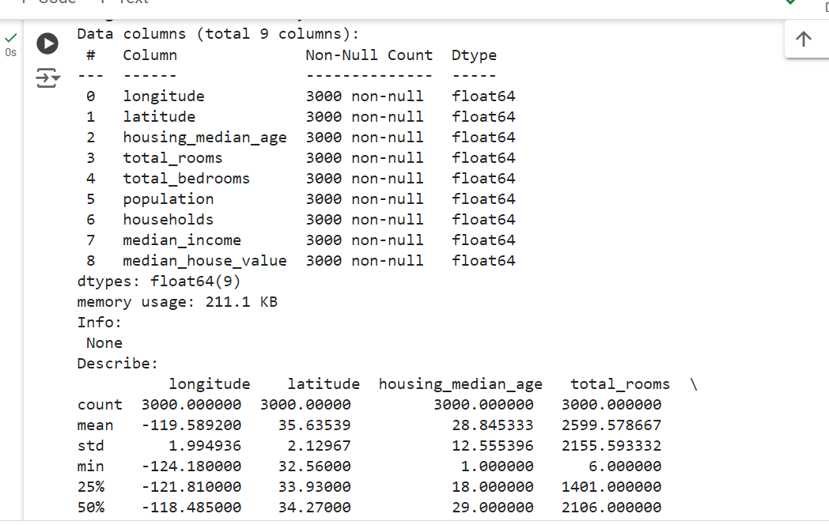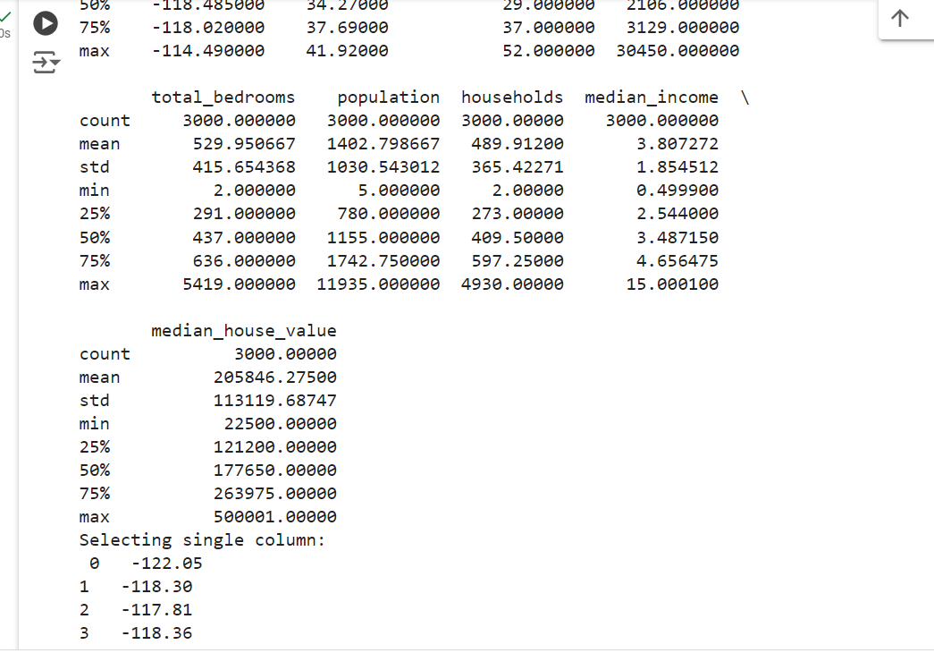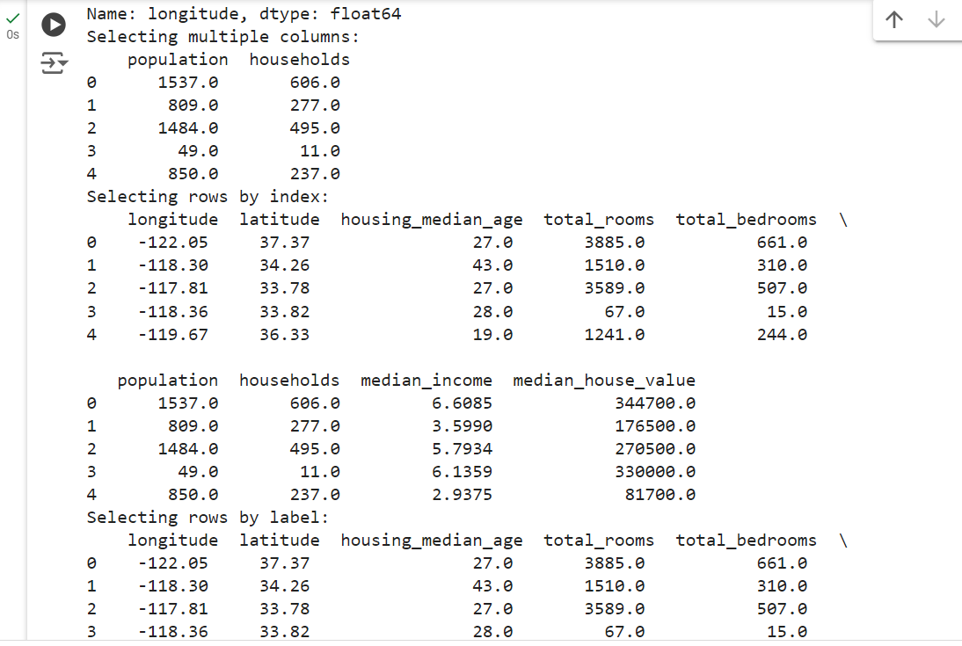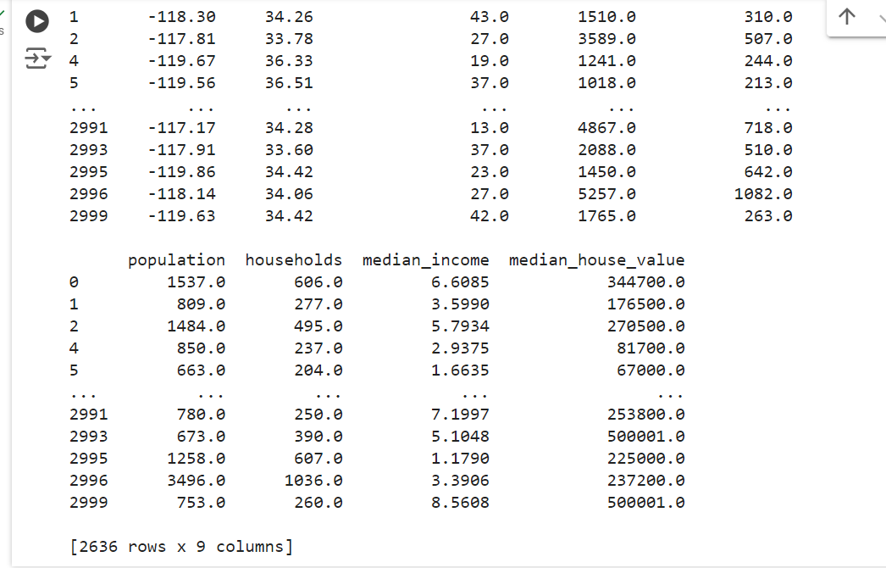

**Q2. Data Cleaning and Preparation**

* Identify missing values using isnull and isna.
* Handle missing values using fillna, dropna, interpolation.
* Apply scaling techniques (min-max, z-score) to numerical columns.
* Create dummy variables for categorical columns.

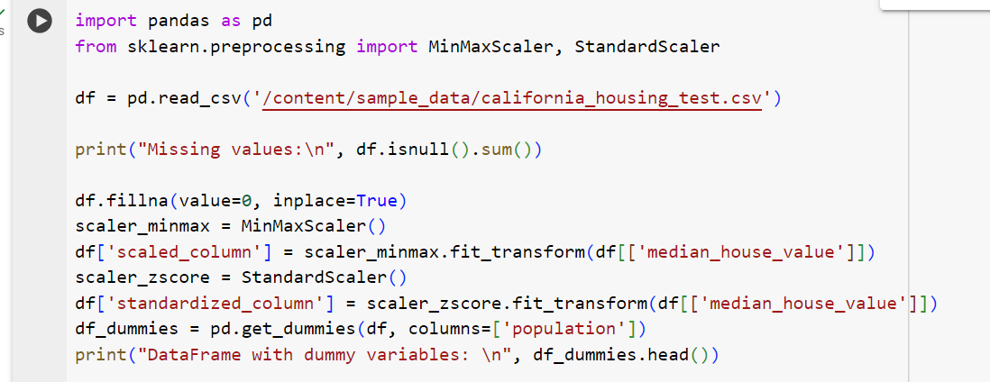

Output:

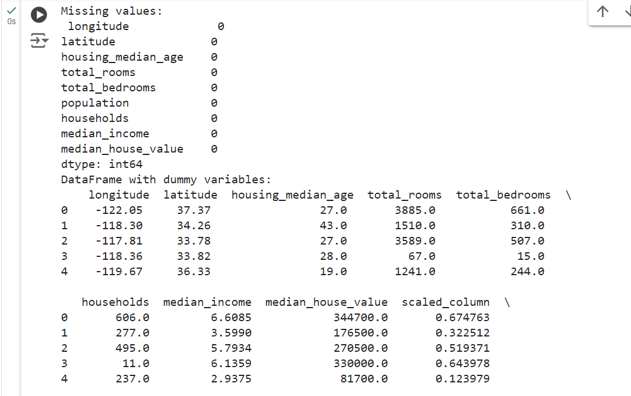

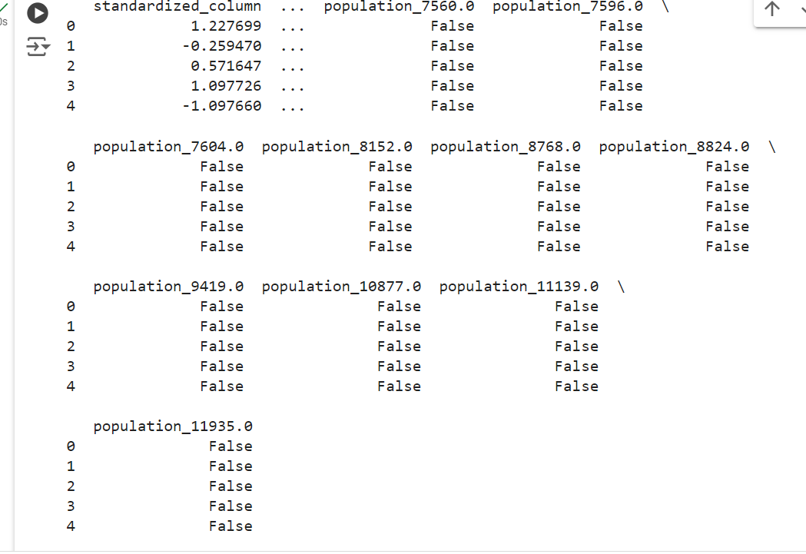

**Q3. Aggregation and Grouping:**

Calculate summary statistics (mean, median, count, etc.) using groupby.

Create pivot tables for data summarization.

Combine DataFrames using concat, merge, and join.

Practice different join types (inner, outer, left, right).

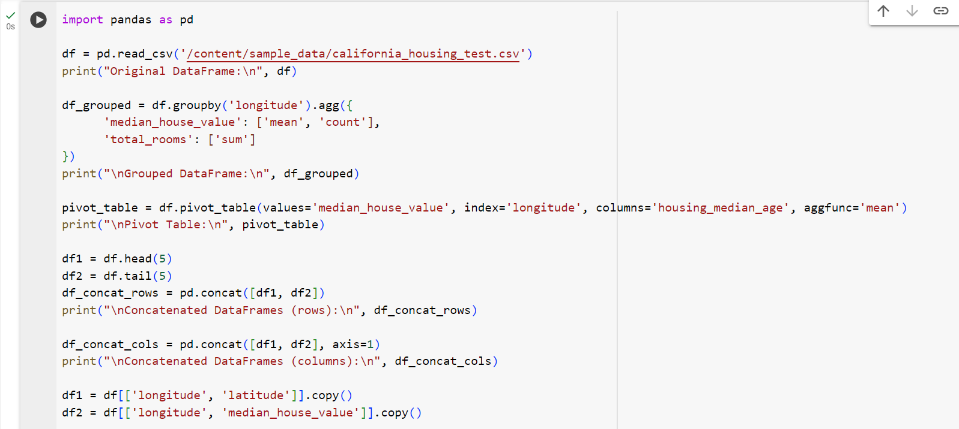

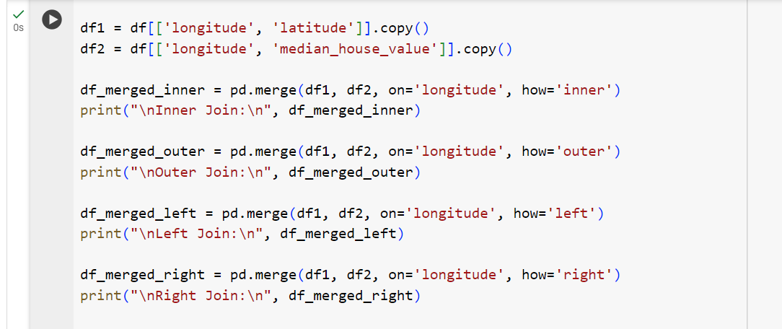

Output:

