Predictive Analytics

Lab 5

**Kumar Animesh Shekhar**

**500107110**

**B-5 AIML**

Descriptive Statistics of data:

* 1. Measure of Central Tendency: Mean, Geometric mean, Harmonic mean, Mode, Median

**Code:**

import pandas as pd

import numpy as np

from scipy import stats

import seaborn as sns

import matplotlib.pyplot as plt

# Load dataset

df = pd.read_csv('/content/bodyPerformance.csv')

# Numeric columns

numeric_columns = ['age', 'height_cm', 'weight_kg', 'body fat_%', 'diastolic', 'systolic',

                   'gripForce', 'sit and bend forward_cm', 'sit-ups counts', 'broad jump_cm']

# Mean

mean_values = df[numeric_columns].mean()

# Geometric Mean (ignoring negative and zero values as they are not valid for geometric mean)

geom_mean_values = df[numeric_columns].apply(lambda x: stats.gmean(x[x > 0]))

# Harmonic Mean (ignoring negative and zero values)

harmonic_mean_values = df[numeric_columns].apply(lambda x: stats.hmean(x[x > 0]))

# Mode

mode_values = df[numeric_columns].mode().iloc[0]

# Median

median_values = df[numeric_columns].median()

# Central Tendency Results

central_tendency = pd.DataFrame({

    'Mean': mean_values,

    'Geometric Mean': geom_mean_values,

    'Harmonic Mean': harmonic_mean_values,

    'Mode': mode_values,

    'Median': median_values

})

print("Central Tendency:\n", central_tendency)

**Output:**

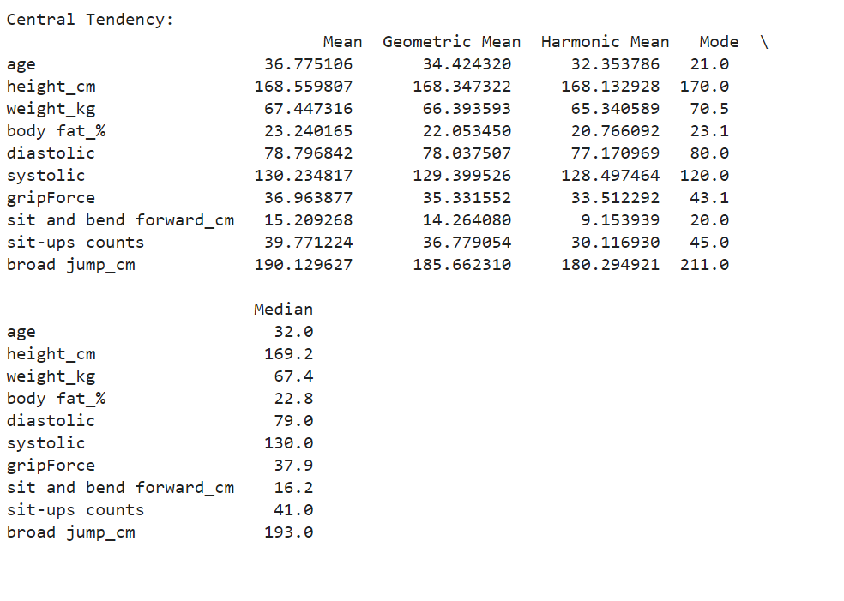

* 1. Measure of Dispersion: Variance, Standard deviation, Shape of Data (Symmetric, Skewness), Inter Quartile Range (IQR) / percentiles, Range, Mean Absolute Deviation(MAD)

**Code:**

# Variance

variance_values = df[numeric_columns].var()

# Standard Deviation

std_dev_values = df[numeric_columns].std()

# Skewness

skewness_values = df[numeric_columns].apply(lambda x: stats.skew(x))

# Interquartile Range (IQR)

iqr_values = df[numeric_columns].apply(lambda x: np.percentile(x, 75) - np.percentile(x, 25))

# Range

range_values = df[numeric_columns].apply(lambda x: np.max(x) - np.min(x))

# Mean Absolute Deviation (MAD)

mad_values = df[numeric_columns].apply(lambda x: np.mean(np.abs(x - np.mean(x))))

# Dispersion Results

dispersion = pd.DataFrame({

    'Variance': variance_values,

    'Standard Deviation': std_dev_values,

    'Skewness': skewness_values,

    'IQR': iqr_values,

    'Range': range_values,

    'MAD': mad_values

})

print("Dispersion:\n", dispersion)

**Output:**

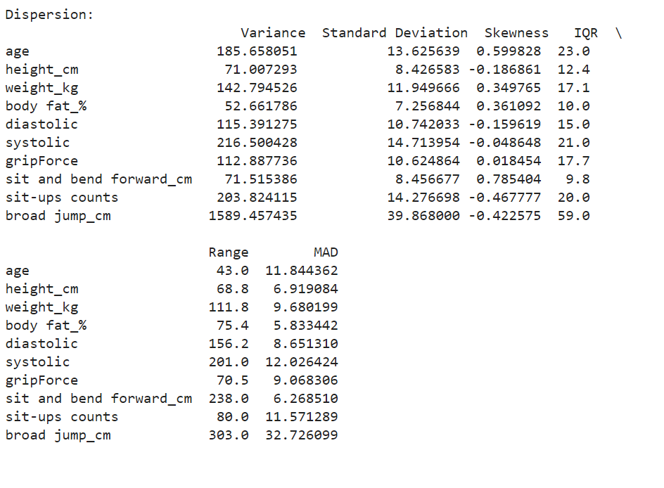

1.3 Correlation between features.

**Code:**

# Correlation Matrix (default is Pearson correlation)

correlation_matrix = df[numeric_columns].corr()

print("Correlation Matrix:\n", correlation_matrix)

**Output:**

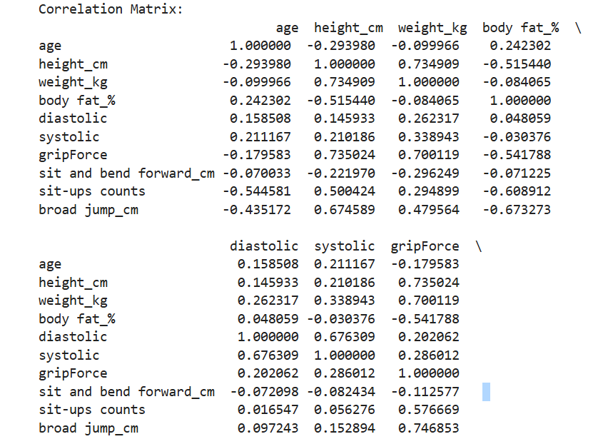

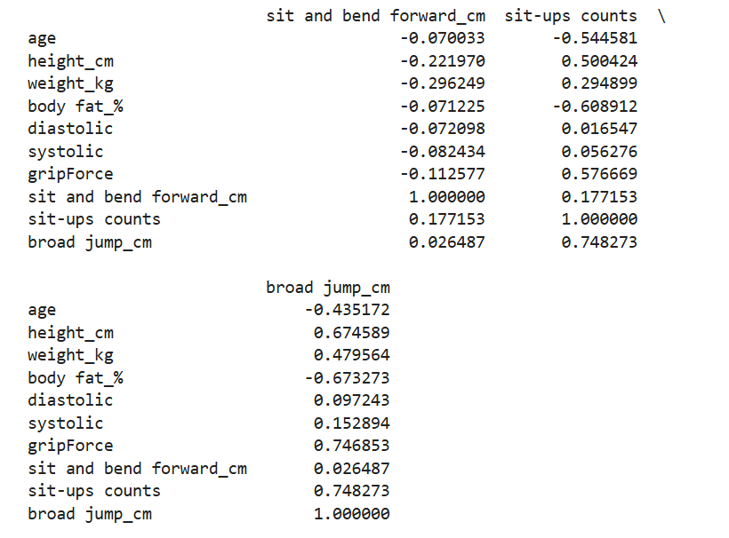

1.4. Visualizing Data Distribution: Boxplot, Histograms, Density plots, Scatterplot, Bar chart

**Code:**

**Boxplot:**

# Boxplot for each numerical feature

sns.boxplot(data=df[numeric_columns])

plt.title('Boxplot of Numerical Features')

plt.xticks(rotation=90)

plt.show()

**Output:**

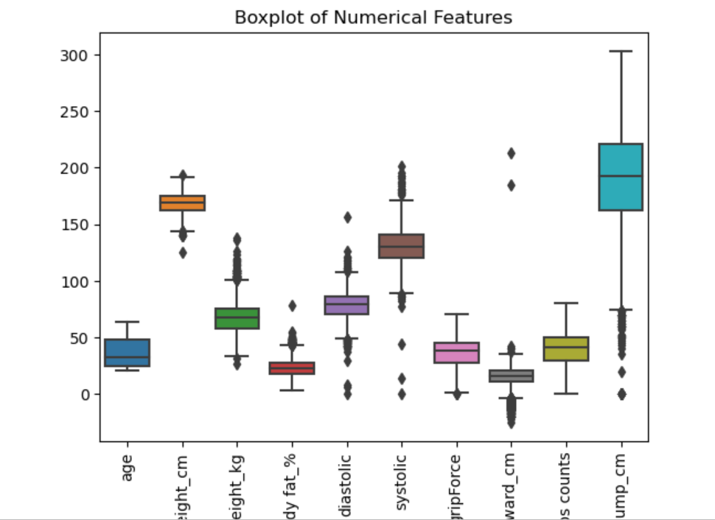

**Histograms**

# Histogram for each feature

df[numeric_columns].hist(figsize=(10, 8), bins=10)

plt.suptitle('Histograms of Numerical Features')

plt.show()

**Output:**

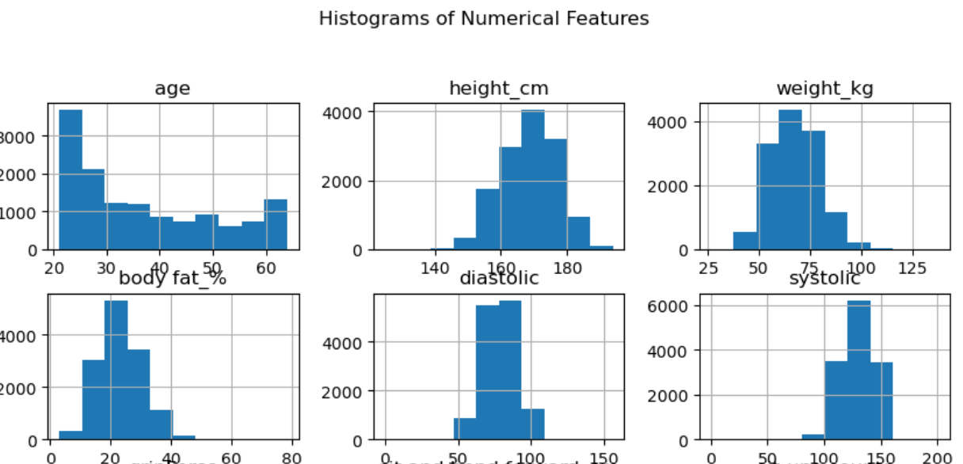

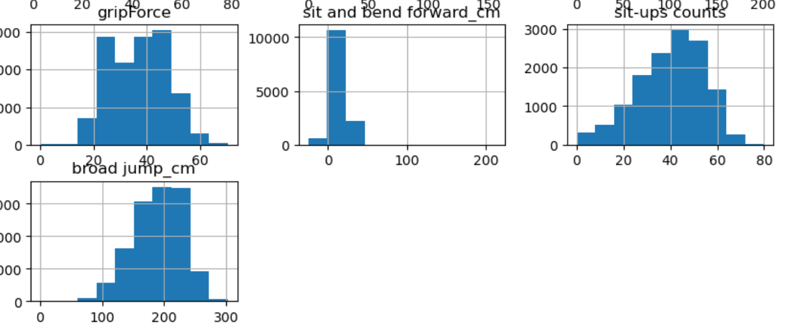

**Density Plots:**

# Density Plot for each feature

df[numeric_columns].plot(kind='density', subplots=True, layout=(4,3), figsize=(12,10), sharex=False)

plt.suptitle('Density Plots of Numerical Features')

plt.show()

**Output:**

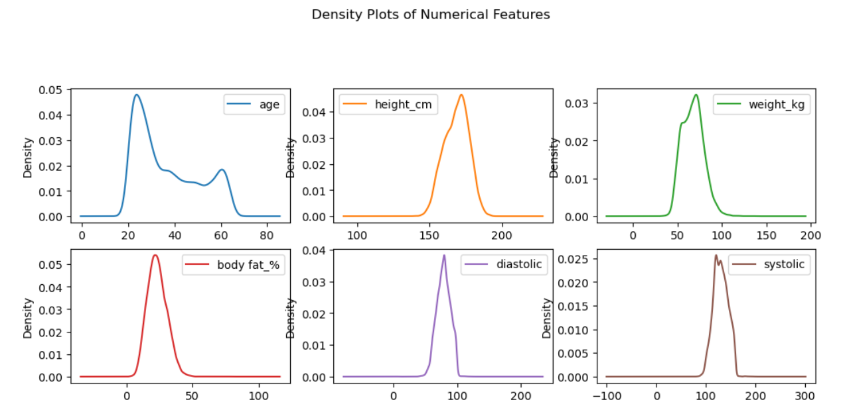

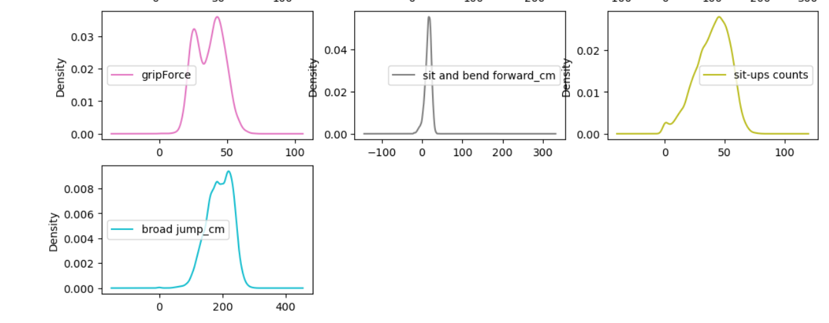

**Scatterplots:**

# Scatterplot between 'height_cm' and 'weight_kg'

sns.scatterplot(x='height_cm', y='weight_kg', data=df)

plt.title('Scatterplot between Height and Weight')

plt.show()

**Output:**

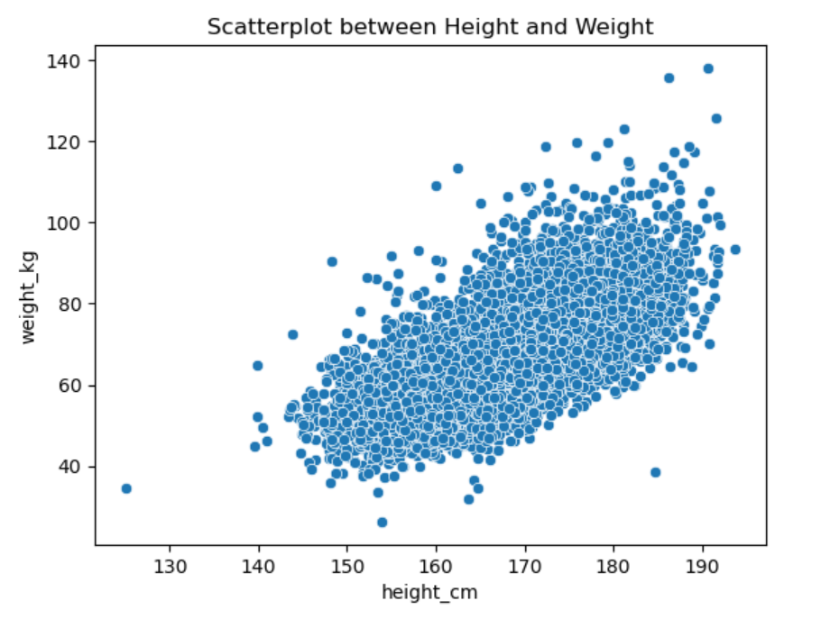

**Bar Chart:**

# Bar chart of Value Counts for 'age' (or any other column)

df['age'].value_counts().plot(kind='bar')

plt.title('Bar Chart of Age Distribution')

plt.xlabel('Age')

plt.ylabel('Count')

plt.show()

**Output:**

