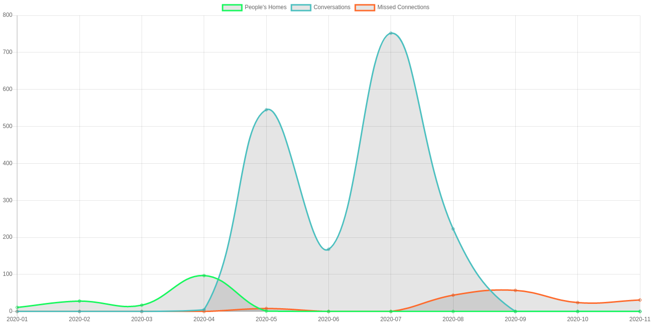
Figure 1. Hold The Phone project content accesses per month.
Counts user selection of Hold The Phone content from any Futel menu.

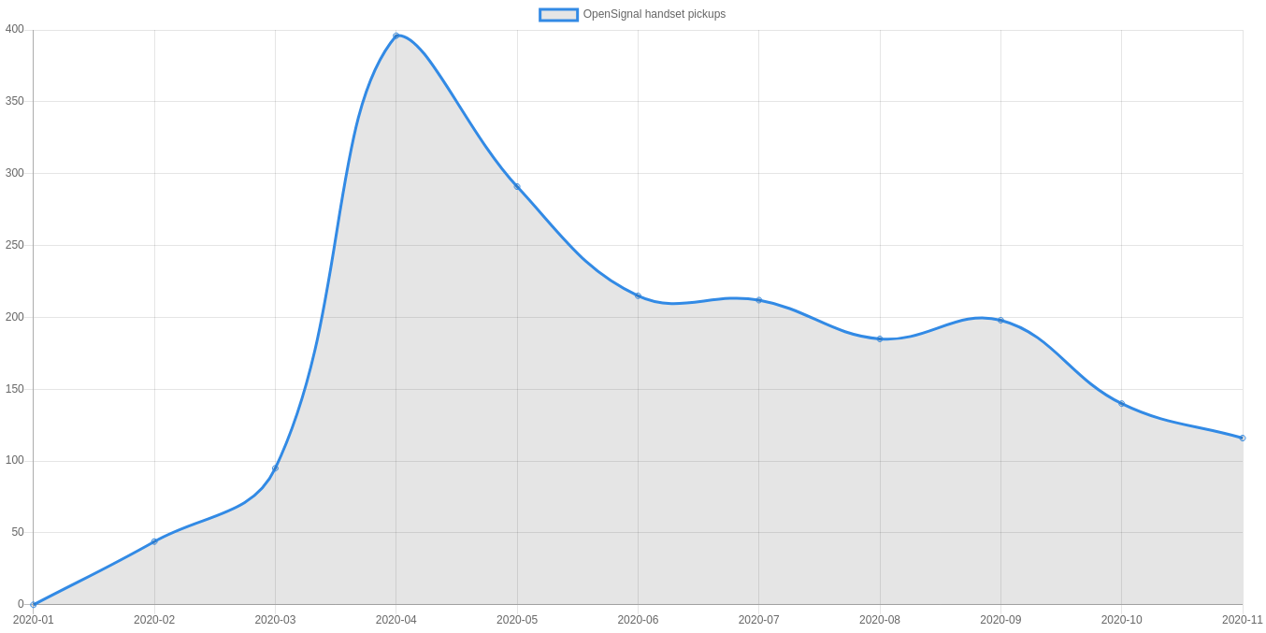
Figure 2. Open Signal phone handset pickups per month.
Counts handset pickups of public phone at sidewalk outside Open Signal.

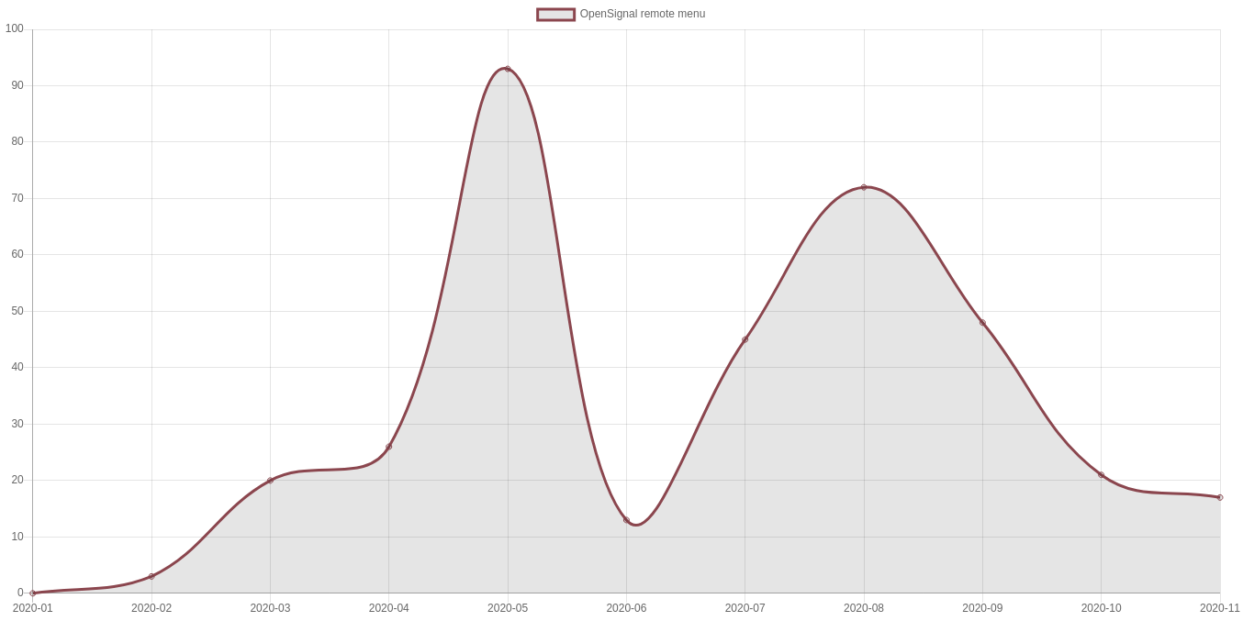
Figure 3. Hold The Phone remote menu accesses per month.
Counts user selection of Hold The Phone menu from incoming Futel telephone number.

