Work samples from C.H.U.N.K. 666 events.

Chunkathlon, 2002, Portland.
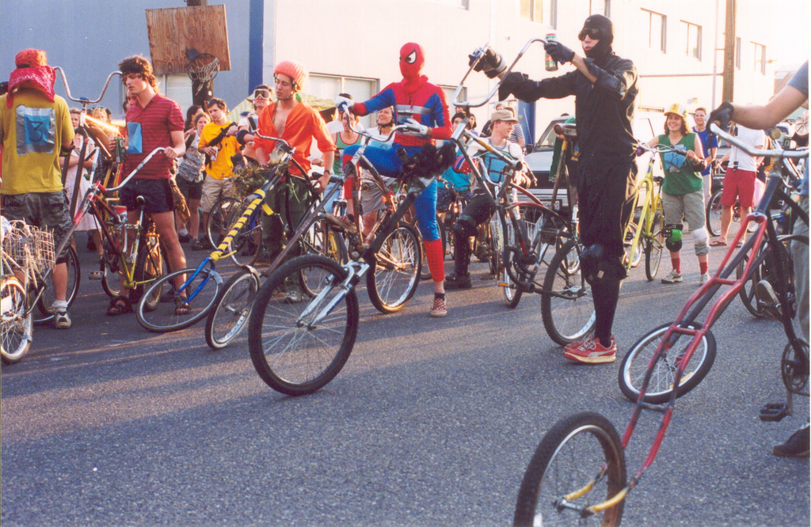

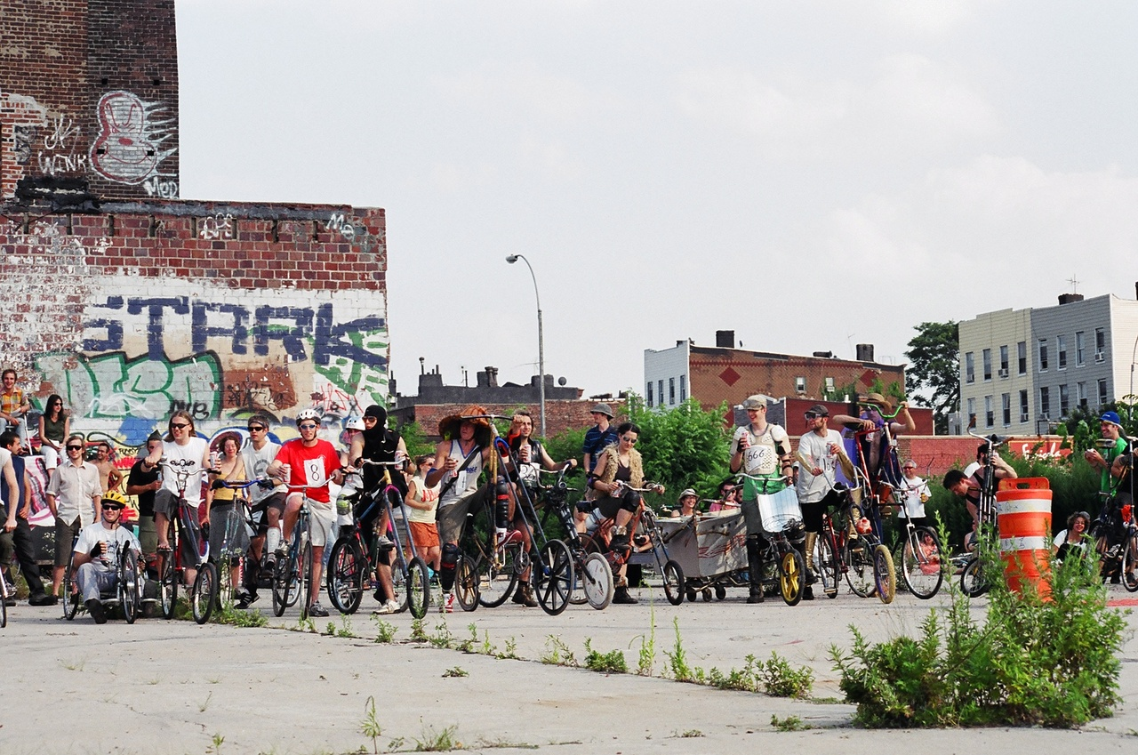
Chunkathlon, 2003, Brooklyn, New York.

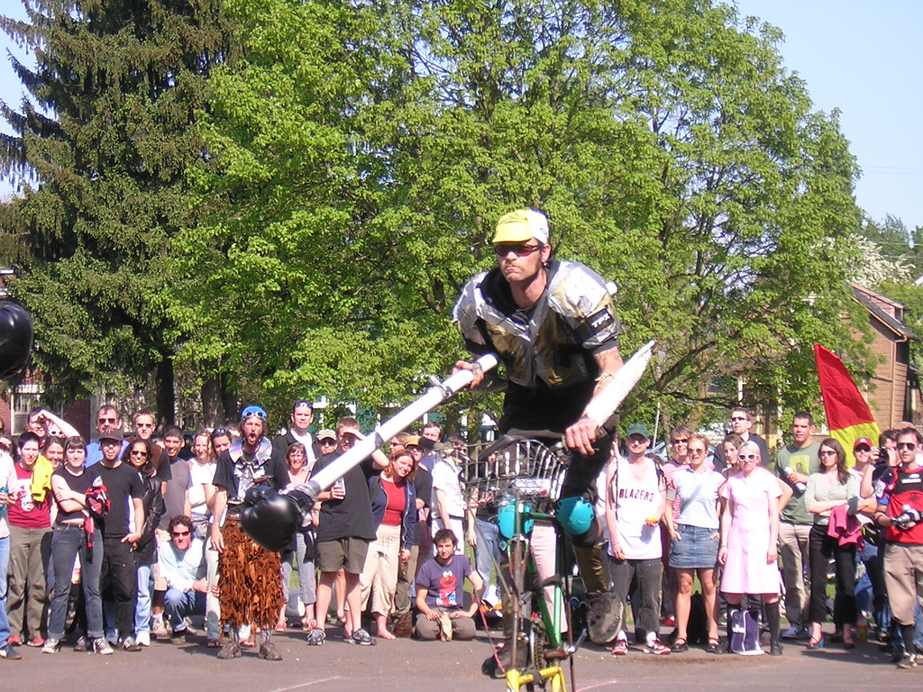
Organ Donor Invitational, Portland, 2005.

Mutant Bike Proving Grounds, Vancouver, British Columbia, 2008.

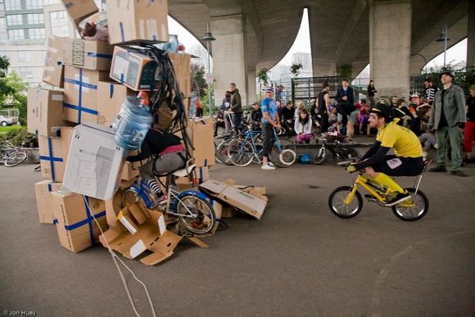

Zine covers, 1997-2001.

