Images from Futel installations, media samples, and interactive work.

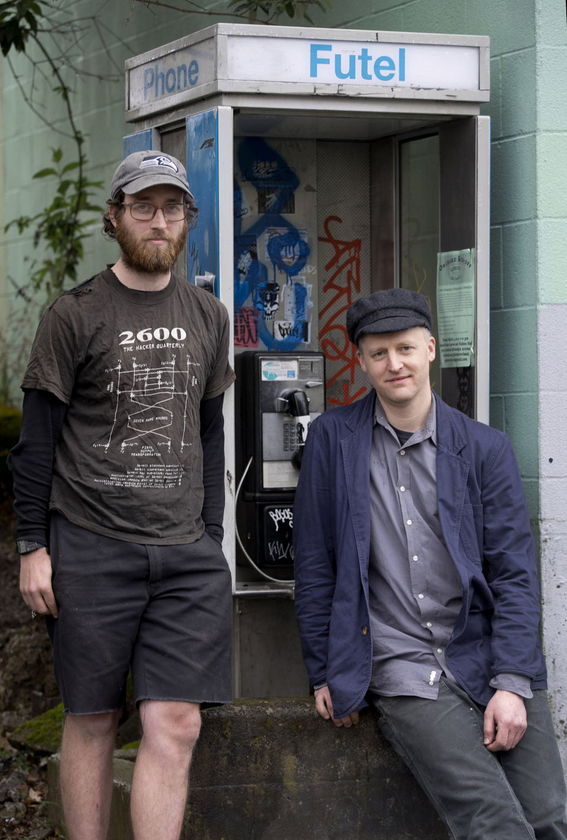
Elijah St. Clair and Karl Anderson in front of a public Futel installation.

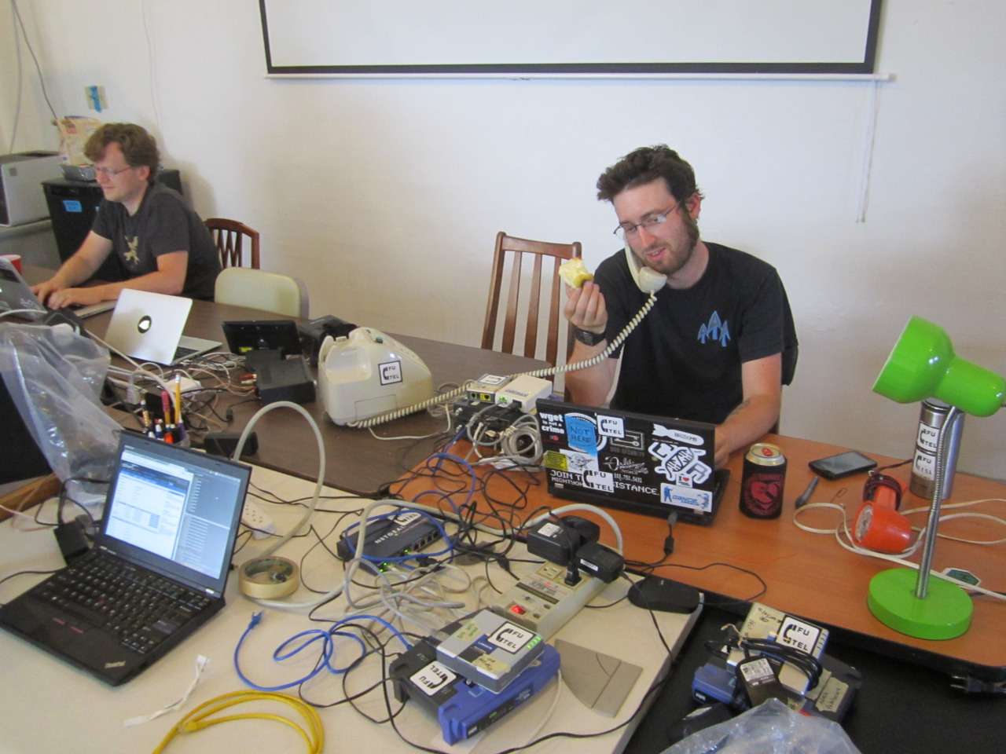
Elijah St. Clair taking an operator call from a user of a public Futel phone during an open house at the CTRL-H hackerspace in Portland.

Information plates used on the front of Futel phones, designed by Debbie Wager.

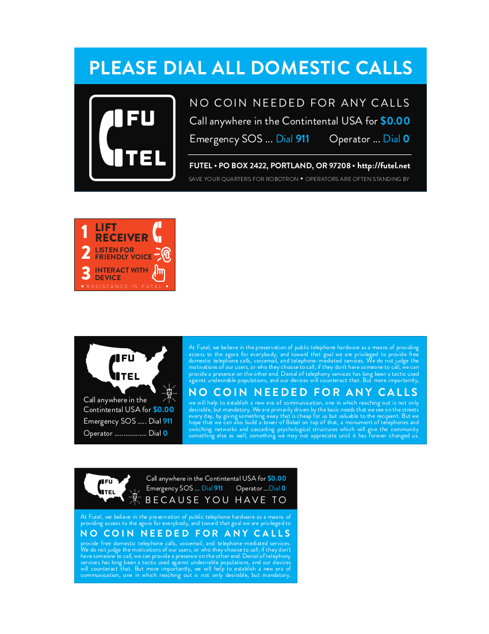
Setting up an installation at ToorCamp, Neah Bay, Washington, 2014.

